- Identify which general testing techniques you will be using - bolded items in Module 07 General Program Testing Techniques
Black Box testing, Functional testing techniques, Equivalence Partitioning
- Create a Test Set - Write down the entries you will use for testing.
Will test inputs : Square 4, square -2, rectangle 2, 4, rectangle ‘a’, triangle 8, 5, with sides 6, 7 circle -2, circle 10, circle 0, exit, menu selecting 9, blank input (testing all with 0 and negative numbers)
- Test The Program - Test the program using your Test Set.
- Identify Errors -
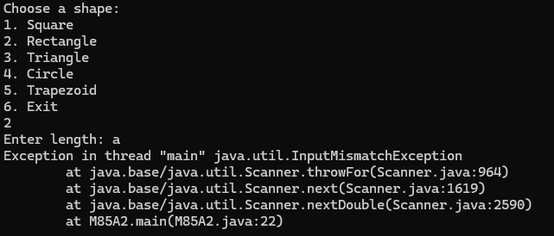 error 1, if input with length or radius of a non numeric value, will throw inputmismatchexception error. Equivalence Partitioning used, testing found error when I inputted character a, it is an error because the scanner and program breaks when incorrect value in the scanner, fix by having a clause to check if the input is a valid numeric value. This applied to all the shapes
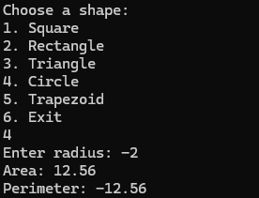error 2 if input is negative, it will still compute the calculations despite being negative Equivalence Partitioning used, testing found error when I tried to use a negative value, it is an error because it should not calculate a negative, could fix by having a if statement that checks if the input value is greater than 0. This also applied to all the shapes.
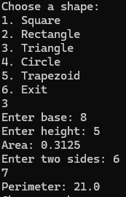 Error 3: triangle area calculation error, the area should have been 20.0 instead was incorrect, Black-Box Testing used, error found when I was testing the triangle with inputs, it is an error because the calculator is wrong in this scenario, fix by fixing the calculations inside the code for the triangle
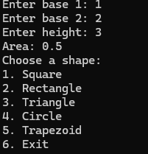 error 4: trapezoid area calculation error, should be 4.5 instead of 0.5, Black-Box Testing used, found error by just attempting to use the trapezoid calculator, is an error because the calculator does not calculate correctly, could be fixed by correcting the calculation code in the trapezoid area.
error 5, no perimeter for trapezoid, Black-Box Testing used error because program should give perimeter for every shape, tested by trying the trapezoid calculations, should also ask for sides to test perimeter to fix
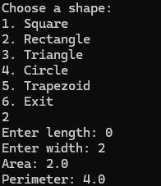error 6, incorrect calculations when 0 is input, equivalence partitioning used, found error when I tried using 0 for my rectangle input, its an error because 0 should not allow area or perimeter to be computed, fix by adding a check, possibly if statement to make sure the input is greater than 0 or that if 0 is input it throws an incorrect input message. (works fine for circle, and square, but not rectangle triangle or trapezoid)
  - List each error with screenshot.
  - Which testing technique identified the error.
  - How your testing detected the error.
  - The reason it is an error.
  - How to fix it - Textual description, code is ok, no source code available so these will be general instructions.

