Employee Attrition and
Workforce Analysis
Academic Project Report

IBM SkillsBuild Data Analytics with AI Academic Internship Program
BharatCares in association with AICTE

Submitted by: Anish Kumar
Dataset: IBM HR Analytics Employee Attrition & Performance
https://www.kaggle.com/datasets/pavansubhasht/ibm-hr-analytics-attrition-dataset

Abstract
This project presents a comprehensive data analytics study on employee attrition using the IBM HR Analytics Employee Attrition & Performance dataset, comprising 1,470 employee records across 35 variables. The full data analytics lifecycle was applied: data loading, quality checking, cleaning, feature engineering, exploratory data analysis, visualization, correlation analysis, and business recommendations. The overall attrition rate was 16.12% (237 employees). Key findings: overtime workers leave at 30.53% vs 10.44% for non-overtime employees; Sales Representatives have the highest role attrition at 39.76%; the 18–25 age group has 34.78% attrition; frequent travelers leave at 24.91%; and employees who left earned on average $2,046/month less than those who stayed. Eight actionable business recommendations are provided.

1. Introduction
Employee attrition — the voluntary or involuntary departure of employees — is one of the most significant challenges facing modern HR management. High turnover leads to direct costs (recruitment, training) and indirect costs (loss of institutional knowledge, reduced team morale, productivity decline). Data analytics provides a structured, evidence-based approach to understanding why employees leave and which segments are at highest risk, enabling proactive, targeted interventions.
This project applies the full data analytics workflow to the IBM HR Analytics dataset to uncover patterns of employee attrition across departments, job roles, demographics, compensation, overtime, business travel, and satisfaction scores — and to provide practical, data-backed HR recommendations.

2. Problem Statement
Despite having access to substantial HR data, many organizations lack analytical frameworks to systematically identify why employees leave. This project addresses five core questions:
- What is the overall attrition rate and how is it distributed across departments?
- Which departments and job roles have the highest attrition rates?
- How do overtime, business travel, and work-life balance relate to attrition?
- What are the demographic and compensation characteristics of employees who leave?
- What data-backed recommendations can help reduce attrition?

3. Project Objectives
- 1. Load and explore the IBM HR Analytics dataset using Python and Pandas.
- 2. Perform a thorough data quality check and clean the dataset appropriately.
- 3. Engineer derived features (AgeGroup, TenureGroup, IncomeGroup) to support analysis.
- 4. Calculate key business metrics including attrition rate, average income, and satisfaction scores.
- 5. Conduct exploratory data analysis (EDA) across 15+ dimensions.
- 6. Create professional, readable data visualizations using Matplotlib and Seaborn.
- 7. Perform a correlation analysis on key numerical variables.
- 8. Identify data-backed insights and provide practical HR recommendations.

4. Dataset Description
The IBM HR Analytics Employee Attrition & Performance dataset is a widely used benchmark for HR analytics, originally created by IBM data scientists and available on Kaggle.

4.1 Dataset Summary
Attribute | Value
Total Records | 1,470 employees
Total Features | 35 columns
Target Variable | Attrition (Yes = 237 / No = 1,233)
Missing Values | None
Duplicate Records | None

4.2 Key Dataset Columns
Column | Type | Description
Age | Numerical | Employee age (range: 18–60)
Attrition | Categorical | Left the organization? (Yes/No) — target variable
BusinessTravel | Categorical | Non-Travel / Travel_Rarely / Travel_Frequently
Department | Categorical | Sales / Research & Development / Human Resources
JobLevel | Numerical | Seniority level (1 = Entry to 5 = Senior)
JobRole | Categorical | Specific job title (9 roles)
JobSatisfaction | Numerical | Rating 1 (Low) to 4 (High)
MonthlyIncome | Numerical | Monthly salary in USD
OverTime | Categorical | Works overtime? (Yes/No)
MaritalStatus | Categorical | Single / Married / Divorced
WorkLifeBalance | Numerical | Rating 1 (Bad) to 4 (Best)
YearsAtCompany | Numerical | Tenure at current company
TotalWorkingYears | Numerical | Total years of work experience
EducationField | Categorical | Field of academic study
Gender | Categorical | Male / Female

5. Technologies and Tools Used
Technology | Version / Notes | Purpose
Python 3 | 3.8+ | Core programming language
Pandas | 1.5+ | Data loading, cleaning, groupby analysis
NumPy | 1.24+ | Numerical operations and array computations
Matplotlib | 3.6+ | Base charting library (bar, histogram, pie)
Seaborn | 0.12+ | Statistical visualizations, correlation heatmap
Jupyter | Notebook / Lab | Interactive development and output display

6. Data Visualizations
All charts below are generated directly from the dataset using Python (Matplotlib / Seaborn). Red bars indicate attrition rates above the company average (16.12%); blue bars indicate below-average rates. Dashed grey lines mark the company average.
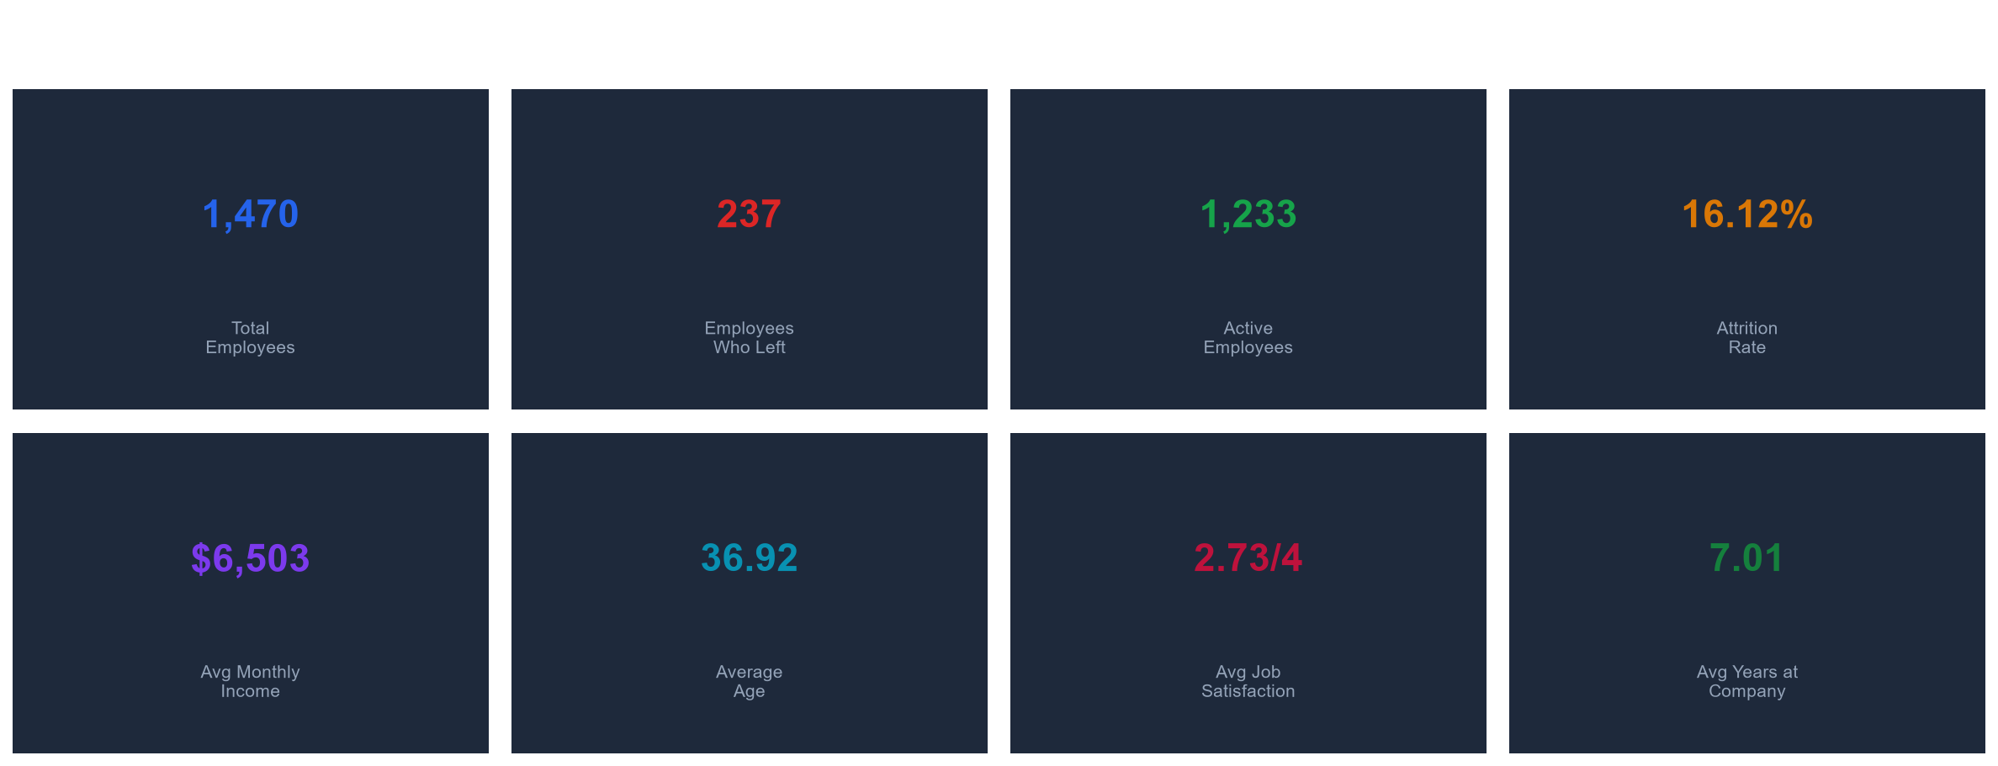
Figure 1 — Key Performance Indicators Dashboard
Core attrition metrics at a glance.
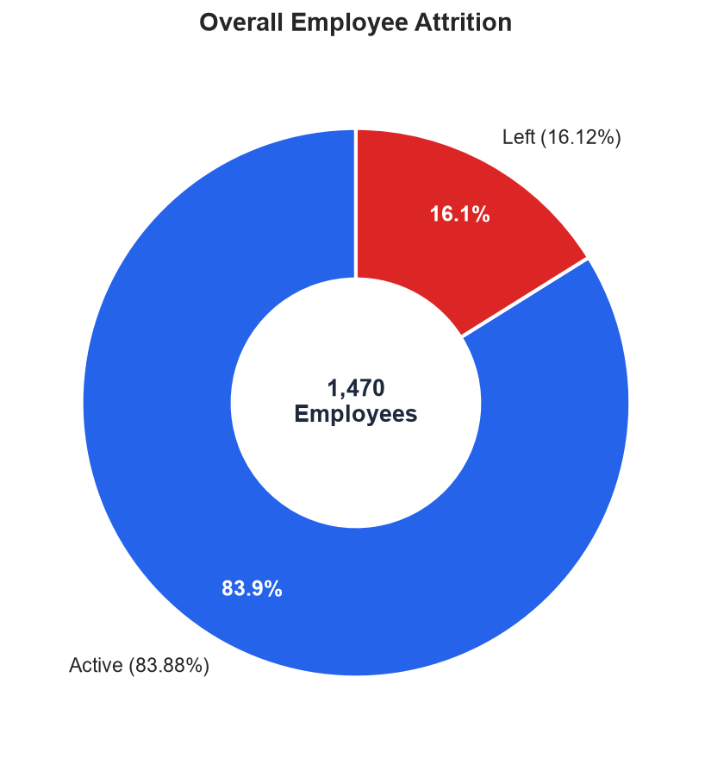
Figure 2 — Overall Attrition (Donut Chart)
83.88% of employees stayed; 16.12% left.
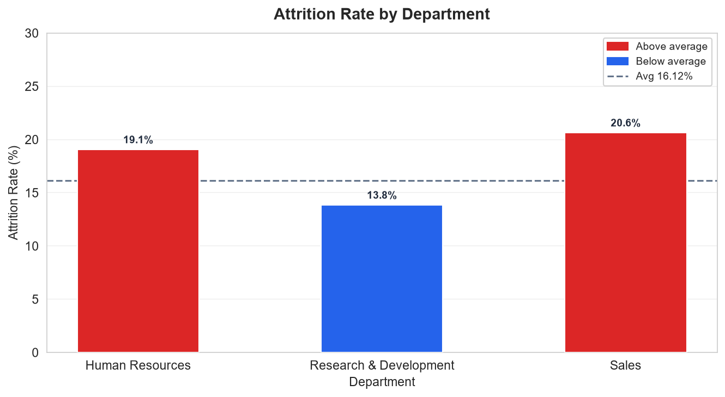
Figure 3 — Attrition Rate by Department
Sales (20.63%) and HR (19.05%) exceed the company average.
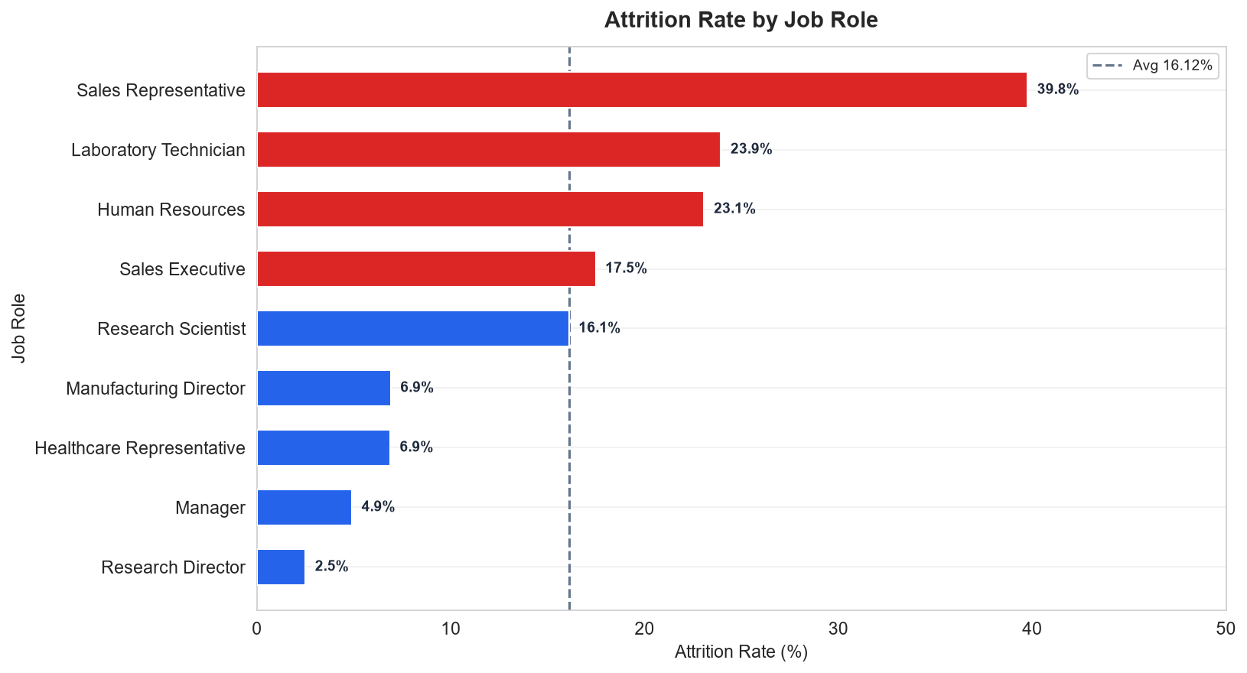
Figure 4 — Attrition Rate by Job Role
Sales Representatives top the list at 39.76%; Research Directors lowest at 2.50%.
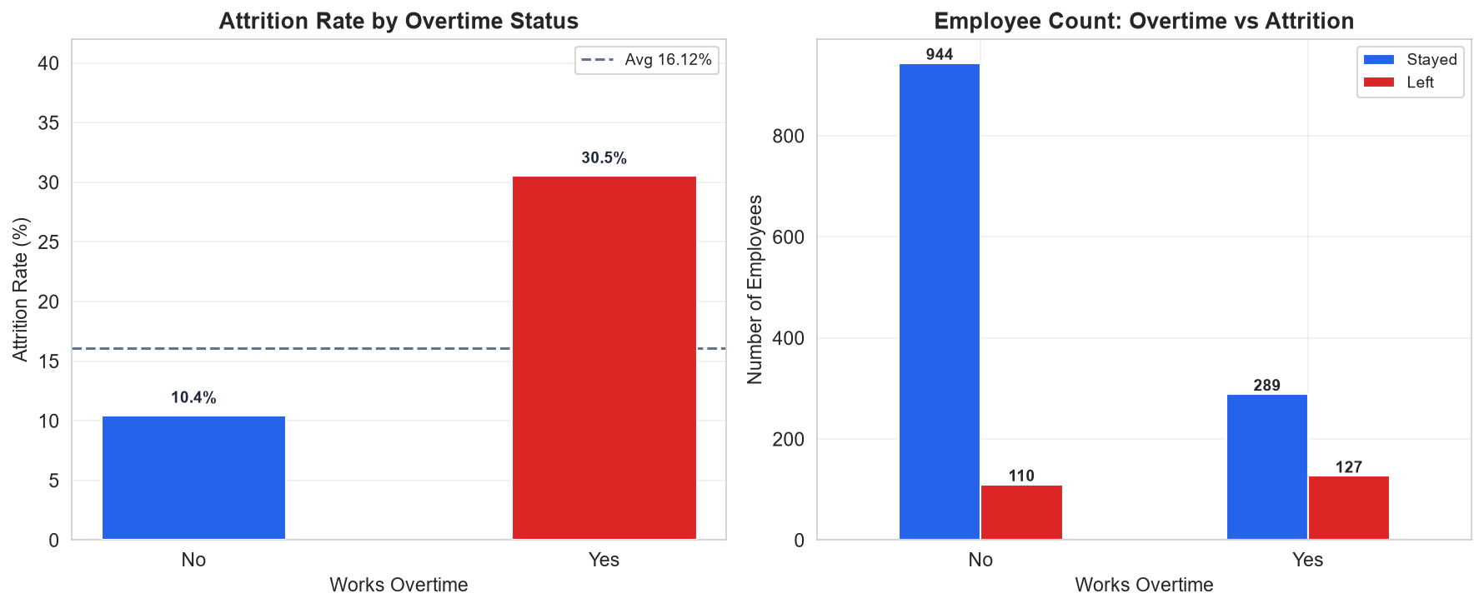
Figure 5 — Overtime vs Attrition
Overtime workers leave at 30.53% — nearly 3× the rate of non-overtime employees.
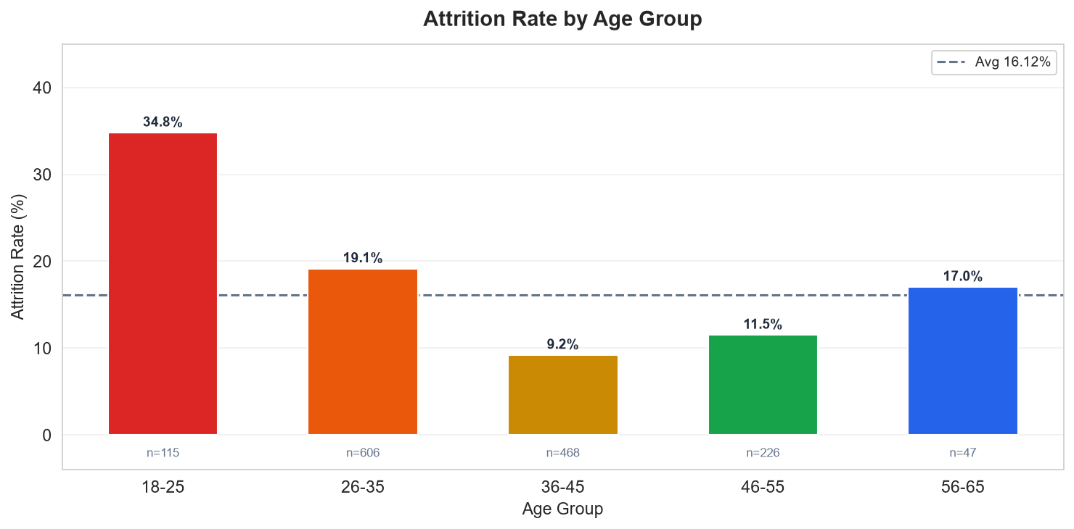
Figure 6 — Attrition by Age Group
Young employees (18–25) leave most frequently at 34.78%.
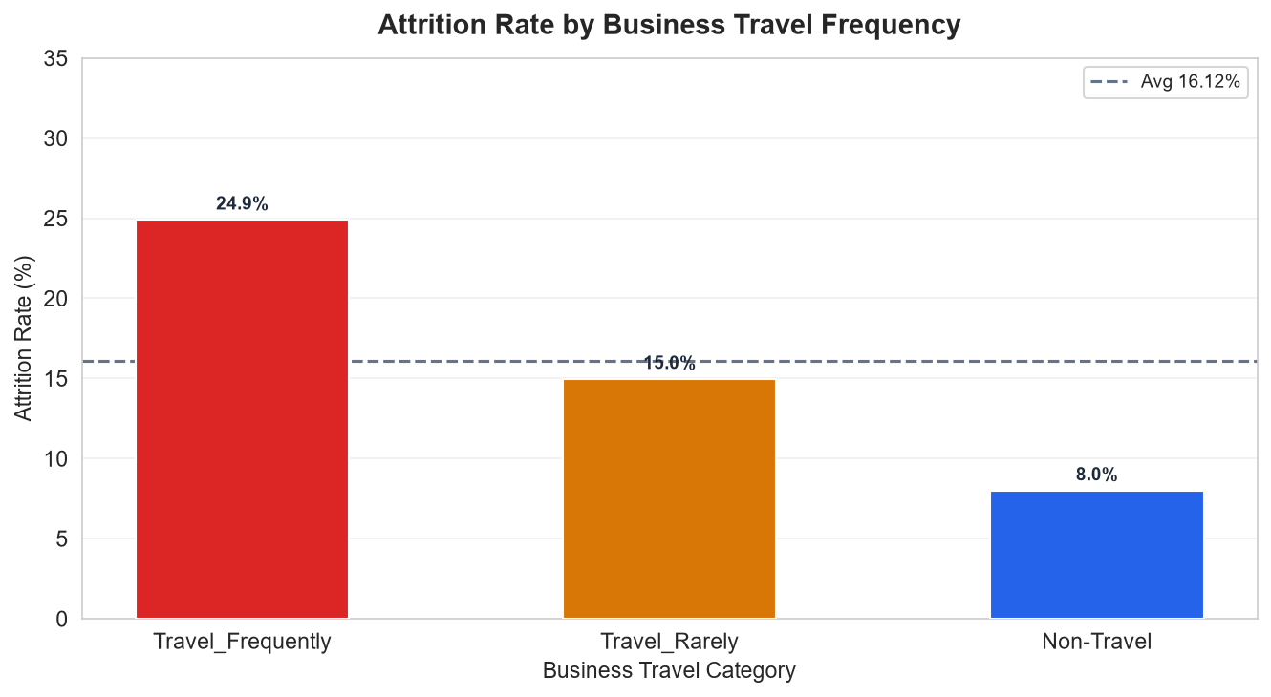
Figure 7 — Attrition by Business Travel Frequency
Frequent travelers: 24.91% vs non-travelers: 8.00%.
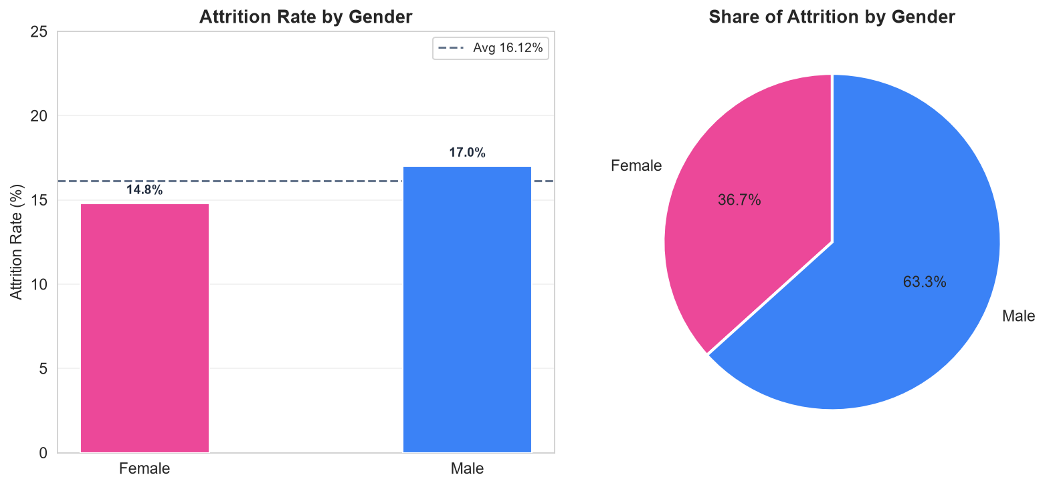
Figure 8 — Attrition by Gender
Male employees (17.01%) have a slightly higher attrition rate than female (14.80%).
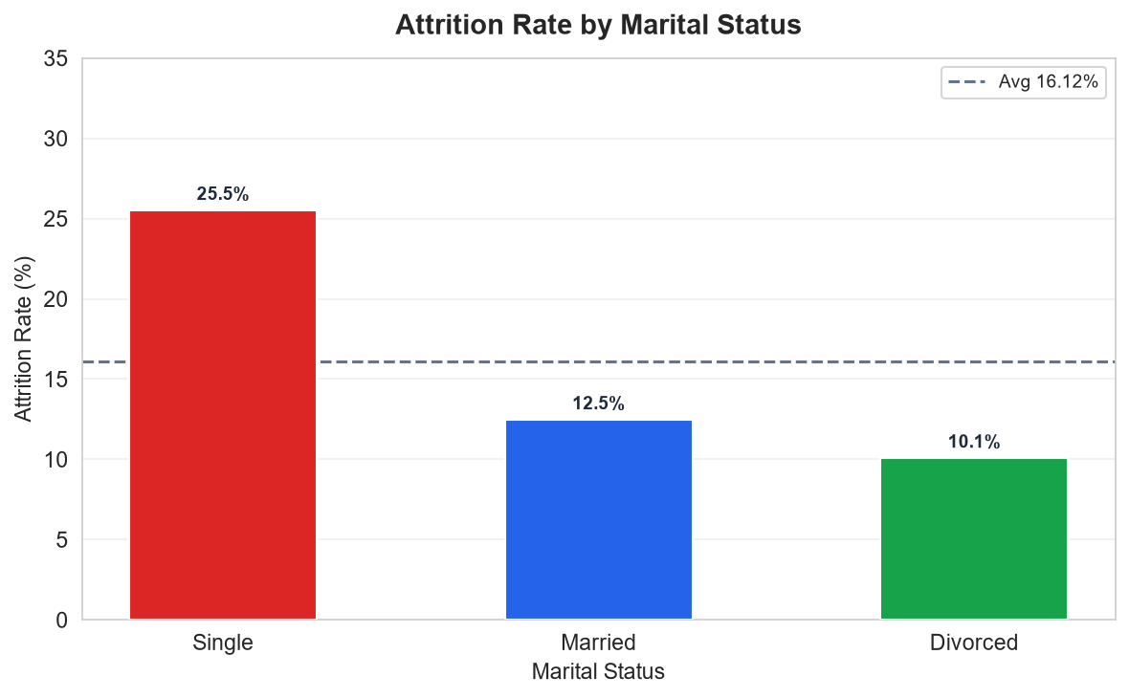
Figure 9 — Attrition by Marital Status
Single employees leave at 25.53% — more than double divorced employees (10.09%).
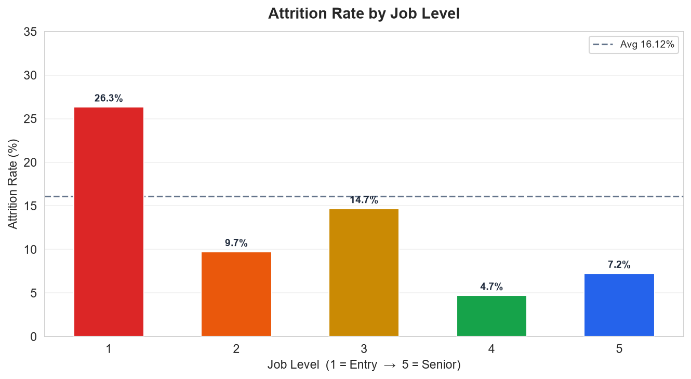
Figure 10 — Attrition by Job Level
Entry-level (Level 1): 26.34% vs senior (Level 5): 7.25%.
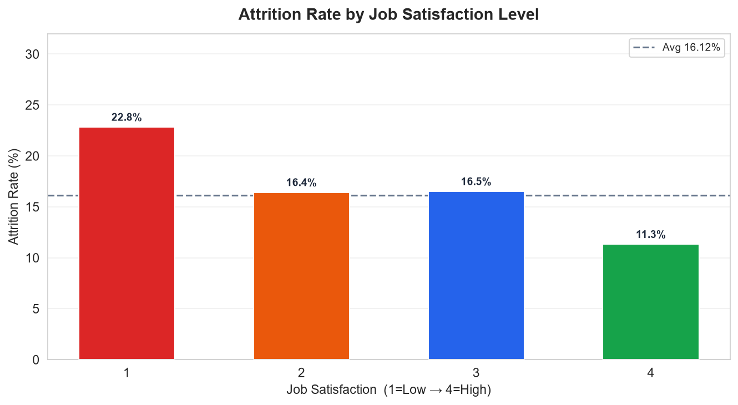
Figure 11 — Attrition by Job Satisfaction
Lowest satisfaction (Level 1) drives 22.84% attrition vs 11.33% at highest (Level 4).
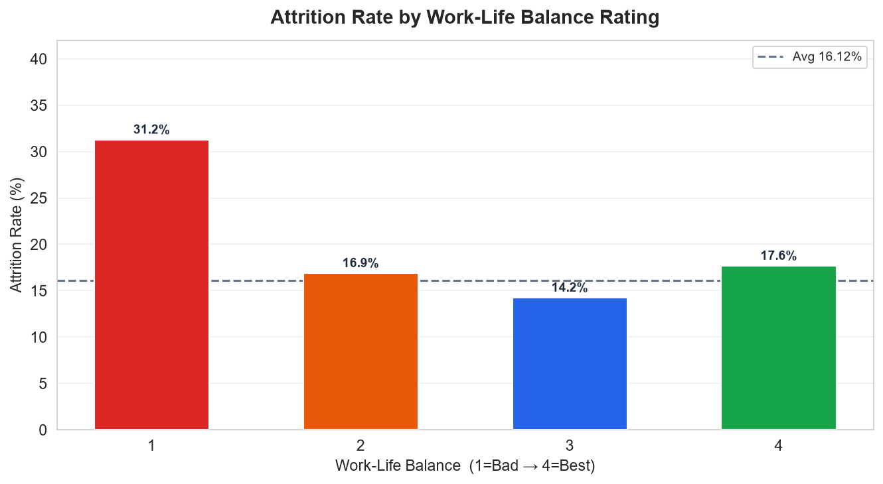
Figure 12 — Attrition by Work-Life Balance
Poor WLB (Level 1): 31.25% attrition.
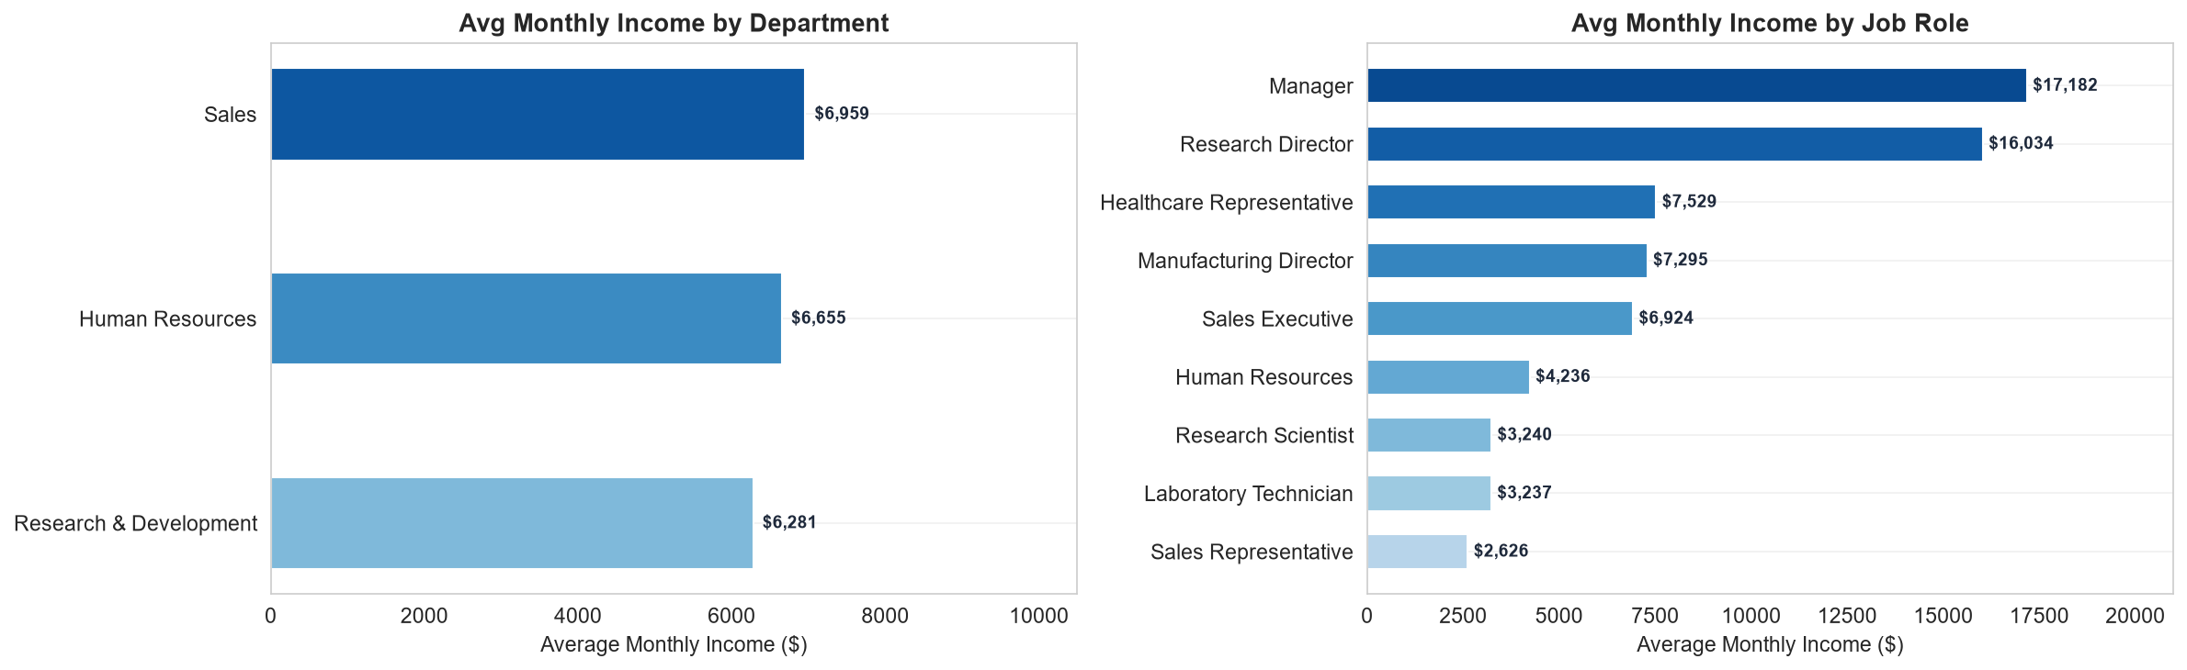
Figure 13 — Average Monthly Income by Department and Job Role
Managers earn most ($17,182); Sales Representatives earn least ($2,626).
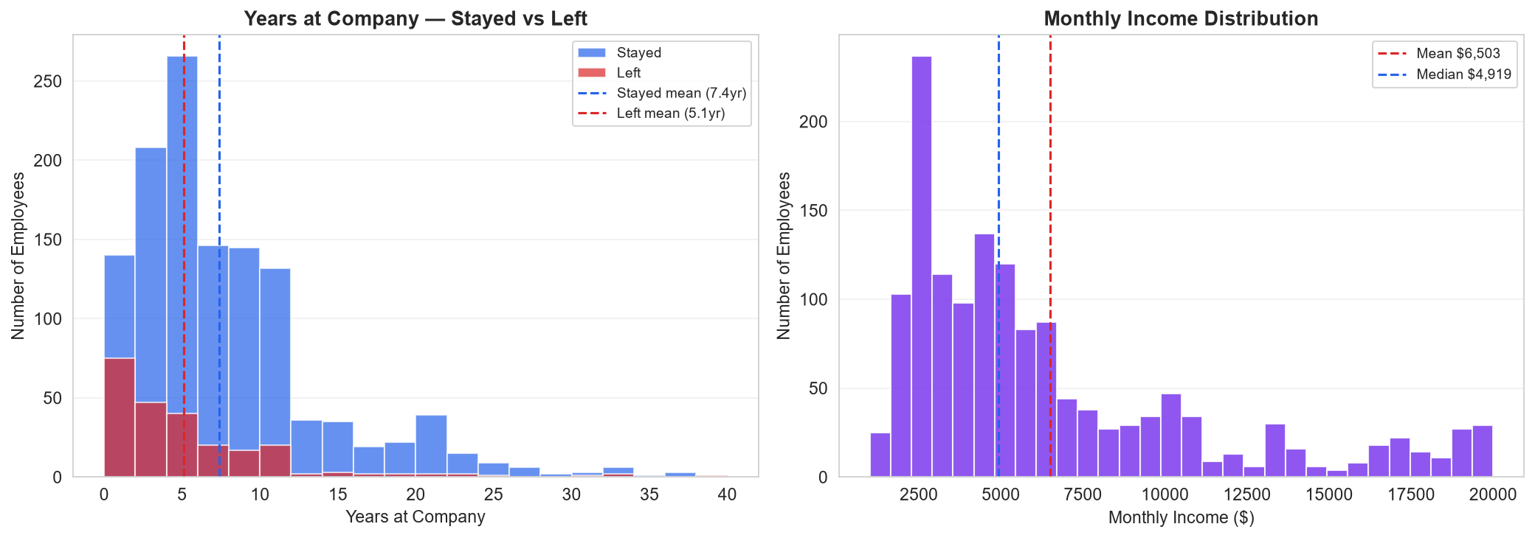
Figure 14 — Years at Company & Monthly Income Distributions
Leavers averaged 5.1 years tenure vs stayers at 7.4 years.
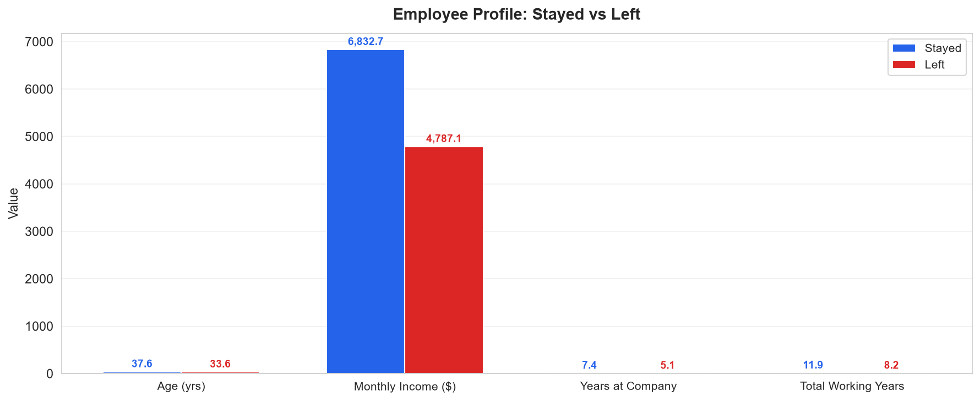
Figure 15 — Employee Profile: Stayed vs Left
Systematic differences in age, income, tenure, and experience between the two groups.
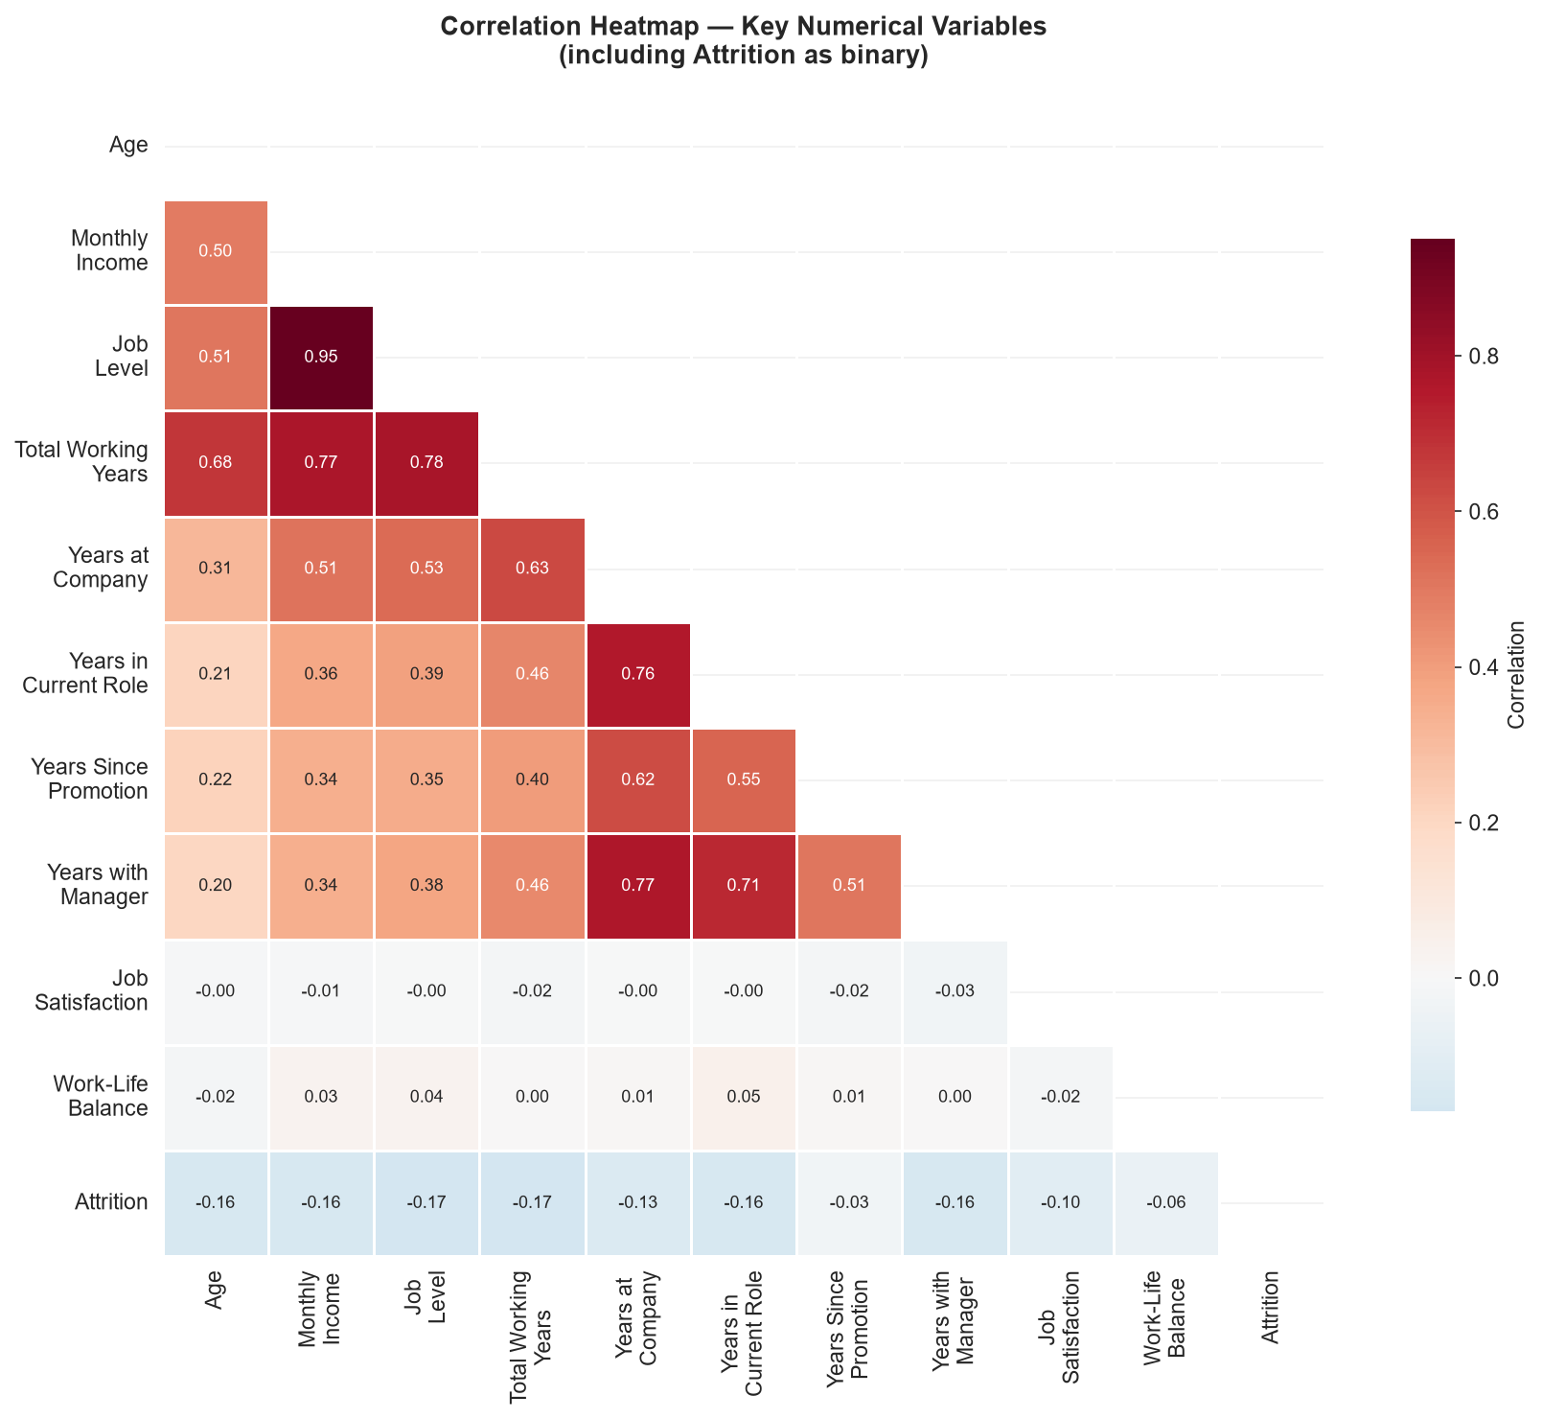
Figure 16 — Correlation Heatmap (11 Variables)
Strong career-progression correlations; attrition binary correlates negatively with seniority.
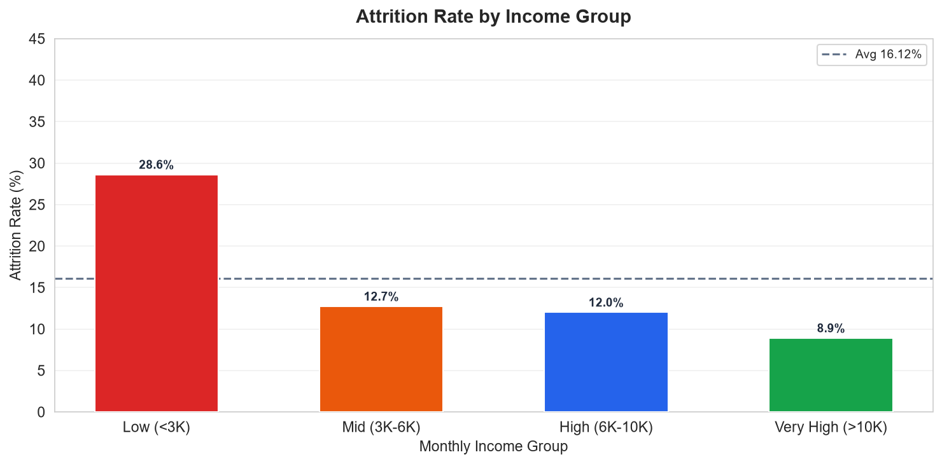
Figure 17 — Attrition by Income Group
Low-income employees (<$3K/month) leave at 34.71% — the highest of any income band.

7. Key Business Metrics
All metrics below were calculated directly from the 1,470-record dataset.
Metric | Value
Total Employees | 1,470
Employees Who Left | 237
Active Employees | 1,233
Overall Attrition Rate | 16.12%
Average Age | 36.92 years
Average Monthly Income | $6,502.93
Average Years at Company | 7.01 years
Average Job Satisfaction | 2.73 / 4
Average Work-Life Balance | 2.76 / 4
Average Years in Current Role | 4.23 years

8. Exploratory Data Analysis

8.1 Attrition by Department
Department | Total | Left | Attrition Rate
Sales | 446 | 92 | 20.63%
Human Resources | 63 | 12 | 19.05%
Research & Development | 961 | 133 | 13.84%
Sales exceeds the company average (20.63%); R&D is below average (13.84%).

8.2 Attrition by Job Role
Job Role | Total | Left | Attrition Rate
Sales Representative | 83 | 33 | 39.76%
Laboratory Technician | 259 | 62 | 23.94%
Human Resources | 52 | 12 | 23.08%
Sales Executive | 326 | 57 | 17.48%
Research Scientist | 292 | 47 | 16.10%
Manufacturing Director | 145 | 10 | 6.90%
Healthcare Representative | 131 | 9 | 6.87%
Manager | 102 | 5 | 4.90%
Research Director | 80 | 2 | 2.50%

8.3 Other Key Attrition Dimensions
Dimension | Category | Attrition Rate
Overtime | Yes | 30.53%
Overtime | No | 10.44%
Age Group | 18-25 | 34.78%
Age Group | 26-35 | 19.14%
Age Group | 36-45 | 9.19%
Business Travel | Travel_Frequently | 24.91%
Business Travel | Travel_Rarely | 14.96%
Business Travel | Non-Travel | 8.00%
Marital Status | Single | 25.53%
Marital Status | Married | 12.48%
Marital Status | Divorced | 10.09%
Job Level | Level 1 (Entry) | 26.34%
Job Level | Level 5 (Senior) | 7.25%
Work-Life Balance | Level 1 (Bad) | 31.25%
Work-Life Balance | Level 3 (Good) | 14.22%
Job Satisfaction | Level 1 (Low) | 22.84%
Job Satisfaction | Level 4 (High) | 11.33%

8.4 Employee Profile Comparison: Stayed vs Left
Attribute | Stayed | Left
Average Age | 37.56 years | 33.61 years
Average Monthly Income | $6,832.74 | $4,787.09
Average Job Satisfaction | 2.77 / 4 | 2.47 / 4
Average Work-Life Balance | 2.78 / 4 | 2.66 / 4
Average Years at Company | 7.37 years | 5.13 years
Average Total Working Years | 11.86 years | 8.24 years
Average Job Level | 2.15 | 1.64

9. Key Findings
All findings below are derived from actual dataset calculations.
01 Overtime is the Strongest Attrition Predictor
Employees working overtime leave at 30.53% vs 10.44% for non-overtime workers — nearly 3× higher. With 28.3% of the workforce (416 employees) doing overtime, this segment represents a critical retention risk.
02 Sales Representatives Are the Highest-Risk Role
Sales Representatives have a 39.76% attrition rate — the highest of any role — while also earning the lowest average salary at $2,626/month. The combination of high performance pressure and low base pay is likely driving rapid turnover.
03 Early-Career Employees Leave Most Frequently
The 18–25 age group shows 34.78% attrition; Job Level 1 employees show 26.34%. The 0–2 year tenure band is the highest-risk period. Onboarding quality, early engagement, and competitive entry-level pay are critical retention levers.
04 Frequent Business Travel Triples Attrition Risk
Frequent travelers leave at 24.91% vs 8.00% for non-travelers — a 3× difference. Travel burden clearly degrades quality of life and contributes to departure.
05 Work-Life Balance Level 1 Has Alarm-Level Attrition
Employees with the worst work-life balance (Level 1) leave at 31.25%, more than double the rate at Level 3 (14.22%). Poor WLB is one of the strongest attrition drivers.
06 There Is a $2,046/Month Compensation Gap Between Leavers and Stayers
Employees who left earned $4,787/month on average vs $6,833/month for those who stayed — a 30% difference. This is the most consistent gap across the entire dataset.
07 Single Employees Are More Likely to Leave
Single employees have a 25.53% attrition rate vs 12.48% (married) and 10.09% (divorced). Fewer financial obligations and greater mobility may contribute.
08 Tenure Is Strongly Protective
Attrition decreases consistently as years at the company increases. The first 2 years are the highest-risk period, emphasising the importance of early engagement programs.
09 Job Satisfaction Inversely Correlates with Attrition
Level 1 satisfaction: 22.84% attrition. Level 4 satisfaction: 11.33% attrition. Improving satisfaction scores has a measurable impact on retention.
10 Senior Roles Are Well Retained
Manager (4.90%), Research Director (2.50%), and Manufacturing Director (6.90%) show very low attrition. Career progression to senior levels is a powerful retention mechanism.

10. Business Recommendations
The following recommendations are directly grounded in the data findings above. Each recommendation cites the specific metric that supports it.
[R1] Implement Overtime Policies and Monitoring
Based on: Overtime attrition 30.53% vs 10.44%.
Monitor overtime hours per employee and introduce mandatory limits or compensation adjustments. Flag employees consistently working long hours for engagement check-ins. Redistribute workloads or add headcount in roles where overtime is systemic.
[R2] Prioritize Retention in Sales
Based on: Sales Representative attrition 39.76%; avg income $2,626/month.
Review the compensation structure for Sales Representatives. Introduce performance bonuses, clear career ladders, mentorship programs, and manageable travel requirements.
[R3] Strengthen Early-Career Onboarding
Based on: 18-25 age group attrition 34.78%; Job Level 1 attrition 26.34%.
Introduce structured 90-day and 12-month onboarding with assigned mentors. Provide clear 12–24 month career roadmaps and competitive entry-level compensation.
[R4] Redesign Business Travel Policy
Based on: Frequent travelers 24.91% vs non-travelers 8.00%.
Evaluate whether all frequent travel is necessary. Explore virtual alternatives. Where travel is mandatory, improve allowances, provide recovery time, and offer flexible scheduling to reduce the quality-of-life burden.
[R5] Formalize Work-Life Balance Initiatives
Based on: Work-Life Balance Level 1 attrition 31.25%.
Launch formal WLB programs: flexible hours, remote work where feasible, wellness initiatives. Run regular pulse surveys to identify early-stage burnout.
[R6] Conduct Compensation Benchmarking
Based on: Leavers earned $4,787/month vs stayers $6,833/month (30% gap).
Benchmark salaries for entry and mid-level roles against the market. Offer transparent salary progression milestones and stock option plans.
[R7] Improve Job Satisfaction Programs
Based on: Job satisfaction Level 1 attrition 22.84% vs Level 4 attrition 11.33%.
Run quarterly satisfaction surveys and take visible, measurable action on feedback. Recognize achievements and connect employee work to organizational goals.
[R8] Create Clear Career Progression Pathways
Based on: Job Level 1 attrition 26.34%; Job Levels 4–5 attrition < 7.25%.
Implement Individual Development Plans (IDPs), promote internally first, and communicate promotion criteria transparently to all employees.

11. Conclusion
This project conducted a comprehensive data analytics study on employee attrition using the IBM HR Analytics dataset. The full analytics lifecycle was applied to 1,470 employee records, following a structured workflow from data loading through cleaning, feature engineering, EDA, visualization, correlation analysis, and business recommendations.
Key conclusions:
- The overall attrition rate is 16.12% — 237 of 1,470 employees left.
- Overtime work is the strongest single driver: 30.53% attrition for overtime workers vs 10.44%.
- Sales Representatives face the highest role-specific attrition (39.76%) with the lowest pay ($2,626/month).
- Young employees (18–25: 34.78%) and entry-level employees (Level 1: 26.34%) are the most vulnerable segments.
- Business travel frequency, poor work-life balance, and low job satisfaction all correlate strongly with higher attrition.
- A consistent $2,046/month compensation gap exists between employees who leave and those who stay.
Data analytics transformed this HR challenge from a general concern into specific, quantified, actionable insights. HR management now has a concrete, evidence-based roadmap — eight targeted recommendations addressing overtime, compensation, onboarding, travel policy, work-life balance, and career development — to measurably reduce the 16.12% attrition rate and build a more engaged, stable workforce.

12. Limitations
- The dataset is a static snapshot and does not capture attrition trends over time.
- Findings apply to a single organization and may not generalize to other industries.
- Correlation does not imply causation — identified relationships do not prove direct causality.
- The dataset lacks qualitative data (e.g., exit interview reasons, manager quality).
- Self-reported satisfaction scores are subjective and may carry response bias.

13. Future Scope
- Develop predictive attrition models (Logistic Regression, Random Forest, XGBoost) to identify high-risk employees proactively.
- Build a live HR analytics dashboard (Power BI, Tableau, or Streamlit) for real-time monitoring.
- Apply clustering (K-Means) to segment employees by attrition risk profile for targeted interventions.
- Conduct time-series analysis to identify seasonal and trend patterns in attrition rates.
- Apply NLP to exit interview text data to extract qualitative departure reasons.

14. References
1. IBM HR Analytics Employee Attrition & Performance Dataset. Kaggle. https://www.kaggle.com/datasets/pavansubhasht/ibm-hr-analytics-attrition-dataset
2. Pandas Documentation. https://pandas.pydata.org/docs/
3. Matplotlib Documentation. https://matplotlib.org/stable/contents.html
4. Seaborn Documentation. https://seaborn.pydata.org/
5. NumPy Documentation. https://numpy.org/doc/
6. IBM SkillsBuild Data Analytics with AI Academic Internship Program. BharatCares in association with AICTE.

