Questions:
- Convert all characters in the string to uppercase. x = "hello"
- Given the string s = 'hello', perform the following operations:
- Convert the string to uppercase.
- Replace 'e' with 'a'.
- Check if the string starts with 'he'.
- Check if the string ends with 'lo'.
Answers :
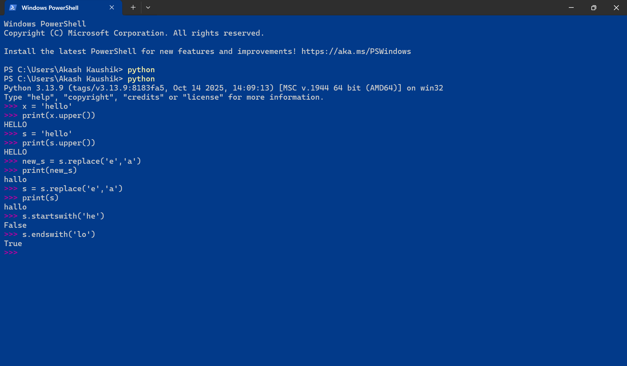

Question:
3 . Convert the following values to the specified types and print the results
- Convert 3.75 to an integer and print the value
- Convert "123" to a float and print the value
- Convert 0 to a boolean and print the value
- Convert False to a string and print the value
4. Given x = 5 and y = 3.14, calculate z = x + y and determine the data type of z. And convert it to integer.
Answer:
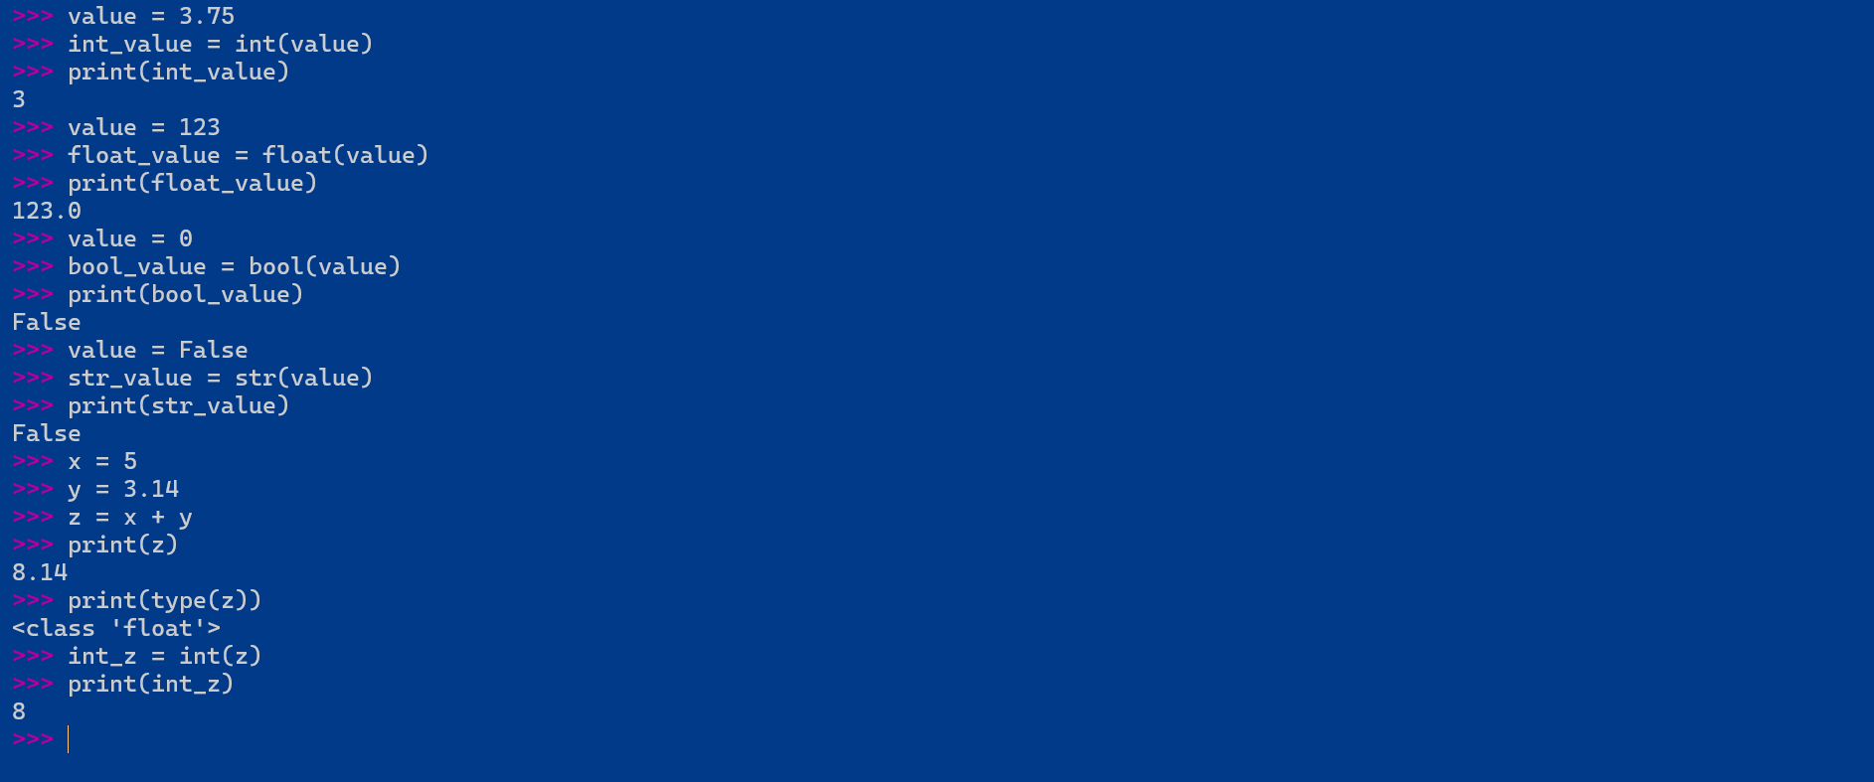
Objective: Ask the user for their name and greet them.
Task: Write a program that asks the user for their name and then prints a greeting message using their name.
name = input("What is your name ? : ")
print("Greeting from Python : " + name)
Objective: Perform basic arithmetic operations based on user input.Task: Ask the user to enter two numbers from the user and print their sum, multiplication, and division.
a = float(input("Enter first number "))
b = float(input("Enter second number "))
sum_result = a + b
mul_result = a * b
div_result = a / b
print("Sum : ",sum_result)
print("Multiply : ",mul_result)
print("Divide : ",div_result)

Task: Ask the user to enter input names separated by commas, split the string from comma and copy to a list and print.
name_input = input("Enter names separated by comma : ")
name_list = name_input.split(",")
print("List : ",name_list)
Task: Ask the user to enter their age and check if they are eligible to vote based on their age.
age = int(input("Enter your age : "))
if age > 18 :
print("You are eligible for vote")
else :
print("You are not eligible for vote")
TASK :For value = 3.14159, Using f-string print output for only up to 2 decimal places. Output: 3.14
value = 3.14159
print(f"{value:.2f}")

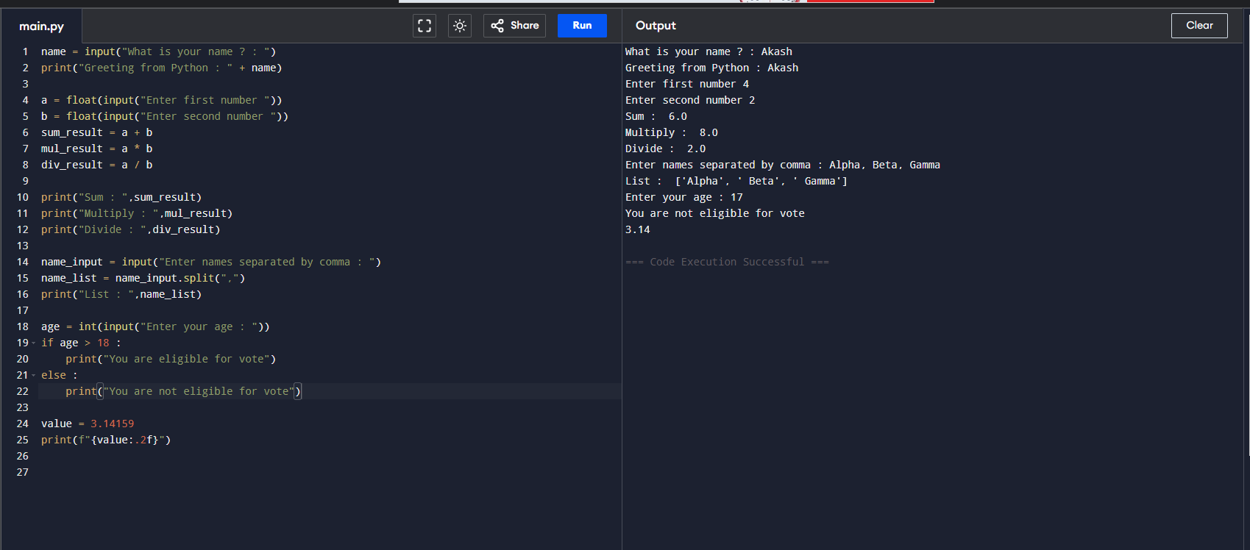

- Given a list of numbers, find and print the maximum and minimum values.
nums = [1, 2, 3, 4, 5]
num_list = [1,2,3,4,5]
print(min(num_list))
print(max(num_list))

- Given two lists below, merge the values from both lists to one and print
a = [1,2,3,4] b = [5,6,7,8]
num_list_1 = [1,2,3,4]
num_list_2 = [5,6,7,8]
num_list_1.extend(num_list_2)
print(num_list_1)

3. From a list, print the number of times the value 3 appears in the list:
a = [1,3,4,5,2,1,3,9,3]
count_of_3 = nums.count(3)
print(count_of_3)
4. From below list, Sort the list and print
a = [1,3,4,5,2,1,3,9,3]
nums = [1,3,4,5,2,1,3,9,3]
nums.sort()
print(nums)

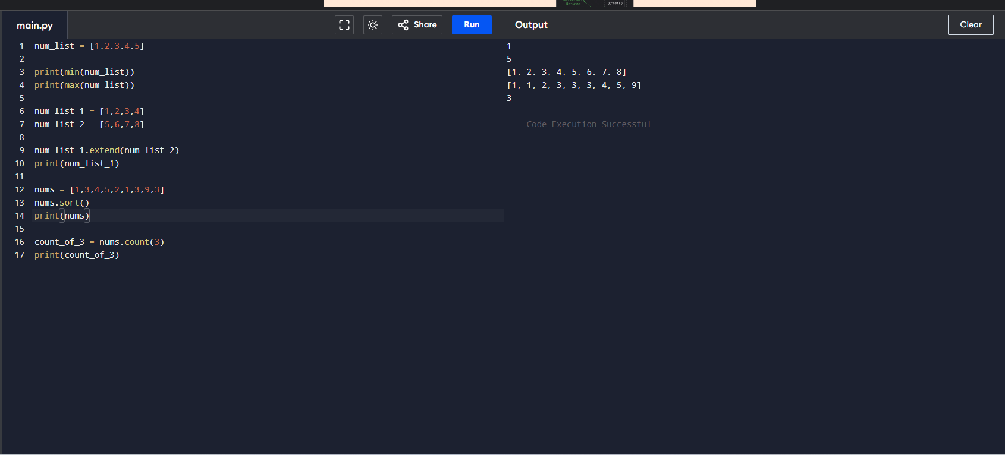
5. Given a set, add the element 6 to it and print the updated set.
numbers = {1, 2, 3, 4, 5}
numbers = {1,2,3,4,5}
numbers.add(6)
print(numbers)

6. Given a set, remove the element 3 from it and print the updated set.
numbers = {1, 2, 3, 4, 5}
numbers.remove(3)
print(numbers)

7. Given two sets, find and print their intersection.
set1 = {1, 2, 3} set2 = {3, 4, 5}
set_1 = {1,2,3}
set_2 = {3,4,4}
print(set_1.intersection(set_2))

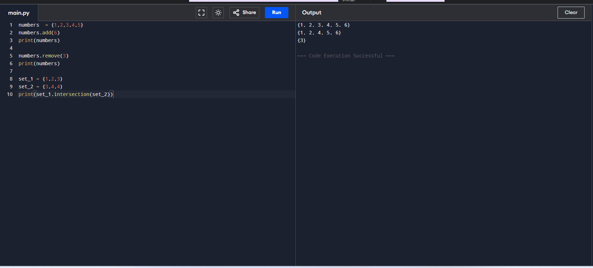
8. Given a tuple, count and print the number of occurrences of the element 'apple'.
fruits = ('apple', 'banana', 'apple', 'cherry')
fruits = ('apple', 'banana', 'apple', 'cherry')
count_apple = fruits.count('apple')
print(count_apple)

9. Given two tuples, concatenate them and print the result.
tuple1 = (1, 2, 3) tuple2 = (4, 5, 6)
tuple_1 = (1, 2, 3)
tuple_2 = (4, 5, 6)
new_tuple = tuple_1 + tuple_2
print(new_tuple)
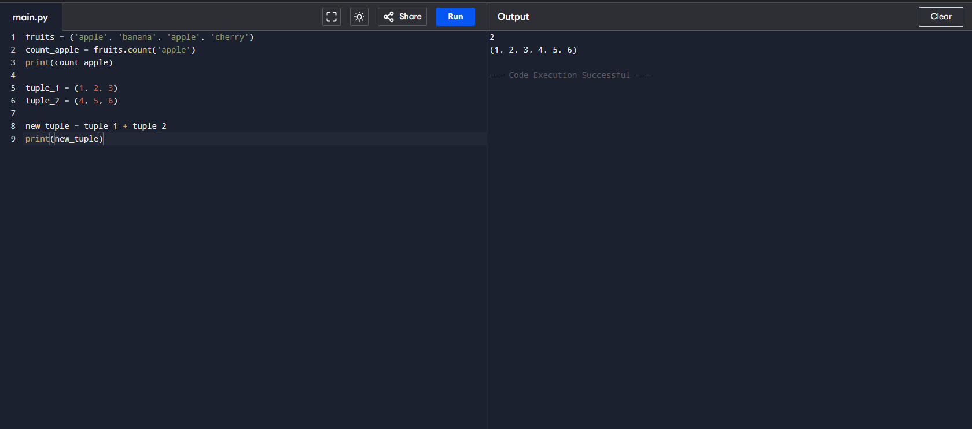
10. Access and print the value associated with the key "age" from the dictionary.
person = {"name": "Alice", "age": 30, "city": "New York"}
person = {"name": "Alice", "age": 30, "city": "New York"}
print(person['age'])

11. Add new key, gender to dictionary and assign “M” to it and print
person = {"name": "Alice", "age": 30, "city": "New York"}
person['gender'] = 'M'
print(person)

12. Remove the key "city" from the above Dict and print
del person['city']
print(person)

13. Given two dictionaries, merge them into one
dict1 = {"a": 1, "b": 2} dict2 = {"c": 3, "d": 4}
dict1.update(dict2)
print(dict1)

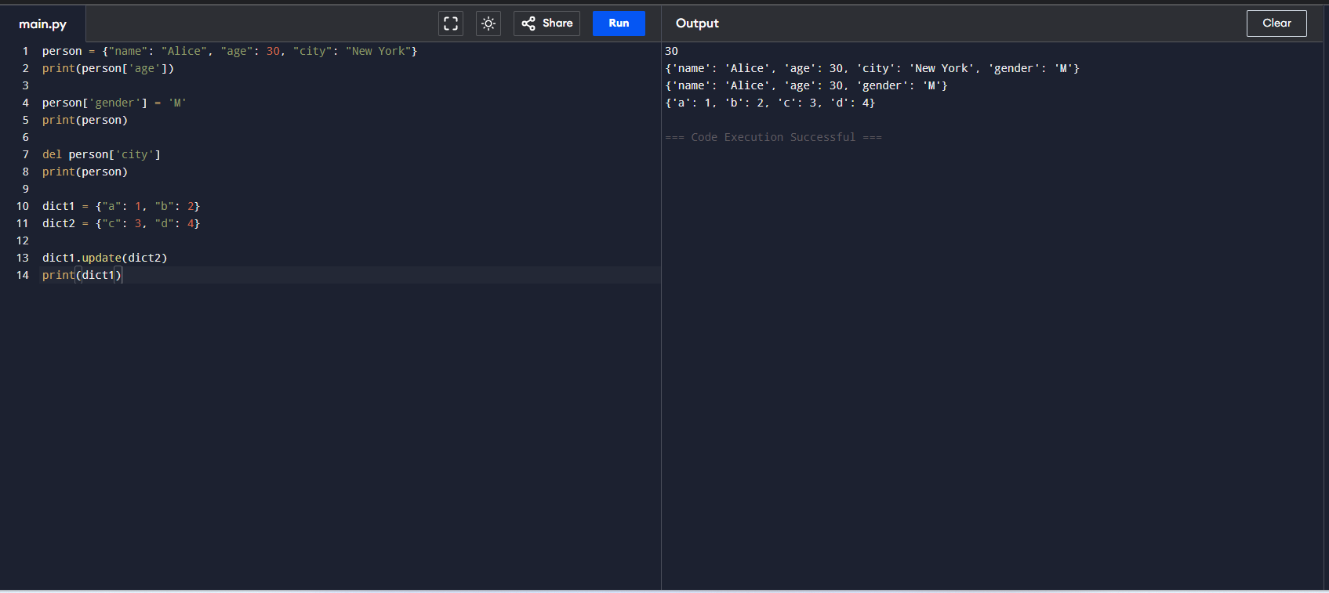

For loop
- Write a program that takes the input from the user and checks if a number is even or odd.

nums = [1,2,3,4,5]
for num in nums:
if num % 2 == 0 :
print("Even : ", num)
else:
print("Odd : ", num)

- Reverse a string using a for loop and check it is a palindrome. - Strings = “civic”, “hello”

def check_palindrome(s):
reversed_str = ""
for char in s:
reversed_str = char + reversed_str

print("Original String:", s)
print("Reversed String:", reversed_str)

if s == reversed_str:
print("It is a palindrome.\n")
else:
print("It is not a palindrome.\n")

check_palindrome("civic")
check_palindrome("hello")

- Using the input from the user, Generate the first N numbers of the Fibonacci sequence.

N = int(input("Enter the number of Fibonacci numbers to generate: "))
fib_sequence = []
a, b = 0, 1
for _ in range(N):
fib_sequence.append(a)
a, b = b, a + b

print("Fibonacci sequence:", fib_sequence)
- From list [1,2,3,4,5]. Write code to find two values from the list when added the result is 9. #Expected output : [4, 5]
numbers = [1, 2, 3, 4, 5]
target = 9

result = []

for num in numbers:
if (target - num) in numbers:
result = [num, target - num]
break
print(result)

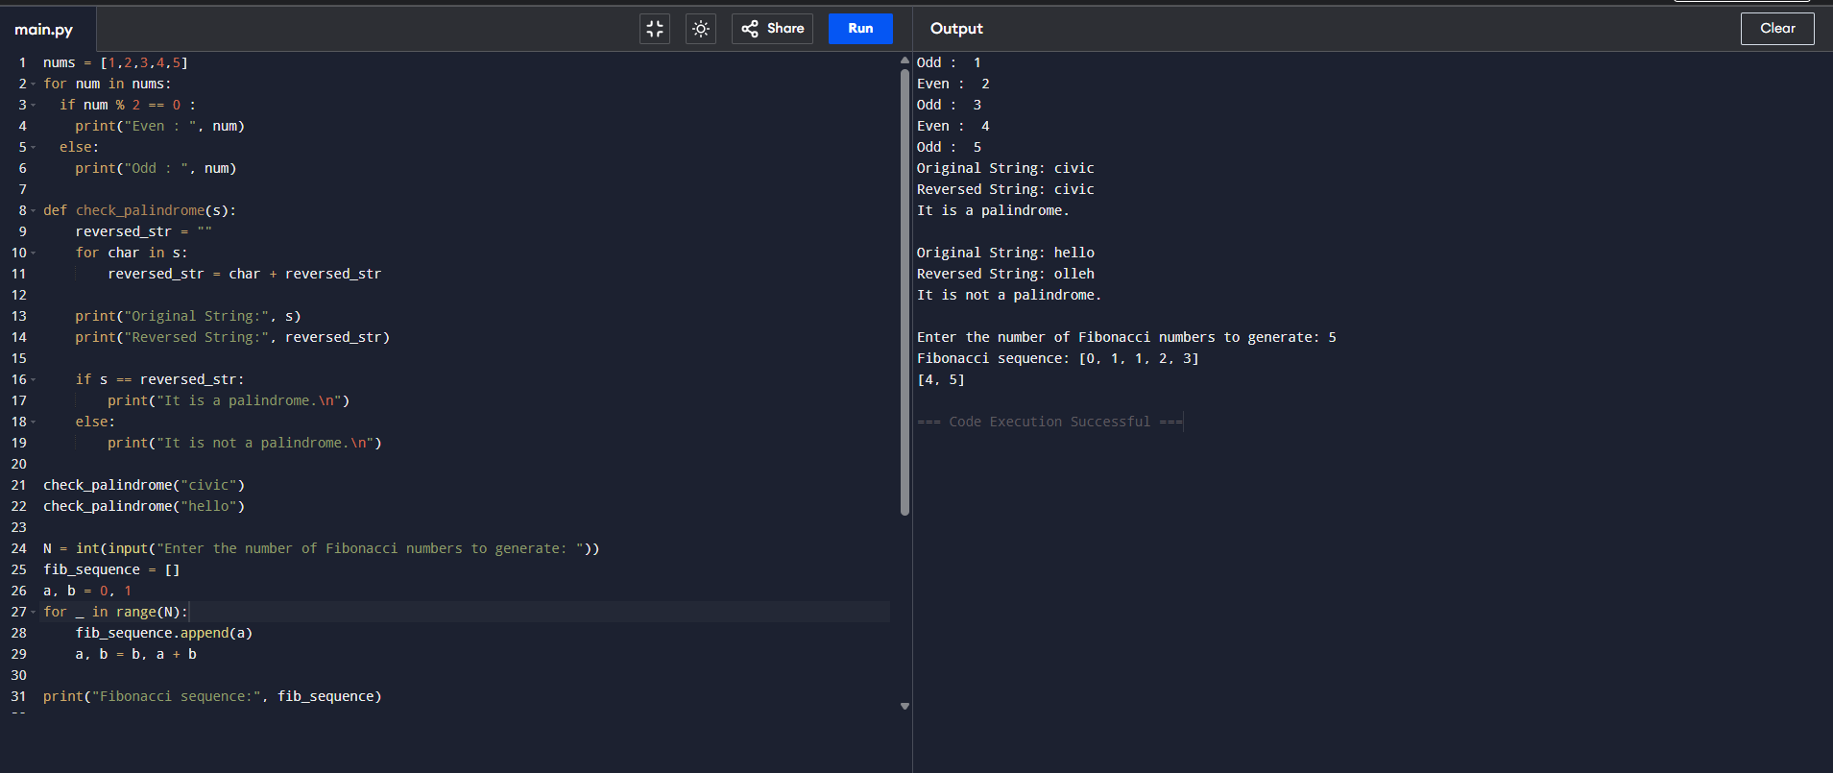
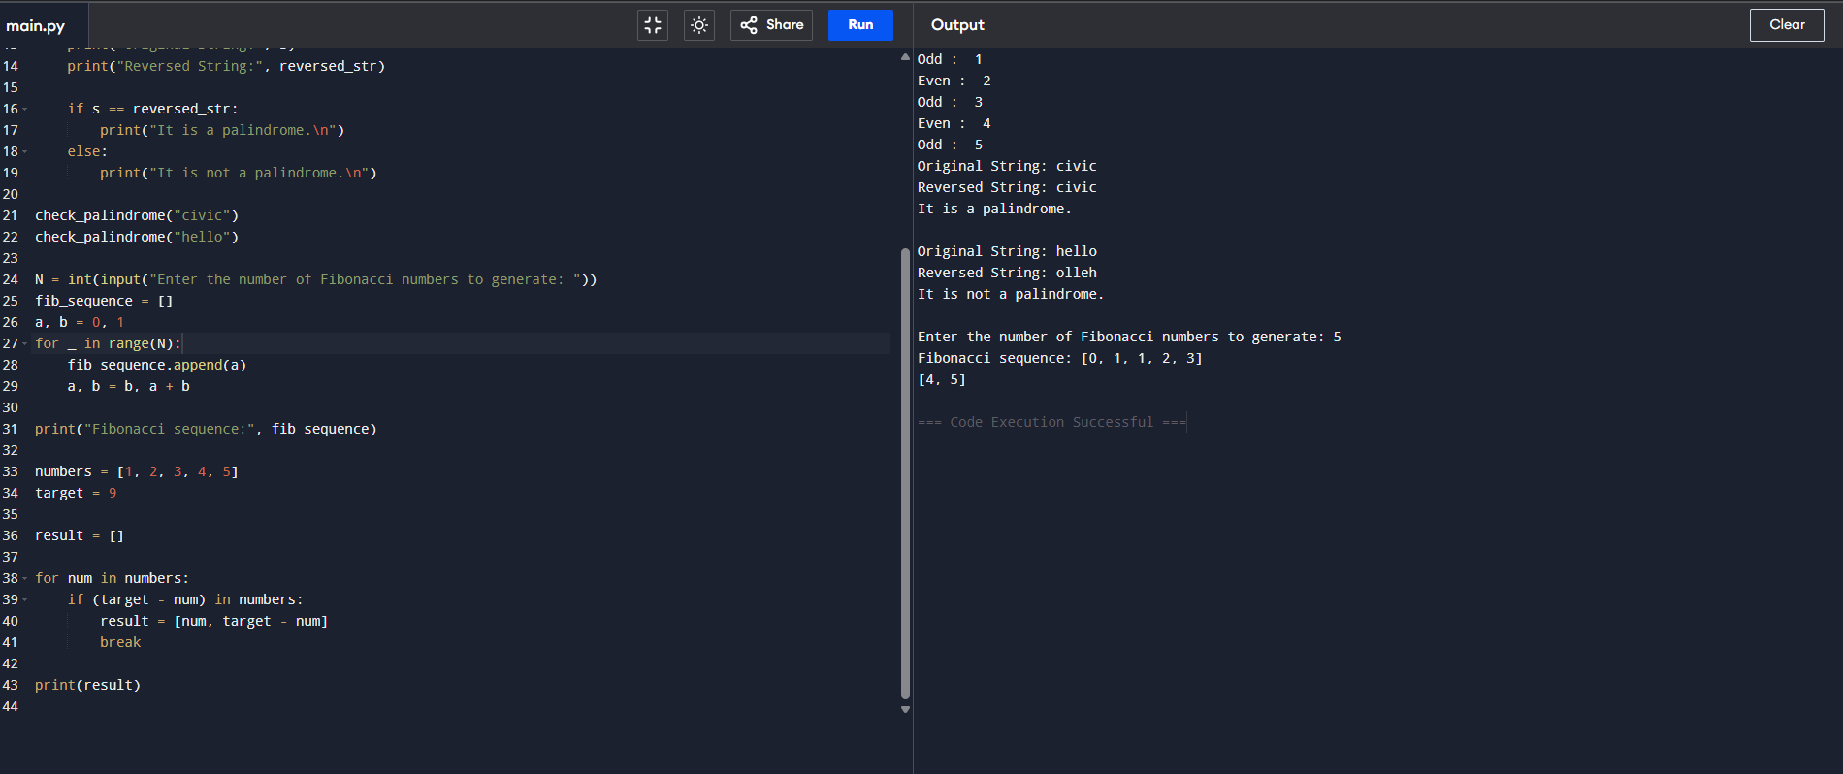

While loop
- Print all even numbers between 1 and 20 using a while loop.
num = 1

while num <= 20:
if num % 2 == 0:
print(num, end=" ")
num += 1

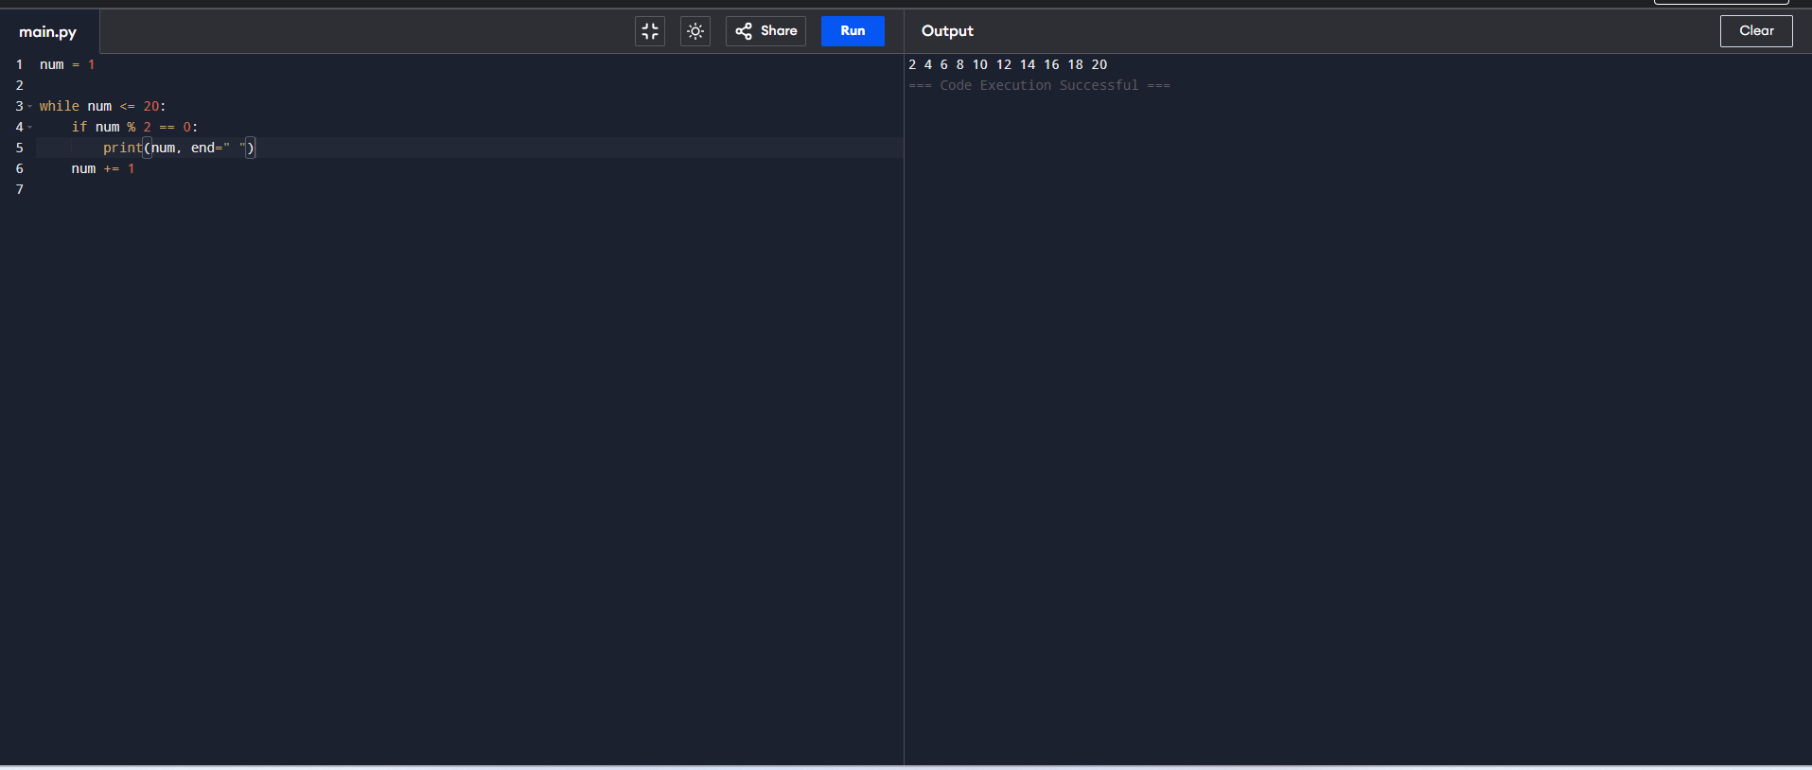

Break
- Find the first occurrence of a number in a list and stop further searching.
numbers = [10, 20, 30, 40, 50]
search_for = 30

numbers = [10, 20, 30, 40, 50]

for num in numbers:
if num == 30:
print('Found !')
break
print(num)

- Using continue statement, print only the odd numbers from 1 to 10.

num = 1
while num <= 10:
if num % 2 == 0:
num += 1
continue # Skip even numbers
print(num, end=" ")
num += 1

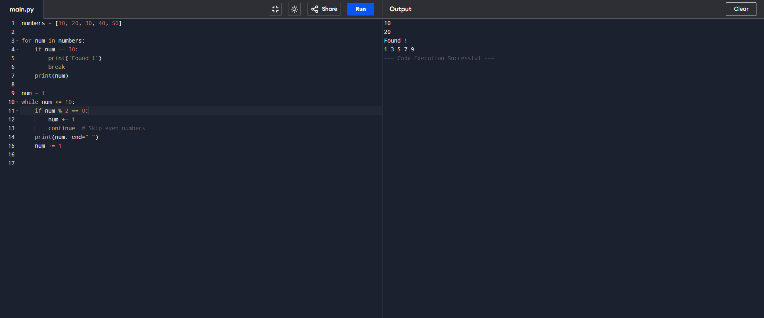

- What will be the output
for i in range(5):
if i == 3:
pass
print(i)

0
1
2
3
4

- Write a program that takes a day of the week as input and prints whether it's a weekday or weekend using match conditional statements.
day = input("Enter a day of the week: ").strip().lower()
match day:
case "monday" | "tuesday" | "wednesday" | "thursday" | "friday":
print("It's a weekday.")
case "saturday" | "sunday":
print("It's a weekend.")
case _:
print("Invalid day entered.")
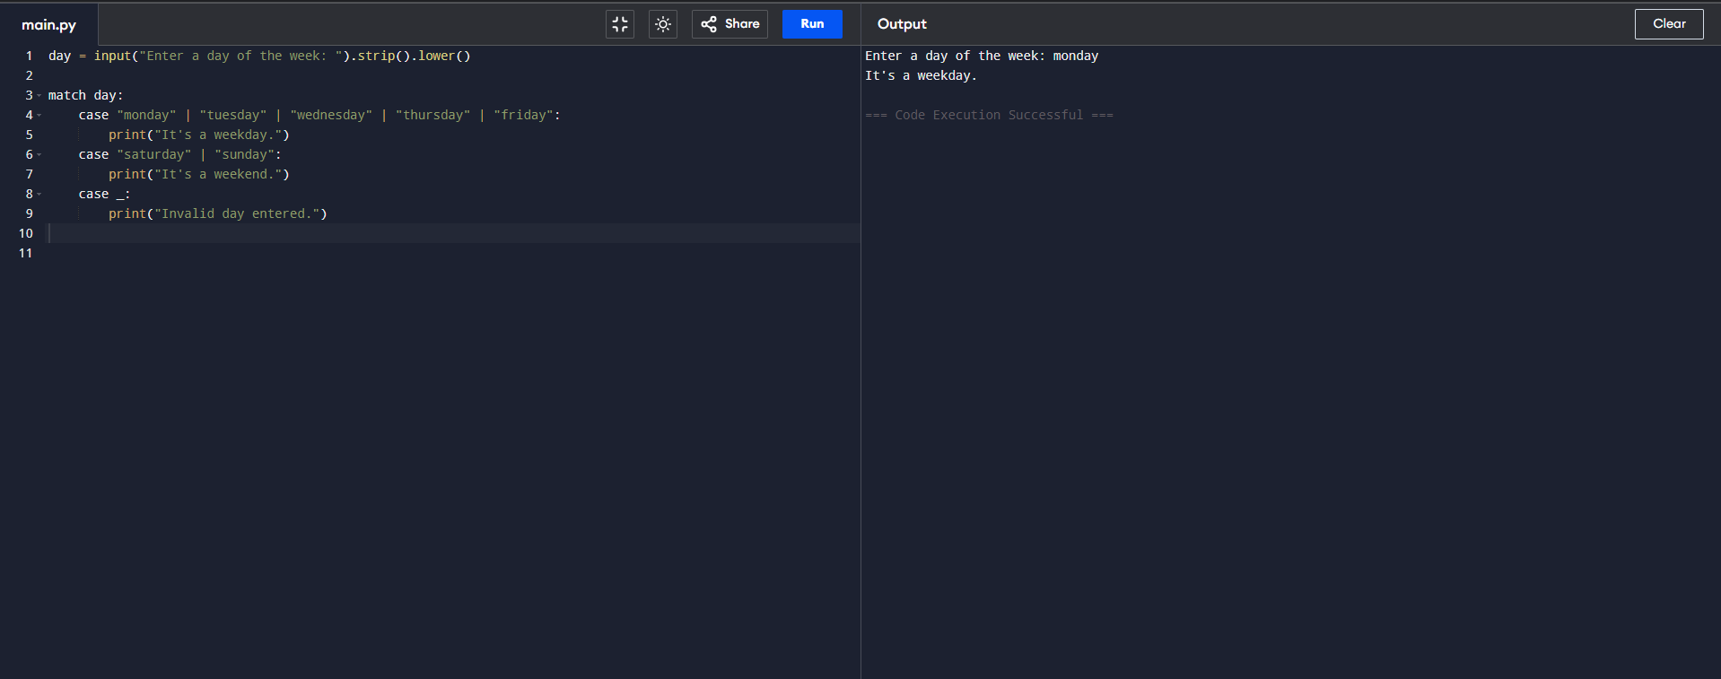

- Define a function calculate_area that calculates the area of a rectangle and return the result. If no width is provided, it defaults to 10.

def calculate_area(length, width=10):
area = length * width
return area
print(calculate_area(5))
print(calculate_area(5, 4))

2. Write a recursive function to compute the factorial of a non-negative integer.

def factorial(n):
if n == 0 or n == 1:
return 1
else:
return n * factorial(n - 1)

num = int(input("Enter a non-negative integer: "))
if num < 0:
print("Factorial is not defined for negative numbers.")
else:
print(f"Factorial of {num} is {factorial(num)}")

3. Write a function that takes one parameter as a string and reverse it and return.

def reverse_string(s):
return s[::-1]

input_str = "Hello"
reversed_str = reverse_string(input_str)
print("Reversed string:", reversed_str)

4. Write a Python function that takes two parameters as lists and to sum all the numbers in a list.
a = [8, 2, 3, 0, 7], b = [3, -2, 5, 1] and return a value.

def sum_two_lists(list1, list2):

total_sum = sum(list1) + sum(list2)
return total_sum

a = [8, 2, 3, 0, 7]
b = [3, -2, 5, 1]

result = sum_two_lists(a, b)
print("Total sum:", result)

5. Write a Python function that takes a list and returns a new list with distinct and sorted elements from the first list. a = [4,1,2,3,3,1,3,4,5,1,7]
Output = [1,2,3,4,5,7]

def distinct_sorted_list(lst):
return sorted(set(lst))
a = [4, 1, 2, 3, 3, 1, 3, 4, 5, 1, 7]
result = distinct_sorted_list(a)
print(result)

- Given a list of numeric strings, convert them into integers. Using List Comprehensions
strings = ["1", "2", "3", "4", "5"]
#Expected output : [1, 2, 3, 4, 5]
strings = ["1", "2", "3", "4", "5"]
numbers = [int(s) for s in strings]

print(numbers)

- Extract all integers from a list that are greater than 10. Using List Comprehensions
numbers = [1, 5, 13, 4, 16, 7]
#Expected output :[13, 16]
numbers = [1, 5, 13, 4, 16, 7]
result = [num for num in numbers if num > 10]
print(result)

- Create a list of squares for numbers from 1 to 5. Using List Comprehensions
#Expected output :[1, 4, 9, 16, 25]
squares = [x**2 for x in range(1, 6)]
print(squares)

- Convert a 2D list into a 1D list.Using List Comprehensions
matrix = [[1, 3, 4], [23, 32, 56, 74], [-2, -6, -9]]
#Expected output : [1, 3, 4, 23, 32, 56, 74, -2, -6, -9]

matrix = [[1, 3, 4], [23, 32, 56, 74], [-2, -6, -9]]
flattened = [item for row in matrix for item in row]

print(flattened)
- Given two lists, keys = ['a', 'b', 'c'] and values = [1, 2, 3], create a dictionary using dictionary comprehension.
#Expected output : {'a': 1, 'b': 2, 'c': 3}
keys = ['a', 'b', 'c']
values = [1, 2, 3]
my_dict = {k: v for k, v in zip(keys, values)}
print(my_dict)

- Given the dictionary scores = {'Alice': 85, 'Bob': 70, 'Charlie': 90}, create a new dictionary containing only the students who scored above 80
#Expected output : {'Alice': 85, 'Charlie': 90}

scores = {'Alice': 85, 'Bob': 70, 'Charlie': 90}
high_scores = {name: score for name, score in scores.items() if score > 80}
print(high_scores)

