广东白云学院

《设计模式》实验报告书

创建型模式（工厂方法，抽象工厂，建造者）

学生姓名：_____梁发灿_________
学 号：____ 202202150353___
班 级：_A22软件工程7班___
指导老师：____齐勇军____________
专 业：_____软件工程_________

提交日期：2023年4月14日

- 五、编程题（画出类图，再编码）
1、用工厂方法模式实现洗衣机工厂的功能。
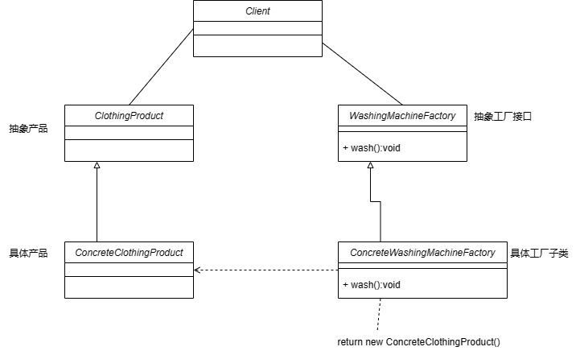//抽象工厂接口
public interface WashingMachineFactory {
ClothingProduct wash();
}
//抽象产品
public interface ClothingProduct {
}
//具体洗的衣服（产品A）
public class ConcreteClothingProduct implements ClothingProduct {
}
//具体工厂类A
public class ConcreteWashingMachineFactory implements WashingMachineFactory{
@Override
public ClothingProduct wash() {
return new ConcreteClothingProduct();
}
}
public class Client {
public static void main(String[] args) {
WashingMachineFactory factory = new ConcreteWashingMachineFactory();
ClothingProduct wash = factory.wash();
System.out.println(wash);//输出具体产品A
}
}
//输出具体产品A
WashingMachineFactory.ConcreteClothingProduct@3ac3fd8b
2、用抽象工厂模式实现服装工厂类。
分析：服装工能生产出各种各样的衣服,但客户完全不知道这些服装是如何被创建的。如果用抽象工厂模式来实现,可以灵活地添加新的服装类型(如夹克等),且不需要修改客户端代码，这增加了应用程序的灵活性。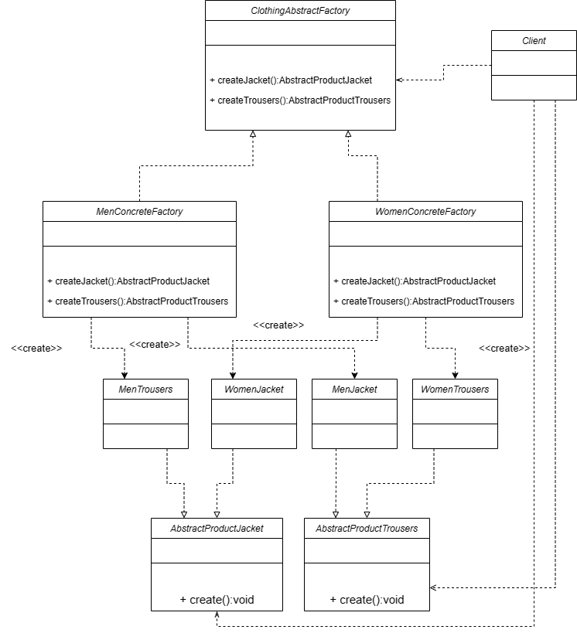
//首先要创建夹克，鞋子接口
public interface AbstractProductJacket {
void create();
}
public interface AbstractProductTrousers {
void create();
}
//接着创建男士夹克，男士鞋子，女士夹克，女士鞋子的具体实现类
public class MenJacket implements AbstractProductJacket {
@Override
public void create() {
System.out.println("男士夹克");
}
}
public class MenTrousers implements AbstractProductTrousers {
@Override
public void create() {
System.out.println("男士鞋子");
}
}
public class WomenJacket implements AbstractProductJacket{
@Override
public void create() {
System.out.println("女士夹克");
}
}
public class WomenTrousers implements AbstractProductTrousers{
@Override
public void create() {
System.out.println("女士鞋子");
}
}
//接着创建工厂接口（也就是抽象工厂）以及它的具体实现类MenConcreteFactory和WomenConcreteFactory
public interface ClothingAbstractFactory {
AbstractProductJacket createJacket();
AbstractProductTrousers createTrousers();
}
public class MenConcreteFactory implements ClothingAbstractFactory{
@Override
public AbstractProductJacket createJacket() {
return new MenJacket();
}
@Override
public AbstractProductTrousers createTrousers() {
return new MenTrousers();
}
}
public class WomenConcreteFactory implements ClothingAbstractFactory{
@Override
public AbstractProductJacket createJacket() {
return new WomenJacket();
}
@Override
public AbstractProductTrousers createTrousers() {
return new WomenTrousers();
}
}
public class Client {
public static void main(String[] args) {
System.out.println("===========男装品牌============");
MenConcreteFactory menConcreteFactory = new MenConcreteFactory();
AbstractProductJacket productMenjacket = menConcreteFactory.createJacket();
productMenjacket.create();
AbstractProductTrousers productMentrousers = menConcreteFactory.createTrousers();
productMentrousers.create();

System.out.println("===========女装品牌============");
WomenConcreteFactory womenConcreteFactory = new WomenConcreteFactory();
AbstractProductJacket productWomenJacket = womenConcreteFactory.createJacket();
productWomenJacket.create();
AbstractProductTrousers productWomenTrousers = womenConcreteFactory.createTrousers();
productWomenTrousers.create();
}
}
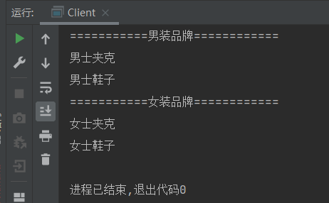

3.用建造者模式实现肯德基“套餐”类。
分析:肯德基店有汉堡、可乐、薯条、炸鸡翅等产品,用户可以随意组合它们,生成出不同的“套餐”,所以适合使用建造者模式实现。
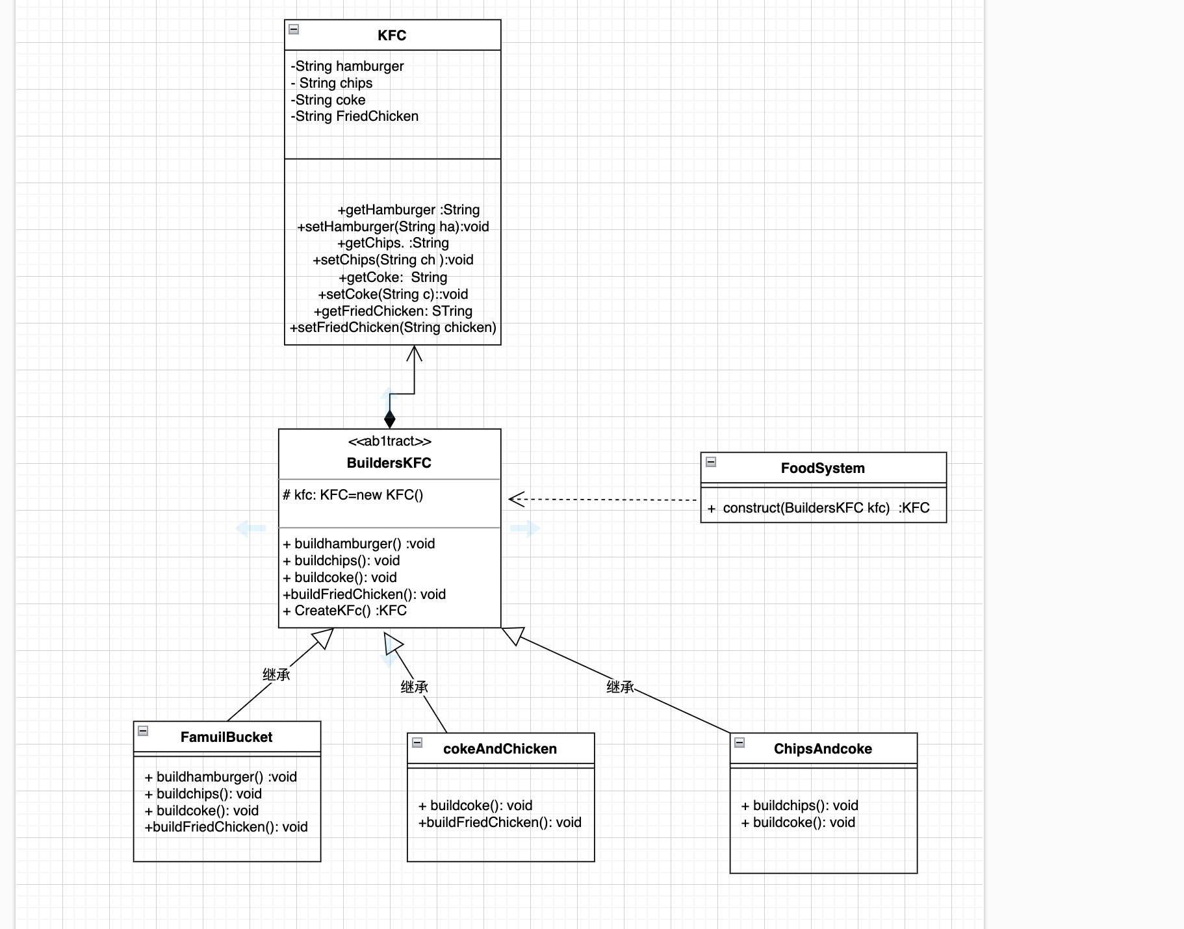
package a.Builders;
public class KFC {
private String hamburger;
private String chips;
private String coke;
private String FriedChicken;
public String getHamburger() {
return hamburger;
}
public void setHamburger(String hamburger) {
this.hamburger = hamburger;
}
public String getChips() {
return chips;
}
public void setChips(String chips) {
this.chips = chips;
}
public String getCoke() {
return coke;
}

public void setCoke(String coke) {
this.coke = coke;
}
public String getFriedChicken() {
return FriedChicken;
}
public void setFriedChicken(String friedChicken) {
FriedChicken = friedChicken;
}
}
package a.Builders;
public abstract class BuildersKFC {
protected KFC kfc;
abstract void builhamburger();
abstract void buildchips();
abstract void buildFriedChicken();
abstract void buildCoke();
// 工厂方法，返回一个完整KFC对象
KFC CreateKFC(){
return kfc;
}
}

package a.Builders;

public class ChipAndcoke extends BuildersKFC{

@Override
void builhamburger() {

}

@Override
void buildchips() {
kfc.setChips("麻辣薯条");
}
@Override
void buildFriedChicken() {
}
@Override
void buildCoke() {
kfc.setCoke("可口可乐");
}
}
package a.Builders;

public class cokeAndChicken extends BuildersKFC{
@Override
void buildFriedChicken() {
kfc.setFriedChicken("香辣鸡腿");
}
@Override
void buildCoke() {
kfc.setCoke("怡宝可口");
}
@Override
void builhamburger() {
}
@Override
void buildchips() {
}
package a.Builders;
public class FamuliBucket extends BuildersKFC{
@Override
public void builhamburger() {
kfc.setHamburger("香辣汉堡");
}
@Override
public void buildchips() {
kfc.setChips("番茄薯条");
}
@Override
public void buildFriedChicken() {
kfc.setCoke("蜜汁鸡");
}
@Override
public void buildCoke() {
kfc.setCoke("可口可乐");
}
}
}
package a.Builders;

//点餐
public class FoodSystem {
public KFC constructKFC(BuildersKFC buildersKFC){
KFC kfc;
buildersKFC.buildchips();
buildersKFC.buildCoke();
buildersKFC.buildFriedChicken();
buildersKFC.builhamburger();
kfc=buildersKFC.CreateKFC();
return kfc;
}

4、用建造者模式实现计算机的“计算机组装”类。
分析:用户去购买计算机时可以根据自己的需要选购计算机的CPU、内存条、显卡、主板、硬盘、显示器、键盘、鼠标等各个配件,所以选用建造者模式来实现比较适合。
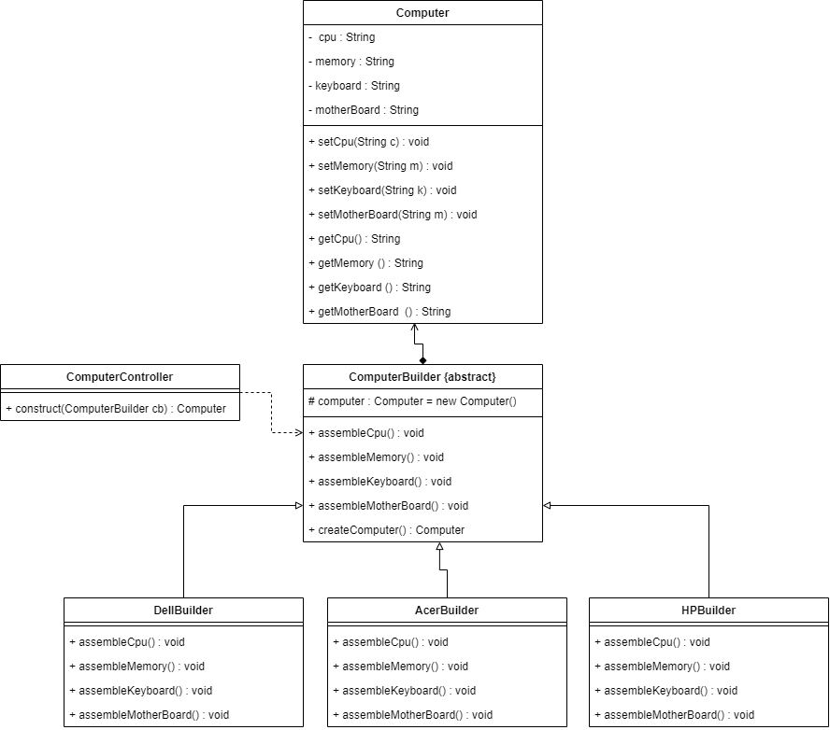
public class CPU {
private String model;
private String company;

public CPU(String model, String company) {
this.model = model;
this.company = company;
}
public class HardDrives {
private String model;
private String company;
private String rmp;

public HardDrives(String model, String company, String rmp) {
this.model = model;
this.company = company;
this.rmp = rmp;
}
public class Keyboards {
private String model;
private String company;

public Keyboards(String model, String company) {
this.model = model;
this.company = company;
}
public class memory {
private String model;
private String company;
private int capacity;

public memory(String model, String company, int capacity) {
this.model = model;
this.company = company;
this.capacity = capacity;
}
public class Motherboards {
private String model;
private String company;

public Motherboards(String model, String company) {
this.model = model;
this.company = company;
}
public class Mouse {
private String model;
private String company;

public Mouse(String model, String company) {
this.model = model;
this.company = company;
}
//指挥者
public class Control {
public Computer computer(BuilderComputer builderComputer){
Computer compute1r;
builderComputer.buildeCPU();
builderComputer.buildeMouse();
builderComputer.buildememory();
builderComputer.buildeMotherboards();
builderComputer.buildeKeyboards();
compute1r= builderComputer.CreateComputer();
return compute1r;
}
//抽象建造
public abstract class BuilderComputer {
public Computer com=new Computer();

abstract void buildeCPU();
abstract void buildememory();
abstract void buildeMotherboards();
abstract void buildeHard();
abstract void buildeKeyboards();
abstract void buildeMouse();
public Computer CreateComputer(){
return com;
}
//实物
public class Computer {

private CPU CPU;
private memory memory;
private Motherboards Motherboards;
private HardDrives HardDrives;
private Keyboards Keyboards;
private Mouse Mouse;

public Computer() {
}

public Computer(CPU CPU, memory memory, Motherboards motherboards, HardDrives hardDrives, Keyboards keyboards, Mouse mouse) {
this.CPU = CPU;
this.memory = memory;
Motherboards = motherboards;
HardDrives = hardDrives;
Keyboards = keyboards;
Mouse = mouse;
}

public b.computer.CPU getCPU() {
return CPU;
}

public void setCPU(b.computer.CPU CPU) {
this.CPU = CPU;
}

public b.computer.memory getMemory() {
return memory;
}

public void setMemory(b.computer.memory memory) {
this.memory = memory;
}

public b.computer.Motherboards getMotherboards() {
return Motherboards;
}

public void setMotherboards(b.computer.Motherboards motherboards) {
Motherboards = motherboards;
}

public b.computer.HardDrives getHardDrives() {
return HardDrives;
}

public void setHardDrives(b.computer.HardDrives hardDrives) {
HardDrives = hardDrives;
}

public b.computer.Keyboards getKeyboards() {
return Keyboards;
}

public void setKeyboards(b.computer.Keyboards keyboards) {
Keyboards = keyboards;
}

public b.computer.Mouse getMouse() {
return Mouse;
}

public void setMouse(b.computer.Mouse mouse) {
Mouse = mouse;
}

@Override
public String toString() {
return "Computer{" +
"CPU=" + CPU +
", memory=" + memory +
", Motherboards=" + Motherboards +
", HardDrives=" + HardDrives +
", Keyboards=" + Keyboards +
", Mouse=" + Mouse +
'}';
}
}
//具体实物
/高配置
public class SpecificComputer extends BuilderComputer {

@Override
void buildeCPU() {
com.setCPU(new CPU("i7900","英特尔"));
System.out.println(com);

}

@Override
void buildememory() {
com.setMemory(new memory("Beast野兽系列 ","金士顿",32));

}

@Override
void buildeMotherboards() {
com.setMotherboards(new Motherboards("PRIME Z690-P主板","华硕"));

}
@Override
void buildeKeyboards() {
com.setKeyboards(new Keyboards("无限键盘","罗技"));

}
@Override
void buildeHard() {
com.setHardDrives(new HardDrives("SSD固态硬盘","金士顿","1TB"));
}
@Override
void buildeMouse() {
com.setMouse(new Mouse("无线鼠标","逻辑"));
}
//客户需要的高配置
public class client {
public static void main(String[] args) throws Exception{
//客户配置高配电脑
BuilderComputer bc;
bc = (BuilderComputer)XMLUtil.getBean();
Control c=new Control();
Computer computer;
computer = c.computer(bc);
System.out.println("-----------------------------------");
System.out.println("CPU"+ computer.getCPU());
System.out.println("鼠标"+computer.getMouse());
System.out.println("主板"+computer.getMotherboards());
System.out.println("内存条"+ computer.getMemory());
System.out.println("硬盘"+ computer.getHardDrives());
System.out.println("键盘"+ computer.getKeyboards());
System.out.println("-----------------------------------");
}
}
//结果
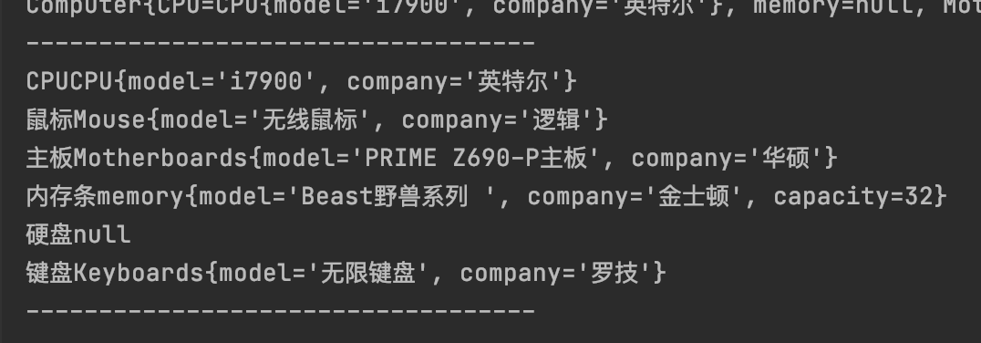

5.用建造者模式实现汽车组装工厂的功能。
分析:汽车组装工厂可以根据汽车的发动机、车轮、底盘、车座数、汽车的排量等指标为用户组装汽车,用建造者模式来实现比较适合。
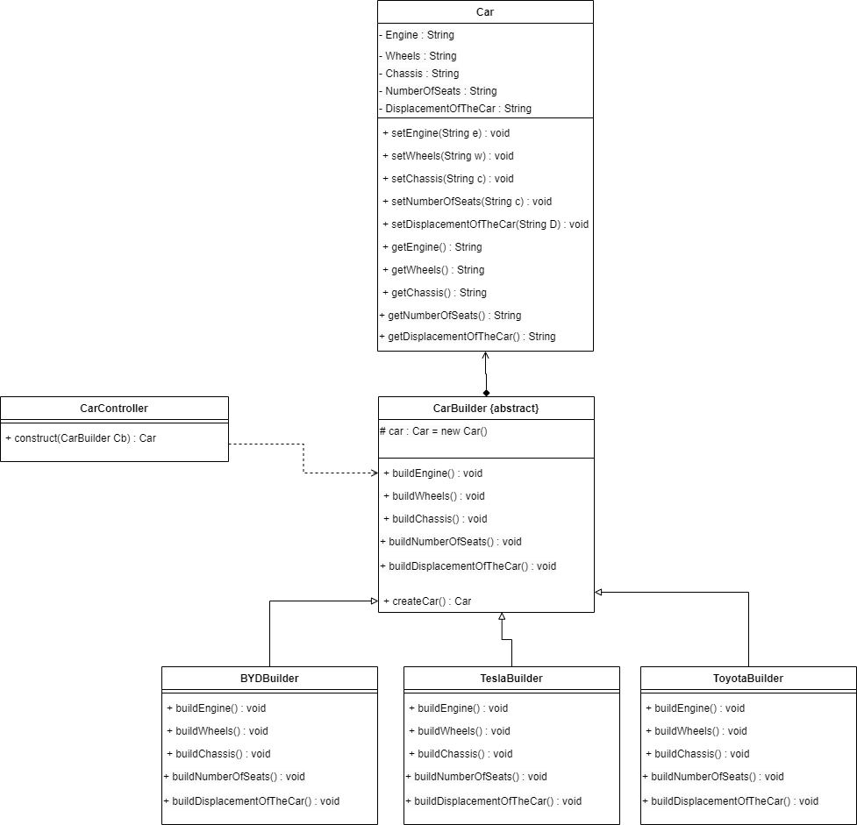

//汽车组建
package c.car;
public class Carseat {
private String Seats;

public Carseat(String seats) {
Seats = seats;
}

@Override
public String toString() {
return "Carseat{" +
"Seats='" + Seats + '\'' +
'}';
}
}package c.car;

public class Chassis {
private String model;
private String type;

public Chassis(String model, String type) {
this.model = model;
this.type = type;
}

@Override
public String toString() {
return "Chassis{" +
"model='" + model + '\'' +
", type='" + type + '\'' +
'}';
}
}

package c.car;
public class Engines {
private String Power;
private String model;

public Engines(String power, String model) {
this.Power = power;
this.model = model;
}

@Override
public String toString() {
return "Engines{" +
"Power='" + Power + '\'' +
", model='" + model + '\'' +
'}';
}
}
package c.car;
public class Tyres {
private String Brand;
private String date;

public Tyres(String brand, String date) {
Brand = brand;
this.date = date;
}

@Override
public String toString() {
return "Tyres{" +
"Brand='" + Brand + '\'' +
", date='" + date + '\'' +
'}';
}
}
package c.car;

public class Wheels {
private int Size;
private String Brand;

public Wheels(int size, String brand) {
Size = size;
Brand = brand;
}

@Override
public String toString() {
return "Wheels{" +
"Size=" + Size +
", Brand='" + Brand + '\'' +
'}';
}
}
//汽油汽车构建
package c.car;
public class NewEnergycar extends BuildeCar{
@Override
void bulildeEngines() {
c.setEngines(new Engines("2.0T","电机"));

}
@Override
void bulildeTyres() {
c.setTyres(new Tyres("马牌和固特异轮胎","2022-12-01"));
}

@Override
void bulildeChassis() {
c.setChassis(new Chassis("大众底盘","合金塑料PVC防护板"));
}
@Override
void bulildeCarseat() {
c.setCarseat(new Carseat("4座"));
}
@Override
void bulildeWheels() {
c.setWheels(new Wheels(19,"双五辐"));
}
}

//汽车
package c.car;
public class Car {
private Engines engines;
private Tyres tyres;
private Chassis chassis;
private Carseat carseat;
private Wheels wheels;

public Car() {
}

public Car(Engines engines, Tyres tyres, Chassis chassis, Carseat carseat, Wheels wheels) {
this.engines = engines;
this.tyres = tyres;
this.chassis = chassis;
this.carseat = carseat;
this.wheels = wheels;
}

public Engines getEngines() {
return engines;
}

public void setEngines(Engines engines) {
this.engines = engines;
}

public Tyres getTyres() {
return tyres;
}

public void setTyres(Tyres tyres) {
this.tyres = tyres;
}

public Chassis getChassis() {
return chassis;
}

public void setChassis(Chassis chassis) {
this.chassis = chassis;
}
public Carseat getCarseat() {
return carseat;
}
public void setCarseat(Carseat carseat) {
this.carseat = carseat;
}
public Wheels getWheels() {
return wheels;
}
public void setWheels(Wheels wheels) {
this.wheels = wheels;
}
@Override
public String toString() {
return "Car{" +
"engines=" + engines +
", tyres=" + tyres +
", chassis=" + chassis +
", carseat=" + carseat +
", wheels=" + wheels +
'}';
}
}
//抽象建造者
package c.car;
public abstract class BuildeCar {
protected Car c=new Car();
abstract void bulildeEngines();
abstract void bulildeTyres();
abstract void bulildeChassis();
abstract void bulildeCarseat();
abstract void bulildeWheels();
public Car CreateCar(){
return c;
}
}
指挥者
package c.car;
public class Control {
public Car Con(BuildeCar buildeCar){
Car car;
buildeCar.bulildeWheels();
buildeCar.bulildeEngines();
buildeCar.bulildeCarseat();
buildeCar.bulildeChassis();
buildeCar.bulildeTyres();
car = buildeCar.CreateCar();
return car;
}

