AWS Hybrid Cloud Network & Security
Functionality & Validation Report
GNS3 • VyOS • AWS VPC • Site-to-Site IPsec VPN

A portfolio-ready rewrite of the network engineering capstone, focused on the architecture, controls, test methods, validated outcomes, and troubleshooting work.

Executive Summary
This project designs and validates a hybrid network for the fictional NorthStar organization. The on-premises environment is simulated in GNS3 and segmented with VLANs, while the cloud environment is hosted in an AWS VPC with separate public, application, and database subnets. The two environments are connected through an encrypted IPsec Site-to-Site VPN.
The functionality report validates eight areas: Layer 2 segmentation, address management, on-premises access control, AWS subnet segmentation, cloud addressing, AWS security-group enforcement, VPN connectivity, and hybrid least-privilege security. Each test was designed to isolate the control being tested rather than relying only on a successful or failed ping.

Architecture at a Glance
- On-premises: GNS3, VyOS router, two Ethernet switches, four VLANs.
- VLAN 10 Administration — 192.168.10.0/24.
- VLAN 20 Design — 192.168.20.0/24.
- VLAN 30 Servers — 192.168.30.0/24.
- VLAN 99 Management — 192.168.99.0/24.
- AWS: NorthStar VPC — 10.20.0.0/16.
- Public subnet — 10.20.1.0/24.
- Application subnet — 10.20.10.0/24.
- Database subnet — 10.20.20.0/24.
- Hybrid connectivity: AWS Virtual Private Gateway + Customer Gateway + IPsec tunnel.

Validation Matrix
Test | Control | Validated Outcome
1 | Layer 2 VLAN Segmentation | Same-VLAN traffic passed; cross-VLAN traffic failed without routing and succeeded after routing was restored.
2 | On-Prem Addressing | DHCP leases validated for user VLANs; static addresses validated for server and management resources.
3 | On-Prem Access Control | VyOS firewall permitted required flows and denied unauthorized flows with rule counters proving enforcement.
4 | AWS Subnet Segmentation | Public, app, and DB route tables produced distinct internet-access behavior.
5 | AWS Addressing | DB private IP and bastion Elastic IP remained unchanged across instance restart.
6 | AWS Reachability Controls | APP-to-DB access on TCP/3306 succeeded; bastion-to-DB access on the same port was denied by SG reference.
7 | Site-to-Site VPN | Tunnel state and IPsec security association were established, and byte counters proved encrypted traffic crossed the tunnel.
8 | Hybrid Least Privilege | On-prem firewall and AWS security groups enforced independent layers of access control across the VPN.

Test Case 1 — Layer 2 VLAN Segmentation

Objective
Replace the original flat on-premises network with separate broadcast domains based on business function and verify that 802.1Q trunking carries VLAN traffic correctly between switches.

Implementation
- Created VLAN 10 (Administration), VLAN 20 (Design), VLAN 30 (Servers), and VLAN 99 (Management).
- Configured SW1 and SW2 with VLAN access ports and 802.1Q trunk links.
- Configured VyOS R1 with one VLAN sub-interface and default gateway address per VLAN.
set interfaces ethernet eth1 vif 10 address 192.168.10.1/24
set interfaces ethernet eth1 vif 20 address 192.168.20.1/24
set interfaces ethernet eth1 vif 30 address 192.168.30.1/24
set interfaces ethernet eth1 vif 99 address 192.168.99.1/24

Validation
- Disabled the routed VLAN interfaces to isolate Layer 2 behavior.
- Verified same-VLAN communication on the same switch.
- Verified same-VLAN communication across the inter-switch 802.1Q trunk.
- Verified cross-VLAN communication failed while routing was disabled.
- Re-enabled routing and confirmed the same cross-VLAN test then succeeded.
Validated result: Layer 2 segmentation and trunking operated as designed, and the test distinguished switching behavior from routing behavior.

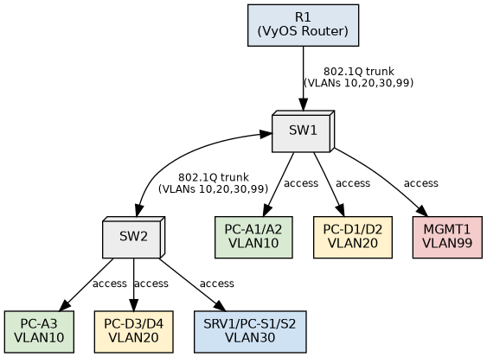
Test Case 1 topology — VLANs, trunks, access ports, and VyOS gateway.

Test Case 2 — On-Premises Address Management

Objective
Provide dynamic addressing for ordinary client devices while reserving stable addresses for infrastructure that must remain reachable at known locations.

Implementation
- Configured separate DHCP scopes on R1 for VLANs 10, 20, and 30.
- Reserved addresses .1 through .19 in each DHCP-enabled subnet.
- Configured SRV1 statically as 192.168.30.10/24.
- Configured MGMT1 statically as 192.168.99.10/24.
- Left VLAN 99 without a DHCP scope so management access does not depend on DHCP.

Validation
- Obtained DHCP leases from representative clients in VLANs 10, 20, and 30.
- Compared the client-side addresses with the VyOS DHCP lease table.
- Confirmed SRV1 and MGMT1 retained manually assigned static addresses.
- Confirmed an authorized Administration client could reach SRV1 at its fixed address.
Validated result: Dynamic and static addressing policies were validated from both the client and server perspectives.

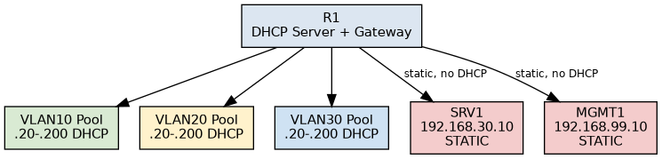
Test Case 2 topology — DHCP scopes and static-address resources.

Test Case 3 — On-Premises Access Control

Objective
Restore inter-VLAN routing while preserving segmentation through explicit least-privilege firewall rules.

Implementation
- Applied a named VyOS IPv4 forward filter to routed traffic.
- Allowed Administration to access SRV1 while denying access to Design and Management networks.
- Allowed Design to access SRV1 only on TCP/445.
- Denied Design from Management and Administration networks.
- Enabled logging and packet counters on deny rules.

Validation
- Captured a pre-policy baseline to prove routing worked before access controls were applied.
- Reset firewall counters before each validation run.
- Tested both permitted and denied flows.
- Used rule packet counters to prove that the intended firewall rule—not an unrelated failure—caused each result.
Validated result: Required inter-VLAN traffic remained available while unauthorized cross-segment traffic was blocked by the intended VyOS rules.

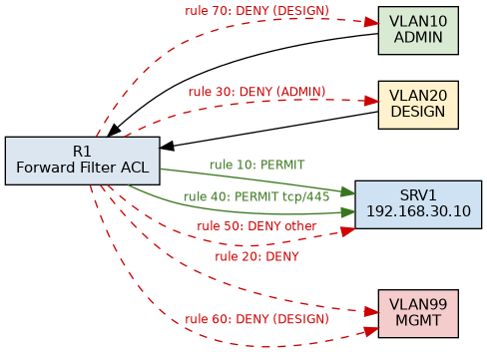
Test Case 3 topology — routed VLANs protected by VyOS access-control rules.

Test Case 4 — AWS Subnet Segmentation

Objective
Apply the same segmentation principle used on-premises to the AWS environment by separating public, application, and database resources with distinct subnet and route-table behavior.

Implementation
- Created NorthStar-VPC with CIDR 10.20.0.0/16.
- Created a public subnet (10.20.1.0/24), private application subnet (10.20.10.0/24), and private database subnet (10.20.20.0/24).
- Associated the public subnet with a route to an Internet Gateway.
- Associated the application subnet with a default route through a NAT Gateway.
- Left the database subnet without a default internet route.

Validation
- Reviewed each subnet's route table.
- Confirmed APP1 could reach external resources through the NAT Gateway.
- Confirmed DB1 could not reach the internet because its route table contained only the local VPC route.
Validated result: AWS subnet routing produced distinct public, outbound-only private, and isolated private network behavior.

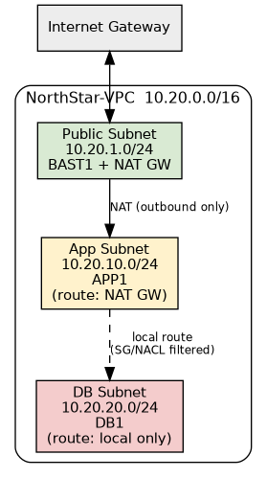
Test Case 4 topology — AWS public, application, and database subnet segmentation.

Test Case 5 — AWS Dynamic and Static Addressing

Objective
Use AWS-assigned addressing for ordinary instances while preserving stable addresses for resources that are referenced directly.

Implementation
- Allowed ordinary EC2 instances to receive AWS-assigned private IP addresses.
- Assigned DB1 a fixed private address of 10.20.20.10.
- Associated an Elastic IP with BAST1 so its public address remained stable across stop/start cycles.

Validation
- Recorded the DB1 private address and BAST1 Elastic IP.
- Stopped and restarted both instances.
- Re-ran the address inventory and confirmed the designated static addresses were unchanged.
Validated result: Stable addressing was preserved for the database and public bastion resources while ordinary cloud addressing remained dynamic.

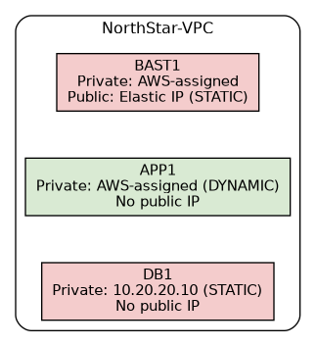
Test Case 5 topology — AWS-assigned addresses, fixed DB private IP, and bastion Elastic IP.

Test Case 6 — AWS Security-Group Reachability

Objective
Verify that database access is based on application security-group membership rather than broad subnet membership or changing IP addresses.

Implementation
- Configured the DB security group to allow inbound TCP/3306 only from the application security group.
- Used a security-group reference rather than a CIDR rule.
- Started a listener on DB1 on TCP/3306 to isolate connectivity testing from database software installation.

Validation
- Tested APP1 to DB1 on TCP/3306 as the authorized flow.
- Tested BAST1 to DB1 on TCP/3306 as the unauthorized flow.
- Used the same target and destination port so the source security-group membership was the only meaningful variable.
Validated result: APP1 reached DB1 on the approved port, while BAST1 was denied on the same port, demonstrating security-group-based least privilege.

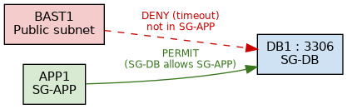
Test Case 6 topology — application-to-database access controlled through security-group references.

Test Case 7 — Site-to-Site VPN Connectivity

Objective
Bridge the GNS3 on-premises network and AWS VPC with an encrypted IPsec VPN and prove that the tunnel carries real traffic, not merely that its status is UP.

Implementation
- Attached an AWS Virtual Private Gateway to the VPC.
- Created a Customer Gateway representing the public endpoint of the GNS3 host.
- Configured a static-route Site-to-Site VPN for the four on-premises VLAN networks.
- Terminated IPsec on the GNS3 host because R1 was behind host NAT; R1 forwarded AWS-bound traffic through tap0 to the host.
- Used strongSwan on the host to encrypt and forward traffic to AWS.

Validation
- Confirmed AWS reported the VPN tunnel as UP.
- Confirmed the local IPsec daemon reported an established security association.
- Captured tunnel byte counters before sending traffic.
- Sent traffic across the VPN and confirmed byte counters increased in both directions.
Validated result: The VPN was not only established; traffic was demonstrably encapsulated and transported across the encrypted hybrid boundary.

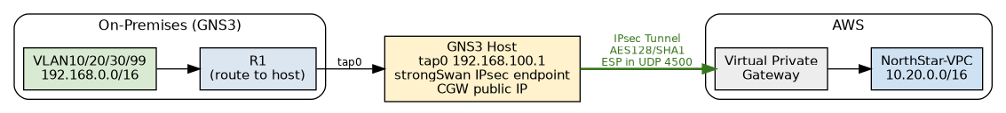
Test Case 7 topology — GNS3/VyOS network connected to AWS through IPsec.

Test Case 8 — Hybrid Least-Privilege Security

Objective
Verify that least-privilege controls remain enforced across the hybrid boundary and that on-premises firewall policy and AWS security groups provide independent layers of protection.

Implementation
- Added an R1 rule denying Administration direct access to the AWS database subnet.
- Added an R1 rule permitting Administration access to the AWS application subnet.
- Added an R1 rule denying the Design VLAN access to AWS private address space.
- Retained AWS security-group controls protecting the database tier.

Validation
- Confirmed Administration could reach the cloud application subnet but not the database subnet.
- Temporarily removed the on-premises database deny rule and confirmed AWS SG-DB still denied the same unauthorized flow.
- Restored the on-premises rule immediately after the defense-in-depth test.
- Confirmed Design could reach neither the AWS application nor database subnet and remained blocked from the on-premises Management VLAN.
- Verified VyOS rule counters incremented for the corresponding permit and deny rules.
Validated result: Hybrid access controls enforced least privilege across both policy domains, and the database remained protected even when one layer was temporarily removed.

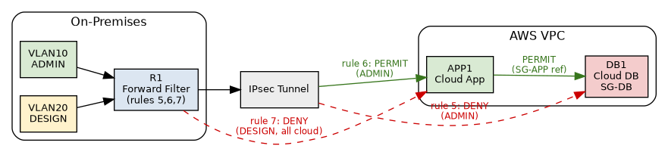
Test Case 8 topology — hybrid policy enforcement across VyOS and AWS security groups.

Network Troubleshooting
Several issues emerged during implementation. Each was isolated by testing one layer at a time and removing known-good components from the list of possible causes.

VLAN 30 DHCP Failure
A VLAN 30 client could not obtain an address. The VyOS DHCP scopes were verified first, and a successful cross-switch VLAN 20 test proved that the 802.1Q trunk was working. That narrowed the failure to the VLAN 30 access port. Correcting the switch-port VLAN assignment restored connectivity.

GNS3 tap0 Binding Failure
GNS3 uBridge could not bind to the host TAP interface. Troubleshooting verified Linux capabilities, group membership, and TAP ownership. The TAP device had been created as root. Recreating it with the correct user ownership and refreshing the user session resolved the binding problem.

VPN Reported UP but Passed No Traffic
AWS and the local IPsec daemon both reported an established tunnel, but byte counters remained at zero. The IPsec selectors and routes were correct, which shifted attention to policy matching. A firewall mark from an earlier multi-tunnel template prevented forwarded GNS3 traffic from matching the IPsec policy. Removing the unnecessary mark allowed traffic to enter the tunnel, and the byte counters then increased in both directions.

VyOS Configuration Persistence
Some VLAN, DHCP, and firewall configuration appeared missing after reopening the lab. In addition to using the VyOS save command, the GNS3 project itself also needed to be saved after successful changes. Maintaining a documented command set also made recovery faster when lab state was lost.

Conclusion
The completed project demonstrated an end-to-end hybrid network with segmentation and security controls on both sides of the connection. On-premises traffic was separated by VLANs and filtered by VyOS policy; AWS resources were separated by subnets, route tables, and security groups; and an encrypted Site-to-Site VPN provided private connectivity between the environments.
The eight validation tests were designed to prove not only that expected traffic succeeded or failed, but also why each outcome occurred. Route-table behavior, DHCP lease records, firewall counters, security-group source references, IPsec security associations, and VPN byte counters were used as evidence. This approach produced a repeatable, defensible validation of the hybrid network architecture.

Technologies Demonstrated
- AWS VPC, subnets, route tables, Internet Gateway, NAT Gateway, EC2, Elastic IP, Security Groups, Virtual Private Gateway, Customer Gateway, Site-to-Site VPN
- GNS3, VyOS, 802.1Q VLAN trunking, DHCP, static routing, stateful firewall rules, packet counters
- IPsec / strongSwan, Linux TAP networking, AWS CLI, connectivity and negative-path validation

