# Introduction

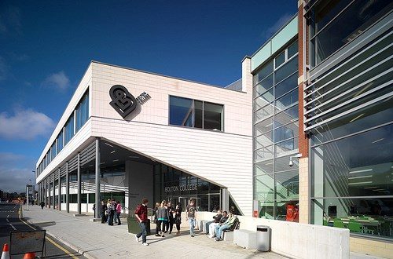

**Bolton College - Gender Pay Report**



As an equal opportunities employer Bolton College recognises the importance of equality of opportunity and valuing diversity and as such is committed to ensuring that staff are treated equitably and fairly. In line with our commitment the College fully supports the principle that all employees should receive equal pay for work of equal value and will take steps to eliminate any bias in our reward systems. The College has a transparent pay structure which is based on evidenced based decisions as to avoid subjectivity and potential unlawful bias.

Under the Equality Act 2010, equal pay is a legal obligation. The Act gives a right to equal pay for equal work. Organisations are responsible for providing employees with equal pay and for ensuring that pay systems are transparent.

All companies with 250 or more employees are now required to publish their gender pay gap under new legislation that came into force in April 2017. Employers have to publish the gap in pay between men and women on both a median and mean basis. In addition, employers are required to disclose the distribution of gender by pay quartile – in other words splitting the workforce into four groups based on their pay, and showing the proportion of men and women in each group. Employers are also required to disclose percentages of staff receiving bonuses by gender and the gender pay gap on bonuses.



# Our Approach

Bolton College have followed the guidelines published by the Equality and Human Rights Commission. The key steps to this process were:

1. Deciding the scope of the audit and identifying the data required.
2. Identifying where men and women were doing equal work / like work.
3. Collecting and comparing pay data to identify any significant equal pay gaps.
4. Establish the causes of the pay gaps and deciding whether they are free from discrimination.
5. Developing an equal pay action plan to address any pay gap.

Under the regulations there are six calculations that the College are required to report on. These are:

* Average gender pay gap as a mean average
* Average gender pay gap as a median average
* Average bonus gender pay gap as a mean average
* Average bonus gender pay gap as a median average
* Proportion of males receiving a bonus payment and proportion of females receiving a bonus payment
* Proportion of males and females when divided into four groups ordered from lowest to highest pay

All data was extracted from the College Human Resources System as at 31 March 2022.

# Gender Pay Gap V Equal Pay

**Gender Pay Gap** - The gender pay gap is the difference between the hourly rate of pay of male employees and female employees (as set out in the regulations), expressed as a percentage of the hourly pay rate of the male employees. The gender pay gap is reported on both a mean (average) and median (mid-point on a distribution) basis.

**Equal Pay** - UK law has, since the 1970s, prohibited paying different amounts to men and women who are doing ‘like work’, ‘work of equal value’ or ‘work rated as equivalent’ unless there is a ‘genuine material factor’ for the difference.

In summary equal pay is different to gender pay gap. Equal pay deals with the differences between men and women who carry out the same or similar job roles of equal value, whereas the gender pay gap shows the differences in the average pay between men and women. A gender pay gap does not automatically mean there is unlawful pay inequality.

**Mean vs. Median -** The Gender Pay Gap reporting regulations specifically require both the median and mean to be reported. The median is a statistic commonly used in analysing both internal pay tendency

and external market norms, because it looks at the central tendency of the sample by showing the middle-most salary of a sample. The mean is the overall average of the whole sample and this can therefore be subject to the influences of any extremely high or low salaries at the top or bottom of the sample, this can distort the picture.

# Bolton College Data

Bolton College employs circa 550 people, of these 70% are female and 30% are male. The overall gender pay gap as at 31 March 2022 at Bolton College is 11.73% on a median basis (10.04% using mean pay). This compares to the UK median which, as reported by the Office of National Statistics, is 14.9%.

The College does not operate a bonus payment scheme and therefore there is no data to report.

The chart below sets out the gender profile by pay quartile. The fact that there are more women in the lower paid quartile and at the lower grades of the College is an explanation of the overall gender pay gap.

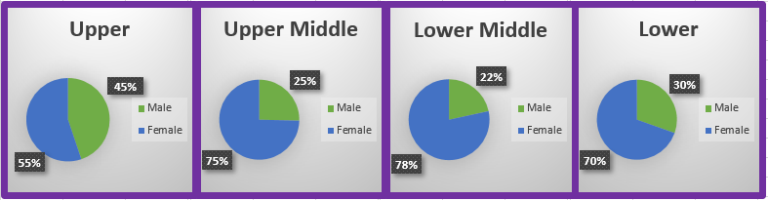

In summary our data indicates that 55% of the female employees hold positions in the ‘upper’ quartile compared to 45% of males which indicates that women are underrepresented in the ‘upper’ quartile of job roles on the basis that 70% of the workforce is female. The ‘lower’ quartile is the most representative followed by the ‘upper middle’ and ‘lower’ quartiles.

Job roles within the ‘lower / middle’ quartiles would include, for example learning development mentors, mentors, learner support workers, some administration roles, cleaners and nursery staff. It is also important to note that within the College a large number of part-time opportunities (i.e. term-time only contracts) are available which reflects our business needs/service provision. Such roles are predominantly filled by female staff. Although the College offers flexible working arrangements to all staff, more requests are made by women, which reflects society norms in that the lion share of childcare / caring responsibilities is still traditionally undertaken by women. It is envisaged that the impact of the pandemic and requests for flexible working will be seen in 12 months’ time.

It should be noted that within the College there are curriculum areas that are more difficult to recruit to than others, and this is reflective of the position nationally. Such areas include Engineering and Construction, which in order to recruit successfully to these areas, the College is required to provide a salary enhancement by way of a Market Rate Supplement to attract suitably skilled individuals. Such roles predominantly attract male applicants and again this is reflective of gender imbalances that exist in these areas nationally. The College actively encourages female staff (and vice versa with males in female dominated environments) to apply for jobs in what are still seen to be traditionally male dominated roles.

Overall across the quartiles the College is confident that men and women are paid equally for doing equivalent jobs across the organisation.

**Closing the Gap**

Below we set out the actions that the College is undertaking to take steps to close the gender pay gap:-

* ‘unconscious bias’ training for all staff as part of the College’s staff development / CPD offer.
* The promotion of flexibility of working arrangements, including career breaks continues to be part of the College talent attraction and retention strategy.
* HR continues to be an active and consistent part of the recruitment process, including salary negotiations.
* Mentoring for new staff and staff who aspire promotional opportunities.

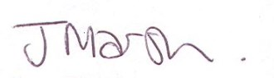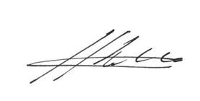

|  |  |
| --- | --- |
| Bill Webster **Principal** | Jane Marsh  **Director of Human Resources** |

