Kill Your Darlings: Curate Your Images
FlyRank AI Internship — Week 3

Final Image Set (Real Captures)
Home — Hero
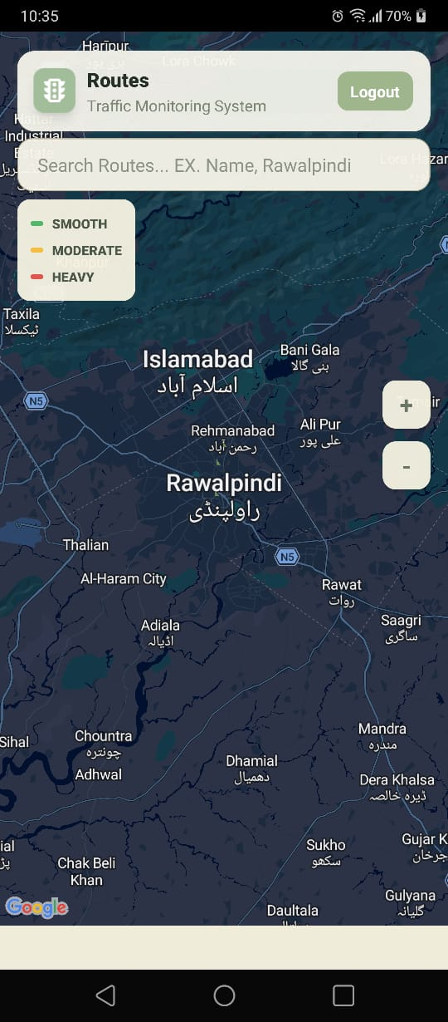
Routes congestion map (Islamabad/Rawalpindi), color-coded smooth/moderate/heavy — real capture, used as the hero image
Work / Case Study
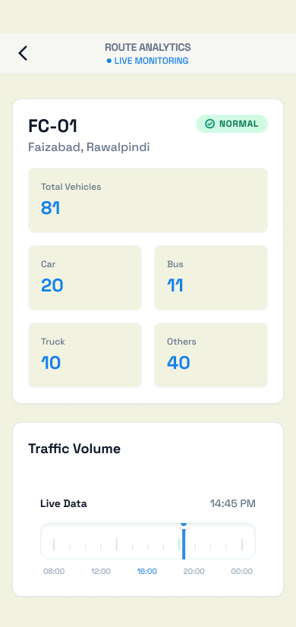
FC-01 Route Analytics — real counting output (Car 20, Bus 11, Truck 10, Others 40)
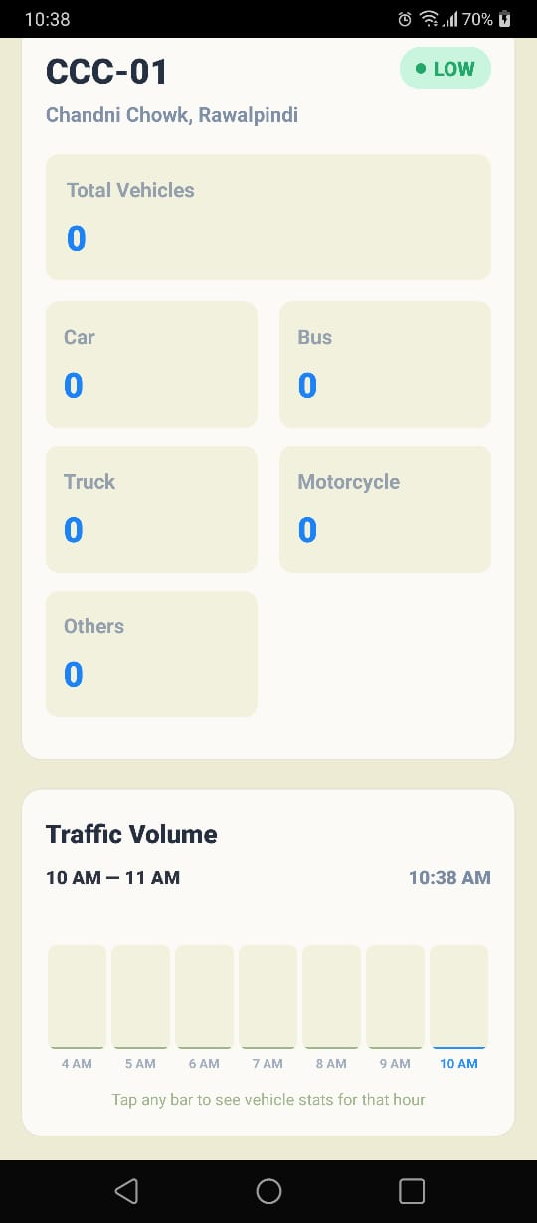
CCC-01 Route Analytics — confirms the full 5-class system including Motorcycle
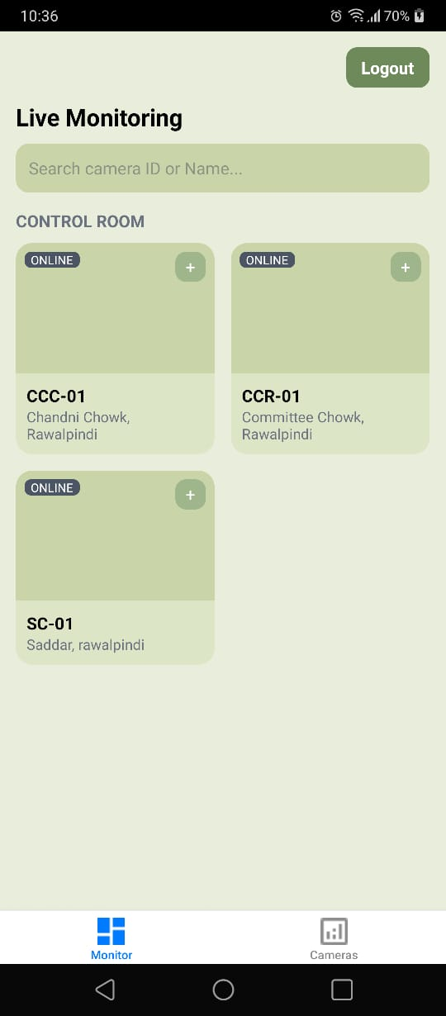
Camera Fleet dashboard — real deployment across multiple Rawalpindi locations
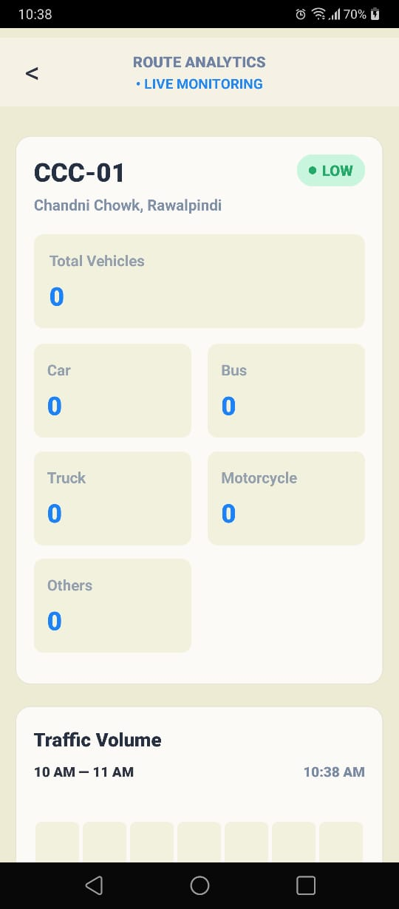
Live Monitoring grid — cameras shown online and active
About
A real photo of myself (on file, to be placed on the About page).

Rejected: Generated Image
A generated abstract hero graphic was created and considered for the Home page: overlapping road-like lines and dots in the locked palette (deep blue #1E3A5F, teal #2E7D8C), evoking a traffic network without showing anything real.
Rejected because it's decorative, not evidence. It uses the right colors but says nothing true about the project — anyone could put this on any traffic-related site. The real Routes map screenshot shows an actual working system monitoring actual Rawalpindi/Islamabad roads, which directly proves the claim instead of just gesturing at the theme. Real beats generated here because the whole portfolio's job is to prove something happened, not to look nice.

Where Real Was Chosen Over AI
Every image serving the Work/Case Study and Home hero is a real screenshot captured directly from the running TrafficSmart app, not an AI-generated stand-in. The About page uses a real photo of myself, not an avatar or illustration. The only generated image made during this process was explicitly rejected in favor of real proof, documented above.

