Decide Once: Build Your Identity Kit
FlyRank AI Internship — Week 3

Type
Heading font: Space Grotesk
Body font: Inter
Both are free (Google Fonts) and widely supported. Space Grotesk gives headlines a confident, technical edge; Inter keeps body copy clean and out of the way so the work stays the focus.

Palette
Role | Hex | Notes
Background (near-white) | #FAFAFA | Page background
Text (near-black) | #1A1A1A | Body and heading text
Main color | #1E3A5F | Deep technical blue, used for headings and key UI elements
Accent | #2E7D8C | Muted teal, used sparingly for links/CTAs only

Logo / Favicon
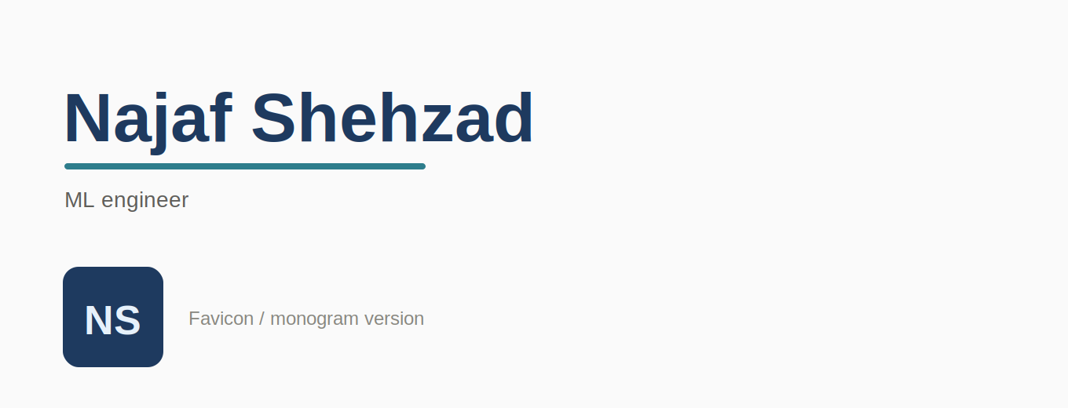
Wordmark in Space Grotesk (top) and "NS" monogram favicon (bottom)

Style Note
Fonts: Space Grotesk (headings), Inter (body). Palette: background #FAFAFA, text #1A1A1A, main #1E3A5F, accent #2E7D8C.
Mood: calm, technical, and confident — the palette and type stay quiet so the work is the loudest thing on the page.
Added to the "ML Portfolio Build" Claude Project as a standing instruction, appended after the proof statement and voice card already set in earlier weeks.

