Empty but Live: Ship a Blank Page
FlyRank AI Internship — Week 4

Live URL
Live site: https://al-najaf.github.io/Najaf-Portfolio/
Stack: static HTML/CSS hosted on GitHub Pages, matching the stack chosen in Three Roads. Styled with the locked identity kit: Space Grotesk (heading), Inter (body), background #FAFAFA, main color #1E3A5F, accent #2E7D8C.

Confirmed Live on a Second Device
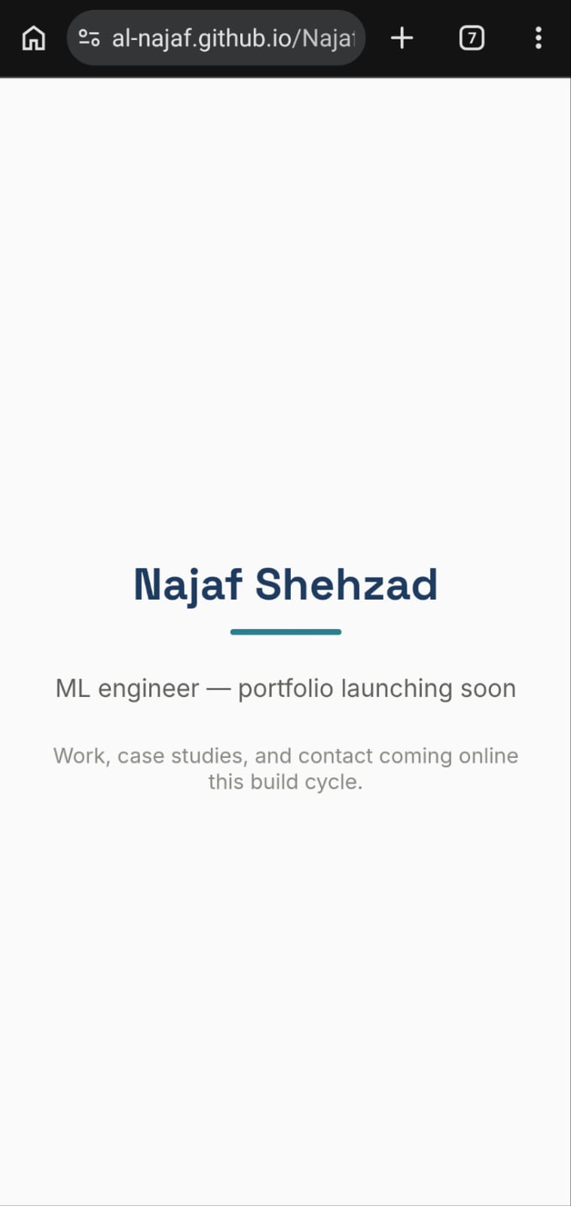
The live page open in a phone browser, real device chrome and URL bar visible, confirming the page is genuinely reachable from a second device.

Project Loaded for the Build Week
The "ML Portfolio Build" Claude Project's Files section now holds the identity kit, case studies, and content map from Weeks 2-3, so every chat in the Project has full context going into the build phase.
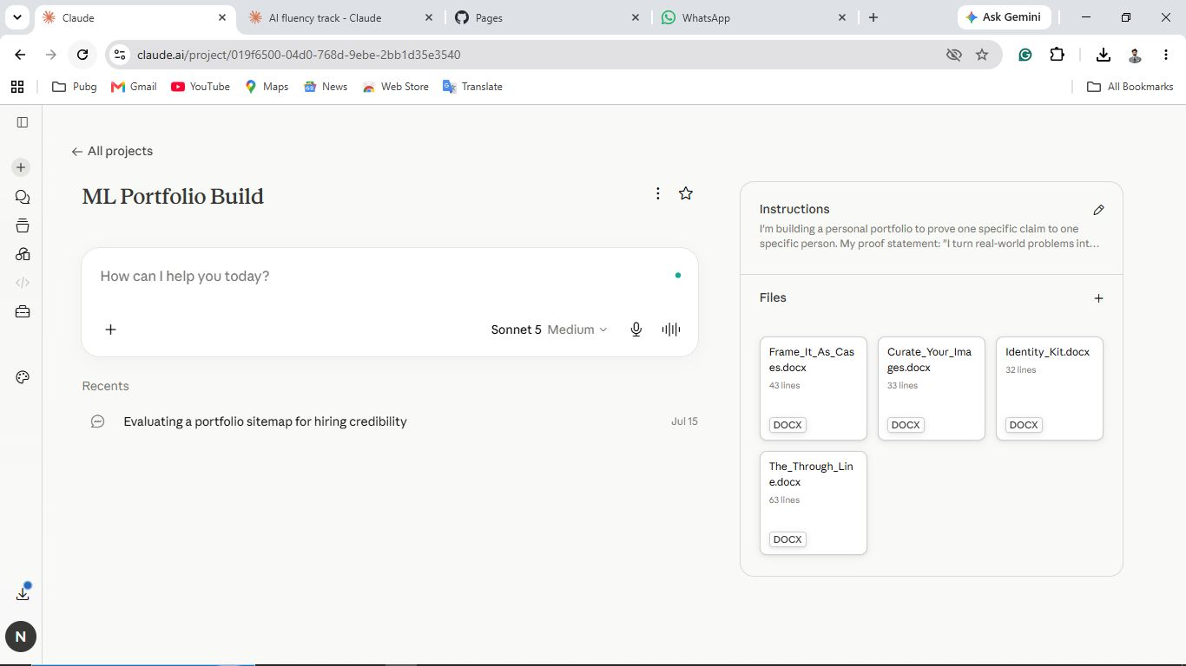
Claude Project Files: Frame_It_As_Cases.docx, Curate_Your_Images.docx, Identity_Kit.docx, and The_Through_Line.docx, alongside the existing Instructions (proof statement, tutor request, voice card, style note).

