AI Workflow Audit and Tool Setup
AI Fluency Framework & Foundations — Setup Phase

1. Workflow Audit
Recurring tasks from my real week (internship, final year project, and course learning), classified using the Just Me / Delegate / Collaborate / Automate framework.
Task | Classification | Rationale
1. Attending live sessions (internship) | Just Me | Requires focused human attention/listening in real time — AI has no role here.
2. Doing internship assignments | Collaborate | I work through problems step by step with AI as I go, rather than handing off a finished task.
3. Writing internship reports | Collaborate | I write alongside AI, going back and forth rather than delegating the whole draft.
4. Coding (internship) | Collaborate | I code alongside AI step by step, checking as we go.
5. Coding (final year project) | Collaborate | I code alongside AI step by step, checking as we go.
6. Checking live demo (FYP) | Just Me | Verifying my own project's output/behavior is something only I can judge.
7. Writing reports (FYP) | Delegate | I write it myself, occasionally ask AI for small fixes/help, and review before using.
8. Meeting with supervisor (FYP) | Just Me | I prepare for and handle the live discussion myself, even though AI helped with the underlying work.
9. DeepLearningAI course | Delegate | I watch lessons and do exercises myself, and ask AI to explain stuck points — reviewing its explanation before trusting it.
10. Checking email | Just Me | Just reading/scrolling myself, no AI involved.
11. Checking LinkedIn | Just Me | Just browsing myself, no AI involved.

2. Toolkit Setup
• ChatGPT account created
• Claude account created
• Anthropic Academy account created
• Enrolled in "AI Fluency: Framework & Foundations" and completed Module 1
• Claude Project created ("FlyRank MLInternship") with custom instructions covering identity, tone preference, and current goals — see screenshot below.
Screenshot: Configured Claude Project with custom instructions
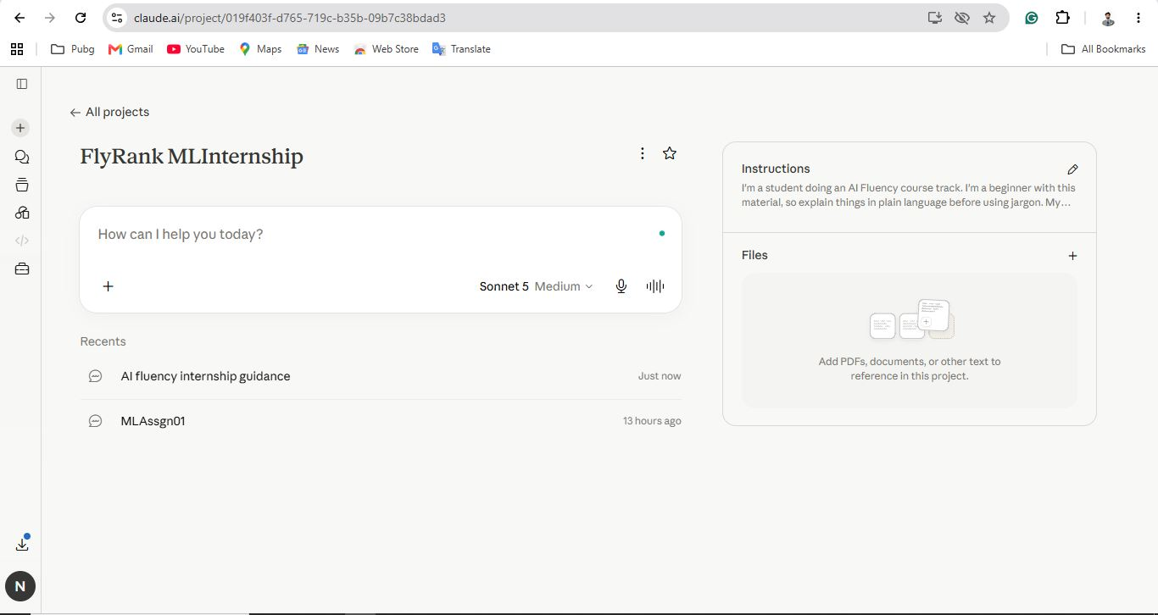

3. Three Target Tasks (for FL-02 through FL-04)
Target Task 1: Coding (final year project)
Classification: Collaborate
"Done well" means: Code AI helps write runs correctly on the first or second try; I understand every line well enough to explain it to my supervisor without help; and I catch any AI mistakes before running the code — not after.
Target Task 2: Writing reports (final year project)
Classification: Delegate
"Done well" means: The report reflects my actual work accurately (no AI-invented details), reads in my own voice, and needs no more than one round of edits after AI's pass before it's ready to submit.
Target Task 3: DeepLearningAI course exercises
Classification: Delegate
"Done well" means: I can solve the exercise myself afterward without AI's help — meaning I used AI to understand the concept, not to skip understanding it.

