Draw the Path: Portfolio Sitemap + Toolkit
FlyRank AI Internship — Week 1 · Decide What You're Proving

1. Portfolio Sitemap
Four pages, each earning its place against the claim and the one action: Home/Hero → Work/Case Study → About → Contact.
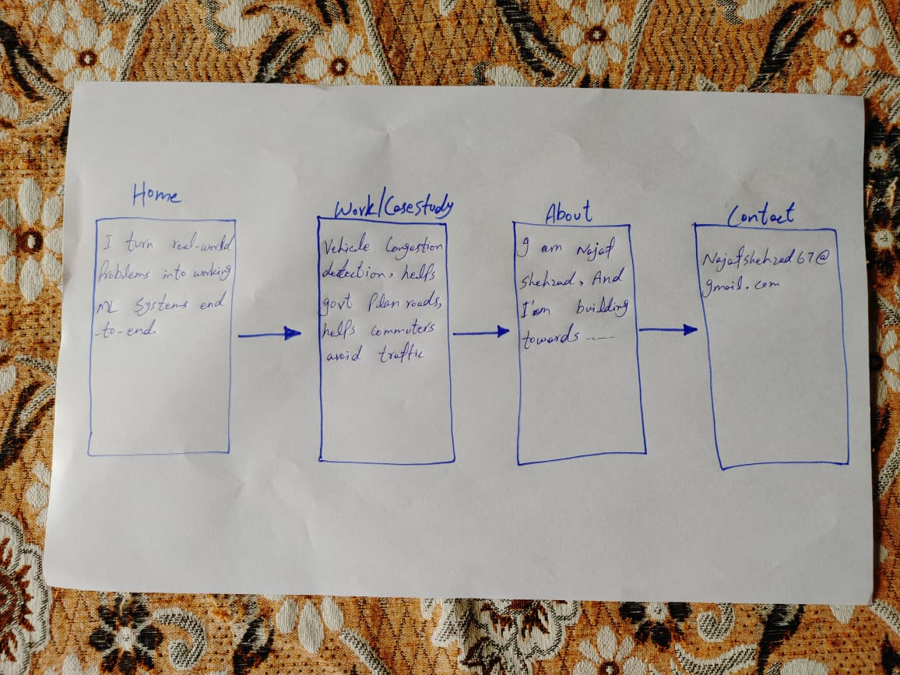
Hand-drawn sitemap sketch

2. Toolkit
Accounts created: Claude, ChatGPT, Gemini, Perplexity. Main build partner: Claude.

3. Claude Project — "ML Portfolio Build"
A dedicated Project created for this 10-week build, separate from the existing internship Project, with the proof statement pasted into custom instructions and a request for Claude to act as a tutor.
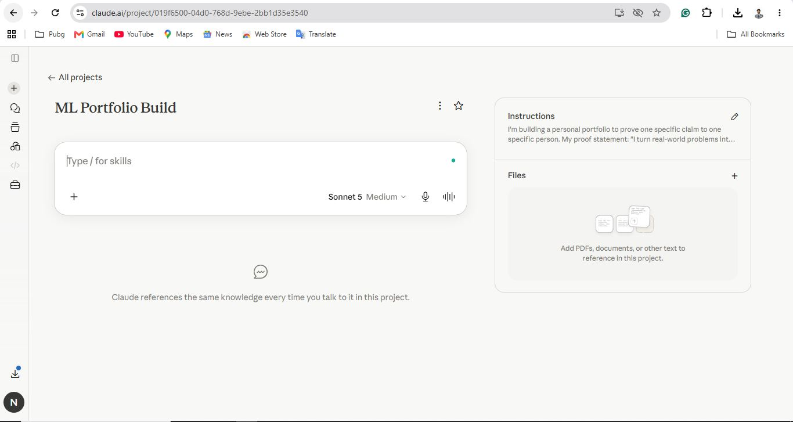
Configured Claude Project with custom instructions

4. Pressure-Test Prompt + Output

Prompt
This is my proof statement: "I turn real-world problems into working machine learning systems end-to-end — like my final year project, which detects vehicle congestion from traffic footage to help governments plan road expansion and help commuters avoid congested routes. I'm proving this to Syed Sarmad Shan Bukhari, an ML team lead who can hire me, so that he emails me directly."
This is my sitemap: Home/Hero (states the claim), Work/Case Study (vehicle congestion detection project, problem/data/difficulty/impact), About (who I am, what I'm building toward), Contact (email).
Does this sitemap walk my one person from landing, to believing me, to taking my one action, and does it actually prove my claim? Tell me which pages earn their place, which are wasted, and what is missing. Be specific, not encouraging.

Claude's Response
Let me go page by page and hold each one to a strict test: does it move Sarmad closer to believing the claim and emailing you, or is it there out of habit because "portfolios have this page"?
Home/Hero — earns its place, but as described it's underbuilt. A claim in words is free; the hero needs a visual proof-fragment (a GIF of the detector running, or a real number) sitting next to the claim, not text alone.
Work/Case Study — earns its place, it's the whole point of the site. But "problem/data/difficulty/impact" is a template, not evidence. Missing: what "end-to-end" actually means here (raw footage to a running system, or just a notebook model); a demo he can watch, not just prose; actual numbers (accuracy, FPS, dataset size); real architecture decisions and tradeoffs, not a humblebrag narrative; and an honest statement of whether the government/commuter impact is real or just the intended use case.
About — this is the one I'd cut, or shrink to almost nothing. It doesn't change whether Sarmad emails you, and it invites scope creep away from the one claim.
Contact — earns its place, but reconsider its position. A dedicated page is unnecessary friction; the email action should be reachable directly from Home and the bottom of the Work page.
Structural flow problem: Home → Work → About → Contact puts a detour (About) right before the action point. The path should be closer to Home (hook) → Work (proof) → CTA (immediately).
What's missing entirely: a working demo artifact (video or live), quantified results, a repo/technical writeup an ML lead can actually evaluate, and honest framing of what's real vs. aspirational in the impact claim.

5. What I'll Change
On the Work/Case Study page, I'll be explicit that the system is fully built and demoable (data pipeline → trained model → working detection on footage) but not yet deployed to real users or government partners — instead of letting "end-to-end" imply real-world deployment. I'll show a demo video/GIF as proof it runs, rather than just describing it in prose.

