Plant Your Flag: Domain + Badge
FlyRank AI Internship — Week 9

Live Address
Site: https://al-najaf.github.io/
A personal paid domain was priced and considered (roughly PKR 3,000–5,200/year for a .com), but was not affordable at this time. Per the brief's accepted fallback, the site was moved to a clean free subdomain: the repo was renamed to AL-NAJAF.github.io, giving a root-level address with no extra path, in place of the previous al-najaf.github.io/Najaf-Portfolio/. Confirmed live over HTTPS.

Analytics
GoatCounter (free tier) installed across all 4 pages via a single script tag before the closing </body> tag. Confirmed working with real, live data:
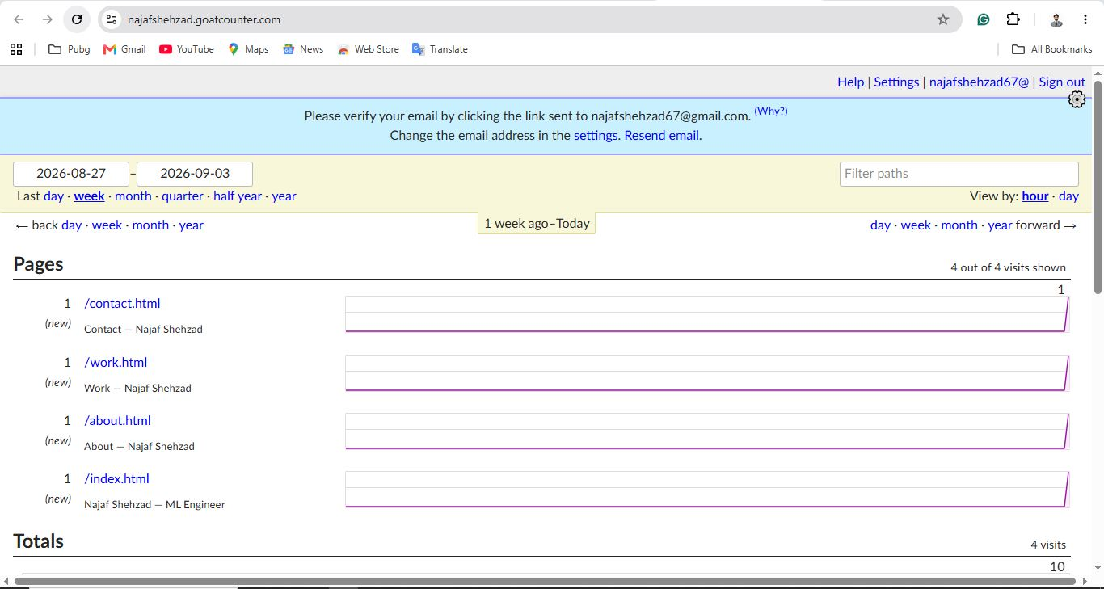
All 4 pages tracked individually (contact, work, about, index), 4 real visits, 10 total pageviews.
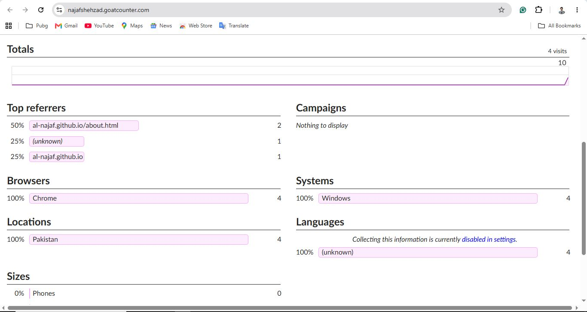
Real referrer, browser, and location data confirming genuine visits (Chrome, Windows, Pakistan).
Note: the dashboard currently shows a pending email verification banner; data is tracking correctly regardless, verification is a follow-up housekeeping step, not a functional blocker.

Launch Hygiene
Favicon: Confirmed showing correctly in the browser tab (custom "NS" monogram, matching the identity kit).
Page titles: Confirmed correct on the live address (e.g. "Najaf Shehzad — ML Engineer" on Home, matching page-specific titles on Work/About/Contact).
Social-share preview: Confirmed via a real WhatsApp link preview test, the card correctly showed the site's title, description, and the custom social-share image (real TrafficSmart routes map screenshot).
Final phone check: Site reopened and reviewed on a real phone after all domain, analytics, and meta changes; confirmed working correctly.

FlyRank Graduate Badge
Status: complete. Two credential badges installed in the site footer across all 4 pages, linking to real verification pages:
FlyRank Verified — Machine Learning → https://internship.flyrank.ai/verify?id=FR-D11-4C1D6-2CB17&first_name=Najaf
FlyRank Verified — AI Fluency → https://internship.flyrank.ai/verify?id=FR-D11-B580F-D77F4&first_name=Najaf

