Plant Your Flag: Domain + Badge
FlyRank AI Internship — Week 9

Live Address
Site: https://al-najaf.github.io/
A personal paid domain was priced and considered (roughly PKR 3,000–5,200/year for a .com), but was not affordable at this time. Per the brief's accepted fallback, the site was moved to a clean free subdomain: the repo was renamed to AL-NAJAF.github.io, giving a root-level address with no extra path, in place of the previous al-najaf.github.io/Najaf-Portfolio/. Confirmed live over HTTPS.

Analytics
GoatCounter (free tier) installed across all 4 pages via a single script tag before the closing </body> tag. Confirmed working with real, live data:
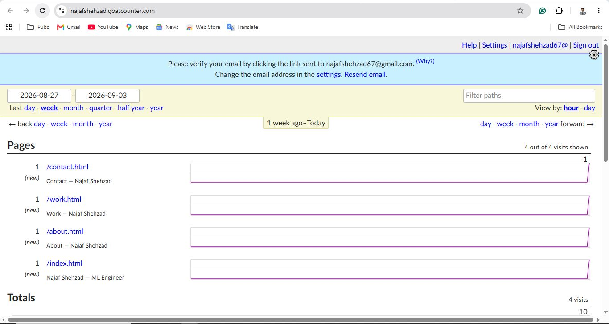
All 4 pages tracked individually (contact, work, about, index), 4 real visits, 10 total pageviews.
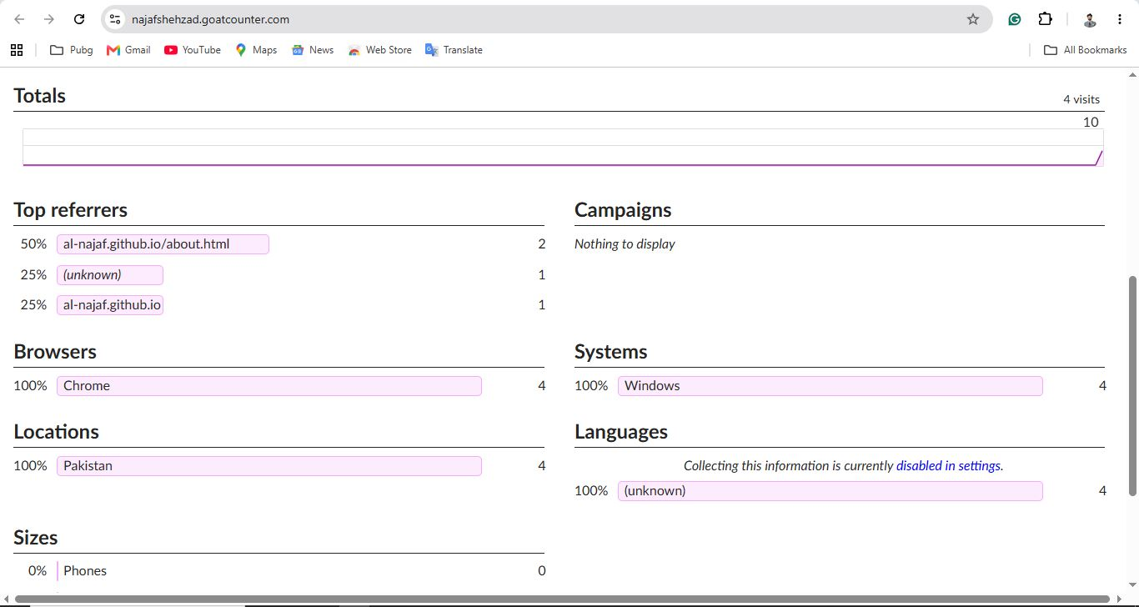
Real referrer, browser, and location data confirming genuine visits (Chrome, Windows, Pakistan).
Note: the dashboard currently shows a pending email verification banner; data is tracking correctly regardless, verification is a follow-up housekeeping step, not a functional blocker.

Launch Hygiene
Favicon: Confirmed showing correctly in the browser tab (custom "NS" monogram, matching the identity kit).
Page titles: Confirmed correct on the live address (e.g. "Najaf Shehzad — ML Engineer" on Home, matching page-specific titles on Work/About/Contact).
Social-share preview: Confirmed via a real WhatsApp link preview test, the card correctly showed the site's title, description, and the custom social-share image (real TrafficSmart routes map screenshot).
Final phone check: Site reopened and reviewed on a real phone after all domain, analytics, and meta changes; confirmed working correctly.

FlyRank Graduate Badge
Status: pending. The badge generator (internship-badge.netlify.app) requires a credential ID, which has not yet been located, still checking the FlyRank portal/enrollment email for this reference number. Once found, the badge will be generated and installed in the site's footer across all 4 pages, linking to the verification page, per the requirement.

