Build the Agent
FlyRank AI Internship — Week 5 — Checkpoint 1 (MVP)

Platform
Built on the platform chosen and justified in FL-06: a Claude Project ("ML Research Scout") with structured custom instructions, connected to the Exa MCP connector (live web search), the same real tool connection proven working in FL-04.

Instructions Used
You are a research scout for machine learning, deep learning, and computer vision developments. Given a topic, search for genuinely new, substantive developments from the last 1-2 weeks. Evaluate your own results: if they're thin, off-topic, or just marketing content, run a follow-up search with a refined angle before settling. Prioritize official sources (papers, company engineering blogs, benchmarks) over aggregators. Distinguish vendor claims from independently verified facts. Stop and produce the brief once you have at least 2 genuinely substantive items, or after 3 search attempts, whichever comes first. Never fabricate a source. If nothing substantive exists, say so honestly. Never post, email, or publish anything, only report back.

Real Tool Connection
Exa MCP connector, live web search, connected and authenticated to the Claude Project. All four runs below show real tool calls (visible search/"reckoning" steps), not answers generated from memory.

Build Log — Four Real Runs
Run 1
Input: "object detection" (self-narrowed by the agent to YOLO specifically)
What happened: Ran 3 searches (hit the cap), found nothing substantive from the last 1-2 weeks. Correctly separated a shipped release (YOLO26, ~7 months old) from an unconfirmed future one (YOLO27, not yet released, expected Sept 2026).
What broke / deviated: Eval case 1 expected 2+ recent items; got zero. This is a pass on the honesty guardrail, not a failure of the agent, but it revealed the eval case's assumption (recency always available) was miscalibrated.
What I'd change: Loosen the eval case's time-window assumption rather than treating an empty, honest result as a failure.
Run 2
Input: Broadened to object detection generally (RF-DETR, DETR variants), per the agent's own suggestion from Run 1
What happened: Ran a full 3-search round. Correctly separated RF-DETR's self-reported COCO benchmark numbers (vendor claim) from its independently verified ICLR 2026 acceptance (peer-reviewed fact), demonstrating the vendor-vs-independent guardrail in real use, not just on paper. Again found nothing within the 1-2 week window and said so.
What broke / deviated: Same recency pattern as Run 1, confirms it's systemic, not a one-off.
What I'd change: Confirms the time-window issue is real and repeatable; worth fixing before relying on this agent weekly.
Run 3
Input: "traffic AI"
What happened: Agent recognized the topic was ambiguous on its own (cybersecurity "bot traffic" vs. road/transportation traffic) and investigated both angles before reporting, real domain reasoning, not generic hedging. Named the specific recurring vendors behind recycled coverage (NoTraffic, Miovision, Hayden AI, etc.). Again found nothing within the strict window.
What broke / deviated: Third consecutive empty-but-honest result. Confirms ML/traffic-AI news publishes in bursts (around releases/conferences), not constant weekly output.
What I'd change: Reframe the job as "most recent genuine development, however old" rather than a hard 1-2 week cutoff.
Run 4 (raw screen capture, unedited, ~32 seconds)
Input: "3D object detection" or "open-vocabulary detection" (agent's own suggested next angle)
What happened: Full real-time run recorded start to finish: topic entered, live tool-use step visible ("Reckoning"), concluding with an explicit "nothing new at all" verdict for 3D detection, all results were either rehashed surveys or older KITTI-based work. Closed with a clear bottom-line summary across all topics tested and named the next real catalysts to watch (YOLO Vision 2026, RF-DETR's develop branch).
What broke / deviated: Fourth consecutive honest "nothing substantive" result, strongest confirmation yet that the recency constraint, not the agent's reasoning, is the actual bottleneck.
What I'd change: This is the clearest evidence for the spec fix: the guardrails (no fabrication, honest reporting, vendor-vs-independent distinction) are working correctly and consistently; the constraint that needs revising is the time window.

Screen Capture Reference
Raw, unedited screen recording (~32 seconds), attached as agent_run_capture.mp4. Below: first and last frame, showing the topic entered and the final honest verdict delivered.
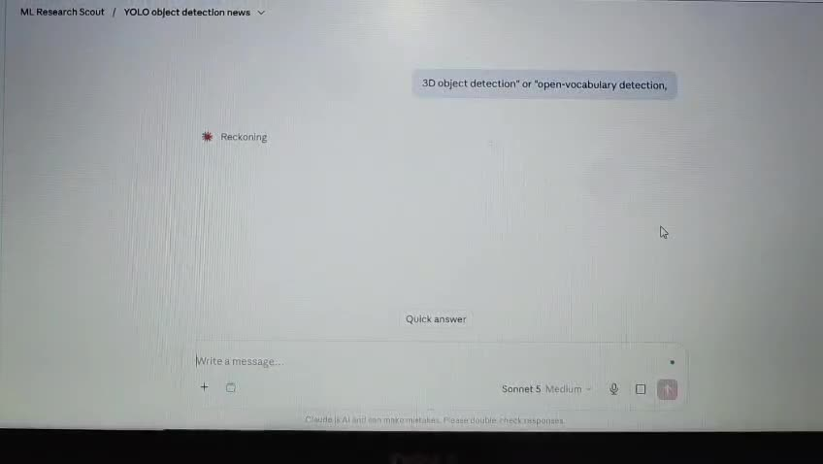
Start: topic entered, live tool-use step ("Reckoning") visible.
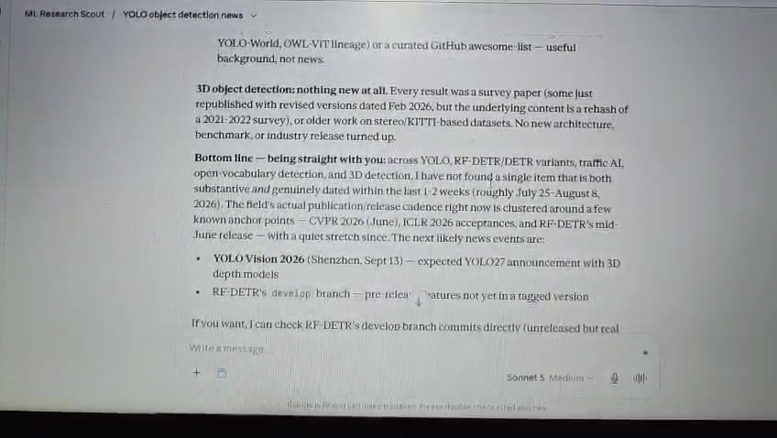
End: final honest "nothing new at all" verdict, with a clear bottom-line summary and next catalysts named.

Deviations from the FL-06 Spec, and Why
The spec assumed genuinely new developments would typically be available within a 1-2 week window. Across all 4 real runs, that assumption did not hold, the field publishes in clustered bursts around conferences and releases, not a steady weekly stream. The agent's actual behavior (honest reporting of "nothing found" rather than padding with old material) is correct and exactly what the guardrails were designed to produce. The deviation worth carrying into the next iteration is a spec change, not a build fix: loosen the time window, or reframe the job as "most recent genuine development" rather than enforcing a hard recency cutoff.

Known Failure Points / Required Human Review
• The strict 1-2 week window causes the agent to correctly, but unhelpfully, return empty results during quiet periods in the field; a human still needs to decide whether to accept an empty week or manually widen the window.
• Topic ambiguity (as seen with "traffic AI") is handled well when the agent catches it itself, but there's no guarantee it always will; a human should sanity-check that the interpretation matches intent before trusting the brief.
• The agent correctly flags vendor claims, but does not independently verify facts beyond checking for peer-reviewed venues (e.g., ICLR); a human should still spot-check anything going into a decision with real stakes.

