

Veterans Experience Office

Contact Center Modernization Operations Hub

Survey Strategy

Deliverable 5.2.G – Contact Center (External) Veteran Survey

*\*The survey strategy is a living document that will be iterated over time to meet evolving needs as the survey tool is configured for distribution. This includes future iterations of the external survey design as well as the defined strategy for distribution. Any modifications to the survey strategy or design will affect the overall data strategy plan and defined metrics for the operations hub.*

Version: 1.0

Last Updated: 02/22/17

Contents

[1 Background 3](#_Toc475106612)

[2 Survey Methodology 3](#_Toc475106613)

[3 Research Insights 4](#_Toc475106614)

[**Effectiveness** 5](#_Toc475106615)

[**Ease** 5](#_Toc475106616)

[**Emotion** 6](#_Toc475106617)

[4 Survey Structure 6](#_Toc475106618)

[**Veteran Survey Structure** 7](#_Toc475106619)

[**Likert Scale** 8](#_Toc475106620)

[**Survey Question Distribution** 8](#_Toc475106621)

[5 Survey Considerations 8](#_Toc475106622)

[**Design** 8](#_Toc475106623)

[**Execution** 11](#_Toc475106624)

[**Format** 11](#_Toc475106625)

[6 Assumptions 12](#_Toc475106626)

[7 Glossary of Acronyms 13](#_Toc475106627)

[8 Resources Cited 13](#_Toc475106628)

[9 Document Revision History 14](#_Toc475106629)

[10 Appendix A - Veteran Survey Design Copy Document 15](#_Toc475106630)

[**Survey – Web** 16](#_Toc475106631)

[**Survey – Mobile** 17](#_Toc475106632)

[**Survey – Tablet** 18](#_Toc475106633)

# Background

The Department of Veterans Affairs (VA) is committed to delivering its vision to become the number one customer service agency in the federal government. To achieve this goal, VA launched the MyVA initiative to enhance the experience for Veterans and employees. The MyVA Transformation Update outlines five strategies to achieve customer service excellence:

1. Improve Veteran experience
2. Improve employee experience
3. Achieve support service excellence
4. Establish culture of continuous performance improvement
5. Enhance strategic partnerships

In support of improving the Veteran and employee experiences, the AbleVets and Accenture Federal Services team was tasked with developing two surveys for the Veterans Experience Office (VEO) to gain insight into the Veteran and employee experience and sentiment surrounding VA contact center services. One survey was created for external use with Veterans, while the other survey was created for internal use with employees. Each survey contains a maximum of five questions, and will be distributed by the VEO. This document addresses the Veteran external survey methodology and design.

# Survey Methodology

VA contact centers provide critical services to Veterans and their beneficiaries. The AbleVets and Accenture Federal Services team supports VA in designing an ***Enterprise Contact Center Operations Hub (Hub)*** to enable contact center modernization and realize the vision of a Veteran-centric organization. The Hub provides customer and employee insights to drive continuous operational improvement and data-driven recommendations that will improve Veteran and employee experience.  The Hub will use the survey results to continuously define and validate recommendations.

Our team applied ***Human Centered Design (HCD)*** techniques using qualitative research to inform the survey methodology and design. Our HCD research process revealed a deeper understanding of stakeholder needs by providing visibility into their current experiences with VA Contact Centers. Our research methods included stakeholder mapping, onsite employee interviews, affinity diagramming, and in-depth secondary research.

The surveys are comprised of ***statements*** that are aligned to ***metrics*** and relate to Veteran experience ***themes***. Experience themes are categories of service that will be measured and compared to desired standards.

Our team will ***analyze the survey results*** according to the identified experience themes (e.g., satisfaction, trust, accuracy), share findings with key stakeholders, and use the results to ***drive strategic and tactical recommendations*** for experience improvements as outlined in the Customer Experience Management (CEM) solution. These findings will also inform the Enterprise Contact Center Dashboard design that displays real-time metrics, increases the visibility of trends, and sets standards for measuring customer and employee experiences. The dashboards will visually display the experience metrics that continually inform CEM recommendations, guiding contact centers toward providing timely, accurate, consistent, and predictable services.

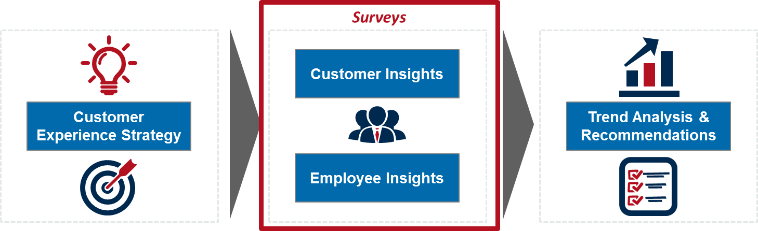

***Figure 1: Surveys are a critical component of Customer Experience Management (CEM)***

Surveys provide valuable insight into what matters most to Veterans and to the employees who serve them. The results of the ongoing feedback are a critical component of CEM. Veteran and employee experience survey results will be incorporated into the enterprise contact center metrics as outlined in the Data Management Plan.

# Research Insights

In recent years, VA has identified the critical need to improve both the Veteran and employee experiences. VA has taken an HCD approach and dedicated significant time and resources to gain an understanding of the Veteran’s experience with VA services through research into the overall end-to-end Veteran journey and their experiences with contact centers, medical centers, the Compensation & Pension (C&P) exam, and the appeals process. Our team conducted an extensive analysis of third-party blogs, review sites, and news articles to gain a foundational understanding of the Veteran and employee experiences, and analyzed the available, existing research conducted by the VEO and Office of Personnel Management (OPM) to better understand the current customer and employee experiences and the ideal future state.

As described within the November 2016 Transformation Update, VEO uses elements of effectiveness, ease, and emotion as the basis to measure the Veteran and employee experience. Our team considered available existing research through the lens of these three experience metrics that impact Veteran and employee trust and confidence in VA.

## **Effectiveness**

An effective Veteran experience provides value to the Veteran, whether that means that the correct information was offered, that the agent had access to the information needed to serve the Veteran, or that the agent was able to provide help to the Veteran. Existing research indicates that employee preparedness and the overall effectiveness of services provided are closely correlated. Specifically:

* Employees are able to best serve Veterans when they are:
  + Prepared with the appropriate tools, knowledge, and training
  + Able to communicate in a language that Veterans understand
  + Supported by their leadership to provide Veterans with the tailored services they need
  + Empowered by VA initiatives that aim to improve both the Veteran and employee experiences
* Veterans perceive an interaction as being effective when the information and processes are predictable and consistent over time

## **Ease**

An easy Veteran experience provides a valuable interaction that is not difficult, whether that means that the end-to-end process was time effective, that the information provided was clear, or that help was otherwise easy to obtain. Existing research indicates that some Veterans view the process to obtain VA benefits as complex and confusing. Specifically:

* Contact center hours and resources limit access to customer service
* Veterans are not aware of the benefits that are available to them, or how to access benefits
* Veterans are frustrated by processes that are not designed around Veteran needs
* Veterans want to understand the benefits process and their responsibilities

## **Emotion**

An emotionally positive Veteran experience leaves the Veteran feeling delighted, whether that means that the agent was compassionate, that the services provided were appealing, or that the general experience with VA was positive. Existing research indicates that Veterans often feel satisfied with their experience when they believe that the agent genuinely cares about their wellbeing. Specifically:

* Veterans want to feel that they are heard
* Veterans want to be treated with respect and empathy
* Veterans form their perceptions of VA based on their interactions with individual agents
* Veterans want VA to be supportive of their needs and eager to provide services
* Veterans take great pride in their service and associate their benefits with the value of their service
* Veterans feel a sense of camaraderie with their fellow Veterans and turn to each other for help

Findings from existing and supplementary research provide a fundamental understanding of Veteran and employee sentiments around experiences with VA. Our team used site visit research data to identify trends and gaps in the Veteran and employee experiences. The research consisted of several one hour, one-on-one interviews with contact center staff to gain insight into the background, needs, and recommendations of employees. Site visit questions centered on themes such as workplace morale, training, and internal communications and processes.

While various end-to-end surveys have been conducted across the VA enterprise to gain insight into the Veteran and employee experiences, our internal and external surveys have been designed specifically to provide metrics that align with the overall data strategy of the Hub.

# Survey Structure

Veterans will receive a brief email survey asking them to respond to 5 statements on a scale of 1-5. The surveys are comprised of ***statements*** that are aligned to ***metrics*** and relate to Veteran experience ***themes***. Experience themes are categories of service that are measured and compared to desired standards.

## **Veteran Survey Structure**

|  |  |  |
| --- | --- | --- |
| **Themes** | **Metrics** | **Survey Questions (Written as Statements)** |
| Expectation | First Call Resolution (FCR) | * I had to call VA more than once to resolve my issue. |
| Transparency | * The agent I spoke to provided me with detailed and thorough information. |
| Responsiveness | * The agent I spoke to was responsive to my needs. |
| Personalization | * The agent understood my unique circumstances. |
| Consistency | * VA contact center services met my expectations based on my previous VA experiences. |
| Trust | Engagement | * It was easy to engage with the agent I spoke to. |
| Kindness | * The agent I spoke to was considerate. |
| Commitment | * The agent I spoke to did everything in his or her power to help solve my problem. |
| Trust | * After the most recent interaction with VA contact centers, I trust VA to provide me with accurate information. |
| Customer Sentiment | * VA values me. * VA has my best interest in mind. |
| Emotion | * I feel better about my situation after calling the VA contact center. |
| Ease | Timeliness | * I spoke to an agent within a reasonable time frame. * My problem was resolved within a reasonable time frame. |
| Access | * I spoke to the right person without difficulty. * It was easy to locate the correct phone number and reach the correct department. |
| User Friendliness | * The call process, from beginning to end, was easy to execute. * It was simple to reach the correct department. |
| Satisfaction | Availability | * I can reach VA contact centers whenever I need to. |
| Customer Satisfaction (CSAT) | * Overall, I am satisfied with my most recent interaction with a VA contact center. |
| Net Promoter Score (NPS) | * I would recommend VA services to my friends and family. |
| Retention | * I would use VA services again. |
| Accuracy | Prepared | * The agent was adequately prepared to help me. |
| Informed | * The agent provided up-to-date information. * The agent understood the information he or she conveyed to me. |
| Clarity | * The agent explained the information in a way that I understood. |
| Accuracy | * I received accurate information. |

***Table 1: Veteran Survey Questions***

## **Likert Scale**

Survey responses will be measured on a Likert Scale. The Likert Scale will be used to quantify survey responses according to respondent sentiment. Based on a scale of 1 to 5, respondents will be asked to indicate which numerical option best represents their response. The Likert Scale can be adapted based on question type, but will always include a scale of 1 to 5 (with 1 being the negative option and 5 being the positive option). A “Not Applicable” option is included for respondents who do not meet the question requirements.

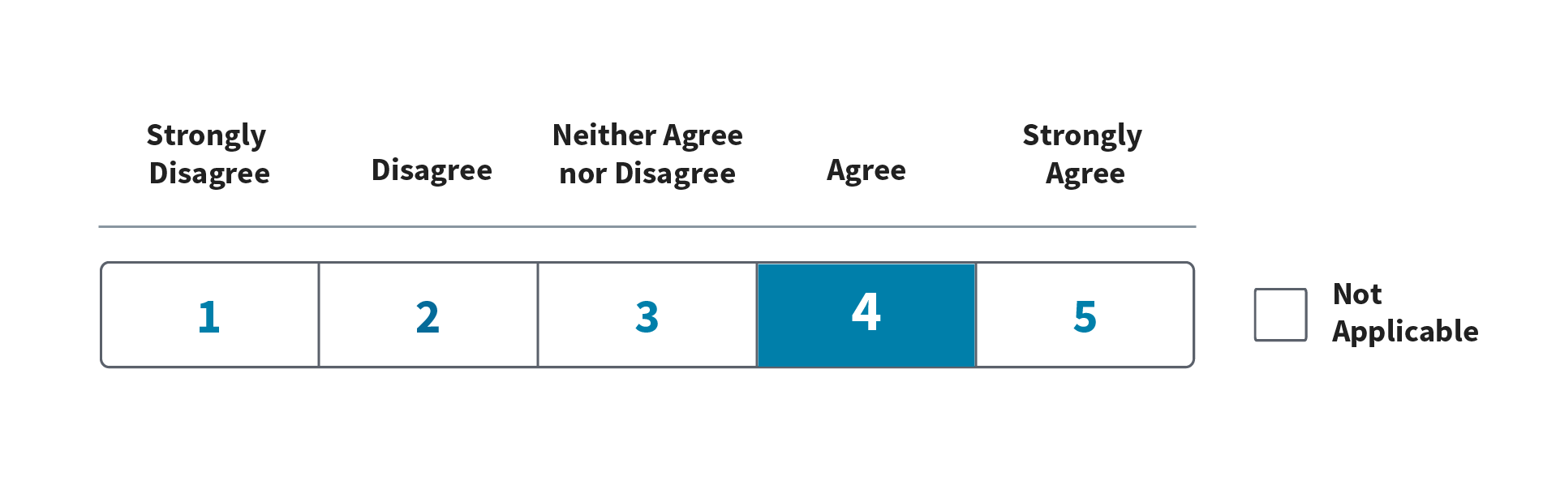

***Figure 2: Likert Scale***

The Likert Scale enables our team to report survey results as percentages. For example, “53% of Veteran survey respondents expressed that their issue was resolved on the first call” (FCR).

## **Survey Question Distribution**

The survey distribution tool will continually randomly generate one question from each theme for a total of five questions per survey.

# Survey Considerations

## **Design**

In 2013, Accenture acquired Fjord Design and Innovation. Fjord is human-centered, with a focus on helping clients answer critical questions around customer relevancy, loyalty, and delight to conceive, design, and deliver innovative service strategies. Our surveys have been designed using Fjord strategies that align with industry best practices including ACSI and Gartner and have been tailored to meet the needs of VA.

Our team recognizes the importance of adhering to defined steps that guide the creation and execution process of the surveys. There are several considerations at each step of the survey creation and execution process. These include:

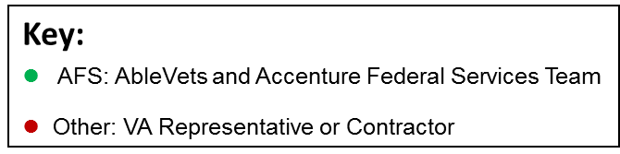

|  |  |
| --- | --- |
| **Steps**  ***To build a meaningful survey*** | **Survey Design Considerations**  ***To take into account when building the survey*** |
| Identify the objectives of the survey | ⚫ Determine segmentation of Veteran and employee respondents |
| ⚫ Determine what information the survey should provide |
| ⚫ Determine survey objectives |
| ⚫ Determine data elements to be used as part of survey (e.g., “Tell us about your experience with the [Contact Center] on [date]”, respondent email address) |
| ⚫ Determine how the survey will be distributed |
| ⚫ Determine how survey responses will be collected |
| ⚫ Determine how data will be analyzed |
| ⚫ Determine who will be involved in the process |
| ⚫ Understand current strengths and weaknesses of the current experience |
| ⚫ Understand leadership perceptions of current experience and objectives for improvement |
| Learn about the Veterans and employees (audience) | ⚫ Determine what the audience wants and needs |
| ⚫ Determine what the audience likes and dislikes |
| ⚫ Determine how the audience currently accomplishes its tasks |
| ⚫ Determine how the audience currently uses the services |
| Compose the survey | ⚫ Avoid sensitive statements |
| ⚫ Establish standard process and template for surveys |
| ⚫ Determine survey length (i.e. a shorter survey will yield fewer insights, but respondents may be more likely to respond) |
| ⚫ Build survey statements in a way that will provide clean feedback data that is easy to understand and analyze using the Likert scale |
| ⚫ Determine what statements are relevant to the target audience |
| ⚫ Statement Formatting   * Closed-ended on Likert scale * “N/A” option |
| ⚫ Statement Wording   * Keep statements short (less than 20 words) * Use plain language * Avoid vague options * Address one issue at a time   Sample customer and employee statements:   * I had to call VA more than once to resolve my issue. * I have a clear understanding of what is expected from me in my role. |
| ⚫ Provide email invitation/instruction text (See Appendix A) |
| Test questionnaire | ⚫ Conduct trial run internally to validate |
| ⚫ Conduct trial run externally to validate |
| ⚫ Identify areas for improvement |
| Final questionnaire | ⚫ Refine final questionnaire based on test questionnaire findings |
| ⚫ Distribute the survey (See Execution Considerations in Table 3) |

***Table 2: Survey Design Considerations***

## **Execution**

Survey response data will be ingested into the Hub to drive improvements in Veteran experiences. Prior to survey distribution, it is imperative that the following be considered:



|  |  |
| --- | --- |
| **Steps**  ***To build a meaningful survey*** | **Survey Execution Considerations**  ***To take into account when building the survey*** |
| Data | ⚫ Provide survey results and present in a user friendly manner |
| Survey Ownership | ⚫ Determine who takes ownership of the feedback and takes action |
| Frequency | ⚫ Determine survey dissemination frequency, while avoiding survey fatigue and adhering to OMB Guidelines |
| Metrics | ⚫ Document defined experience metrics and update |
| Feedback Format | ⚫ Provide simple survey instructions |
| ⚫ Deliver a survey that is intuitive |
| Sample | ⚫ Disseminate the survey to enough respondents to provide an adequate sample size |
| ⚫ Determine sampling business rules (i.e. selecting who is invited to complete the survey) |
| Trigger Rules | ⚫ Determine criteria that trigger survey distribution |
| Timing | ⚫ Administer surveys based on a specific schedule (i.e. the beginning of every quarter) to capture continuous feedback |
| Results Reporting | ⚫ Determine process for reporting survey results to the Hub |

***Table 3: Survey Execution Considerations***

## **Format**

There are several types of surveys that can be used to solicit feedback from respondents, including: in person, phone, paper or email forms, and automated web forms. For the purposes of this survey strategy, we assume that the survey will be conducted email/web form-based surveys using the Medallia survey tool. Our team assumes that potential respondents will receive an email containing a link to a web-based survey. Additional details can be found in the “Assumptions” section.

It is important to begin the survey by informing the Veterans of the purpose of the survey and how long it will take to complete. By setting expectations, Veterans have a clear understanding of the purpose and completion time. Response rates may be favorably impacted if the survey contains a limited number of closed-ended questions and is easy to complete and return.

A successful survey is comprised of several key components:

|  |  |
| --- | --- |
| **Survey Component** | **Description** |
| Title | * Short yet descriptive |
| Instructions | * Time to complete * How to submit when complete |
| Introduction | * Guarantee of anonymity * Purpose of the survey * Benefit of participating * How findings will be shared |
| Questions (expressed as statements) | * Veteran specific |
| Contact Information | * Email * Phone number * Address |
| Thank you | * Example:   Thank you for your time. Your responses have been recorded and will be used to help improve the Veteran experience. |

***Table 4: Components of a Survey***

# Assumptions

The Survey Strategy is built on the following assumptions. Changes to these assumptions are subject to impact the Survey Strategy.

* Survey will be distributed via email (web link)
* Medallia will be used as the survey distribution and collection tool
* Survey Design Copy document will be populated into a pre-formatted Medallia template
* Final survey design is dependent upon Medallia capabilities
* VA will not follow up with individuals who do not respond
* VA will provide previous surveys for reference
* Veteran survey responses will be anonymous at the individual level, but will provide insight into respondent groups (based on contact center, geographic location, etc.)

# Glossary of Acronyms

|  |  |
| --- | --- |
| **Term** | **Definition** |
| C&P | Compensation & Pension |
| CEM | Customer Experience Management |
| CSAT | Customer Satisfaction |
| ESAT | Employee Satisfaction |
| FCR | First Call Resolution |
| HCD | Human Centered Design |
| Hub | Enterprise Contact Center Operations Hub |
| NPS | Net Promoter Score |
| OPM | Office of Personnel Management |
| VA | Department of Veterans Affairs |
| VEO | Veterans Experience Office |

# Resources Cited

* “Department of Veterans Affairs Employee Reviews for Customer Service Representative”, Indeed, 2011-2016.
* “Effective Communications: IT Satisfaction Surveys”, Gartner, December 7, 2015.
* “EXPOSED: VA Call Center Block Majority Veterans’ Calls”, Disabled Veterans, February 18, 2015.
* “How to Design Surveys for Humans”, Latitude, n.d.
* “Principles of Survey Methodology”, UCLA, Winter 2014.
* “Seven Steps to Successful Customer Experience Measurement Programs”, Forrester, February 4, 2016.
* “The C&P Exam, A Discovery”, VA Center for Innovation, September 2015.
* “Toward a Veteran-Centered VA: Piloting Tools of Human-Centered Design for America’s Vets”, VA Center for Innovation, July 2014.
* “Transformation Update”, MyVA Putting Veterans First, November 2016.
* “US Department of Veterans Affairs Complaints and Reviews”, Pissed Customer, 2016.
* “VA crisis line left vets in limbo, says report”, CNN, February 19, 2016.
* “Veteran Appeals Experience”, VA Center for Innovation, January 2016.
* “Veterans take complaints to VA officials”, Chicago Tribune, September 8, 2016.

# Document Revision History

|  |  |  |  |
| --- | --- | --- | --- |
| Date | Version | Description | Name |
| 2/22/2017 | 1.0 | VA Survey Strategy Document delivered | CEM Team |
|  |  | *\*Any further revisions to this document will be noted here* |  |

# Appendix A - Veteran Survey Design Copy Document

This Veteran Survey Design Copy document provides copy for the first and subsequent email survey distributions called VA Contact Center Modernization Operations Hub Veteran Survey.  This is designed to be an email survey that will launch in a browser.  The respondent will be prompted to answer the first survey question within the body of the email. Selecting the first response within the email will launch the complete 5 question survey on a new web page. The answer to question 1 that the respondent completed within the email will pre-populate on the new web page, but may be edited if the respondent chooses.

The intent of the survey copy document is to show the same design look and feel of other enterprise-wide VA surveys currently being distributed.  The content from the survey copy document should be populated into a pre-existing Medallia survey template for distribution.

## **Survey – Web**

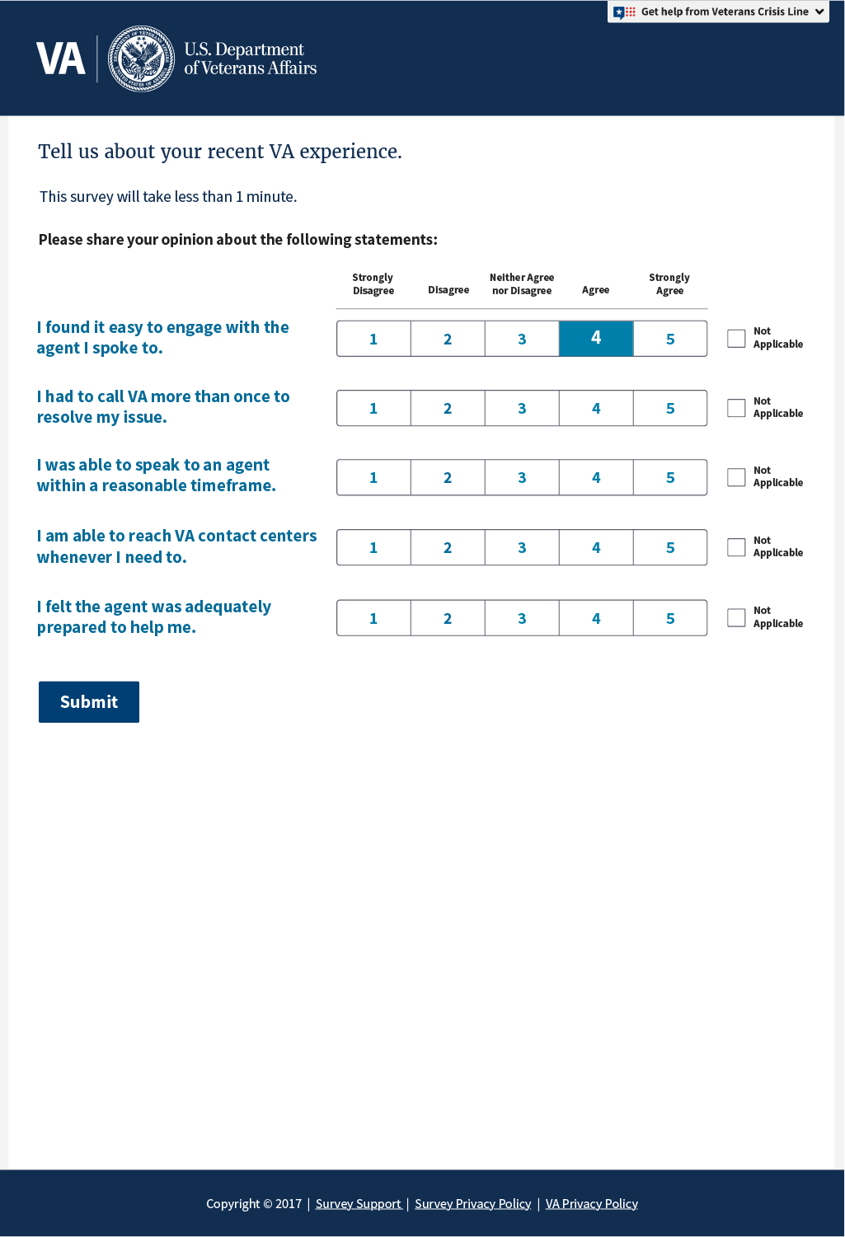

## **Survey – Mobile**

## C:\Users\nicole.yin\AppData\Local\Microsoft\Windows\Temporary Internet Files\Content.Outlook\XHDQEHRD\va_survey_Vet Email Mobile (002).png

## **Survey – Tablet**

**