Memorials Eligibility BCTA Snapshot

March 3, 2017

Contents

Business Architecture 1

VA Enterprise Architecture Business Reference Model (VA BRM) Extract 1

VA BRM Function Descriptions 2

NCA Business Function Model (BFM) Elaboration of Veteran Validation 5

Memorials Burial Eligibility Process 7

Veteran Validation Business Process Model (BPM) High-Level (C1) 7

BPM C1.1 Claim Submission 8

BPM C1.2 Claim Establishment 9

BPM C1.3 Veteran Validation 9

BPM C1.4 Eligibility Determination 10

High Level Solution Architecture 10

Memorials HL Solution 10

Memorials Eligibility HL Solution 12

# Business Architecture

## VA Enterprise Architecture Business Reference Model (VA BRM) Extract

This view shows the VA EA BRM extract for the three Memorials branches, 1.1.1.3, 1.1.2.3, and 1.1.3.6. The highlighted capabilities (1.1.1.3.2.1 Receive Benefits Request, 1.1.1.3.2.2 Validate Veterans Entitlement, and 1.1.1.3.2.3 Determine or Communicate Request Entitlement) are the subject of the Memorials Eligibility BCTA. These capabilities are realized by the NCA Business Processes (C1.1 Claim Submission, C1.2 Claim Establishment, C1.3 Veteran Validation, and C1.4 Eligibility Determination). These processes come from the reference document, NCA IBRD Business high level processes091214.pdf.

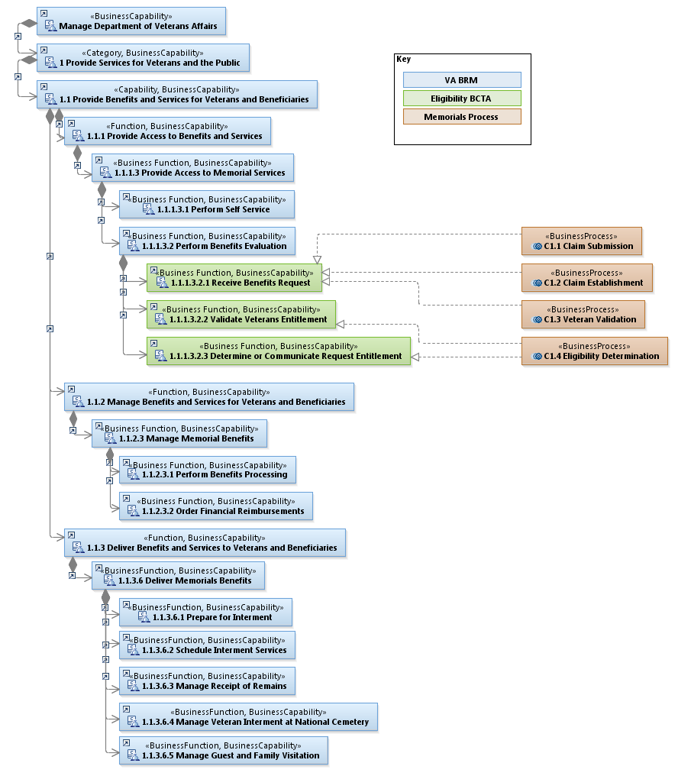

## VA BRM Function Descriptions

These are the VA BRM function descriptions from the EA BRM source, 20161216_VA-BRM-Report.xlsx.

|  |  |  |
| --- | --- | --- |
|  | **Function** | **Description** |
| 1 | Provide Services for Veterans and the Public | Provide Services for Veterans and the Public describes the mission and purpose of the Department of Veterans Affairs in terms of the services it provides both to and on behalf of the Veteran and the public. |
| 1.1 | Provide Benefits and Services for Veterans and Beneficiaries | Provide Benefits and Services for Veterans and Beneficiaries includes activities designed to ensure that Veterans and their eligible beneficiaries are provided with the benefits and services they are entitled to receive from the VA and its partners. |
| 1.1.1 | Provide Access to Benefits and Services | Provide Access to Benefits and Services focuses on access to appropriate benefits and/or services. This includes streamlining efforts for customer obtainment of benefits and services; ensuring benefits and services are appropriate in terms of type, intensity, location and availability; providing seamless access to knowledge about the benefits and services available, performing eligibility determination, assessing claims, determining award action, and managing customer information. |
| 1.1.1.3 | Provide Access to Memorial Services | Provide Access to Memorial Services focuses on the access to appropriate services. This includes streamlining efforts to receive services; ensuring services are appropriate in terms of type, intensity, location and availability; providing seamless access to knowledge about the services available, performing eligibility determination, and managing beneficiary information. |
| 1.1.1.3.1 | Perform Self Service | Perform Self Service includes all activities and processes that enable NCA to develop and present external facing services to its customers to access self service capabilities. This includes research, analysis, and engagement with key stakeholders to ensure that strategic plans meet VA goals. |
| 1.1.1.3.2 | Perform Benefits Evaluation | Perform Benefits Evaluation performs the systematic collection of information about the activities, characteristics, and outcomes of programs to make judgments about the program, improve program effectiveness, and/or inform decisions about future program development. |
| 1.1.1.3.2.1 | Receive Benefit Request | Receive Benefits Request allows for the Veteran/family to register the DD214 with the VA and receive a cursory eligibility evaluation although final determination is made at the time of need. Additionally this function establishes a case to initiate the benefit review process which may include families brining cremated remains directly to the cemetery; recording First Notice of Veteran Deaths based on Burial Flag, headstone or marker, burial applications, Prudential, VHA CBO, ANC; and providing insurance information from the VA Insurance Claims Office into VA IT systems (NCA_Business_Function_Definitions_20120725.xlsx). This function contains all activities following the death of a Veteran or Veteran's spouse to assign a case number and collect information necessary to verify an individual's burial eligibility (www.arlingtoncemetery.mil/funderalinformation/SchedulingServices.aspx). |
| 1.1.1.3.2.2 | Validate Veteran Entitlement | Validate Veterans Entitlement is a determination of eligibility that is made in response to a request for burial in a VA National Cemetery and includes a review for a capital felony or schedule 3 sexual offense (NCA_Business_Function_Definitions_20120725.xlsx). |
| 1.1.1.3.2.3 | Determine or Communicate Request Entitlement | Determine or Communicate Request Entitlement includes all activities necessary to communicate eligibility to the contact and process the benefit which includes updating VA systems with the Veteran DoD, DOB, gender, name and System ID. If the eligibility is questioned, a letter is sent to the family and outlines their rights to due process. |
| 1.1.2 | Manage Benefits and Services for Veterans and Beneficiaries | Manage Benefits and Services for Veterans and Beneficiaries involves developing strategies, management and administration of benefits and/or services for and on behalf of customers in compliance with laws, policies and regulations. This includes communications with customers for planning and maintaining benefits and services over time. |
| 1.1.2.3 | Manage Memorial Benefits | Manage Memorial Benefits includes furnishing lasting tributes that commemorates a Veteran’s service such as headstones and markers for the graves of eligible persons in national, state or tribal government Veterans cemeteries and private cemeteries and furnishing flags and Presidential Memorial Certificates to families of deceased Veterans. |
| 1.1.2.3.1 | Perform Benefits Processing | Perform Benefits Processing is the process of establishing, maintaining, and managing Memorial Benefits for the customers of NCA. |
| 1.1.2.3.2 | Order Financial Reimbursements | Order Financial Reimbursements contains activities to provide partial reimbursement of an eligible Veteran's burial and funeral costs (NCA_Business_Function_Definitions_20120725.xlsx). |
| 1.1.3 | Deliver Benefits and Services to Veterans and Beneficiaries | Deliver Benefits and Services to Veterans and Beneficiaries involves the delivery of benefits and/or services to the claimant or verified beneficiary. It includes education and outreach activities; health care benefit programs; assessing health status; planning health services; ensuring quality of services and continuity of care; and managing clinical information and documentation. It also includes delivery of memorial services to honor the memory of Veterans and Beneficiaries for their service to our Nation. |
| 1.1.3.6 | Deliver Memorial Benefits | Deliver Memorial Benefits involves all activities related to burial of eligible Veterans and family members in national cemeteries and aid to support the burial of Veterans and family members in state or tribal government Veterans cemeteries (NCA_Business_Function_Definitions_20120725.xlsx). |
| 1.1.3.6.1 | Prepare for Interment | Prepare for Interment includes all activities necessary to provide for the family's beliefs at time of burial, which typically includes providing a committal service shelter for the ceremony (http://www.cem.va.gov/cem/burial_benefits/committal_service.asp). |
| 1.1.3.6.2 | Schedule Interment Services | Schedule Interment Services involves the schedule of a burial in any VA National Cemetery for any Veteran, or eligible dependent, released from service under conditions other than dishonorable as determined by appropriate eligibility documentation. Also included is the custody of remains within the cemetery from drop off, normally at the committal shelter to final interment. Schedule Interment Services involves the schedule of a burial in any VA National Cemetery for any Veteran, or eligible dependent, released from service under conditions other than dishonorable as determined by appropriate eligibility documentation. Also included is the custody of remains within the cemetery from drop off, normally at the committal shelter to final interment. |
| 1.1.3.6.3 | Manage Receipt of Remains | Manage Receipt of Remains is part of the chain of custody for the remains and allows for cremated remains to temporarily be stored at a cemetery awaiting interment. |
| 1.1.3.6.4 | Manage Veteran Interment at National Cemetery | Manage Veteran Interment at National Cemetery includes all actions associated with the physical burial or cremation of a Veteran (http://www.cem.va.gov/CEM/pdf/IS1_Jan_2011.pdf). Gravesite information is recorded as burials are completed. The gravesite information allows the public to search for a Veteran through the National Gravesite Locator (http://gravelocator.cem.va.gov/). This function also includes the physical storage of Veterans' gravesite location information to include backup and disaster recovery of the information (NCA As-Is Business Architecture 8/17/10.ppt). |
| 1.1.3.6.5 | Manage Guest and Family Visitation | Manage Guest and Family Visitation is the process that organizes and manages visitation to our national cemeteries. |

## NCA Business Function Model (BFM) Elaboration of Veteran Validation

This view shows the elaboration of the C1. Veteran Validation Business Capability from the older NCA Business Function Model (BFM) that pre-dates the EA VA BRM. These detailed capabilities were elaborated to cover the scope of Memorials Eligibility for the BCTA and are a starting point to detail the Software Capabilities for the solution. This elaboration needs to be refactored to align to the VA BRM top-level structure but the low-level capabilities can be reviewed. The Business Processes are also decomposed to show the more detailed realizations.

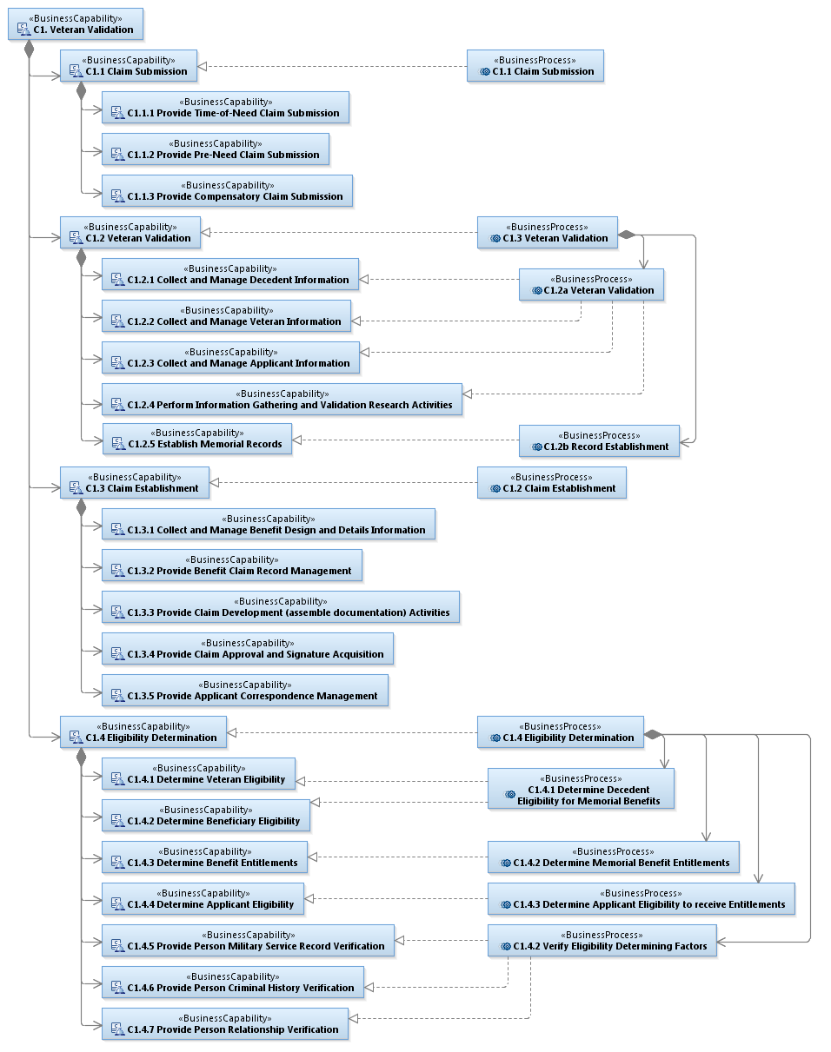

## Memorials Burial Eligibility Process

This is an illustration of the eligibility rules described at [**http://www.cem.va.gov/cem/burial_benefits/eligible.asp**](http://www.cem.va.gov/cem/burial_benefits/eligible.asp).

This illustrates the decisions and information inputs that lead to a determination of Eligible or Not Eligible. With the distinction between Eligibility and Entitlement coming from Veteran Experience it’s important to note that Memorials has not previously made this distinction in their rules and process. This flow exceeds the bounds of what VE is calling Eligibility.

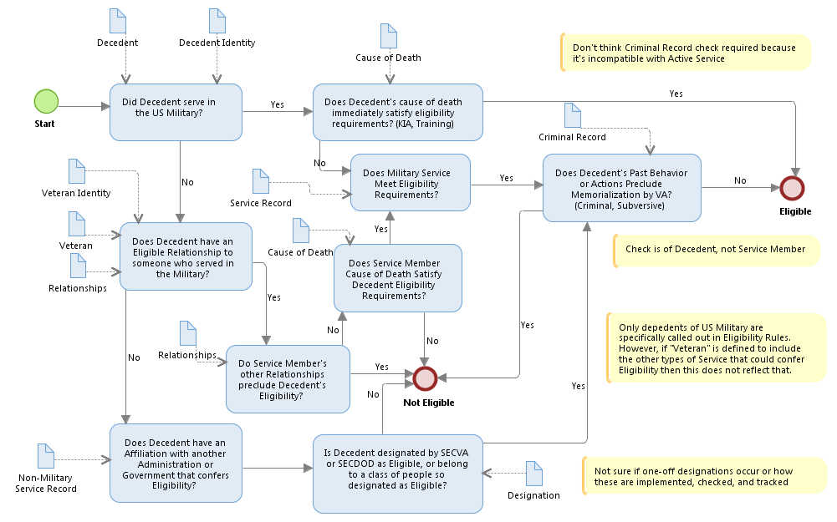

## Veteran Validation Business Process Model (BPM) High-Level (C1)

This view of the BPM shows the high-level Business Processes with their Input and Output information concepts. This illustrates the relationship between the processes and implies the ‘flow’ through them. The names of the high-level concepts are drawn from the source, IBRD processes explanations v2.pptx that accompanied the PDF dated Sep 12 2014.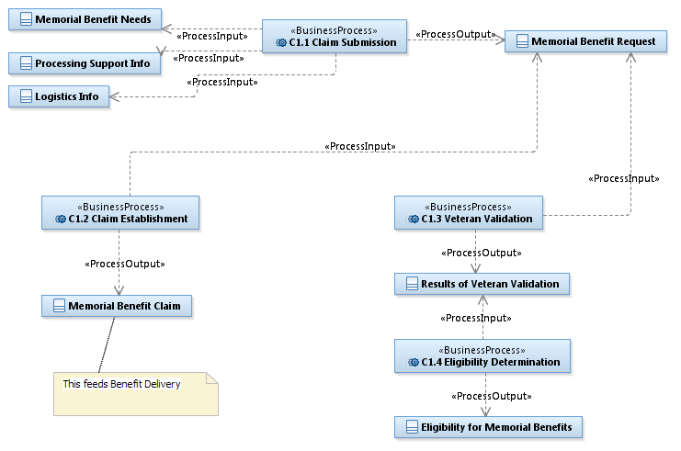

## BPM C1.1 Claim Submission

This view details the C1.1 Claim Submission process, the decomposition of the process, and the elaboration of the Input and Output. The Claim Submission process is the activity of the Applicant to assemble supporting information and contact the VA to request a benefit. The result of the process is a Memorial Benefit Request that typically includes an official VA Form (40-1330 for Headstone/Marker, 21P-530 for Burial Allowance, 27-2008 for Flag, 40-0247 for PMC, ), evidentiary documentation. This covers both pre-need and time-of-need claims. This process is primarily manual today.

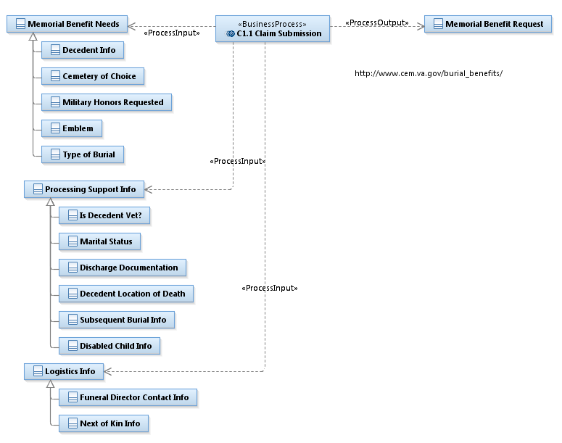

## BPM C1.2 Claim Establishment

This view details the C1.2 Claim Establishment process, the decomposition of the process, and the elaboration of the Input and Output.



## BPM C1.3 Veteran Validation

This view details the C1.3 Veteran Validation process, the decomposition of the process, and the elaboration of the Input and Output.

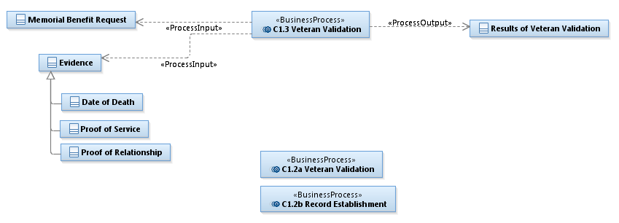

## BPM C1.4 Eligibility Determination

This view details the C1.4 Eligibility Determination process, the decomposition of the process, and the elaboration of the Input and Output.

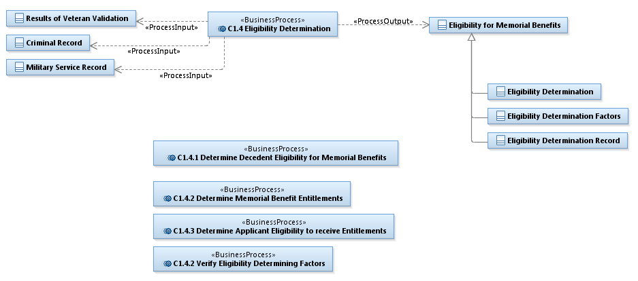

# High Level Solution Architecture

## Memorials HL Solution

This view illustrates Memorials integration with Enterprise information services and user channels. Both provided by Veterans’ Experience Office through the Vets.gov and Vets360 programs. In this view, “Memorials” encapsulates everything specific to Memorials Benefits Management. The scope of Eligibility covers a lot of the interaction but the scope of this exceeds the BCTA.



This is a view of Memorials Eligibility that details the allocation of business capability to the participants in the solution. Veteran Experience user channels will realize the capability to Perform Self Service. The solution will heavily leverage enterprise person information services for Identity, Relationship, Military Info, Contact Info, and Basic Eligibility. Memorials Eligibility should coordinate use of these services in all phases. Relationships, Personal Financial Info and Judicial/Criminal Record Info are in-scope for Vets360 but not yet designed or prioritized. Memorials should document and communicate their needs for these services, but plan alternate interim solutions.

## Memorials Eligibility HL Solution

