Dear [Regina Yount],

I wanted to let you know that on Tuesday, March 20th 2018, Vets.gov team will launch an updated version of our Appeals Status tool. The updated version allows users to see their sequence of events in a timeline and set expectations for what happens next.

The improvements and changes include:

* Current status and description
* Alerts with due dates
* Wait time and progress bar
* Current and past issues on appeal

Here are some examples of the view:

Current status including where your appeal is and who is reviewing it

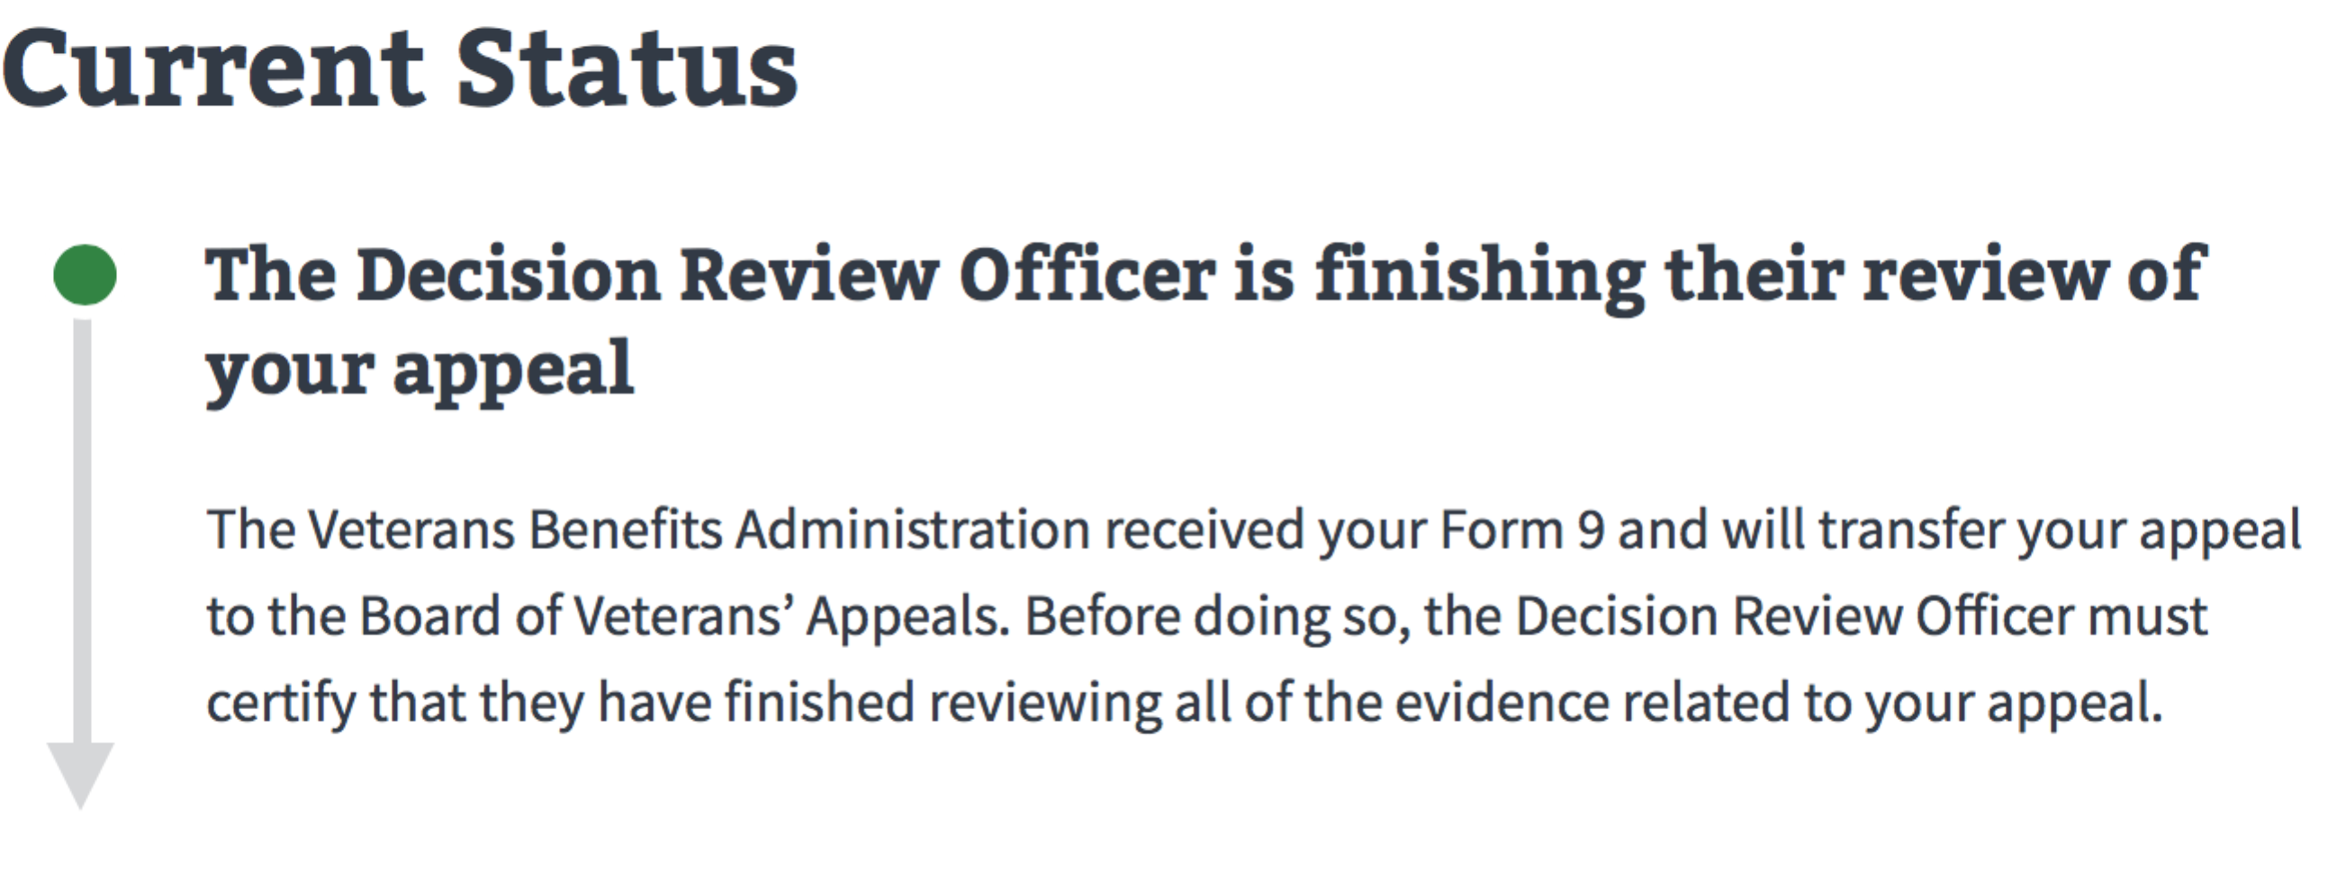

Issues that are currently on the appeal

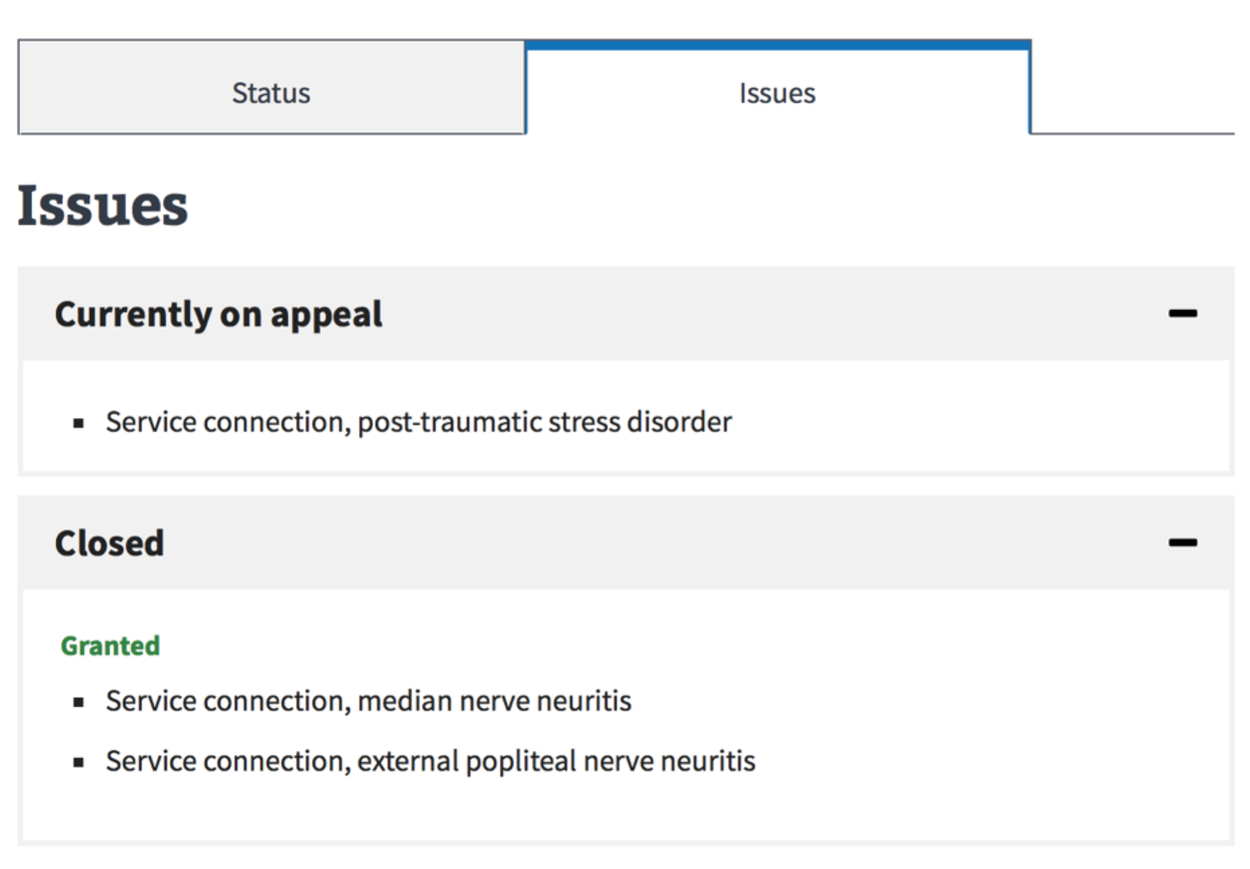

Wait time and progress bar

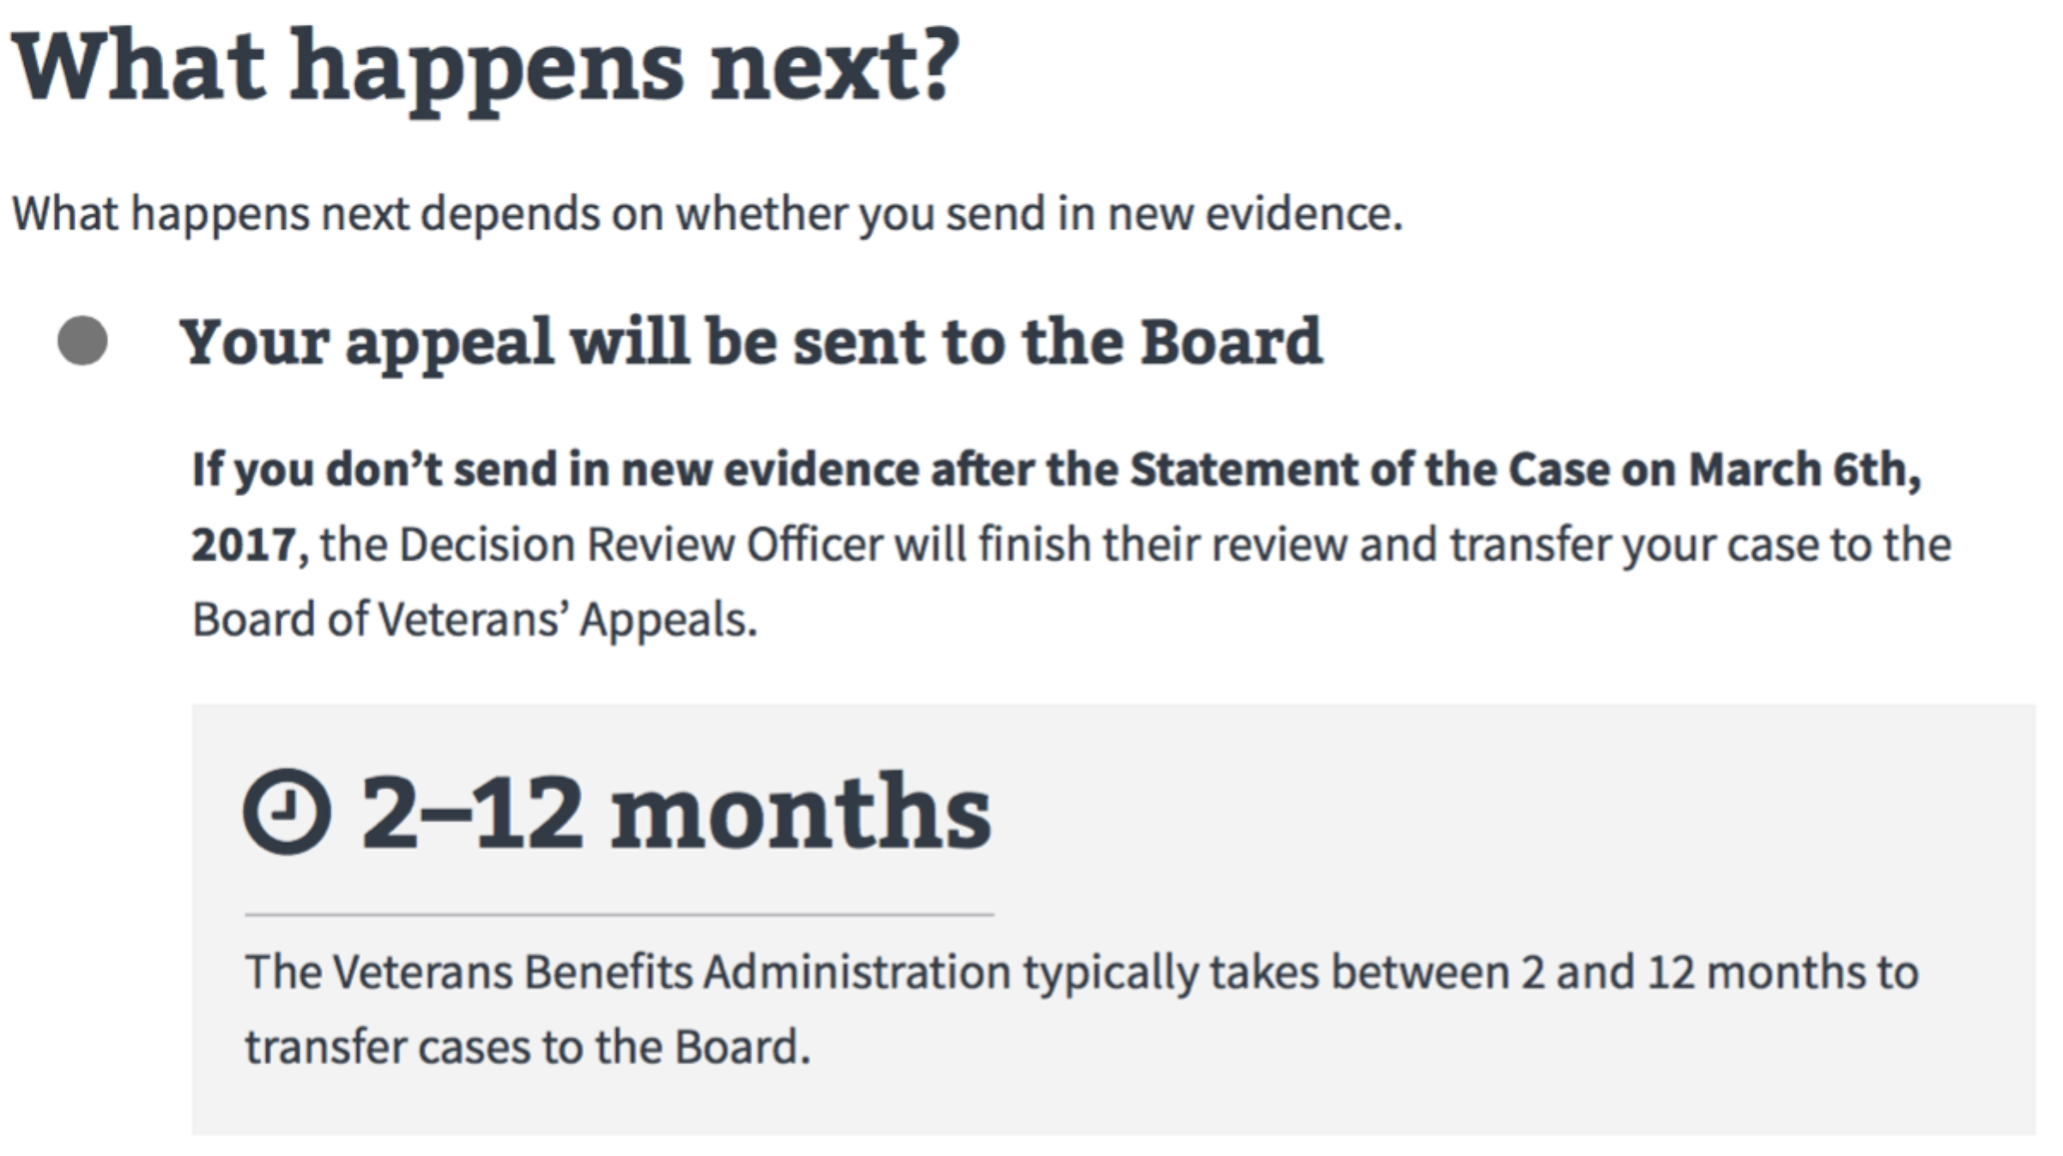

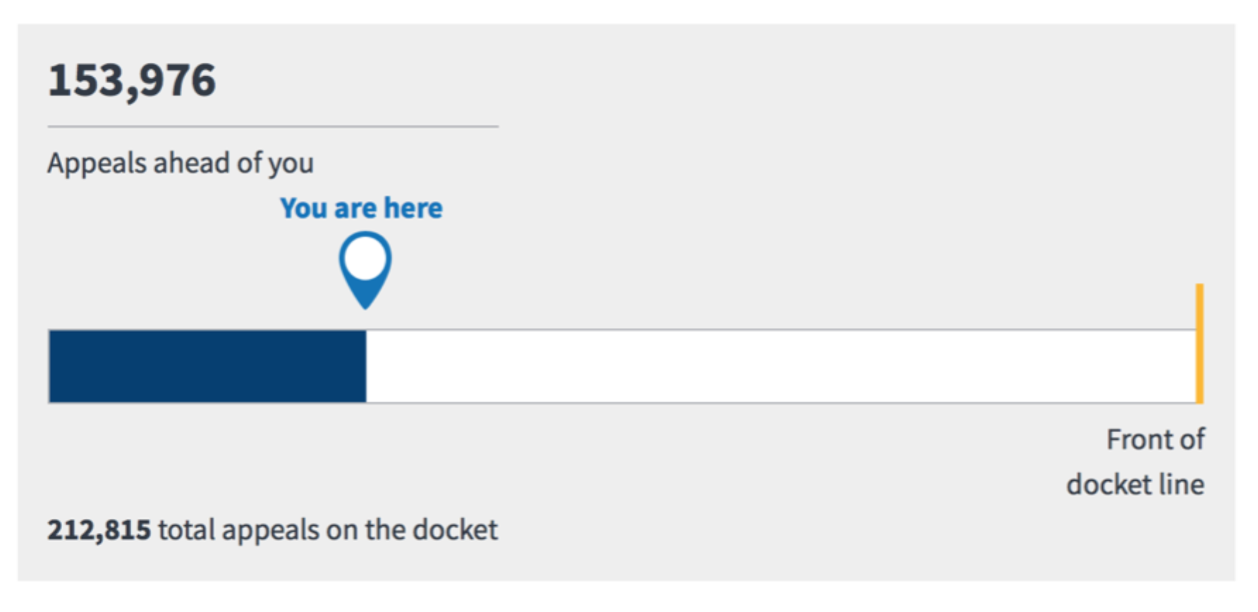

Here is a video that demonstrates the new features:

<http://www.youtube.com/watch?v=0y-D_Uw7ZeA>

As mentioned, our focus has been improving data, providing transparency, designing an easy to use user interface and decreasing call center volume. Longer term, we would like Vets.gov to connect the Claims and Appeals endpoints so that Veterans can see their whole story from the original claim. We would also like Appeals status to support the implementations of the Appeals Modernization Acts, allowing Veterans to make informed choices.

Big thanks to the hardworking engineers, designers, data and product folks from both Vets.gov and the Caseflow team for putting our Veterans first and building a product based on understanding their needs. Special thanks to VBA and the Board for providing feedback and supporting our efforts.

Thank you both for your support of the team – and have a great weekend,   
  
U.S. Digital Service

