Vets.gov Technical Integration with eBenefits to Support Claims/Benefits Features

**Description of Claims Feature**

Vets.gov will provide Veterans with the ability to submit and track claims for benefits. Currently, this feature is available in eBenefits.

**Overview of Current eBenefits Architecture**

Diagram of eBenefits architecture

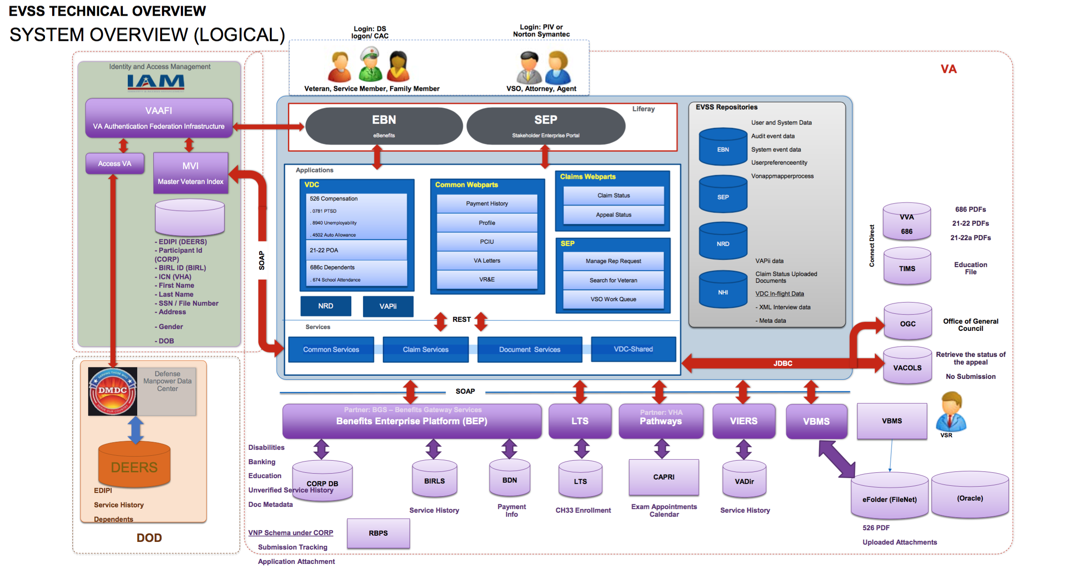

Application Tier

(labeled ‘Applications’ on the above diagram)

eBenefits provides user-facing services in the form of a set of applications. These applications are typically Java/J2EE applications, with some front end/single-page app features or components. These applications are typically server-based, since they communicate with backend eBenefits resources.

The application tier communicates almost exclusively with the REST Services tier.

REST Services

(labeled ‘Services’ on the diagram above)

All business logic for processing claims, submitting documents, and getting claims status are provided by a set of REST Services. eBenefits applications from the Application tier utilize the REST Services layer to orchestrate all communication with VA backend/enterprise services.

The REST Services tier provides four major groups of functionality:

* Claims
* Documents
* VDC-Shared
  + VDC stands for VONAPP Direct Connection. From VA: “Veterans Online Application (VONAPP) Direct Connect (VDC) allows claimants to file disability compensation and dependency applications directly to their station of origination (SOO) via eBenefits.” See [this Word doc](http://www.benefits.va.gov/WARMS/docs/admin21/m21_1/mr/part3/subpti/M21-1III_i_4_SecA.docx). Note that Googling this brings up some interesting documents on va.gov that might be useful.
  + VDC encompasses a bit more than just the 526-EZ, so we need to speak carefully as to not confuse stakeholders.
* Common/shared services

The REST Services tier is available on the VA network.

Information on the methods available from the Claims and Documents REST Services was provided by the REST Services development team in the form of WADL files. There are some requests that do not specify parameters, instead the parameters are specified as headers, the information for which comes from eBenefits integration with AccessVA/VAAFI. More details on the specs for these headers has been requested.

Open questions

How is it secured?

Some element of security is done through information provided by the AccessVA/VAAFI session, but this would not account for all the security needs for this kind of service.

Can we get documentation on the various services that are available?

WADL files have been provided by the eBenefits development team. They are checked into GitHub. We require additional details on how to specify information as parameters in headers.

What is the process for getting access to lower environments for development and testing?

We have reached out to Angela Gant-Curtis to provide more details.

VA Backend Services

(everything under the ‘SOAP’ divider in the diagram above)

The REST Services tier integrates with several VA backend/enterprise services and systems, including:

* BEP
* LTS
* VBMS
* VIERS

By extension, through those various services it interacts with directly, eBenefits also communicates with other VA enterprise services including BIRLS, BDN, CAPRI, eFolder, and more.

Communication protocols to backend services varies, but is typically something like SOAP. All services are only available on the VA network.

Data storage

(labeled above as ‘EVSS Repositories’ in the diagram above)

eBenefits does not store information about a Veteran. Instead, eBenefits uses a database called NHI to store all relevant information about a claim. This may have originally been done to obviate the need to classify a system as FISMA High, but currently, VA policy is that FISMA High is only applied to applications that utilize data for direct patient care, which would not include eBenefits.

What is the lifecycle of information in NHI?

eBenefits’ Applications communicate with NHI directly using JDBC. [need to confirm]

Identity and Access Management

Access to eBenefits is federated to DS Logon, brokered through VA’s AccessVA/VAAFI service. DS Logon provides attributes that verify the user is a Veteran; SEP users are required to authenticate with Norton Symantec, or some other LOA 2 FICAM provider, with attributes that establish legal identity.

AccessVA, in brokering the authentication to eBenefits, calls into VA’s MVI to obtain correlated identifiers for the current user in other VA systems, and other basic user profile information.

The following diagram illustrates how eBenefits, AccessVA/VAAFI, and MVI are integrated.

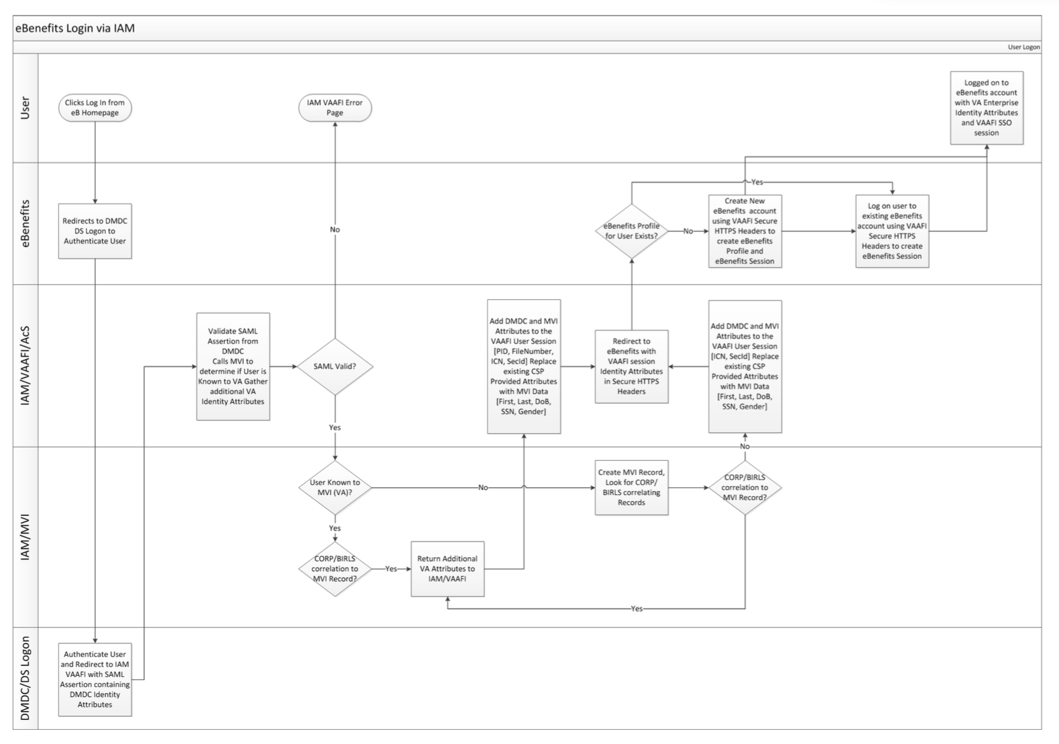

**Proposed vets.gov Integration with eBenefits**

In order to simplify the integration between vets.gov and eBenefits, vets.gov will integrate with eBenefits REST Services tier. Vets.gov will therefore look very much like an eBenefits application.

Vets.gov will create a benefits/claims API that will communicate with the REST Services tier using a server-to-server connection. This will allow the vets.gov benefits/claims API to account for any downtime or service degradation in eBenefits’ REST Services.

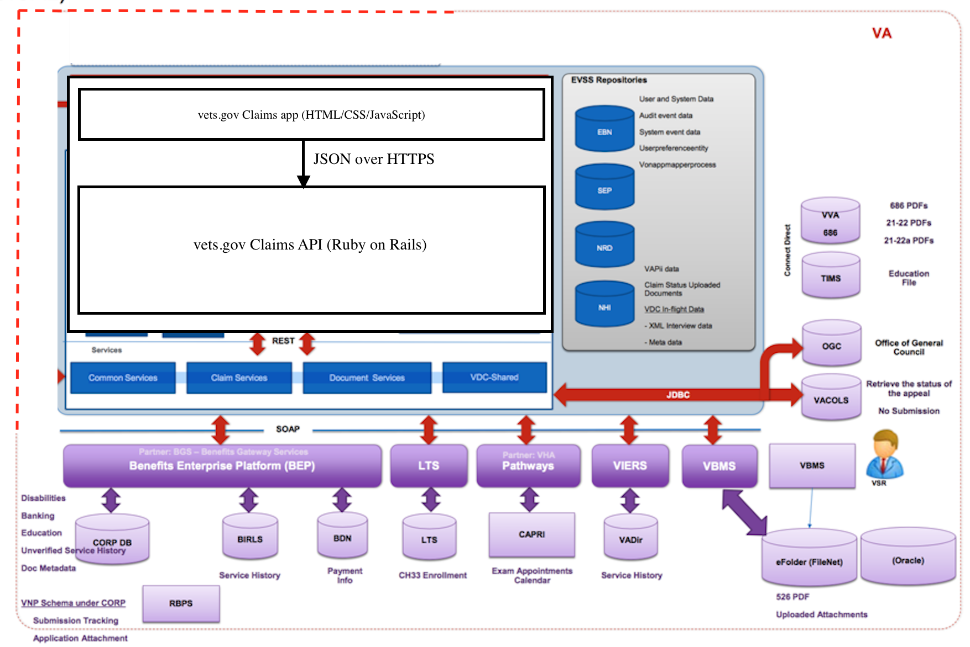

Notes on the above: regarding the EVSS repositories, the NRD database is scheduled to be shutdown in August 2017. The EBN and NHI ones should go away with vets.gov migration. The SEP database is for use by the SEP application. All of these databases will be replaced with internal databases/datastores in the vets.gov Claims API tier.

VACOLS will be replaced with VA Digital Services Appeals service in the near future.

Open questions

**Identity and Access Management**

Login to Vets.gov with ID.me

Vets.gov users will authenticate with ID.me. Users will be able to login both with their ID.me account, as well as with their DS Logon account.

What Level of Assurance is required? Since DS Logon is LOA 2, all interactions with vets.gov should be at least LOA 2.

Vets.gov integation with MVI

The vets.gov Platform will integate with the Master Veterans Index to provide identity correlation to the user session for the Claims application.

**Veteran Service Record**

Part of the information that is collected during the current eBenefits claims process is a Veteran’s service record. This information is entered by the Veteran, and then verified against several VA enterprise systems.

A potential user experience enhancement is to prepopulate the Veteran’s service record from a known datasource.

Potential data sources for prepopulating the Veteran’s service record are:

* eMIS
* VADIR
* DEERS

This may not be in scope for the first release of the Claims application. More discovery is required before deciding the technical feasibility of this approach.