Vets.gov Technical Integration with eBenefits to Support Claims/Benefits Features

**Description of Claims Feature**

Vets.gov will provide Veterans with the ability to submit and track claims for benefits. Currently, this feature is available in eBenefits.

**Overview of Current eBenefits Architecture**

Diagram of eBenefits architecture

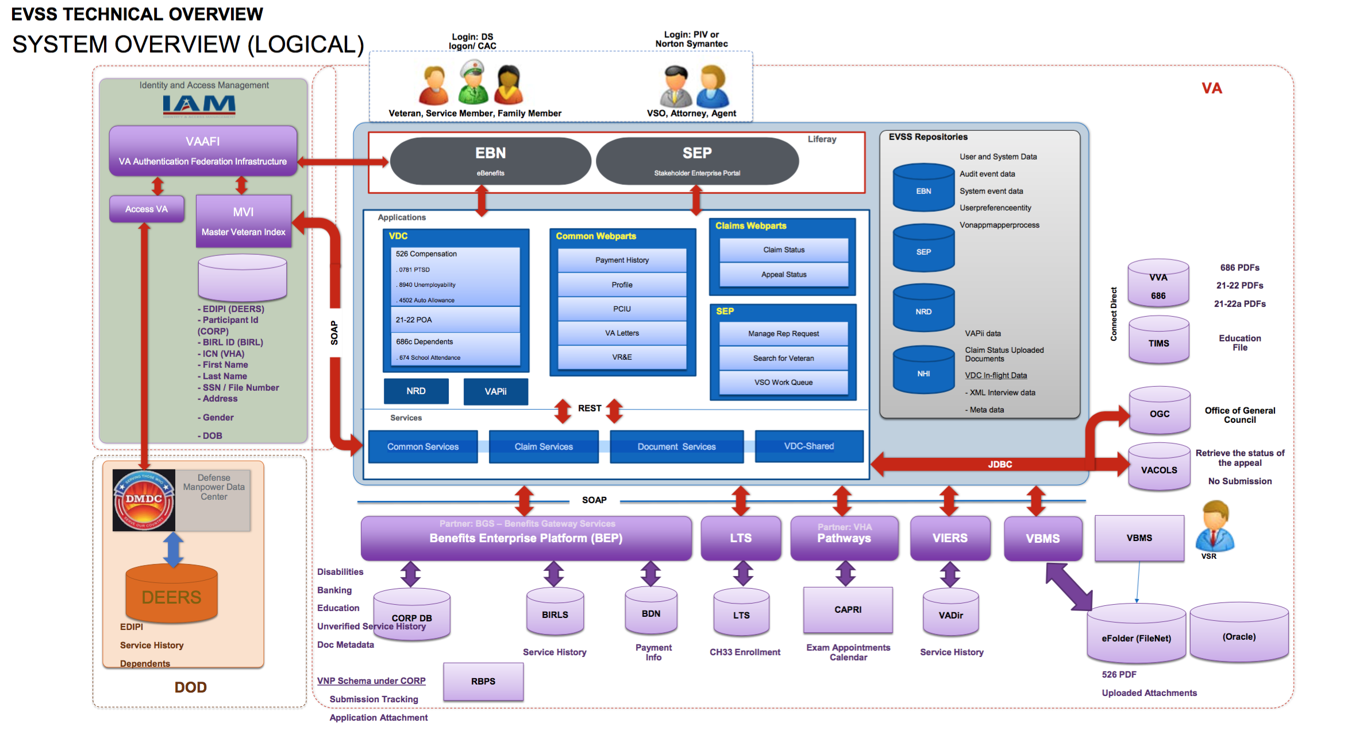

Application Tier

(labeled ‘Applications’ on the above diagram)

eBenefits provides user-facing services in the form of a set of applications. These applications are typically Java/J2EE applications, with some front end/single-page app features or components. These applications are typically server-based, since they communicate with backend eBenefits resources.

The application tier communicates almost exclusively with the REST Services tier.

REST Services

(labeled ‘Services’ on the diagram above)

All business logic for processing claims, submitting documents, and getting claims status are provided by a set of REST Services. eBenefits applications from the Application tier utilize the REST Services layer to orchestrate all communication with VA backend/enterprise services.

The REST Services tier provides four major groups of functionality:

* Claims
* Documents
* VDC-Shared [What is this?]
* Common/shared services

The REST Services tier is available on the VA network.

How is it secured?

Can we get documentation on the various services that are available?

What is the process for getting access to lower environments for development and testing?

VA Backend Services

(everything under the ‘SOAP’ divider in the diagram above)

The REST Services tier integrates with several VA backend/enterprise services and systems, including:

* BEP
* LTS
* VBMS
* VIERS

By extension, through those various services it interacts with directly, eBenefits also communicates with other VA enterprise services including BIRLS, BDN, CAPRI, eFolder, and more.

Communication protocols to backend services varies, but is typically something like SOAP. All services are only available on the VA network.

Data storage

(labeled above as ‘EVSS Repositories’ in the diagram above)

To avoid a FISMA High rating, eBenefits does not store information about a Veteran. Instead, eBenefits uses a database called NHI to store all relevant information about a claim.

What is the lifecycle of information in NHI?

eBenefits’ Applications communicate with NHI directly using JDBC. [need to confirm]

Identity and Access Management

Access to eBenefits is federated to DS Logon, brokered through VA’s AccessVA/VAAFI service. DS Logon provides attributes that verify the user is a Veteran; SEP users are required to authenticate with Norton Symantec, or some other LOA 2 FICAM provider, with attributes that establish legal identity.

AccessVA, in brokering the authentication to eBenefits, calls into VA’s MVI to obtain correlated identifiers for the current user in other VA systems, and other basic user profile information.

The following diagram illustrates how eBenefits, AccessVA/VAAFI, and MVI are integrated.

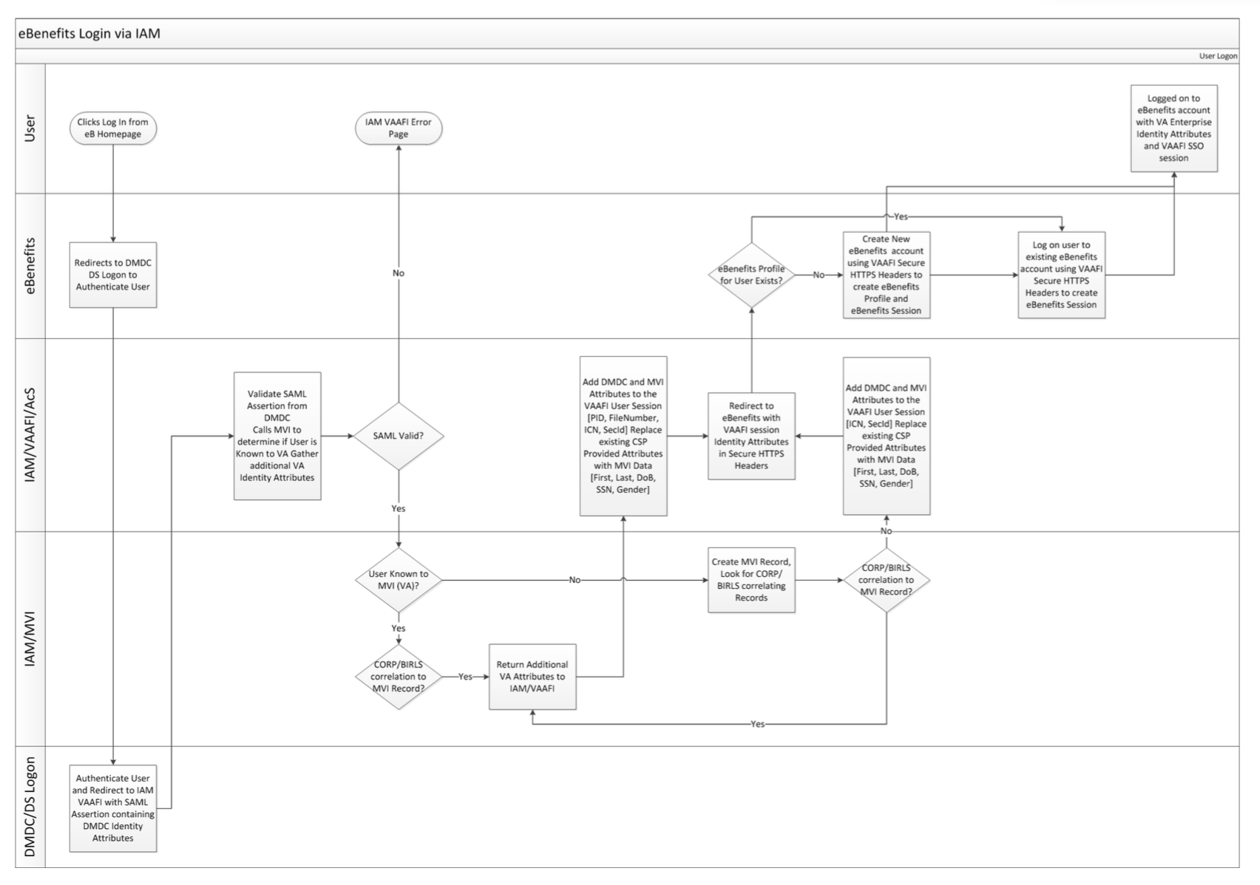

**Proposed vets.gov Integration with eBenefits**

In order to simplify the integration between vets.gov and eBenefits, vets.gov will integrate with eBenefits REST Services tier. Vets.gov will therefore look very much like an eBenefits application.

Vets.gov will create a benefits/claims API that will communicate with the eBenefits REST Services tier using a server-to-server connection. This will allow the vets.gov benefits/claims API to account for any downtime or service degradation in eBenefits’ REST Services.

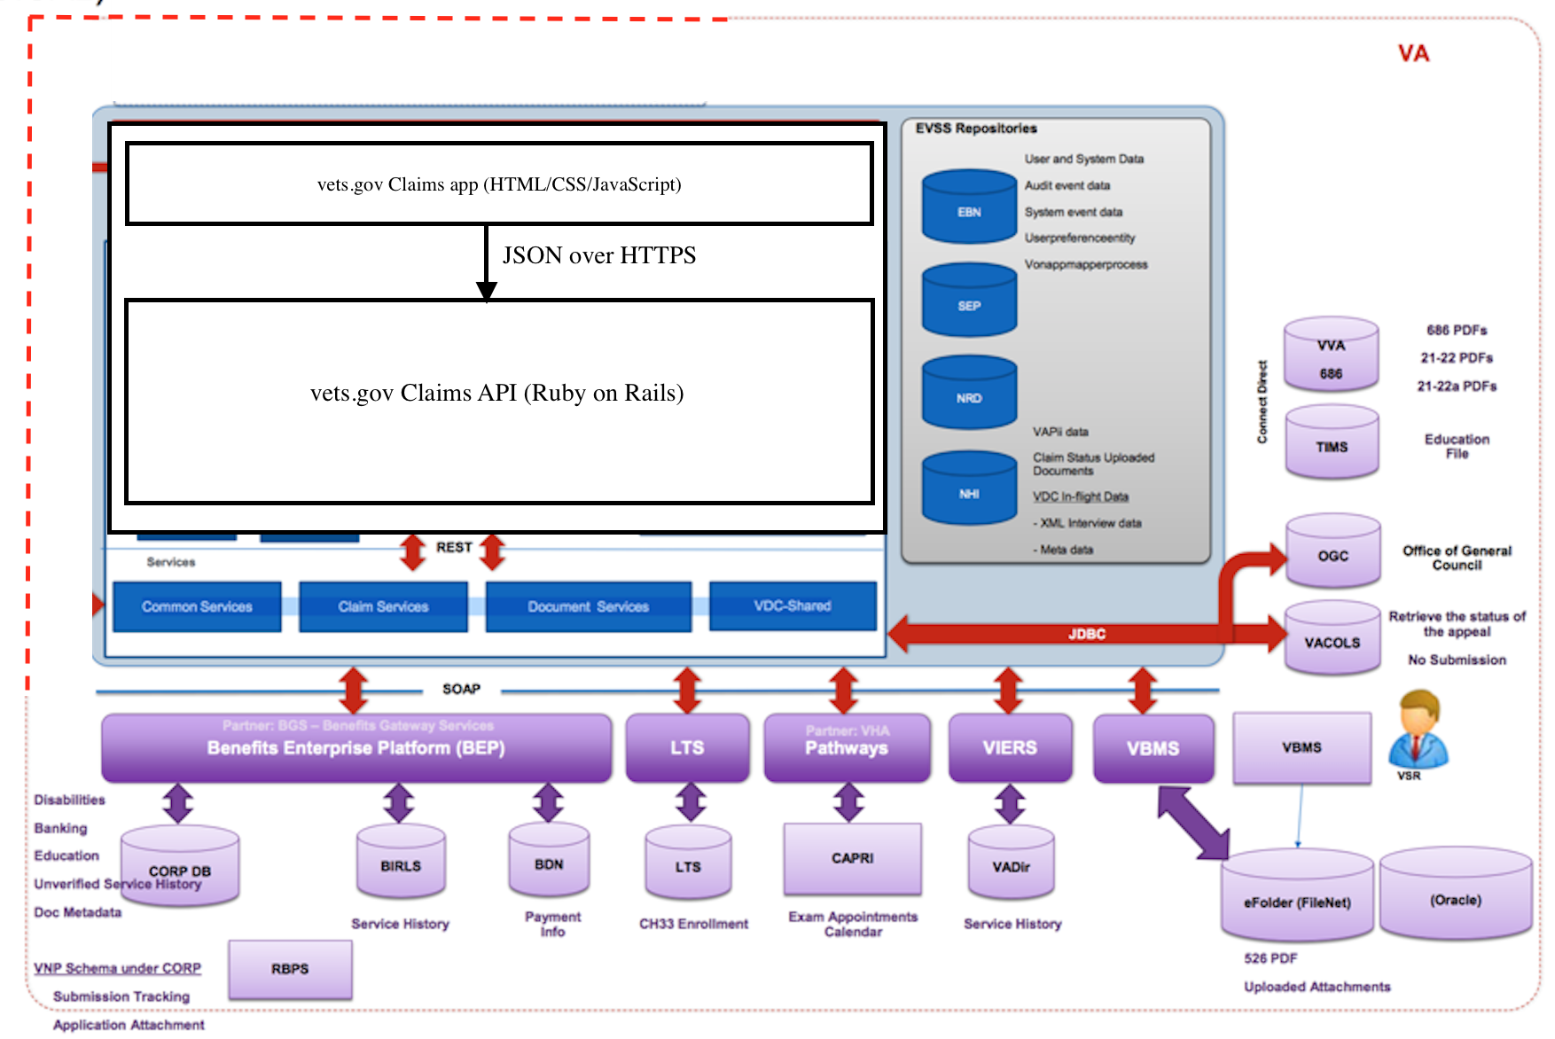

Open questions

**Identity and Access Management**

Login to Vets.gov with ID.me

Vets.gov users will authenticate with ID.me. Users will be able to login both with their ID.me account, as well as with their DS Logon account.

What Level of Assurance is required?

Vets.gov integation with MVI

The vets.gov Platform will integate with the Master Veterans Index to provide identity correlation to the user session for the Claims application.

**Veteran Service Record**

Part of the information that is collected during the current eBenefits claims process is a Veteran’s service record. This information is entered by the Veteran, and then verified against several VA enterprise systems.

A potential user experience enhancement is to prepopulate the Veteran’s service record from a known datasource.

Potential data sources for prepopulating the Veteran’s service record are:

* eMIS
* VADIR
* DEERS

This may not be in scope for the first release of the Claims application. More discovery is required before deciding the technical feasibility of this approach.