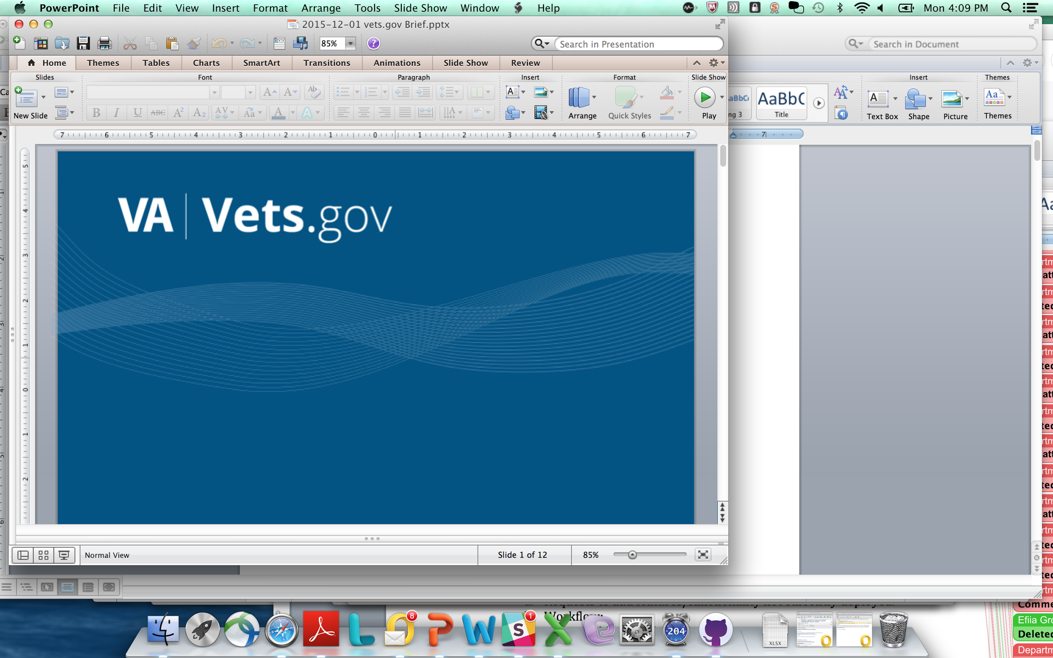

Vets.gov Product Charter

Benefits – Download VA Letters

*Draft v1.0*

*6/06/2017*

**Table of Contents**

Authorization 3

1 Document Purpose 4

2 Vision and Approach 4

3 Product Team Roles and Responsibilities 4

4 Minimum Viable Product (MVP) Scope of Work 5

5 Ongoing Maintenance 6

6 Assumptions and Constraints 6

7 Vets.gov Product Methodology 6

# Authorization

VBA Product Business Owner:

Mike Carr and/or Jennifer Rudisill

*Signature Date*

Clare Martorana, Vets.gov Product Manager

*Signature Date*

# Document Purpose

The purpose of this document is to define role, scope of work, and milestones for the Vets.gov Benefits – EDU product team to improve and migrate the existing “Download VA Letters” which are data-generated letters.

The product MVP will be a phased launch. Phase 1 will focus on creating the page infrastructure and migrating 7 of the VA Letters currently available in eBenefits. Phase 2 will focus on adding the Veteran Benefits Summary and Dependent Benefits Summary Letters (both currently available on eBenefits) and creating a new generated letter, the Education Certificate of Eligibility Letter (note this has a dependency on EVSS technical tasks). In total, depending upon the user’s eligibility, there will be 10 Letters available to download from this product.

The period of performance for this work is approximately **June 2017 through July 2017.**  Future enhancements will continue throughout 2017 and beyond with new charters to define future work per our

# Vision and Approach

Vets.gov enables Veterans to discover, apply for, track, and manage the benefits they have earned. Migration activities are done in collaboration with VA business stakeholders identified in this charter per our product life cycle defined in our VA Digital Service playbook ([https://www.Vets.gov/playbook/](https://www.vets.gov/playbook/)).

# Product Team Roles and Responsibilities

| **Role** | **Names** | **Responsibilities** |
| --- | --- | --- |
| Vets.gov Team Members | Product Lead, Rachael Roueche  Designers, Research, Engineers & Content Team Members | * Manage product activities and schedule * Design, develop, and deploy product * Manage internal communications in collaboration with VA Business Owner * Write content in plain language * Integrate / deploy Vets.gov account logon |
| VA Business Stakeholders | Mike Carr  Jennifer Rudisill  Frank Bryceland  Mike Davis (VHA POC for 2 letters) | * Sign / approve charter (Rob) * Accept the product (Rodney, Shay) * Provide the team with access to backend systems and test accounts (Shay) * Coordinate any related VA / OIT contract work (Stephanie, Shay) * Coordinate redirects (Shay) * Direct OIT and other technical, VA contractors, and / or business resources and ensure timely task completion (Stephanie, Shay) * Serve as an escalation point (Rodney) * Provide Veteran testers to participate in testing with Vets.gov team prior to launch * Provide context and subject matter expertise on requirements |
| OI&T and EVSS | EVSS Team (CSRA)  Melissa Rebstock (VE / VRM)  Angela Gant Curtis (EVSS COR/PM)  Courtney Swenson (EVSS PM) | * Provide technical support for discovery and migration including insight on systems, architecture, APIs, and data * Coordinate all API and / or other backend IT system changes that impact this scope of work with the Vets.gov team and VA Business Owner *prior* to making any changes that will impact Vets.gov * Provide access to systems, APIs, and code repositories as needed and in a timely way * Provide testing support * Provide test accounts and system access as needed |
| Content Subject Matter Experts (SMEs) | Jennifer Rudisill | * Provide VBA content expertise * Work collaboratively with Web Communication Leads on the content concurrence process to provide fact checking and ensure accuracy of content * Continue to update / maintain content on VA.gov |
| Vet.gov Call Center Support | Brenda Torres-Hill  Sylvia Palmer  Kathleen Reavy, Regina Yount, Pamela Liverman (NCC) | * Provide Vets.gov Call Center (Tier 1) support * Support ongoing maintenance and breakfix * Participate in pre-launch and launch activities * Coordinate all call center coordination tasks including script updates, call center team training, etc. * Work directly with Vets.gov team (Bob Fairhead) and ID.me to coordinate Tiers 1, 2, and 3 support |
| Web Comms Leads | Jennifer Rudisill, VBA  Tammy Hurley, VA  Maegan Hester Edmondson | * Lead content concurrence for VBA and VBA * Assist with pre-launch activities, including redirects * Support VA Business Owner with messaging and internal change management * Participate in product team and communications activities * Coordinate communications with Office of the Secretary |
| Office of Secretary | Martin Taylor | * Oversee all Vets.gov branding * Approve *any and all* external communications / media activities regarding Vets.gov including, but not limited to: media, White House, OIG, GAO, Congress, Veteran Service Organizations (VSOs), other government agencies * Coordinates VA-wide messaging and communications with VA senior leadership |

# Minimum Viable Product (MVP) Scope of Work

The Download VA Letters tool is used by Veterans to download documents validating their Veteran status and eligibility for various benefits.

The scope of work required for MVP includes existing functionality on eBenefits, plus a printable certificate of eligibility (COE) feature.

1. Discovery
   1. Understand current as-is business process and technical environment
      1. Refine and validate documentation developed during technical discovery

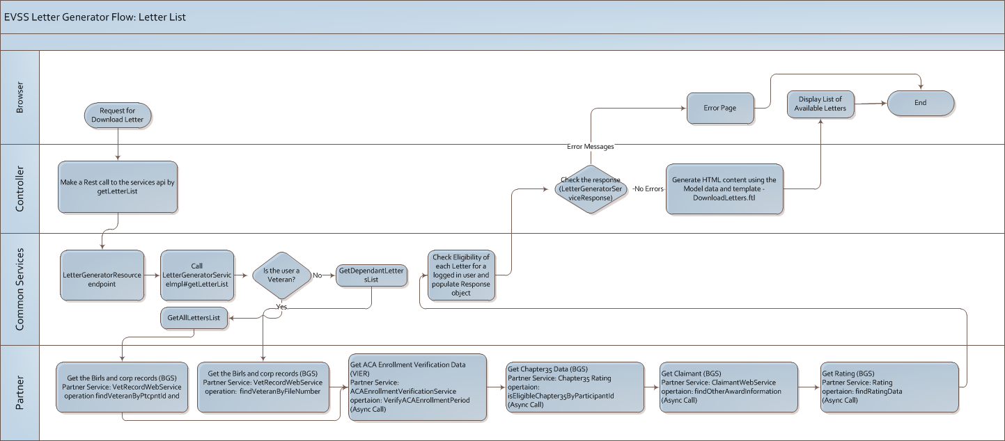

* 1. Understand business requirements

**Outputs:**

* Signed Charter
* As-is Diagram

1. Design & Develop
   1. Based on existing features and functionality

Outputs:

* Final stakeholder acceptance demo
* Approved product in staging (behind a password, not available to public)

1. Launch Activities
   1. Complete all testing, including end-to-end testing
   2. Develop communications and redirect strategy as needed
   3. Call Center readiness
   4. Go-live on site

Outputs:

* All Testing Completed
* Communications (e.g., blog)
* Call Center scripts updated
* Redirect strategy
* Pre launch checklist completed

|  |  |  |  |  |  |
| --- | --- | --- | --- | --- | --- |
| Tasks | 6/16 | 6/23 | 6/30 | 7/7 | 7/14 |
| Discovery completed (signed charter and documented as-is process) |  |  |  |  |  |
| Design |  |  |  |  |  |
| EVSS dependency work completed |  |  |  |  |  |
| User Testing |  |  |  |  |  |
| Development (incl. new Education COE letter ) |  |  |  |  |  |
| Testing (end to end) |  |  |  |  |  |
| Stakeholder demo / final acceptance |  |  |  |  |  |
| Soft launch (behind password / not available to public) |  |  |  |  |  |
| Launch (available on Vets.gov) |  |  |  |  |  |
| Post-Launch Monitoring / Support |  |  |  |  |  |

# Ongoing Maintenance

The Vets.gov team will provide ongoing maintenance and support for adding/updating content and providing break/fix for any technical issues on the Vets.gov platform.

***We anticipate that improving the frontend design and access to VA features may exacerbate current challenges and technical issues with ageing VA legacy systems on the backend. Please plan accordingly to support increased traffic to your systems, increased online applications received, call center traffic, etc. Please keep in mind if you have any manual workarounds happening on your back end systems, increased online traffic will impact the level of effort required to continue those workarounds.***  
  
Vets.gov is supported by the Health Resource Center (HRC) customer support center, which provides phone, email, and eventually chat support. HRC provides all Tier 1 support for Vets.gov features and functionality. Please report any breakfix items / bugs to the Vets.gov call center 1-855-574-7286

TTY: 1-800-829-4833, Monday – Friday, 8:00 am – 8:00 pm (ET)  
  
HRC will coordinate all call center processes with the Education Call Center (ECC). The ECC POC is responsible for all training, script updates and ECC communications.

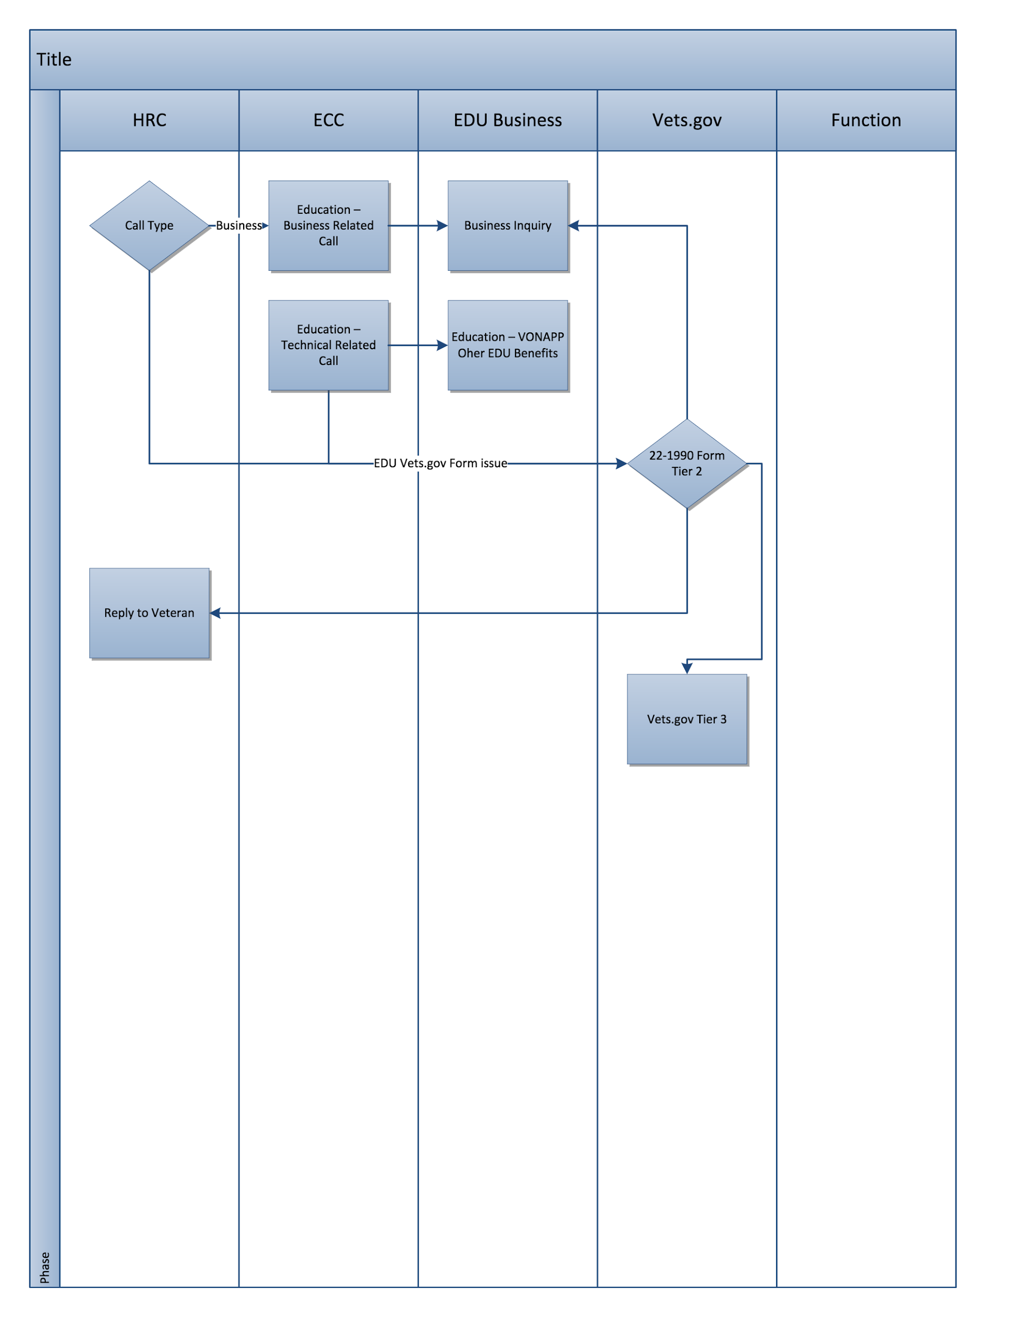

# Assumptions and Constraints

1. Users will be required to set up a Vets.gov login for the initial launch MVP. Users will not be able to logon using current eBenefits (DS Logon) account; they will need to create a new Vets.gov account.
2. The Benefit Verification letter and Service Verification Letter may be replaced by the Benefit Summary Letters since various Summary sections are duplicates of those 2 letters..
3. Proof of Service is really a Veteran ID card. Veteran Identification Card of 2015
4. Two (2) letters are generated by Veterans Health Administration (VISTA): Mike Davis is the POC

* "MEDICAREPARTD"
* "MINIMUMESSENTIALCOVERAGE"

1. Stakeholders have confirmed no issue with changing name of this feature if better, more intuitive name for Veterans.
2. One additional letter will be added to existing letters for the education certificate of eligibility (COE). This work will be coordinated with Shay Norton and Rodney Alexander and has technical dependency on EVSS team.
3. VBA team will identify 4-5 Veteran testers who will use the tool to download letters available to them and work with the Vets.gov team prior to launch.
4. EVSS team is responsible for the timely resolution of all issues with EVSS backend systems.
5. To ensure best production results, the Vets.gov team will require test accounts and read-only access to all production systems related to this work.
6. Product team members and business owner will be required to identify all back-end system endpoints during discovery.
7. API endpoints and request and response format (including data types and error codes) will not be changed without prior planning with the Vets.gov team and approval from the VA Business Owner and notifying the Vets.gov product lead in advance.
8. Backend VA system changes that impact this scope of work will not be changed without prior planning with the Vets.gov team and approval from the VA Business Owner.
9. Content for benefits will be aligned with overall Vets.gov approach to content, plain language best practices, and the Vets.gov editorial guidelines.
10. The Vets.gov team will not directly modify any backend VA systems.
11. Vets.gov team will identify required changes to existing backend VA systems (e.g., identity integration, additional data fields in API, etc.); VA Business Owner will ensure that VA resources complete required technical and/or business work in a timely way in order to meet milestone schedule.
12. The VA Business Owner and SMEs will assist with gathering / providing Vets.gov team with baseline performance data in order to compare before and after Veteran experience and improvements with this product.

# Vets.gov Product Methodology

Please refer to the Vets.gov playbook (<https://www.vets.gov/playbook/> ) that defines the product methodology, outputs, and roles in further detail. Relevant content will be reviewed and migrated per the editorial guidelines in the playbook (<https://www.vets.gov/playbook/editorial/> ). All Vets.gov products will adhere to the standards and processes defined in the playbook.