|  |  |
| --- | --- |
| **eBenefits | Letter Generator** | Version: 1.4.5 |
| Date: June 26, 2013 |
| User Experience (UE) Specification | |
| Prepared by: Paul Trumble & Jim DeGoey, SRA International | |

1. Revision History

**U.S. Department of Veterans Affairs**

|  |  |  |  |
| --- | --- | --- | --- |
| REV /  VER LEVEL | Description of Change | Author | Date |
| Rev: 1.0 | Initial Draft | Paul Trumble | 5/2/13 |
| Rev: 1.1 | Revised Stories, removed a note from Non-Veteran Letter. | Paul Trumble | 5/2/13 |
| Rev: 1.2 | Added Download VA Letters links wireframe | Jim DeGoey | 5/30/13 |
| Rev: 1.3 | Revised Download VA Letters links wireframe | Jim DeGoey | 6/3/13 |
| Rev: 1.4 | Edits to downloadable letter links and descriptions. | Jim DeGoey | 6/5/13 |
| Rev: 1.4.1 | Removed “BSL” acronym from two Benefit Summary letter descriptions; edits to three link titles. | Jim DeGoey | 6/5/13 |
| Rev: 1.4.2 | Removed “Letter” from “Benefit Summary” (2) link titles and “Card” from “Veteran Proof of Service” link title | Jim DeGoey | 6/5/13 |
| Rev: 1.4.3 | Edited “Benefit Summary Letter” to lowercase “l” in “Letter” in descriptive text on pages 4, and the second to last sentence in top info text on pages 5 and 6. | Jim DeGoey | 6/5/13 |
| Rev: 1.4.4 | Changed "Benefits" to "Benefit" on pages 5/6 in the 2nd to last sentence in top info text, wireframe title, page title, and bottom button. Changed title of document to “Letter Generator.” | Jim DeGoey | 6/5/13 |
| Rev: 1.4.5 | Added two new links to “Download VA Letters” menu on page 3: “Related: Application for Uniformed Services Identification Card DEERS Enrollment” and “Related: Application for 10-Point Veteran Preference.” | Jim DeGoey | 6/26/13 |

1. Table of Contents

1.0 Revision History 1

2.0 Table of Contents 3

Pages 3

Stories 3

Download VA Letters 4

User Interface 4

Benefit Summary Letter - Veteran 5

User Interface 5

Benefit Summary Letter - Non-Veteran 6

User Interface 6

Pages

Stories

As a Veteran, I want to create a Benefit Summary letter, so that I can use it to show that am I receiving certain benefits from VA.

As a (surviving) spouse or dependent, I want to create a Benefit Summary letter, so that I can use it to show that am I receiving certain benefits from VA.

Download VA Letters

User Interface

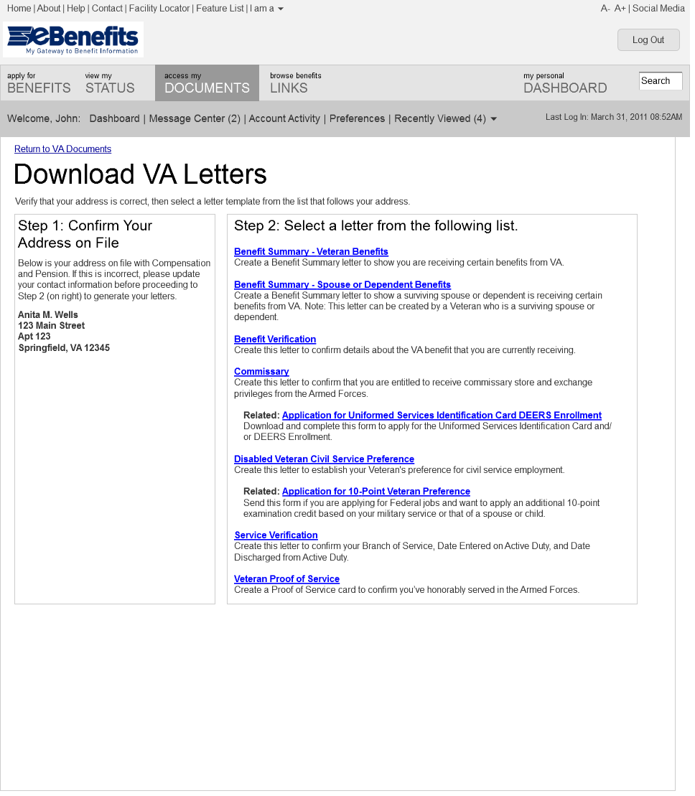

Benefit Summary Letter - Veteran

User Interface

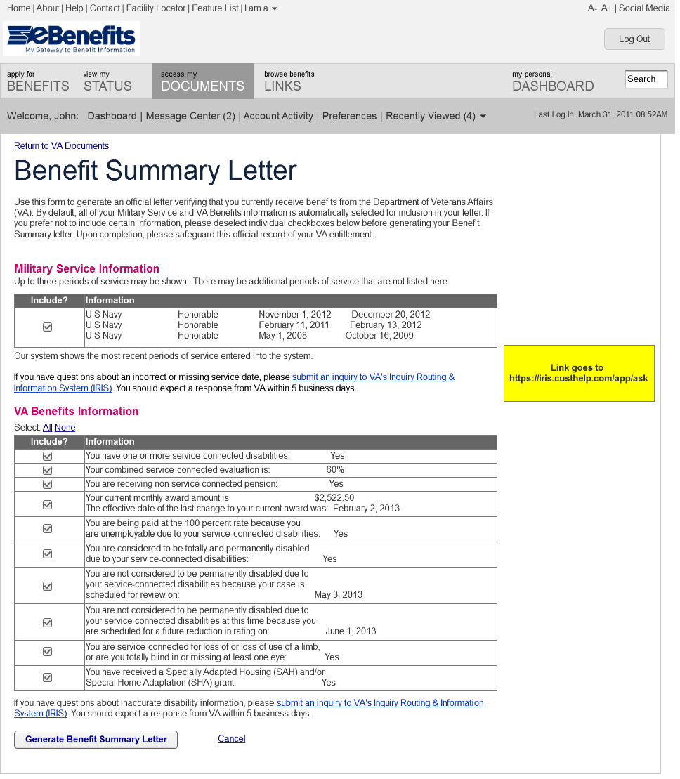

This version of the form produces a benefit summary letter for a Veteran.

Benefit Summary Letter - Non-Veteran

User Interface

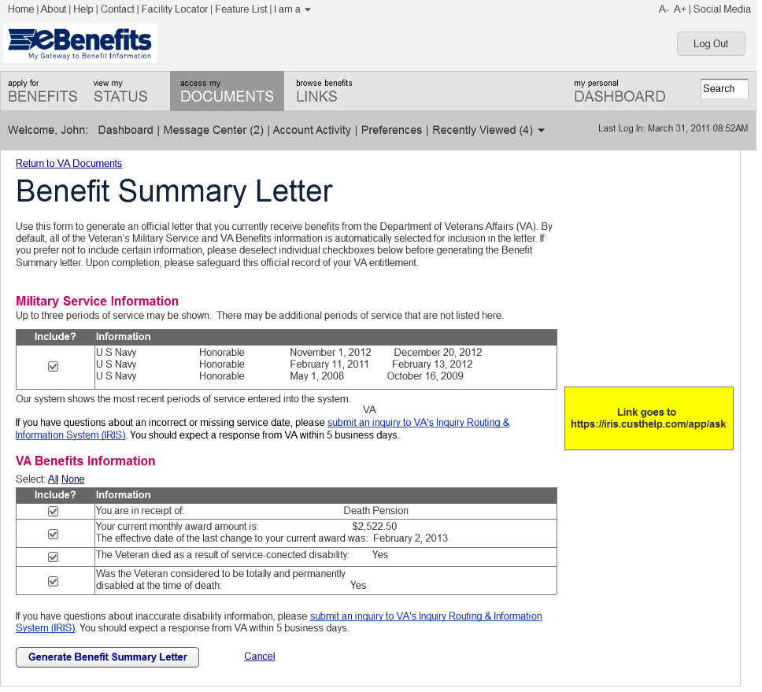

This version of the form produces a benefit letter for the survivor of a Veteran.