PROJECT – MonkeyBusiness



Namen: [Anisha Basropansingh]

Studiejaar: [2020-2021]

Werkgroep: [AMO1a.1]

Projectleider: [M. Boukiour]

Inleverdatum: [29-09-2020]

Versie: [1.0]

Inhoud

Klasse diagram 3

ERD 3

# Klasse diagram

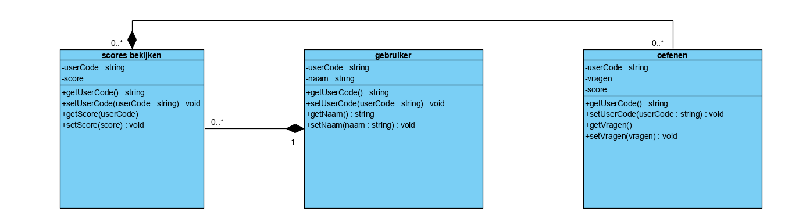

# ERD

