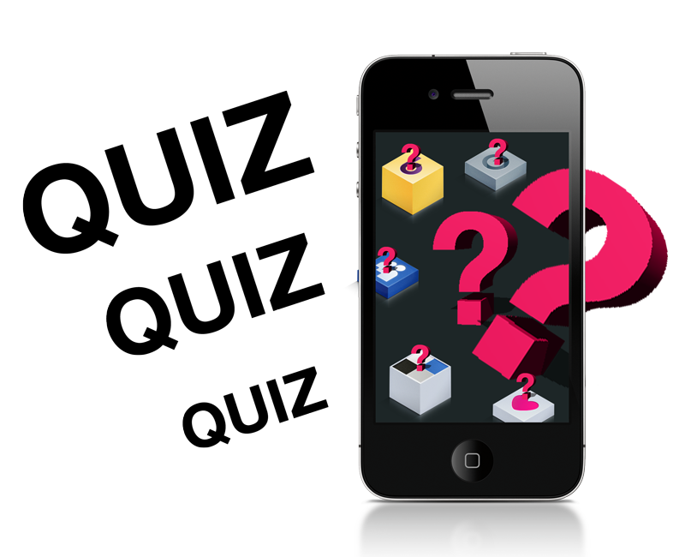Mobile app - Quiz

|  |  |
| --- | --- |
| **Namen:** | Tim de Kok |
| **Datum:** | 1-10-2020 |
| **Klas:** | LO8E-AMO1 |
| **Docent:** | M. Boukiour |
| **Project groep:** | 3 |
| **Versie:** | 1 |

Inhoud

Technische ontwerp 3

Klassen diagram 3

ERD 3

# Technische ontwerp

## Klassen diagram

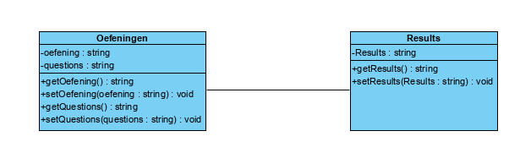

## ERD

