App Amazigh

Ontwikkel omgeving

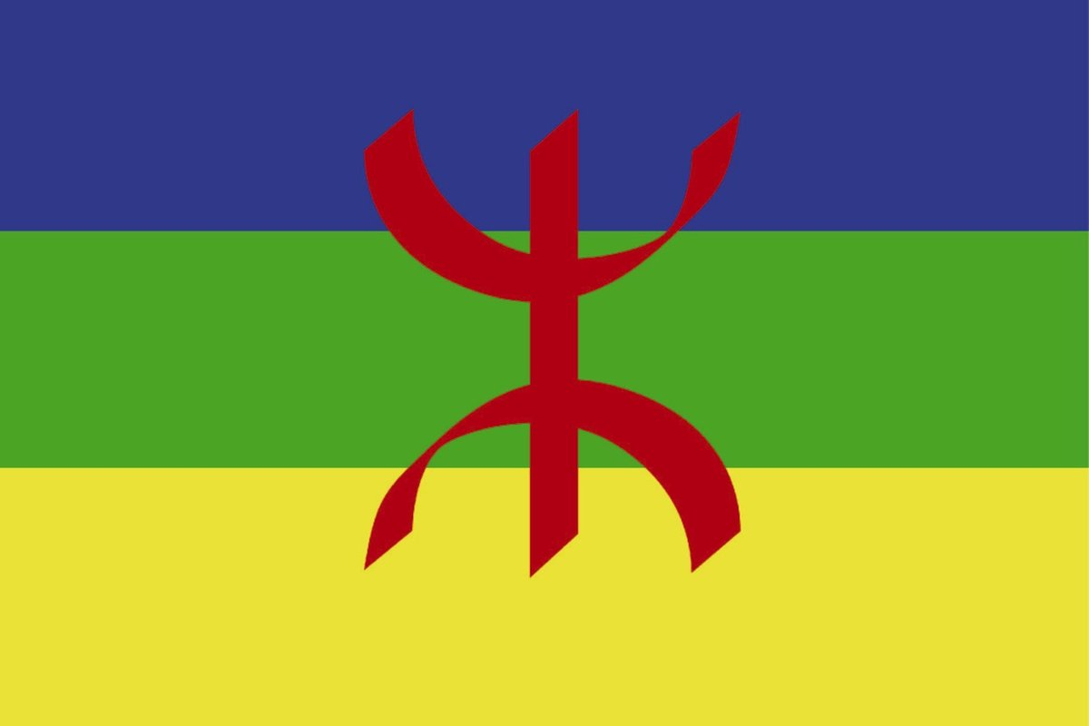

|  |  |
| --- | --- |
| Namen | Fabian van Lierop,  Sephr Abdoli,  Sander Grimmelikhuizen |
| Studiejaar | 2020-2021 |
| Groep | 8AMO1_5 |
| Projectleider | M. Boukiour |
| Inleverdatum | 08/10/2020 |
| Versie | 1.0 |

Inhoud

Ontwikkelomgeving 2

# Ontwikkelomgeving

Hardware:

|  |  |
| --- | --- |
| **Onderdeel** | **Asus / Zenbook pro 2019** |
| CPU | Intel Core i7-8565U |
| GPU | NVIDEA GeForce 1050 Max Q |
| RAM | 8GB |
| Disk | 512 GB SSD M.2 |
| Monitor | 14inch 1920x 1080 |
| Internet | WIFI 5.1 |

**Software:**

|  |  |
| --- | --- |
| **Naam** | **Versie** |
| Windows OS | 10.0.18362 |
| Android Studio | 4.0.1 |
| Visual Paradigm | 16.1 |
| Office | 2020 |
| Github Desktop | 2.5.5 |
| Microsoft Teams | 1.3.00.21759(64-bits) |