Monkeybusiness

Ontwikkelomgeving

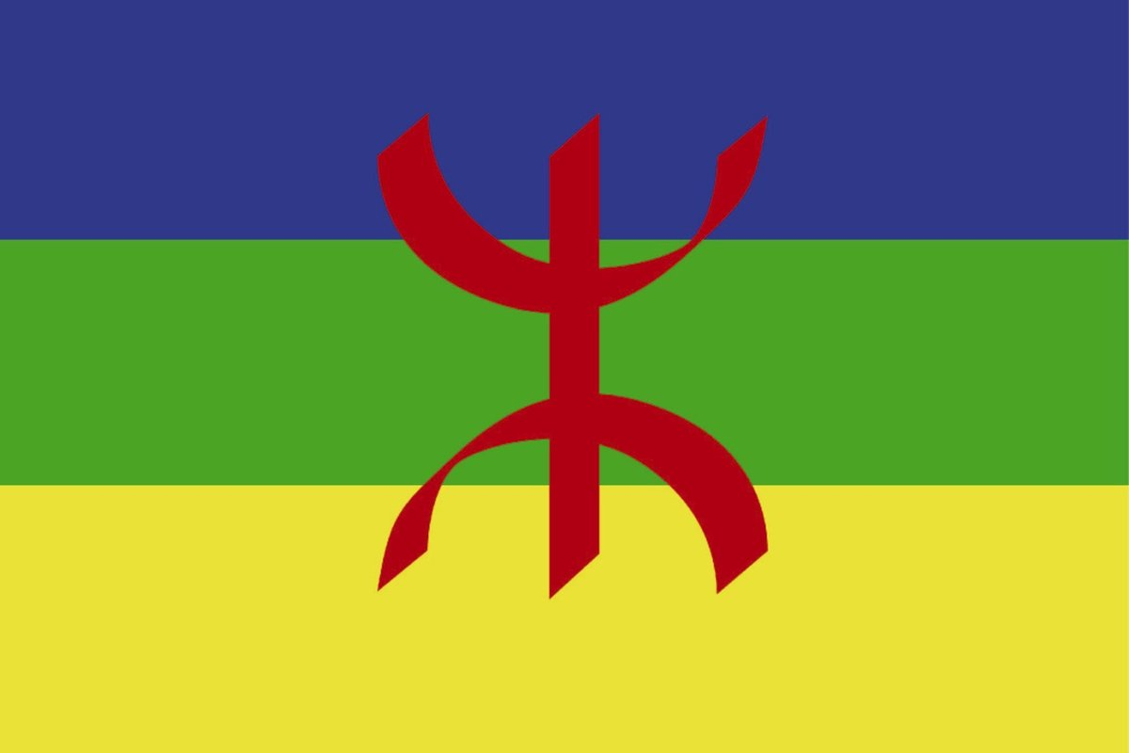

|  |  |
| --- | --- |
| Namen | Fabian van Lierop,  Sephr Abdoli,  Sander Grimmelikhuizen |
| Studiejaar | 2020-2021 |
| Groep | 8AMO1_5 |
| Projectleider | M. Boukiour |
| Inleverdatum | 08/10/2020 |
| Versie | 1 |

Inhoud

* Benodigde hardware
* Benodigde software

Benodigde hardware

Pc:

|  |  |
| --- | --- |
| **Onderdeel** | **Merk/Naam** |
| CPU | AMD Ryzen 5 3600 6-Core Processor |
| GPU | NVIDEA GeForce 1060 6GB |
| Moederbord | MSI B450 Tomahawk |
| RAM | 16GB Corsair |
| Disk | Intel 660p 1TB M.2 SSD |
| Voeding | Corsair RM650 |
| Muis | Logitech Hyperion Fury |
| Toetsenbord | Corsair K70 MK2 LP RGB MXRed |
| Monitor | AOC 24” L C24G1 monitor  AOC G2590VXQ monitor |
| Internetkabel | Ethernet Kabel 1gbit |
| Headset | Razer Kraken 2.0 |

Benodigde software

|  |  |
| --- | --- |
| **Naam** | **Versie** |
| Windows OS | 10.0.18362 |
| Android Studio | 4.0.1 |
| Visual Paradigm | 16.1 |
| Microsoft Office | 2020 |
| Github Desktop | 2.5.5 |
| Microsoft Teams | 1.3.00.21759(64-bits) |