1. Display the lines that contain the word “lp” in /etc/passwd file.

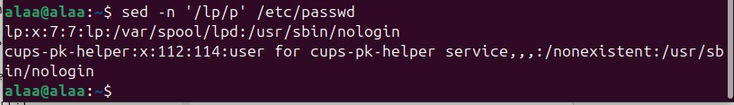

1. Display /etc/passwd file except the third line.

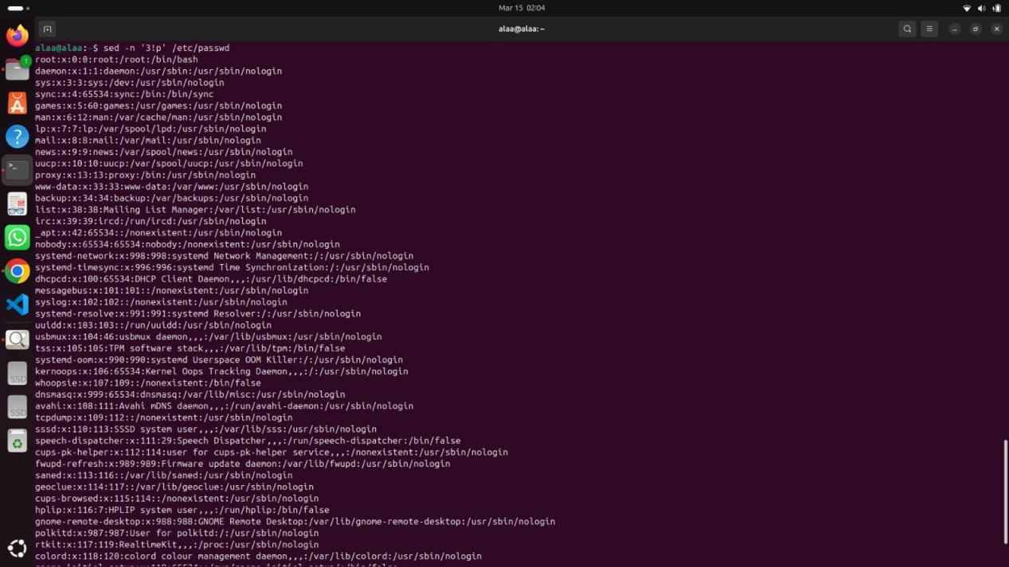

1. Display /etc/passwd file except the last line.

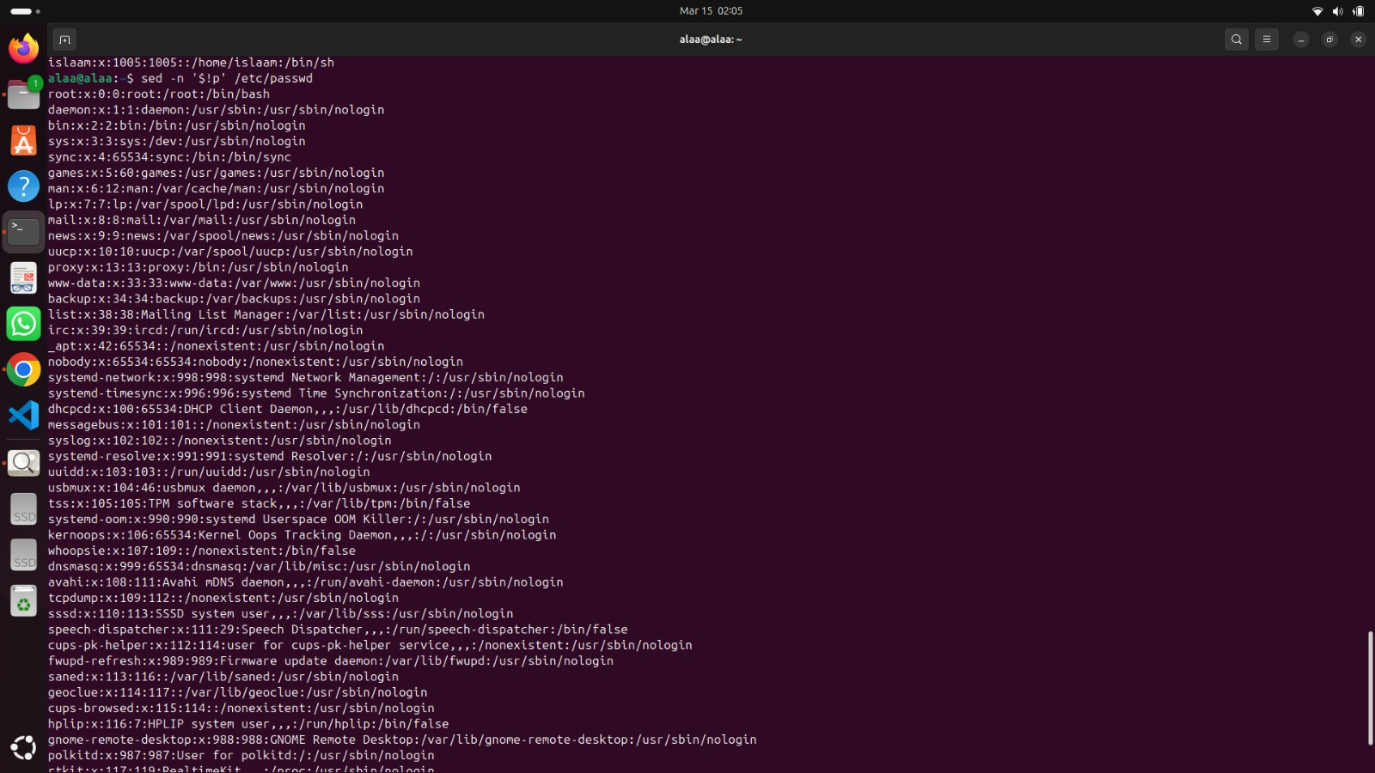

1. Display /etc/passwd file except the lines that contain the word “lp”.



5- Substitute all the words that contain “lp” with “mylp” in /etc/passwd file.

