 Simplifi Med Ltd

PROJECT INITIATION DOCUMENT
Cardiology AI: Reading ECGs and Echo Studies
Conceive phase and project management (assignment brief items i, ii and iv)
Client and sponsor | Simplifi Med Ltd, Dr Alaa
Module | COS6032-E Industrial AI Project, University of Bradford
Module leader | Dr Kulvinder Panesar
Group number | B26
Repository and tracking | GitHub [link]; Jira project CAI; group blog

Team member | Role | Student number
Alaedine Ait Bella | Project manager and technical lead | 24019746
Reyad Taha | Data analyst | 24005092
Pana Sharif | Tester, code refiner, ethics and legal | 22011714

Version | Date | Status | Prepared by
0.1 | 18 Oct 2026 | First draft from brief and course materials | Alaedine Ait Bella
1.0 | 19 Oct 2026 | Jira Scrum plan added; team review | Alaedine, Reyad, Pana
1.1 | [after PR1] | Project round 1 feedback | [ after PR1]

1. Problem context and statement
ECGs show the heart’s electrical activity and echo studies show its structure and pumping. Both are read under time pressure, and the quality of the reading depends on who reads it. Junior clinicians often decide on these studies out of hours without a cardiologist nearby. Tools that help already exist, mostly in the United States, but they are expensive (Simplifi Med Ltd, 2026). This PID covers items (i), (ii) and the governance summary of item (iv) in the assignment brief (Panesar, 2026).
Problem statement: clinicians reading ECGs and echo studies without a cardiology opinion to hand lack a low-cost, transparent second opinion that tells them whether a study looks abnormal, how sure it is, why, and who to contact. We will build and test a prototype that does this, with a clinician in control of every decision.

2. Business case
Option | Benefit | Drawback | Decision
A. Do nothing | No cost | Reads stay inconsistent; acute changes may be escalated late | Rejected
B. Buy an imported tool | Mature product | Expensive, opaque, not built around a UK escalation table | Rejected
C. Build a explainable prototype | Low cost, transparent, fits the client’s fixed action table | Needs data approval and clinical sign-off | Selected
Benefits: faster, consistent escalation; evidence shown with every result; reusable audited code. Costs are in section 13.

3. Aims, objectives and outcomes
Aim: to give clinicians a trustworthy second opinion on ECGs and echo studies that always shows its evidence and points to the right next step.
SMART goal: by 16 April 2027, build, test and demonstrate a decision support prototype that classifies ECGs and echo studies with calibrated confidence, an explanation and a fixed-table action, meets the client-confirmed targets on public practice data, and is shown at the AI Exhibition on 19 or 20 April 2027.

SMART | How the goal meets it
Specific | A decision support app (ECG and echo, normal or abnormal, confidence, explanation, fixed-table action, audit log). Not a diagnosis tool, no treatment advice, no live patients.
Measurable | Client targets (suggested in the brief, to be confirmed): at least 9 in 10 abnormal ECGs flagged; at least 19 in 20 acute changes flagged; no more than 2 in 10 normal ECGs falsely flagged; calibrated confidence; cardiologist agreement with the suggested action in at least 18 of 20 reviewed cases; results reproducible from a fresh clone.
Attainable | Public data (PTB-XL, EchoNet-Dynamic) and published benchmarks exist, a baseline-to-CNN route is proven (Strodthoff et al., 2021), and the echo target is deliberately set lower once first results are in.
Relevant | Directly addresses the client brief, the CDIO approach and learning outcomes 1 to 5 of COS6032-E.
Time-bound | Element 1 on 4 Jan 2027; group evidence 16 Apr 2027; exhibition 19 or 20 Apr 2027; Element 2 on 26 Apr 2027.

Objective | Key results
O1: A trustworthy ECG classifier | 90%+ abnormal ECGs flagged with max 20% false alarms (Feb 2027)  95%+ acute changes flagged (Mar 2027)  3+ approaches compared on one protocol, calibration reported (Feb 2027)
O2: A safe, auditable app with an echo pathway | 3+ echo approaches compared; echo target agreed (Mar 2027)  100% of runs show finding, confidence, explanation, action and are logged (Mar 2027)  18 of 20 reviewed cases agree with the suggested action (Apr 2027)
O3: Professional, responsible delivery | Repo shared in week 1; every blog entry within 3 weeks  100% project round attendance and a client meeting after each  Governance strategy and FAIR log complete before 16 Apr 2027
OKRs are scored 0 to 1 at every project round in the OKR scorecard (Doerr, 2018).

Expected outcomes
- A working app that reads ECG and echo studies and returns finding, confidence, explanation and a fixed-table action, with every run logged.
- A fair comparison of at least three approaches per study type, with calibration and failure examples.
- A governance strategy, user guide, final report and client summary that the client can use for the pilot trusts.

4. Scope
Within scope | Reading 12-lead ECGs; reading echo pictures and clips; normal or abnormal with confidence; spotting acute changes; showing what the model looked at; recommending who to contact from a fixed table; an audit log; a working app and written report.
Outside of scope | CT and MRI; anything shown to patients; treatment, drug or dose advice; free text written by a model; links to hospital systems; medical device approval; use on real patients during the project.
Change control | Changes need written agreement from the client and the module organiser, and are logged in Jira.

5. Stakeholders
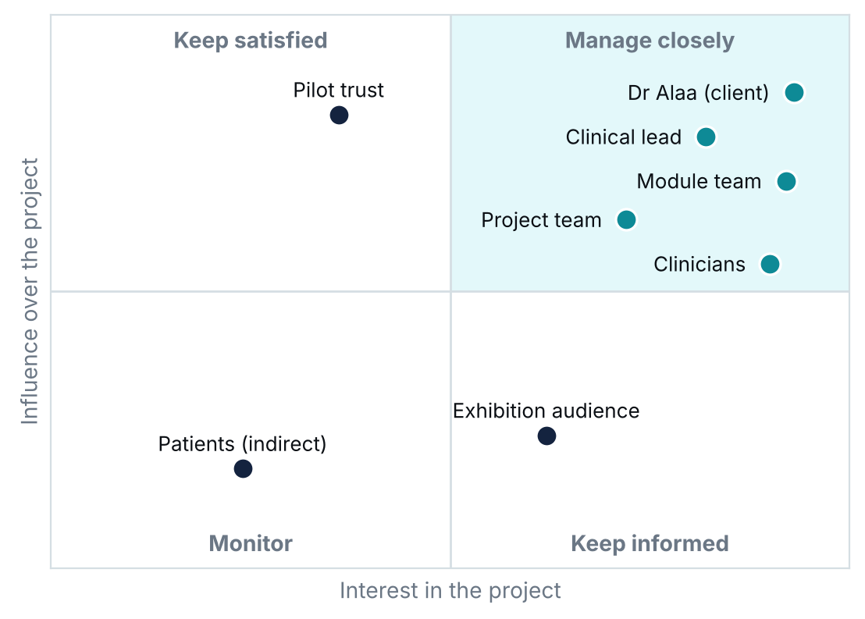
Figure 1. Stakeholder map by influence and interest.
Activity | Alaedine | Reyad | Pana | Client
Plan, Jira, risks, client liaison | A/R | C | C | I
Data preparation and ECG experiments | C | A/R | C | I
Echo pipeline; app, rules, audit log | A/R | C | C | I
Testing, calibration, governance, FAIR log | C | C | A/R | I
Findings-to-action table | R | C | C | A
Blogs, poster and demo | R | R | R | I
RACI: R = does the work, A = accountable, C = consulted, I = informed.

6. Domain knowledge and data availability
A 12-lead ECG records ten seconds of the heart’s electrical activity; acute changes such as ST elevation need urgent escalation. Echo is an ultrasound video of the heart, judged by view quality and how well the left ventricle pumps. Published work shows that convolutional networks beat feature-based methods on PTB-XL (Strodthoff et al., 2021) and that video models can assess pumping on EchoNet-Dynamic (Ouyang et al., 2020).
Dataset | Contents | Use and status
PTB-XL (PhysioNet) | About 21,800 12-lead ECGs from 18,900 patients, labelled by cardiologists | Build and test ECG models; open; recommended ten-fold split (Wagner et al., 2020)
EchoNet-Dynamic (Stanford) | Over 10,000 echo videos with expert tracings | Build and test echo models; fixed train and test groups; licence checked in sprint 2
Client ECG and echo studies | Normal and abnormal studies with reports | Only after written trust approval; swapped in without changing the build

Data rules: patient details removed and checked (including file names and metadata), approved storage only, labels from reports with disagreements recorded, and all of one patient’s studies kept in the same split.

7. Research methodology
CDIO phase | Sprints | Main activities
Conceive | 1 to 3 | Problem, business case, data understanding, labels, targets, first baseline
Design | 4 to 5 | Experiment design, system architecture, sub-designs, findings-to-action table
Implement | 6 to 10 | ECG and echo models, calibration, explanations, app, rule engine, audit log
Operate | 11 to 12 | End-to-end testing, client review, user guide, poster, demo, closure
Table 1. CDIO phases mapped to our sprints.
We follow an experimental, quantitative method inside CDIO. Each study type is tested with at least three approaches, from a simple feature-based baseline to deep models, using the same splits, metrics and random seeds. We report sensitivity, false alarm rate, ROC-AUC and calibration, and we review the cases each model gets wrong.
Member | Proposed Element 1 research and sub-design focus
Alaedine | Echo transfer learning and overall system design (architecture, rule engine, audit log)
Reyad | ECG data engineering and model experiments (baseline to 1D CNN and ResNet)
Pana | Evaluation, calibration, testing and governance controls
Split agreed so there is no overlap, as the brief requires. To confirm at project round 1.

8. Constraints, limitations, opportunities and challenges
Constraints | Limitations
Fixed dates: 4 Jan, 16 Apr, 19 or 20 Apr, 26 Apr 2027  Three part-time people  Decision support only, no live patients  Approved storage only | Public data may not match UK patients  Report labels can be wrong  Echo image quality varies  No medical device approval in scope

Opportunities | Challenges
Large open datasets and benchmarks  Pilot trusts after evaluation  Reusable method for other studies  Strong portfolio evidence for the team | Data approval timing  Class imbalance and acute labels  Compute for echo video  Keeping clinical claims honest

9. Agile project management framework
We use Scrum inside CDIO (Schwaber and Sutherland, 2020). CDIO sets the phases; Scrum sets a two-week rhythm. Each sprint ends just before a project round, so every round shows a reviewed increment, and the client meeting after the round feeds the next sprint.
Scrum event | When |  |  | Output
Sprint planning | Day 1 of each sprint, 45 minutes |  |  | Sprint goal and sprint backlog in Jira
Stand-up | Monday, Wednesday, Friday, 10 minutes |  |  | Progress and blockers raised in Jira
Backlog refinement | Mid sprint, 30 minutes |  |  | Next stories split, estimated and ready
Sprint review | Before each project round |  |  | Ten-minute round presentation; evidence on group blog
Client meeting | After each project round |  |  | Minutes on group blog within 3 working days
Retrospective | Last day of sprint, 20 minutes |  |  | Group blog entry and one improvement action
Scrum role |  | Who | Responsibilities
Product owner contact |  | Alaedine | Orders the backlog, speaks for the client between meetings, accepts finished work
ScrumMaster (rotating) |  | Alaedine, Pana, Reyad in turn | Runs the events, removes blockers, keeps Jira and the 3-week blog tracker up to date
Developers |  | All three | Estimate, build, test and review; every pull request reviewed by another member
Customer |  | Dr Alaa | Sets priorities, signs off the action table, reviews increments
The rotation gives each member ScrumMaster evidence for Element 1 part (e).

9.1 Jira setup
All work is planned and tracked in our Jira project Cardiology AI (CAI): 9 epics that follow the brief, 58 user stories (183 story points), each with an owner, due date and acceptance criteria, and 12 sprints. Stories move through To Do, In Progress, In Review and Done; nothing is Done without review.
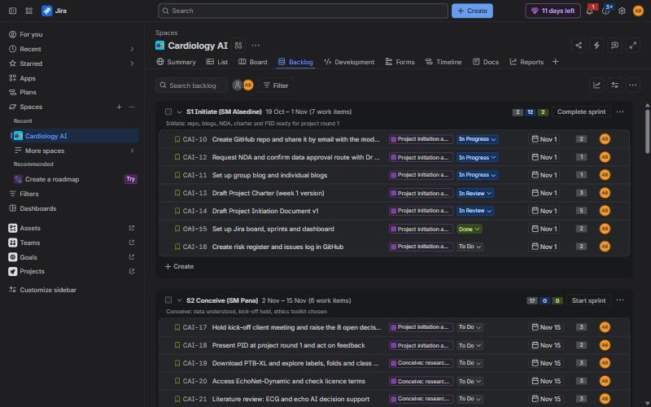
Figure 2. The Jira backlog with Sprint 1 active (screenshot, 19 October 2026).
Definition of ready | Definition of done
Clear value and acceptance criteria  Estimated in story points  Owner agreed  No blocker or missing approval | Acceptance criteria met  Reviewed by another member  Tests pass; reproducible from README  GitHub, blog and FAIR log updated

10. Project plan
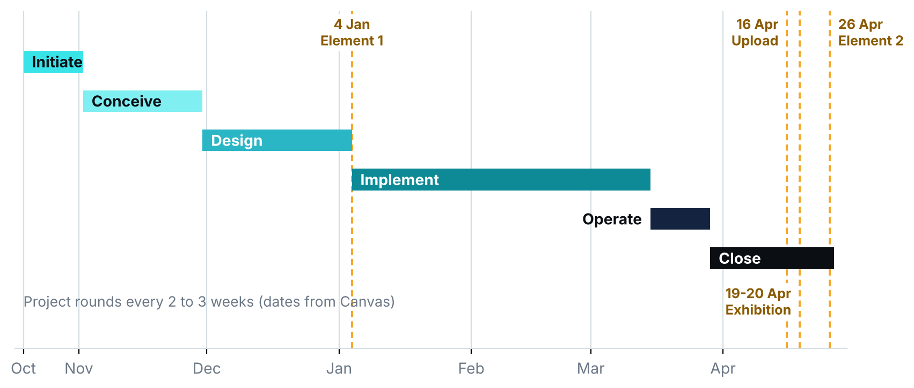
Figure 3. Phases and assessment dates. Project rounds every 2 to 3 weeks (dates from Canvas).
Sprint | Dates | Sprint goal | ScrumMaster | Points
S1 | 19 Oct to 1 Nov | Initiate: repo, blogs, NDA, charter and PID ready for project round 1 | Alaedine | 16
S2 | 2 Nov to 15 Nov | Conceive: data understood, kick-off held, ethics toolkit chosen | Pana | 17
S3 | 16 Nov to 29 Nov | Conceive: first simple ECG baseline and research summary | Reyad | 10
S4 | 30 Nov to 13 Dec | Design: experiment design, architecture and action table draft | Alaedine | 18
S5 | 14 Dec to 3 Jan | Design: Element 1 written and submitted (reduced capacity) | Pana | 15
S6 | 4 Jan to 17 Jan | Implement: data pipeline hardened, first neural ECG model | Reyad | 14
S7 | 18 Jan to 31 Jan | Implement: second ECG model and echo baseline | Alaedine | 13
S8 | 1 Feb to 14 Feb | Implement: rule engine, audit log and first UI | Pana | 16
S9 | 15 Feb to 28 Feb | Implement: ECG comparison, calibration and explanations | Reyad | 15
S10 | 1 Mar to 14 Mar | Implement: echo comparison and ECG plus echo in the app | Alaedine | 13
S11 | 15 Mar to 28 Mar | Operate: end-to-end testing, user guide, client review | Pana | 12
S12 | 29 Mar to 16 Apr | Close: poster, demo rehearsal, governance and evidence upload | Reyad | 24
Sprint 5 covers the winter break at reduced capacity; Sprint 12 runs three weeks to the 16 April upload.

11. Quality plan
Area | Standard | Check | Owner
Code | Reviewed pull requests; README marks original, adapted and new code | Every story | Pana
Data | No patient details; patient-level splits; before and after datasets kept | Each data change | Reyad, Pana
Models | Same protocol for all approaches; fresh-clone rerun gives the same result | Every 2nd sprint | Reyad, Pana
App | Every result shows finding, confidence, explanation and action; every run logged | Sprint 8 onwards | Alaedine, Pana
Documents | Brief writing guidelines, Harvard referencing, proofread; blogs within 3 weeks | Every sprint | ScrumMaster

12. Roles and responsibilities
Member | Project role | Technical responsibilities
Alaedine Ait Bella | Project manager, technical lead, product owner contact | Jira and plan, client liaison, system design, echo models, app, rule engine, audit log
Reyad Taha | Data analyst | Data understanding and preparation, labels, splits, ECG baseline and neural models, error analysis
Pana Sharif | Tester, code refiner, ethics and legal | Test plan, code review, calibration, governance strategy, data protection, FAIR log

13. Resource allocation and cost estimation
Resource | Estimate | Basis
Team time | 600 hours (notional £9,000) | 3 people x about 10 hours a week x 20 active weeks, at an assumed £15 an hour
Compute | Up to £40 | Only if free tiers and university GPUs are not enough; GPU hours logged
Poster print | £25 | A1 poster for the exhibition
Contingency | About £10 | 10% of cash costs
Tools | £0 | GitHub, Jira (free plan), Python, FastAPI, PyTorch, open data

14. Risk assessment and management
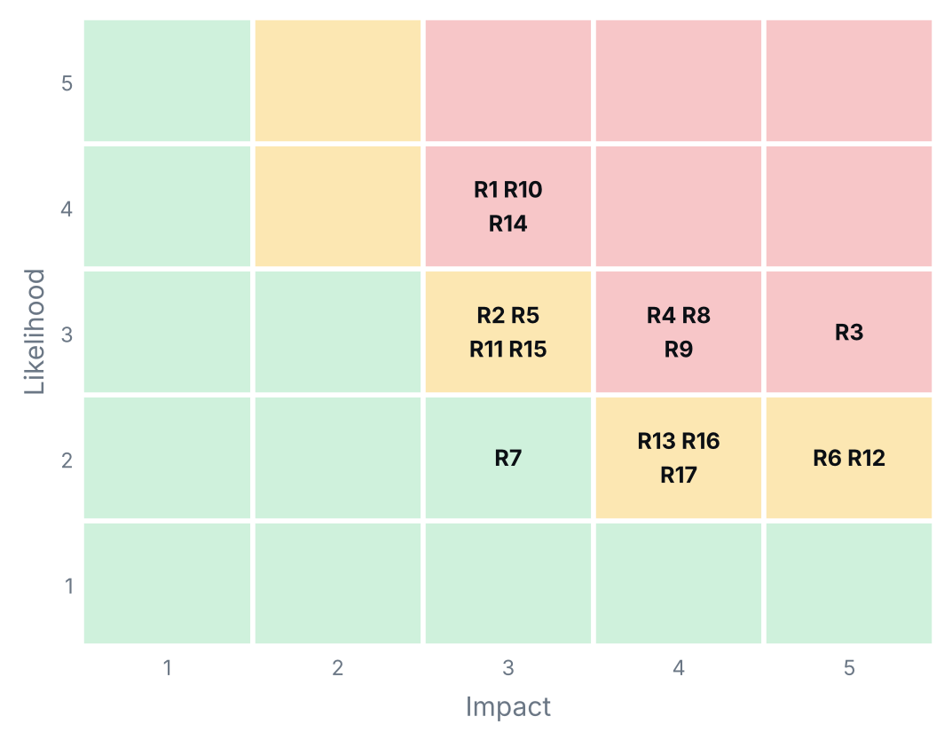
Figure 4. Risk map: 17 risks by likelihood and impact.
ID | Risk | Score | Response | Owner
R3 | Data leakage: studies from one patient appear in both training and test sets | 15 | Patient-level splits; Pana reviews the split code. | Reyad, Pana
R1 | Trust data approval is slow or refused (client brief) | 12 | Start on public data; no real data before written approval. | Alaedine, Dr Alaa
R4 | Too few abnormal studies, class imbalance | 12 | Balance classes; report misses, not just accuracy. | Reyad
R8 | Scope creep into CT, MRI or treatment advice | 12 | Scope baseline and written change control. | Alaedine
R9 | Claims go beyond what the results support | 12 | Report limits; clinical lead reviews wording. | All
R10 | Compute limits for echo video training | 12 | Pretrained models, data subsets, free GPU time. | Alaedine
R14 | Competing deadlines in other modules and work commitments reduce team capacity | 12 | Plan around deadlines; 15% capacity buffer. | Sprint ScrumMaster
Top 7 of 17 risks (score = likelihood x impact). The full register is in GitHub, reviewed at every sprint retrospective; new risks are raised in Jira and flagged on the board.

15. Deliverables and documentation
Deliverable | Where it lives | Due
Charter, PID, Jira backlog and dashboard | GitHub, Jira, group blog | Week 1 to PR1
Research summary and baseline results | GitHub, client email | Nov 2026
Element 1 reports (individual) | Canvas | 4 Jan 2027
Models, code, settings and comparison | GitHub (README) | Feb to Mar 2027
Action table, app, audit log, user guide | GitHub, client | Mar 2027
Governance strategy, FAIR report, closure report | Group evidence | 16 Apr 2027
Poster and live demo | AI Exhibition | 19 or 20 Apr 2027
Element 2 reports (individual) | Canvas | 26 Apr 2027

16. Governance summary
Area | Our approach
Ethics | Always show finding, confidence, evidence and rule; the action is a suggestion and a clinician decides. Ethical toolkit chosen in sprint 2.
Data protection | UK GDPR and Data Protection Act 2018 (UK Government, 2018): public data first, no real data without written approval, details removed.
Regulation | MHRA software as a medical device guidance (Medicines and Healthcare products Regulatory Agency, no date): fixed signed-off action table, past studies only, no treatment advice.
Accountability | Named owner for the action table; audit log of model, file and time for every run.
Sustainability | Pretrained and smaller models first; GPU hours logged.
The full governance strategy and its justification are developed in sprints 2 to 9 (brief item iv).

17. Monitoring and next steps
Progress is monitored on our Jira dashboard: sprint burndown, sprint health, days left, current sprint work, items due in 14 days, workload by owner and phase, and created versus resolved.
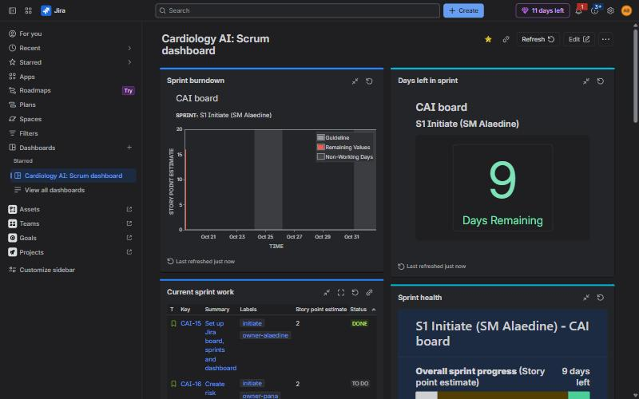
Figure 5. Jira Scrum dashboard (screenshot, 19 October 2026).
# | Decision needed from the client | Until then
1 | Permission for the data: process, forms, and how long it takes | Work on public data until approved in writing
2 | Table of findings and actions: which findings exist, what each triggers, who signs it off | Draft table prepared by the team in S4 for sign-off
3 | Out of hours: who the app names when cardiology is not on site | Placeholder contact names in the table until confirmed
4 | ECG and echo shown together as one answer, or kept separate | Keep separate first, combine only if client agrees
5 | Confirm or change the suggested targets | Suggested targets used as working baseline
7 | Does echo also estimate how well the heart pumps (LVEF), or stay normal or abnormal | Start with normal or abnormal; LVEF is a stretch goal

Sprint 1 actions (19 Oct to 1 Nov): share the GitHub repo with the module team, start the blogs, request the NDA, finish this PID and the charter, build the risk register, and prepare for project round 1 and the kick-off client meeting.

Approval | Decision | Signature and date
Dr Alaa, client | Approved / With changes / Not approved
Dr Kulvinder Panesar, module leader | Approved / With changes / Not approved
Alaedine, Reyad, Pana | Agreed

References
Doerr, J. (2018) Measure what matters: how Google, Bono, and the Gates Foundation rock the world with OKRs. New York: Portfolio/Penguin.
Medicines and Healthcare products Regulatory Agency (no date) Software and artificial intelligence (AI) as a medical device. Available at: https://www.gov.uk/government/publications/software-and-artificial-intelligence-ai-as-a-medical-device (Accessed: 18 October 2026).
Ouyang, D., He, B., Ghorbani, A., Yuan, N., Ebinger, J., Langlotz, C.P., Heidenreich, P.A., Harrington, R.A., Liang, D.H., Ashley, E.A. and Zou, J.Y. (2020) ‘Video-based AI for beat-to-beat assessment of cardiac function’, Nature, 580, pp. 252–256.
Panesar, K. (2026) COS6032-E Industrial AI Project: assignment brief and assessment information. University of Bradford, published 12 October 2026.
Schwaber, K. and Sutherland, J. (2020) The Scrum Guide. Available at: https://scrumguides.org (Accessed: 18 October 2026).
Simplifi Med Ltd (2026) Cardiology AI: reading ECGs and echo studies. Client brief, student project, September 2026.
Strodthoff, N., Wagner, P., Schaeffter, T. and Samek, W. (2021) ‘Deep learning for ECG analysis: benchmarks and insights from PTB-XL’, IEEE Journal of Biomedical and Health Informatics, 25(5), pp. 1519–1528. doi: 10.1109/JBHI.2020.3022989.
UK Government (2018) Data Protection Act 2018. c. 12. Available at: https://www.legislation.gov.uk/ukpga/2018/12/contents (Accessed: 18 October 2026).
Wagner, P., Strodthoff, N., Bousseljot, R.-D., Kreiseler, D., Lunze, F.I., Samek, W. and Schaeffter, T. (2020) ‘PTB-XL, a large publicly available electrocardiography dataset’, Scientific Data, 7, article 154. doi: 10.1038/s41597-020-0495-6.

Appendix A. FAIR report
FAIR | Our answer
Find: what AI did we use? | Claude (Anthropic) [add any other tools].
Analyse: how did we use it? | To structure this PID and the charter from the brief and course materials, draft wording and charts, and set up the Jira backlog. The team supplied the facts and decisions and checked every figure and date.
Inform: what effect did it have? | It saved time on layout and planning, so more time went into checking scope, risks and data. All content was reviewed against the brief and Canvas.
Reflect: why, and what did we learn? | [Team to add a short reflection]
URLs not in the reference list | [add]

