 Simplifi Med Ltd

PROJECT INITIATION DOCUMENT
Cardiology AI: Reading ECGs and Echo Studies
Conceive phase and project management (assignment brief items i, ii and iv)
Client and sponsor | Simplifi Med Ltd, Dr Alaa
Module | COS6032-E Industrial AI Project, University of Bradford
Module leader | Dr Kulvinder Panesar
Group number | B26
Repository and tracking | GitHub : ; Jira project CAI; group blog

Team member | Role | Student number
Alaedine Ait Bella | Project manager and technical lead | 24019746
Reyad Taha | Data analyst | 24005092
Pana Sharif | Tester, code refiner, ethics and legal | 22011714

Version | Date | Status | Prepared by
0.1 | 18 Oct 2026 | First draft from the brief | Alaedine Ait Bella
1.0 | 19 Oct 2026 | Jira Scrum plan added | Alaedine, Reyad, Pana
1.1 | 22 Oct 2026 | Dr Ramzi, objectives, MoSCoW | Alaedine Ait Bella
1.2 | 5 Nov 2026 | After project round 1 feedback | Alaedine Ait Bella

1. Problem context and statement
ECGs show the heart’s electrical activity and echo studies show its structure and pumping. Both are read under time pressure, and the quality of the reading depends on who reads it. Junior clinicians often decide on these studies out of hours without a cardiologist nearby. Tools that help already exist, mostly in the United States, but they are expensive (Simplifi Med Ltd, 2026). This PID covers items (i), (ii) and the governance summary of item (iv) in the assignment brief (Panesar, 2026).
Problem statement: clinicians reading ECGs and echo studies without a cardiology opinion to hand lack a low-cost, transparent second opinion that tells them whether a study looks abnormal, how sure it is, why, and who to contact. We will build and test a prototype that does this for both tests and combines them into one final answer, with a clinician in control of every decision.

2. Business case
Option | Benefit | Drawback | Decision
A. Do nothing | No cost | Reads stay inconsistent; acute changes may be escalated late | Rejected
B. Buy an imported tool | Mature product | Expensive, opaque, not built around a UK escalation table | Rejected
C. Build a explainable prototype | Low cost, transparent, one combined answer from ECG and echo, fits the client’s fixed action table | Needs data approval and clinical sign-off | Selected
Benefits: faster, consistent escalation; evidence shown with every result; reusable audited code. Costs are in section 13.

3. Aims, objectives and outcomes
Aim: to give clinicians a trustworthy second opinion on ECGs and echo studies that combines both into one answer, always shows its evidence and points to the right next step.
SMART goal: by 16 April 2027, build, test and demonstrate a decision support prototype that classifies ECGs and echo studies and combines them into one final answer with calibrated confidence, an explanation and a fixed-table action, meets the client-confirmed targets on public practice data, and is shown at the AI Exhibition on 19 or 20 April 2027.

SMART | How the goal meets it
Specific | A decision support app (ECG and echo, each read as normal or abnormal and combined into one final answer, with confidence, explanation, fixed-table action and audit log). Not a diagnosis tool, no treatment advice, no live patients.
Measurable | Client targets (suggested in the brief, to be confirmed): at least 9 in 10 abnormal ECGs flagged; at least 19 in 20 acute changes flagged; no more than 2 in 10 normal ECGs falsely flagged; calibrated confidence; every case with both studies returns one combined answer that shows both findings and flags disagreement; cardiologist agreement with the suggested action in at least 18 of 20 reviewed cases; results reproducible from a fresh clone.
Attainable | Public data (PTB-XL, EchoNet-Dynamic) and published benchmarks exist, a baseline-to-CNN route is proven (Strodthoff et al., 2021), and the echo target is deliberately set lower once first results are in. The combined answer uses a fixed rule (late fusion), so it needs no paired training data.
Relevant | Directly addresses the client brief, the CDIO approach and learning outcomes 1 to 5 of COS6032-E.
Time-bound | Element 1 on 4 Jan 2027; group evidence 16 Apr 2027; exhibition 19 or 20 Apr 2027; Element 2 on 26 Apr 2027.

Objective | Key results
O1: Deliver a trustworthy ECG classifier | 1. At least 90% of abnormal ECGs flagged (sensitivity) with no more than 20% false alarms on normal ECGs, measured on the held-out PTB-XL test fold (28 Feb 2027)  2. At least 95% of acute changes (for example ST elevation) flagged on the agreed acute-change labels (14 Mar 2027); the label list is confirmed by Dr Alaa, as clinical lead, by 13 Dec 2026, the end of Sprint 4  3. At least three approaches (feature baseline, 1D CNN, ResNet) compared on one protocol with patient-level splits, and calibration error plus a reliability plot reported (28 Feb 2027)  4. Explanations (highlighted parts of the ECG) reviewed by Dr Alaa, as clinical lead, for clinical sense on at least 20 cases (14 Mar 2027)
O2: Deliver a safe, auditable app that combines ECG and echo into one answer | 1. At least three echo approaches compared on the EchoNet-Dynamic fixed test group, and the echo target (normal or abnormal first, LVEF as a stretch goal) agreed with Dr Alaa, with technical advice from Dr Ramzi (14 Mar 2027)  2. 100% of runs show finding, confidence, explanation and fixed-table action, and are logged with model version, file and time (28 Mar 2027)  3. Suggested action from the combined answer agrees with clinical review in at least 18 of 20 reviewed cases (9 Apr 2027)  4. Fusion rule signed off by Dr Alaa, with its technical design guided by Dr Ramzi, by 13 Dec 2026, and 100% of cases with both studies return one combined answer that shows both findings and flags any disagreement (14 Mar 2027)
O3: Run the project professionally and responsibly | 1. Repo shared with the module team in week 1 and every individual blog entry posted within 3 weeks (ongoing)  2. All project rounds attended, with a client meeting after each (ongoing)  3. Governance strategy and FAIR log complete (16 Apr 2027)
O4: Agree clear, prioritised requirements with the client and supervisor | 1. MoSCoW adopted after project round 1; list agreed with Dr Alaa at the first client meeting, guided by Dr Ramzi, and reviewed at the start of every two sprints (Nov 2026, then ongoing)  2. Every Jira epic and story tagged Must, Should, Could or Won't, and all Must items done by 14 Mar 2027  3. Every scope change logged and checked against the MoSCoW list (ongoing)
OKRs are scored 0 to 1 at every project round in the OKR scorecard (Doerr, 2018).

Expected outcomes
- A working app that reads ECG and echo studies, combines them into one final answer, and returns finding, confidence, explanation and a fixed-table action, with every run logged.
- A fair comparison of at least three approaches per study type, with calibration and failure examples.
- A governance strategy, user guide, final report and client summary that the client can use for the pilot trusts.

4. Scope
Within scope | Reading 12-lead ECGs; reading echo pictures and clips; normal or abnormal with confidence; spotting acute changes; combining the ECG and echo readings into one final answer; showing what the model looked at; recommending who to contact from a fixed table; an audit log; a working app and written report.
Outside of scope | CT and MRI; anything shown to patients; treatment, drug or dose advice; free text written by a model; links to hospital systems; medical device approval; use on real patients during the project.
Change control | Changes need written agreement from the client and the module organiser, and are logged in Jira.
MoSCoW prioritisation was adopted after project round 1, following feedback from the module team. Each requirement has an ID; the full list with sources, checks and WBS links is in the MoSCoW Requirements document. The list is confirmed with Dr Alaa at the first client meeting, with technical guidance from our supervisor Dr Ramzi, and reviewed every two sprints, and each Jira epic and story is tagged Must, Should, Could or Won't.
Must have | • M1 Read 12-lead ECGs and return normal or abnormal with a calibrated confidence  • M2 Read echo clips and return normal or abnormal with a confidence (moved up from Should)  • M3 Combine ECG and echo into one final answer: one finding, a combined confidence, the evidence from both tests and one fixed-table action; if only one test exists, answer from it and say so (new after project round 1)  • M4 Meet the client-confirmed ECG targets (abnormal flagged, acute changes flagged, false alarms) on the held-out PTB-XL test fold  • M5 Compare at least three approaches per study type on one protocol with patient-level splits  • M6 Show finding, confidence, explanation and fixed-table action for every result, with an audit log  • M7 Signed NDA, no real patient data before written trust approval, and a clinician confirms every result (decision support only)
Should have | • S1 Calibration reported with a reliability plot for each test and for the combined answer  • S2 Clinical review of the action table, the fusion rule, the acute-change labels and sample cases by Dr Alaa (clinical lead), with technical review of the fusion rule by Dr Ramzi  • S3 Test the combined answer on paired ECG and echo studies from the same patients (MIMIC-IV, or client data after approval)  • S4 User guide, poster and live demo for the AI Exhibition
Could have | • C1 Estimate of how well the heart pumps (LVEF) from echo, as a stretch goal  • C2 A learned fusion model instead of the fixed rule, only if paired training data is available  • C3 Client data swapped in if written trust approval arrives in time  • C4 Simple dashboard of the audit log
Won't have (this time) | • W1 CT and MRI  • W2 Anything shown to patients  • W3 Treatment, drug or dose advice, or free text written by a model  • W4 Links to hospital systems, medical device approval, or use on real patients

5. Stakeholders
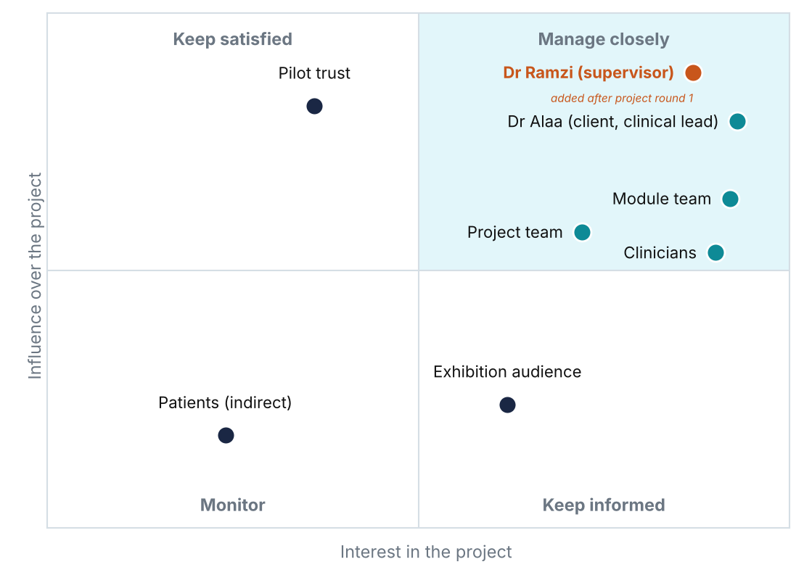
Figure 1. Stakeholder map by influence and interest, updated after project round 1: Dr Ramzi (project supervisor) in the manage closely group and Dr Alaa as client and clinical lead.
Activity | Alaedine | Reyad | Pana | Client
Plan, Jira, risks, client liaison | A/R | C | C | I
Data preparation and ECG experiments | C | A/R | C | I
Echo pipeline; app, rules, fusion engine, audit log | A/R | C | C | I
Testing, calibration, governance, FAIR log | C | C | A/R | I
Findings-to-action table | R | C | C | A
Fusion rule (how ECG and echo combine) | R | C | C | A
Clinical review of labels, wording and sample cases (Dr Alaa, clinical lead) | R | C | C | A
Blogs, poster and demo | R | R | R | I
RACI: R = does the work, A = accountable, C = consulted, I = informed.
Dr Ramzi was added as a key stakeholder after project round 1. He is our project supervisor: he helps the team, explains methods and leads us technically on model approaches, experiment design, system architecture and the technical design of the fusion rule. He has high interest and high influence, so he sits in the manage closely group (Figure 1), and is invited to sprint reviews and client meetings. Dr Alaa is the client and the clinical lead: she owns and signs off the findings-to-action table, the fusion rule and the acute-change labels, and reviews the wording of explanations and the clinical evaluation. Communication with every stakeholder follows the Communications Plan.

6. Domain knowledge and data availability
A 12-lead ECG records ten seconds of the heart’s electrical activity; acute changes such as ST elevation need urgent escalation. Echo is an ultrasound video of the heart, judged by view quality and how well the left ventricle pumps. Published work shows that convolutional networks beat feature-based methods on PTB-XL (Strodthoff et al., 2021) and that video models can assess pumping on EchoNet-Dynamic (Ouyang et al., 2020).
How the heart and the two tests fit together. The heart pumps blood through four chambers, and each beat is triggered by an electrical signal that starts in the sinoatrial node and spreads through the heart. An ECG records this electrical activity from electrodes on the skin. A standard 12-lead ECG views the heart from 12 angles and is used to spot abnormal rhythms such as atrial fibrillation, signs of a heart attack such as ST elevation, and conduction problems. An echocardiogram uses ultrasound to show the structure and movement of the heart: chamber size, valve function, wall motion and the ejection fraction (LVEF), the share of blood the left ventricle pumps out with each beat. An LVEF of 40% or below is generally used to describe heart failure with reduced ejection fraction (McDonagh et al., 2021), and chamber measurements follow published guidance (Lang et al., 2015).
Feature | ECG | Echo
What it shows | Electrical activity of the heart | Structure, valves and pumping, using ultrasound
Data for AI | Multichannel time series: 12 leads over 10 seconds (PTB-XL) | Short ultrasound videos from set views such as apical four-chamber (EchoNet-Dynamic)
Typical findings | Atrial fibrillation, conduction problems, ST changes | Reduced LVEF, enlarged chambers, valve disease, abnormal wall motion
Main AI challenge | Label noise, class imbalance, data leakage between splits | Image quality, operator differences, higher compute cost for video
Table: ECG and echo compared for our prototype.
Challenges we plan for. Labels depend on clinician opinion and may disagree, so disagreements are recorded. Abnormal studies are rarer than normal ones, so we report misses and not only accuracy. A model trained on one set of patients or machines may not work on another, so we state its limits. Echo quality depends on the operator and the view. Clinicians need to see why a result was given, so we show what the model looked at. Dr Alaa, as clinical lead, will review labels and wording and advise which findings matter most clinically; Dr Ramzi guides the technical choices.
Combining ECG and echo into one answer. After project round 1 the team agreed that the app should give one final answer when a patient has both an ECG and an echo study. We will use decision-level (late) fusion: each model gives its own finding and confidence, and a fixed fusion rule, signed off by the clinical lead, turns the pair into one answer. The more urgent action of the two always wins, agreement is reported, and disagreement is flagged for clinician review rather than averaged away. Late fusion suits our data because PTB-XL and EchoNet-Dynamic come from different patients, so a joint model cannot be trained on them. To test the combined answer on real pairs we will either request credentialed access to MIMIC-IV-ECG and MIMIC-IV-Echo, which link to the same MIMIC-IV patients (Gow et al., 2023; Gow et al., 2026), or use client studies once the trust approves. If neither arrives in time, clinicians review constructed case pairs and we state this as a limitation (risk R18).
Dataset | Contents | Use and status
PTB-XL (PhysioNet) | About 21,800 12-lead ECGs from 18,900 patients, labelled by cardiologists | Build and test ECG models; open; recommended ten-fold split (Wagner et al., 2020)
EchoNet-Dynamic (Stanford) | Over 10,000 echo videos with expert tracings | Build and test echo models; fixed train and test groups; licence checked in sprint 2
MIMIC-IV-ECG and MIMIC-IV-Echo (PhysioNet) | About 800,000 12-lead ECGs from about 160,000 patients (open access) and echo studies for MIMIC-IV patients, with images for 4,572 patients (credentialed), linked by patient | Optional: test the combined answer on paired studies; needs PhysioNet credentialing and CITI training; decision in Sprint 3
Client ECG and echo studies | Normal and abnormal studies with reports | Only after written trust approval; swapped in without changing the build

Data rules: patient details removed and checked (including file names and metadata), approved storage only, labels from reports with disagreements recorded, and all of one patient’s studies kept in the same split.

7. Research methodology
CDIO phase | Sprints | Main activities
Conceive | 1 to 3 | Problem, business case, data understanding, labels, targets, first baseline
Design | 4 to 5 | Experiment design, system architecture, sub-designs, findings-to-action table, fusion rule
Implement | 6 to 10 | ECG and echo models, calibration, explanations, app, rule engine, fusion engine, audit log
Operate | 11 to 12 | End-to-end and combined-answer testing, client review, user guide, poster, demo, closure
Table 1. CDIO phases mapped to our sprints.
We follow an experimental, quantitative method inside CDIO. Each study type is tested with at least three approaches, from a simple feature-based baseline to deep models, using the same splits, metrics and random seeds. We report sensitivity, false alarm rate, ROC-AUC and calibration, and we review the cases each model gets wrong. The combined answer is tested separately on paired cases: how often its action agrees with clinical review, and whether every disagreement between the two tests is shown.
Member | Proposed Element 1 research and sub-design focus
Alaedine | Echo transfer learning and overall system design (architecture, fusion rule, rule engine, audit log)
Reyad | ECG data engineering and model experiments (baseline to 1D CNN and ResNet)
Pana | Evaluation, calibration, testing and governance controls
Split agreed so there is no overlap, as the brief requires. The fusion rule added after project round 1 sits in the system design sub-design.

8. Constraints, limitations, opportunities and challenges
Constraints | Limitations
Fixed dates: 4 Jan, 16 Apr, 19 or 20 Apr, 26 Apr 2027  Three part-time people  Decision support only, no live patients  Approved storage only | Public data may not match UK patients  Report labels can be wrong  Echo image quality varies  No medical device approval in scope  No paired ECG and echo data in the main public sets

Opportunities | Challenges
Large open datasets and benchmarks  Pilot trusts after evaluation  Reusable method for other studies  Strong portfolio evidence for the team  Paired MIMIC-IV data to test the combined answer | Data approval timing  Class imbalance and acute labels  Compute for echo video  Keeping clinical claims honest  Testing the combined answer on paired cases

9. Agile project management framework
We use Scrum inside CDIO (Schwaber and Sutherland, 2020). CDIO sets the phases; Scrum sets a two-week rhythm. Each sprint ends just before a project round, so every round shows a reviewed increment, and the client meeting after the round feeds the next sprint.
Scrum event | When |  |  | Output
Sprint planning | Day 1 of each sprint, 45 minutes |  |  | Sprint goal and sprint backlog in Jira
Stand-up | Monday, Wednesday, Friday, 10 minutes |  |  | Progress and blockers raised in Jira
Backlog refinement | Mid sprint, 30 minutes |  |  | Next stories split, estimated and ready
Sprint review | Before each project round |  |  | Ten-minute round presentation; evidence on group blog
Client meeting | After each project round |  |  | Minutes on group blog within 3 working days
Retrospective | Last day of sprint, 20 minutes |  |  | Group blog entry and one improvement action
Scrum role |  | Who | Responsibilities
Product owner contact |  | Alaedine | Orders the backlog, speaks for the client between meetings, accepts finished work
ScrumMaster (rotating) |  | Alaedine, Pana, Reyad in turn | Runs the events, removes blockers, keeps Jira and the 3-week blog tracker up to date
Developers |  | All three | Estimate, build, test and review; every pull request reviewed by another member
Customer |  | Dr Alaa | Sets priorities, signs off the action table, reviews increments
The rotation gives each member ScrumMaster evidence for Element 1 part (e).

9.1 Jira setup
All work is planned and tracked in our Jira project Cardiology AI (CAI): 9 epics that follow the brief, 58 user stories (183 story points), each with an owner, due date and acceptance criteria, and 12 sprints. Stories move through To Do, In Progress, In Review and Done; nothing is Done without review. Stories for the fusion rule, fusion engine and combined-answer tests were added after project round 1 and will be pointed at the next backlog refinement.
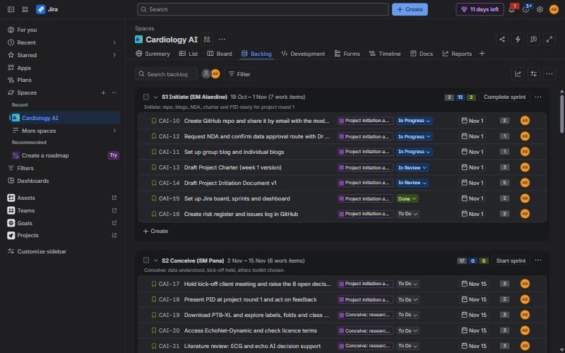
Figure 2. The Jira backlog with Sprint 1 active (screenshot, 19 October 2026).
Definition of ready | Definition of done
Clear value and acceptance criteria  Estimated in story points  Owner agreed  No blocker or missing approval | Acceptance criteria met  Reviewed by another member  Tests pass; reproducible from README  GitHub, blog and FAIR log updated

10. Project plan
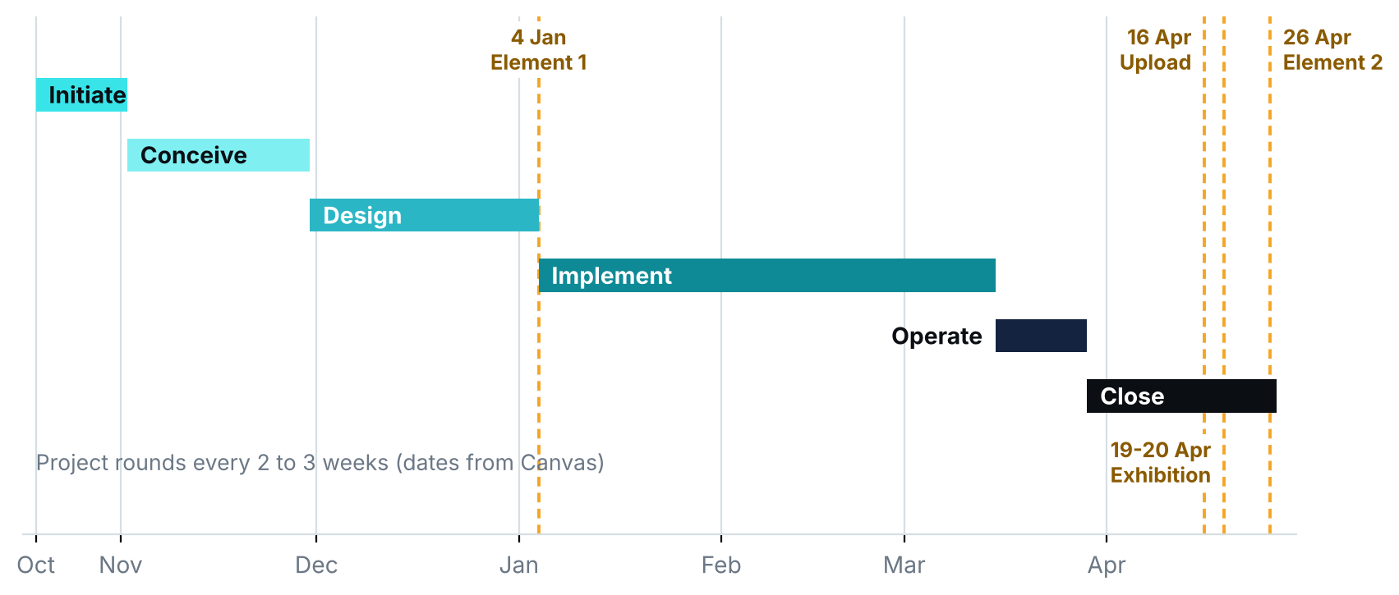
Figure 3. Phases and assessment dates. Project rounds every 2 to 3 weeks (dates from Canvas).
Sprint | Dates | Sprint goal | ScrumMaster | Points
S1 | 19 Oct to 1 Nov | Initiate: repo, blogs, NDA, charter and PID ready for project round 1 | Alaedine | 16
S2 | 2 Nov to 15 Nov | Conceive: data understood, kick-off held, ethics toolkit chosen | Pana | 17
S3 | 16 Nov to 29 Nov | Conceive: first simple ECG baseline and research summary | Reyad | 10
S4 | 30 Nov to 13 Dec | Design: experiment design, architecture, fusion rule and action table draft | Alaedine | 18
S5 | 14 Dec to 3 Jan | Design: Element 1 written and submitted (reduced capacity) | Pana | 15
S6 | 4 Jan to 17 Jan | Implement: data pipeline hardened, first neural ECG model | Reyad | 14
S7 | 18 Jan to 31 Jan | Implement: second ECG model and echo baseline | Alaedine | 13
S8 | 1 Feb to 14 Feb | Implement: rule engine, audit log and first UI | Pana | 16
S9 | 15 Feb to 28 Feb | Implement: ECG comparison, calibration and explanations | Reyad | 15
S10 | 1 Mar to 14 Mar | Implement: echo comparison and the combined ECG plus echo answer in the app | Alaedine | 13
S11 | 15 Mar to 28 Mar | Operate: end-to-end and combined-answer testing, user guide, client review | Pana | 12
S12 | 29 Mar to 16 Apr | Close: poster, demo rehearsal, governance and evidence upload | Reyad | 24
Sprint 5 covers the winter break at reduced capacity; Sprint 12 runs three weeks to the 16 April upload.

11. Quality plan
Area | Standard | Check | Owner
Code | Reviewed pull requests; README marks original, adapted and new code | Every story | Pana
Data | No patient details; patient-level splits; before and after datasets kept | Each data change | Reyad, Pana
Models | Same protocol for all approaches; fresh-clone rerun gives the same result | Every 2nd sprint | Reyad, Pana
App | Every result shows finding, confidence, explanation and action; the combined answer shows both findings and flags disagreement; every run logged | Sprint 8 onwards | Alaedine, Pana
Documents | Brief writing guidelines, Harvard referencing, proofread; blogs within 3 weeks | Every sprint | ScrumMaster

12. Roles and responsibilities
Member | Project role | Technical responsibilities
Alaedine Ait Bella | Project manager, technical lead, product owner contact | Jira and plan, client liaison, system design, echo models, app, rule engine, fusion engine, audit log
Reyad Taha | Data analyst | Data understanding and preparation, labels, splits, ECG baseline and neural models, error analysis
Pana Sharif | Tester, code refiner, ethics and legal | Test plan, code review, calibration, governance strategy, data protection, FAIR log

13. Resource allocation and cost estimation
Resource | Estimate | Basis
Team time | 600 hours (notional £9,000) | 3 people x about 10 hours a week x 20 active weeks, at an assumed £15 an hour
Compute | Up to £40 | Only if free tiers and university GPUs are not enough; GPU hours logged
Poster print | £25 | A1 poster for the exhibition
Contingency | £10 | Rounded up: about 15% of £65 cash costs
Tools | £0 | GitHub, Jira (free plan), Python, FastAPI, PyTorch, open data
Total cash cost | £75 | Cap £100, headroom £25
Total project value | £9,075 | £75 cash plus £9,000 notional labour (not paid)
Estimation techniques. The 600 hours is a top-down figure (3 people x 10 hours x 20 active weeks). We checked it bottom-up: each of the 38 WBS work packages has a three-point (PERT) estimate, recurring work such as Scrum events and client meetings is estimated parametrically, and sprint work is sized in story points with planning poker in Jira (183 points). The first-pass bottom-up total is 712 hours, 112 hours above the envelope, so the estimates will be re-scored with real velocity after Sprint 2 and Should items are the first to drop (Estimation workbook). A 15% capacity buffer covers known unknowns (R14).

14. Risk assessment and management
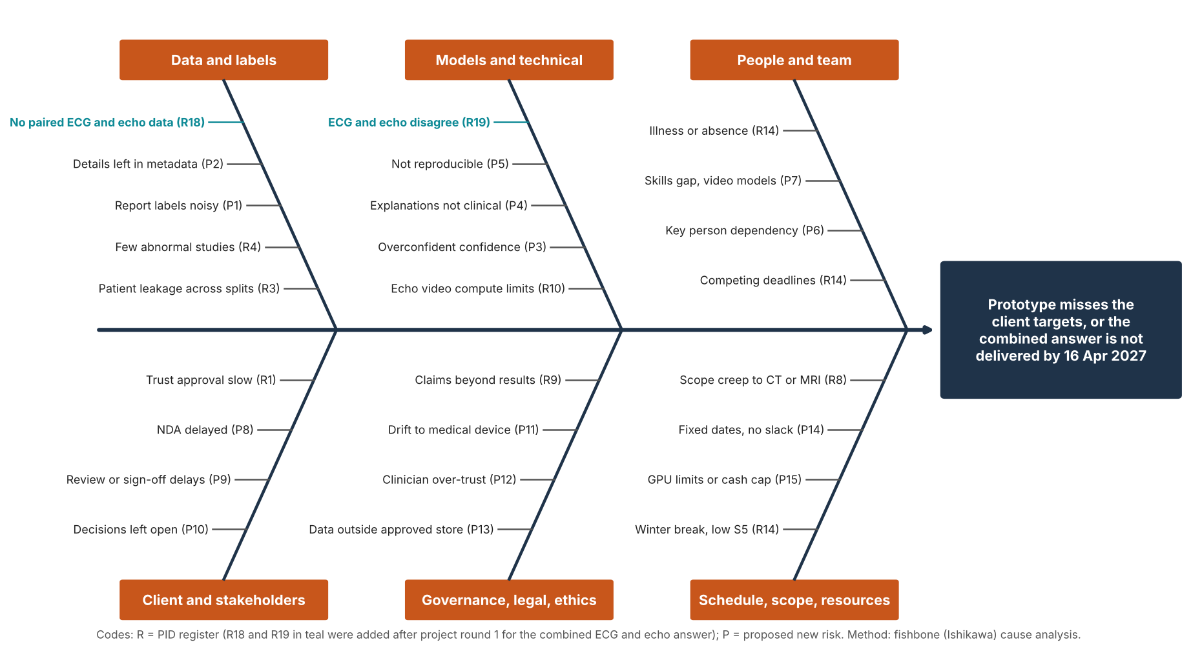
Figure 4a. Fishbone analysis of the causes behind the main risks, including R18 and R19 added after project round 1.
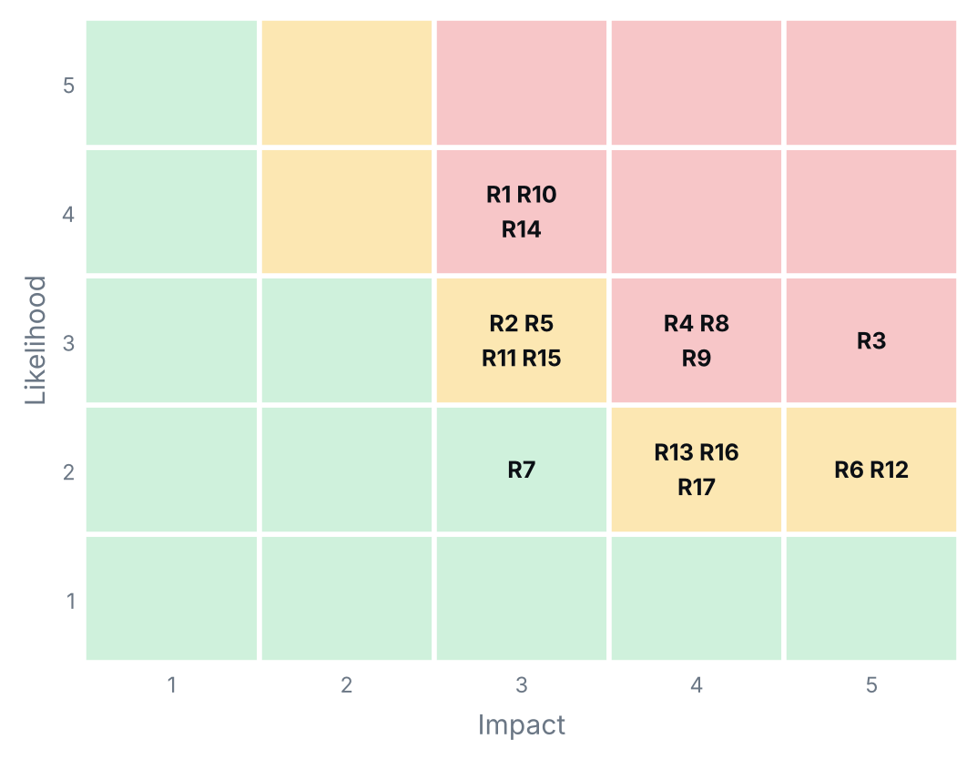
Figure 4b. Risk map: the 17 risks scored before project round 1.
ID | Risk | Score | Response | Owner
R18 | No paired ECG and echo studies from the same patients to test the combined answer | 16 | Fixed-rule fusion needs no paired training data; test on MIMIC-IV pairs or client data when approved; otherwise state the limit. | Reyad, Alaedine
R3 | Data leakage: studies from one patient appear in both training and test sets | 15 | Patient-level splits; Pana reviews the split code. | Reyad, Pana
R1 | Trust data approval is slow or refused (client brief) | 12 | Start on public data; no real data before written approval. | Alaedine, Dr Alaa
R4 | Too few abnormal studies, class imbalance | 12 | Balance classes; report misses, not just accuracy. | Reyad
R8 | Scope creep into CT, MRI or treatment advice | 12 | Scope baseline and written change control. | Alaedine
R9 | Claims go beyond what the results support | 12 | Report limits; clinical lead reviews wording. | All
R10 | Compute limits for echo video training | 12 | Pretrained models, data subsets, free GPU time. | Alaedine
R14 | Competing deadlines in other modules and work commitments reduce team capacity | 12 | Plan around deadlines; 15% capacity buffer. | Sprint ScrumMaster
R19 | ECG and echo results disagree and the combined answer hides it | 12 | Show both findings, flag disagreement for clinician review, most urgent action wins; rule signed off by Dr Alaa. | Pana
Top risks (score = likelihood x impact). R18 and R19 were added after project round 1 for the combined answer, so the register now holds 19 risks. The full register is in GitHub and is reviewed at every sprint retrospective using the process in the Risk Management Plan; new risks are raised in Jira and flagged on the board.

15. Deliverables and documentation
Deliverable | Where it lives | Due
Charter, PID, Jira backlog and dashboard | GitHub, Jira, group blog | Week 1 to PR1
MoSCoW list, communications plan, risk management plan, WBS, estimates and plan | GitHub, group blog | Nov 2026
Research summary and baseline results | GitHub, client email | Nov 2026
Element 1 reports (individual) | Canvas | 4 Jan 2027
Models, code, settings and comparison | GitHub (README) | Feb to Mar 2027
Action table, app, audit log, user guide | GitHub, client | Mar 2027
Fusion rule (signed) and combined-answer test results | GitHub, client | Dec 2026 (rule), Mar 2027 (tests)
Governance strategy, FAIR report, closure report | Group evidence | 16 Apr 2027
Poster and live demo | AI Exhibition | 19 or 20 Apr 2027
Element 2 reports (individual) | Canvas | 26 Apr 2027

16. Governance summary
Area | Our approach
Ethics | Always show finding, confidence, evidence and rule; the action is a suggestion and a clinician decides. Ethical toolkit chosen in sprint 2.
Data protection | UK GDPR and Data Protection Act 2018 (UK Government, 2018): public data first, no real data without written approval, details removed.
Regulation | MHRA software as a medical device guidance (Medicines and Healthcare products Regulatory Agency, no date): fixed signed-off action table, past studies only, no treatment advice.
Accountability | Named owner for the action table and the fusion rule; audit log of model, file and time for every run.
Sustainability | Pretrained and smaller models first; GPU hours logged.
The full governance strategy and its justification are developed in sprints 2 to 9 (brief item iv).

17. Monitoring and next steps
Progress is monitored on our Jira dashboard: sprint burndown, sprint health, days left, current sprint work, items due in 14 days, workload by owner and phase, and created versus resolved.
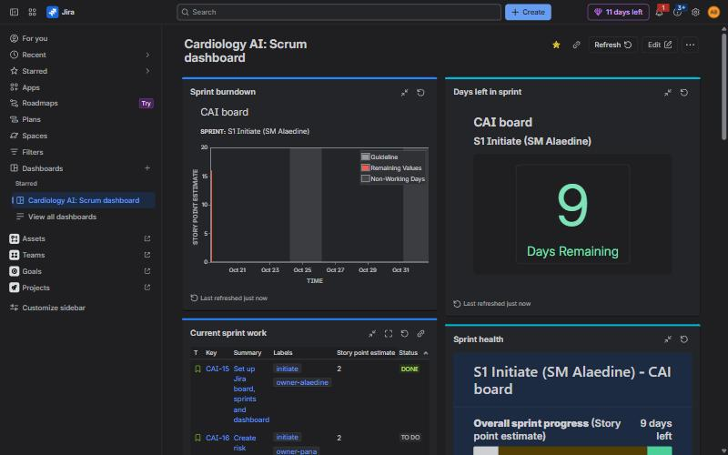
Figure 5. Jira Scrum dashboard (screenshot, 19 October 2026).
# | Decision needed from the client | Until then
1 | Permission for the data: process, forms, and how long it takes | Work on public data until approved in writing
2 | Table of findings and actions: which findings exist, what each trigger, who signs it off | Draft table prepared by the team in S4 for sign-off
3 | Out of hours: who the app names when cardiology is not on site | Placeholder contact names in the table until confirmed
4 | ECG and echo shown together as one answer, or kept separate | Decided after project round 1: combine into one final answer by a fixed rule (MoSCoW M3). Dr Alaa to confirm in writing (change control)
5 | Confirm or change the suggested targets | Suggested targets used as working baseline
6 | Which hospital is approached first (Sheffield Teaching Hospitals was mentioned, not agreed) | Not needed while we work on public data
7 | Does echo also estimate how well the heart pumps (LVEF), or stay normal or abnormal | Start with normal or abnormal; LVEF is a stretch goal
8 | Dr Ramzi's role, how often he can review, and who signs off the action table (Dr Alaa, Dr Ramzi or both) | Decided after project round 1: Dr Ramzi is our project supervisor (technical lead and guidance); Dr Alaa is the clinical lead and signs off the action table
9 | Confirm or change the MoSCoW list of requirements | Working list in section 4 used
10 | Confirm the research papers and the example app to be sent with the brief | Use the four sources in the client brief

Sprint 2 actions (2 Nov to 15 Nov): confirm in writing with Dr Alaa the MoSCoW list and the change to one combined answer; agree a regular supervision slot with Dr Ramzi; check the EchoNet-Dynamic licence and the paired data options; choose the ethics toolkit; publish the communications plan and risk register; hold the kick-off client meeting.

Approval | Decision | Signature and date
Dr Alaa, client | Approved / With changes / Not approved
Dr Kulvinder Panesar, module leader | Approved / With changes / Not approved
Alaedine, Reyad, Pana | Agreed

References
Agile Business Consortium (no date) What is MoSCoW prioritization? Available at: https://www.agilebusiness.org/resource/what-is-moscow-prioritization/ (Accessed: 5 November 2026).
Doerr, J. (2018) Measure what matters: how Google, Bono, and the Gates Foundation rock the world with OKRs. New York: Portfolio/Penguin.
Gow, B. et al. (2023) MIMIC-IV-ECG: diagnostic electrocardiogram matched subset (version 1.0). PhysioNet. doi: 10.13026/4nqg-sb35.
Gow, B. et al. (2026) MIMIC-IV-Echo: echocardiogram matched subset (version 1.0.1). PhysioNet. doi: 10.13026/307c-mr50.
Lang, R.M., Badano, L.P., Mor-Avi, V. et al. (2015) ‘Recommendations for cardiac chamber quantification by echocardiography in adults’, Journal of the American Society of Echocardiography, 28(1), pp. 1–39.
McDonagh, T.A., Metra, M., Adamo, M. et al. (2021) ‘2021 ESC Guidelines for the diagnosis and treatment of acute and chronic heart failure’, European Heart Journal, 42(36), pp. 3599–3726.
Medicines and Healthcare products Regulatory Agency (no date) Software and artificial intelligence (AI) as a medical device. Available at: https://www.gov.uk/government/publications/software-and-artificial-intelligence-ai-as-a-medical-device (Accessed: 18 October 2026).
Ouyang, D., He, B., Ghorbani, A., Yuan, N., Ebinger, J., Langlotz, C.P., Heidenreich, P.A., Harrington, R.A., Liang, D.H., Ashley, E.A. and Zou, J.Y. (2020) ‘Video-based AI for beat-to-beat assessment of cardiac function’, Nature, 580, pp. 252–256.
Panesar, K. (2026) COS6032-E Industrial AI Project: assignment brief and assessment information. University of Bradford, published 12 October 2026.
Schwaber, K. and Sutherland, J. (2020) The Scrum Guide. Available at: https://scrumguides.org (Accessed: 18 October 2026).
Simplifi Med Ltd (2026) Cardiology AI: reading ECGs and echo studies. Client brief, student project, September 2026.
Strodthoff, N., Wagner, P., Schaeffter, T. and Samek, W. (2021) ‘Deep learning for ECG analysis: benchmarks and insights from PTB-XL’, IEEE Journal of Biomedical and Health Informatics, 25(5), pp. 1519–1528. doi: 10.1109/JBHI.2020.3022989.
UK Government (2018) Data Protection Act 2018. c. 12. Available at: https://www.legislation.gov.uk/ukpga/2018/12/contents (Accessed: 18 October 2026).
Wagner, P., Strodthoff, N., Bousseljot, R.-D., Kreiseler, D., Lunze, F.I., Samek, W. and Schaeffter, T. (2020) ‘PTB-XL, a large publicly available electrocardiography dataset’, Scientific Data, 7, article 154. doi: 10.1038/s41597-020-0495-6.

Appendix A. FAIR report

