STAKEHOLDER REGISTER
Stakeholder Register
Who has an interest in the Cardiology AI project, how much influence they have, and how we engage them; updated after project round 1 with Dr Ramzi as project supervisor
Project | Cardiology AI: reading ECGs and echo studies
Client and sponsor | Simplifi Med Ltd, Dr Alaa
Module | COS6032-E Industrial AI Project, University of Bradford
Module leader | Dr Kulvinder Panesar
Group | B26
Version and date | 1.2, 5 November 2026 (after project round 1)
Prepared by | Alaedine Ait Bella, project manager

Team member | Role | Student number
Alaedine Ait Bella | Project manager and technical lead | 24019746
Reyad Taha | Data analyst | 24005092
Pana Sharif | Tester, code refiner, ethics and legal | 22011714

1. Purpose
This register lists every stakeholder, rates their interest and influence, and sets how we engage them. After project round 1 the module team asked us to add Dr Ramzi as a stakeholder. He is our project supervisor and sits in the manage closely group; Dr Alaa is the client and clinical lead. The register feeds the Communications Plan and the RACI in PID section 5.

2. Stakeholder map
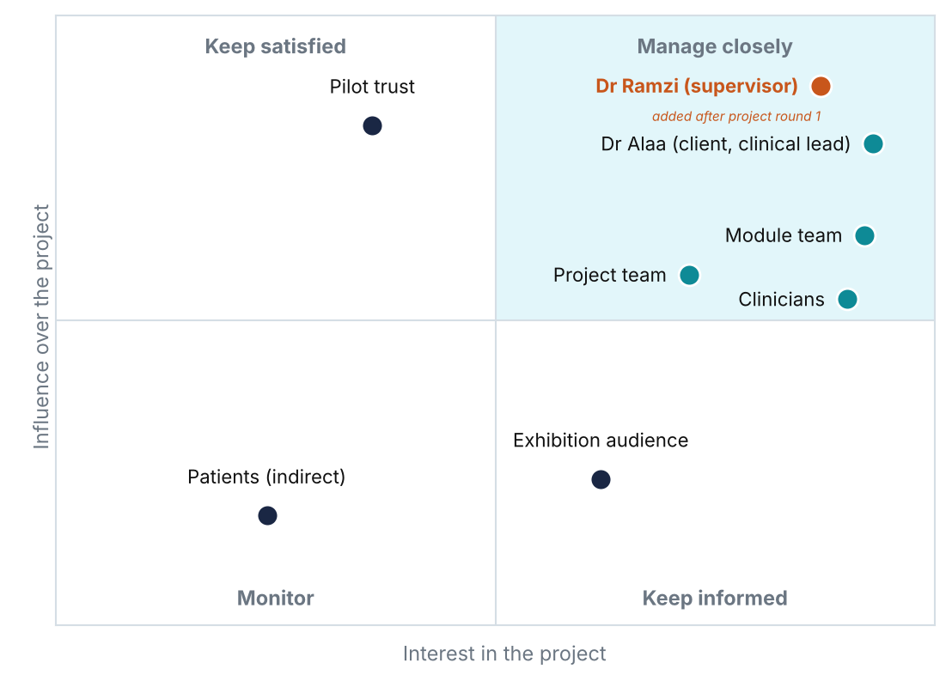
Figure 1. Stakeholder map by influence and interest, updated after project round 1.
Interest and influence come from charter section 8. The strategy follows the usual grid: high interest and high influence are managed closely; high influence with lower interest are kept satisfied; high interest with lower influence are kept informed; the rest are monitored.

3. Register
ID | Stakeholder | Role | Interest | Influence | Strategy | What they need from us
S1 | Dr Alaa | Client, sponsor and clinical lead, Simplifi Med Ltd | High | High | Manage closely | Sets targets; as clinical lead owns and signs off the action table and fusion rule, checks labels and wording, reviews sample cases; NDA; data approval status; decisions list
S2 | Dr Ramzi | Project supervisor: guides the team technically, explains methods, leads technical decisions | High | High | Manage closely | Progress, technical blockers, model and experiment choices, architecture and fusion design questions
S3 | Dr Kulvinder Panesar and module team | Module leader; runs rounds and assessment | High | High | Manage closely | Progress against plan, risks, repo link, evidence on blog; change requests
S4 | Pilot trusts and clinicians | Future users; approve data use | Medium | High | Keep satisfied | Data approval process, forms and timings; later: results and limits
S5 | Alaedine Ait Bella | Project manager and technical lead | High | High | Manage closely | Plan, Jira, client liaison, system design, echo, app
S6 | Reyad Taha | Data analyst | High | Medium | Keep informed | Data preparation, splits, ECG experiments; blockers
S7 | Pana Sharif | Tester, ethics and legal | High | Medium | Keep informed | Testing, calibration, governance, FAIR log; blockers
S8 | Exhibition audience and secondary stakeholders | Invited guests at the AI Exhibition | Medium | Medium | Monitor | What the prototype does, its limits, how to ask questions

4. Dr Ramzi, project supervisor
Dr Ramzi is our project supervisor. He helps the team, explains methods and concepts, and leads us technically. He has high interest and high influence, because his guidance shapes the technical choices the project depends on. Clinical decisions stay with Dr Alaa, who is the client and the clinical lead.
Added | After project round 1, on feedback from the module team
Role | Project supervisor: technical lead and guidance
Strategy | Manage closely
Guides us on | Model approaches for ECG and echo; experiment design and evaluation; system architecture; the technical design of the fusion rule that combines ECG and echo; the MoSCoW list; how to solve technical blockers
How we engage | Regular supervision meetings [confirm frequency]; invited to sprint reviews and client meetings; questions by email or chat between meetings
Records | Supervision notes on the group blog; technical actions added to Jira
Clinical sign-off | Not his role. Dr Alaa, as clinical lead, signs off the action table, the acute-change labels, the fusion rule and the clinical review of sample cases

5. Responsibilities (RACI)
Activity | Alaedine | Reyad | Pana | Client
Plan, Jira, risks, client liaison | A/R | C | C | I
Data preparation and ECG experiments | C | A/R | C | I
Echo pipeline; app, rules, fusion engine, audit log | A/R | C | C | I
Testing, calibration, governance, FAIR log | C | C | A/R | I
Findings-to-action table | R | C | C | A
Fusion rule (how ECG and echo combine) | R | C | C | A
Clinical review of labels, wording and sample cases (Dr Alaa, clinical lead) | R | C | C | A
Blogs, poster and demo | R | R | R | I
R = does the work, A = accountable, C = consulted, I = informed. The fusion rule row was added after project round 1.

6. Keeping the register current
- Reviewed at every second sprint planning, together with the MoSCoW list.
- New stakeholders are added with a rating and a strategy before anyone contacts them.
- Pilot trusts and clinicians are reached only through Dr Alaa.

References
Project Management Institute (2021) A guide to the project management body of knowledge (PMBOK guide). 7th edn. Newtown Square, PA: Project Management Institute.
Panesar, K. (2026) COS6032-E Industrial AI Project: assignment brief and assessment information. University of Bradford.
Simplifi Med Ltd (2026) Cardiology AI: reading ECGs and echo studies. Client brief, student project, September 2026.

