RISK MANAGEMENT PLAN
Risk Management Plan
Process, fishbone analysis, scoring and register for the Cardiology AI project, updated after project round 1
Project | Cardiology AI: reading ECGs and echo studies
Client and sponsor | Simplifi Med Ltd, Dr Alaa
Module | COS6032-E Industrial AI Project, University of Bradford
Module leader | Dr Kulvinder Panesar
Group | B26
Version and date | 1.2, 5 November 2026 (after project round 1)
Prepared by | Alaedine Ait Bella, project manager

Team member | Role | Student number
Alaedine Ait Bella | Project manager and technical lead | 24019746
Reyad Taha | Data analyst | 24005092
Pana Sharif | Tester, code refiner, ethics and legal | 22011714

1. Purpose and scope
This plan sets out how we find, score, respond to and monitor risks across all CDIO phases. It covers project, technical, clinical, legal and ethical risks. After project round 1 the app must combine ECG and echo into one final answer, which brings two new risks: R18 (no paired data to test the combined answer) and R19 (the combined answer hides a disagreement between the two tests).

2. Process
Step | Name | What we do | Tools and output | Who and when
1 | Identify | Use the fishbone below to find causes under six branches (data, models, people, client, governance, schedule). Add risks from the client brief s10 and any raised in retros. | Fishbone diagram; risk raised in Jira with label 'risk' | Whole team; Sprint 1, then every retrospective
2 | Assess | Score likelihood (1 to 5) and impact (1 to 5). Score = likelihood x impact. Rate Critical (15 to 25), High (10 to 14), Medium (5 to 9), Low (1 to 4). | Scales in Part C; register in Part D | Risk owner proposes, ScrumMaster confirms at sprint planning
3 | Respond | Choose a strategy: avoid, mitigate, transfer or accept. Name an owner, a response, and an early-warning trigger. | Register columns J to L; actions as Jira stories | Risk owner; within the sprint the risk is scored
4 | Monitor and report | Review the register at every sprint retrospective; show top risks at each project round; re-score after each response. Escalate any Critical risk to the client and module leader within 3 working days. | Heat map (Part E); Jira dashboard; blog entry per retro | ScrumMaster each sprint; project manager at rounds
5 | Close or learn | Close a risk when its trigger date has passed or it is retired. Record lessons in the retrospective and the closure report. | Status column; lessons learned in 6.3.1 | Project manager at closure

3. Identification with a fishbone diagram
We used a fishbone (Ishikawa) diagram to look for causes under six branches before writing risks (Ishikawa, 1986). The effect is the outcome we most want to avoid: the prototype misses the client targets, or the combined answer is not delivered by 16 April 2027.
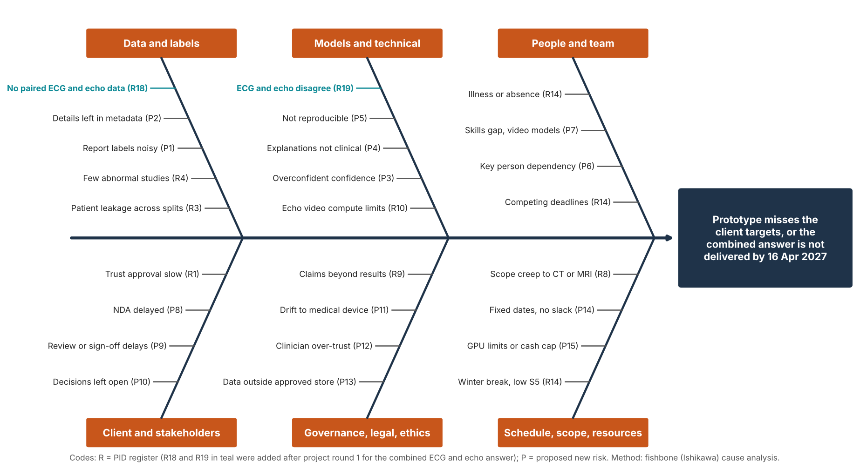
Figure 1. Fishbone analysis. R18 and R19, in teal, were added after project round 1.

4. Assessment scales
Score | Likelihood | Impact (time, quality, safety and ethics)
1 | Rare: under 10% | Negligible: under 1 day lost; no effect on targets or marks
2 | Unlikely: 10 to 30% | Minor: 1 to 3 days lost; one Should or Could item affected
3 | Possible: 30 to 50% | Moderate: up to 1 sprint lost; a Should item lost or a target missed narrowly
4 | Likely: 50 to 80% | Major: a Must item or deadline at risk; client sign-off blocked
5 | Almost certain: over 80% | Severe: results invalid, patient data breach, or prototype undeliverable

Rating | Score (likelihood x impact) | Action
Critical | 15 to 25 | Response started this sprint; client and module leader told within 3 working days
High | 10 to 14 | Response planned in the next sprint; reviewed at every retrospective
Medium | 5 to 9 | Owner monitors the trigger; reviewed every second sprint
Low | 1 to 4 | Accepted and watched

5. Risk register
R1 to R17 come from the PID register (the PID gives a score only, so the split into likelihood and impact is our proposal for the team to confirm). R18 and R19 were added after project round 1. P1 to P15 are proposed new risks from the fishbone analysis. Sorted by score.
ID | Source | Risk | L | I | Score | Rating | Strategy | Response | Early-warning trigger | Owner
R18 | New after PR1 | No paired ECG and echo studies from the same patients to test the combined answer (PTB-XL and EchoNet-Dynamic are different patients) | 4 | 4 | 16 | Critical | Mitigate | Fixed-rule late fusion needs no paired training data. Test on paired cases from MIMIC-IV-ECG with MIMIC-IV-Echo if credentialed access is approved, or client data after trust approval; otherwise clinicians review constructed case pairs and the limit is stated. | No paired data route confirmed by end of Sprint 4 (13 Dec 2026) | Reyad, Alaedine
R3 | PID | Data leakage: studies from one patient appear in both training and test sets | 3 | 5 | 15 | Critical | Mitigate | Patient-level splits; Pana reviews the split code. | Split script changed without review; scores far above published benchmarks | Reyad, Pana
R1 | PID | Trust data approval is slow or refused (client brief) | 4 | 3 | 12 | High | Mitigate | Start on public data; no real data before written approval. | No approval timeline from client by end of Sprint 3 | Alaedine, Dr Alaa
R4 | PID | Too few abnormal studies, class imbalance | 4 | 3 | 12 | High | Mitigate | Balance classes; report misses, not just accuracy. | Abnormal share in a split under 10% | Reyad
R8 | PID | Scope creep into CT, MRI or treatment advice | 3 | 4 | 12 | High | Avoid | Scope baseline and written change control. | Request outside charter s5 scope reaches the backlog | Alaedine
R9 | PID | Claims go beyond what the results support | 3 | 4 | 12 | High | Mitigate | Report limits; clinical lead reviews wording. | Poster or report draft states a diagnosis or untested accuracy | All
R10 | PID | Compute limits for echo video training | 4 | 3 | 12 | High | Mitigate | Pretrained models, data subsets, free GPU time. | Echo epoch time over 1 hour; free GPU quota used | Alaedine
R14 | PID | Competing deadlines in other modules and work commitments reduce team capacity | 4 | 3 | 12 | High | Mitigate | Plan around deadlines; 15% capacity buffer. | Sprint velocity under 80% of plan for two sprints | Sprint ScrumMaster
R19 | New after PR1 | ECG and echo results disagree and the combined answer hides the disagreement | 3 | 4 | 12 | High | Avoid | Fusion rule always shows both findings, flags 'results disagree: clinician review', and the most urgent action wins; rule signed off by Dr Alaa, with its technical design guided by Dr Ramzi. | Any combined answer in testing that does not show both findings | Pana
P3 | Proposed | Confidence scores are overconfident or poorly calibrated | 3 | 4 | 12 | High | Mitigate | Report calibration error and reliability plot; apply calibration method from protocol. | Calibration error above agreed threshold on validation fold | Pana
P6 | Proposed | Key-person dependency: one member holds project manager, technical lead, echo and app roles | 3 | 4 | 12 | High | Mitigate | Pair on echo and app; every pull request reviewed by another member; document handover notes. | One member holds over 40% of open stories | Alaedine
P9 | Proposed | Dr Alaa is slow to review or sign off, or supervision time with Dr Ramzi is limited | 3 | 4 | 12 | High | Mitigate | Agree review dates at the first client meeting; send review packs 1 week ahead; use placeholder contacts until confirmed. | Review pack unanswered after 7 days | Alaedine
P10 | Proposed | Targets and open decisions (echo target, action table, out-of-hours contact) stay unconfirmed | 3 | 4 | 12 | High | Mitigate | Track decisions in the comms plan; use suggested targets as working baseline; escalate through module leader. | Decision still open 2 sprints after it is needed | Alaedine
P14 | Proposed | Fixed dates leave no slack, especially Element 1 on 4 Jan after the winter break | 3 | 4 | 12 | High | Mitigate | Write Element 1 in Sprint 4 to 5; keep Sprint 5 tasks small; freeze scope on 14 Mar. | Element 1 draft not ready by 14 Dec | ScrumMaster
P2 | Proposed | Patient details left in file names or hidden file metadata | 2 | 5 | 10 | High | Avoid | Check names and metadata before the team sees data; log each check. | Any identifier found in a dataset | Pana
P11 | Proposed | Software drifts towards a regulated medical device (MHRA) | 2 | 5 | 10 | High | Avoid | Fixed signed-off action table; past studies only; no treatment advice. | Request to extend advice beyond who to contact and when to review | Pana
P13 | Proposed | Data held outside approved storage (UK GDPR) | 2 | 5 | 10 | High | Avoid | Approved storage only; no copies on personal laptops or public sites. | Any data file found outside approved storage | Pana
P1 | Proposed | Labels from reports are wrong or reports disagree | 3 | 3 | 9 | Medium | Mitigate | Record disagreements; clinical lead checks a sample; state as a limitation (client brief s10). | Label audit finds more than 5% disagreement | Reyad
P4 | Proposed | Explanations (highlighted regions) do not make clinical sense | 3 | 3 | 9 | Medium | Mitigate | Dr Alaa reviews 20 cases for clinical sense; show failure examples. | Reviewer rejects more than 5 of 20 explanations | Pana, Reyad
P7 | Proposed | Skills gap in video models and transfer learning | 3 | 3 | 9 | Medium | Mitigate | Use pretrained models; time-box learning in Sprint 6; ask tutors early. | No echo baseline by end of S7 | Alaedine
P5 | Proposed | Results cannot be reproduced from a fresh copy of the repository | 2 | 4 | 8 | Medium | Mitigate | Fixed seeds, pinned versions, README, rerun by another member every second sprint. | Rerun differs from reported results | Reyad, Pana
P8 | Proposed | NDA is delayed or not signed before confidential material arrives | 2 | 4 | 8 | Medium | Avoid | No confidential material is opened until the NDA is signed; chase at each client contact. | NDA still unsigned 2 weeks after request | Alaedine
P12 | Proposed | Clinicians trust the app over their own judgement | 2 | 4 | 8 | Medium | Mitigate | Always show finding, confidence, explanation and rule; label as decision support only. | UI text or demo implies the app decides | Pana
P15 | Proposed | Free GPU limits are exceeded or the 100 cash cap is breached | 3 | 2 | 6 | Medium | Mitigate | Log GPU hours; smaller models first; approve any spend against the cap. | Cloud spend above 20 | Alaedine

6. Heat map
 | Likelihood 1 | Likelihood 2 | Likelihood 3 | Likelihood 4 | Likelihood 5
Impact 5 |  | P2, P11, P13 | R3
Impact 4 |  | P5, P8, P12 | R8, R9, R19, P3, P6, P9, P10, P14 | R18
Impact 3 |  |  | P1, P4, P7 | R1, R4, R10, R14
Impact 2 |  |  | P15
Impact 1

Rating | Number of risks
Critical | 2
High | 15
Medium | 7
Low | 0

7. The two new risks from the combined answer
R18, no paired data (score 16, Critical). PTB-XL and EchoNet-Dynamic come from different patients, so we cannot test how the two answers combine for the same person. Our response is a fixed fusion rule, which needs no paired training data, tested on paired studies from MIMIC-IV-ECG with MIMIC-IV-Echo if credentialed access is approved, or on client data after trust approval (Gow et al., 2023; Gow et al., 2026). If neither arrives by the end of Sprint 4, clinicians review constructed case pairs and we report the limit.
R19, disagreement hidden (score 12, High). If the ECG looks normal and the echo looks abnormal, an average could hide the problem. The fusion rule always shows both findings, flags the disagreement for clinician review, and takes the more urgent action. Dr Alaa signs the rule off as clinical lead, and Dr Ramzi guides its technical design.

8. Monitoring and reporting
- The register is reviewed at every sprint retrospective; owners re-score their risks after each response.
- Top risks are shown at every project round and discussed at the client meeting that follows.
- New risks are raised in Jira with the label 'risk' and added to the register within the sprint.
- Closed risks and lessons learned go into the retrospective blog entry and the closure report.
The live register with formulas and the heat map is the Risk Register spreadsheet in this folder and sheet 3 of the master planning workbook.

References
Ishikawa, K. (1986) Guide to quality control. 2nd edn. Tokyo: Asian Productivity Organization.
Gow, B. et al. (2023) MIMIC-IV-ECG: diagnostic electrocardiogram matched subset (version 1.0). PhysioNet. doi: 10.13026/4nqg-sb35.
Gow, B. et al. (2026) MIMIC-IV-Echo: echocardiogram matched subset (version 1.0.1). PhysioNet. doi: 10.13026/307c-mr50.
Medicines and Healthcare products Regulatory Agency (no date) Software and artificial intelligence (AI) as a medical device. Available at: https://www.gov.uk/government/publications/software-and-artificial-intelligence-ai-as-a-medical-device (Accessed: 18 October 2026).
Project Management Institute (2021) A guide to the project management body of knowledge (PMBOK guide). 7th edn. Newtown Square, PA: Project Management Institute.
Panesar, K. (2026) COS6032-E Industrial AI Project: assignment brief and assessment information. University of Bradford.
Simplifi Med Ltd (2026) Cardiology AI: reading ECGs and echo studies. Client brief, student project, September 2026.

