Naan Mudhalvan- Frontend Development And Database Administration

VALLIAMMAL COLLEGE FOR WOMEN

DEPARTMENT OF COMPUTER APPLICATIONS

**Project Title:** Cryptoverse- Cryptocurrency Dashboard

**Team Leader:** Al Afrah A

**Team ID:** SWTID1741253676147516

**Team Size:** 4

**Team Member:** Al Afrah A

**Team Member:** Jayalakshmi S

**Team Member:** Swetha S

**Team Member:** Kanimozhi M

**Github Link:** <https://github.com/ALAFRAH3/cryptoverse-Alafrah>

**Google Drive Link:** <https://drive.google.com/drive/folders/1sh79C168EGvnl_uy93-A1GyvKW3xQ-rk?usp=sharing>

**CRYPTOVERSE**

**INTRODUCTION**

A cryptocurrency dashboard that displays historical price data over the past five years is a powerful tool for investors seeking a comprehensive understanding of market dynamics. This feature-rich interface offers users a detailed historical perspective on the performance of various cryptocurrencies, enabling insightful analysis and informed decision-making. Through visually intuitive charts and graphs, the dashboard allows for effective comparisons of multiple crypto currencies, aiding in identifying top performers and overall market trends. Users can customize timeframes for a more granular examination of price movements, facilitating in-depth volatility analysis and risk assessment. This historical data not only supports investors in making data-driven decisions but also assists in recognizing recurring patterns and cycles. Beyond its role in optimizing cryptocurrency portfolios, the dashboard serves as an educational resource, empowering users to grasp the evolving nature of cryptocurrency markets and the nuanced factors shaping price movements over an extended period.

**DESCRIPTION**

Cryptoverse is a sophisticated cryptocurrency dashboard designed to give investors comprehensive insights into market dynamics through detailed historical price data analysis spanning five years. Featuring visually intuitive charts, interactive tools, and seamless navigation, the platform empowers users to identify top-performing assets and make informed investment decisions. With its robust search functionality, users can easily explore a wide range of cryptocurrencies and compare their performance over time. Cryptoverse not only serves as a powerful tool for optimizing investment portfolios but also acts as an educational resource, helping users understand the evolving nature of cryptocurrency markets.

## **PROJECT STRUCTURE:**

## 

## 

## 

**PROJECT FLOW**

Project setup and configuration:

**1. Setup React Application:**

• Create a React app in the client folder.

• Install required libraries.

• Create the required pages and components and add routes.

**2. Design UI components:**

• Create Components.

• Implement layout and styling.

• Add navigation.

**3. Implement frontend logic:**

• Integration with API endpoints.

• Implement data binding.

**REFERENCE IMAGE**

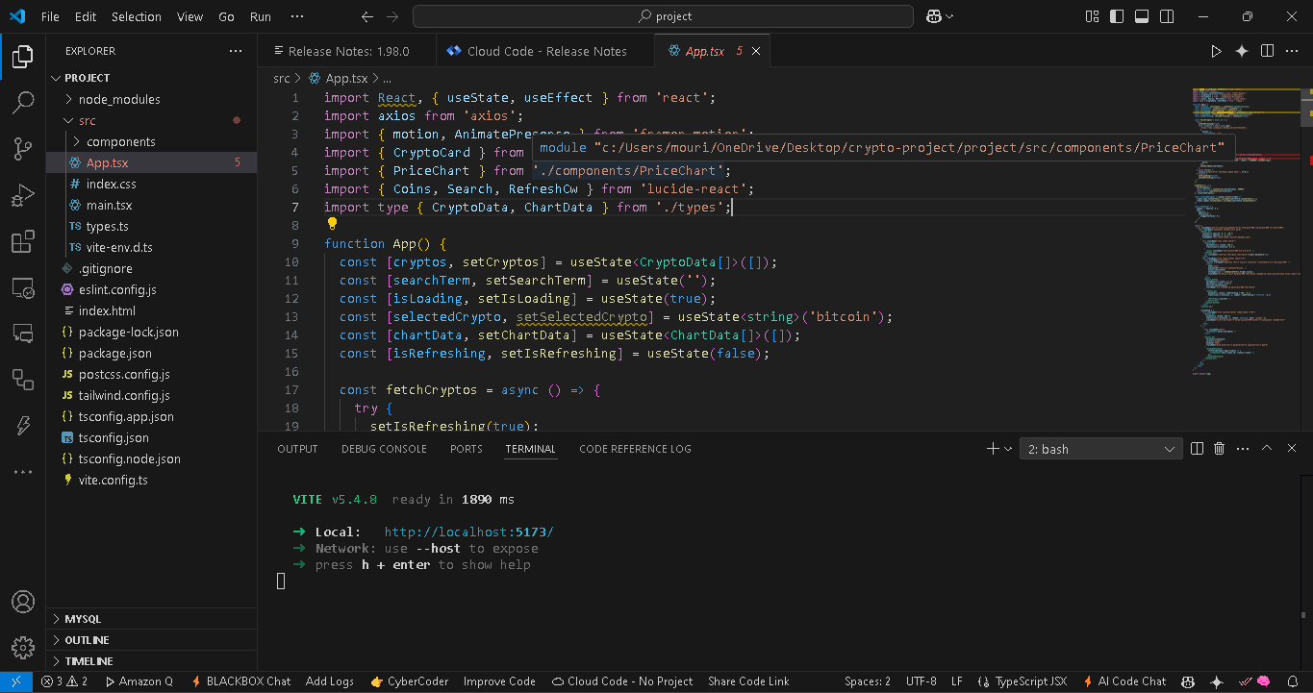

**PRE-REQUISITES**

Here are the key prerequisites for developing a front-end application using React.js: ✔ Node.js and npm:

Node.js is a powerful JavaScript runtime environment that allows you to run JavaScript code in the local environment. It provides a scalable and efficient platform for building network applications.

Install Node.js and npm on your development machine, as they are required to run JavaScript on the server side.

● Download: https://nodejs.org/en/download/

● Installation instructions: https://nodejs.org/en/download/package-manager/

✔ React.js:

React.js is a popular JavaScript library for building user interfaces. It enables developers to create interactive and reusable UI components, making it easier to build dynamic and responsive web applications.

Install React.js, a JavaScript library for building user interfaces.

● Create a new React app:

npx create-react-app my-react-app

Replace my-react-app with your preferred project name.

● Navigate to the project directory:

cd my-react-app

● Running the React App:

With the React app created, you can now start the development server and see your React application in action.

● Start the development server:

npm start.

This command launches the development server, and you can access your React app at http://localhost:3000 in your web browser.

✔ HTML, CSS, and JavaScript: Basic knowledge of HTML for creating the structure of your app, CSS for styling, and JavaScript for client-side interactivity is essential.

✔ Version Control: Use Git for version control, enabling collaboration and tracking changes throughout the development process. Platforms like GitHub or Bitbucket can host your repository.

• Git: Download and installation instructions can be found at: https://git-scm.com/downloads

✔ Development Environment: Choose a code editor or Integrated Development Environment (IDE) that suits your preferences, such as Visual Studio Code, Sublime Text, or WebStorm.

• Visual Studio Code: Download from https://code.visualstudio.com/download • Sublime Text: Download from https://www.sublimetext.com/download

• WebStorm: Download from https://www.jetbrains.com/webstorm/download

**USER INTERFACE SNIPS**

⮚ Home page: This page consists of stats of global crypto like total cryptocurrencies, total exchanges, market cap, etc. Also, it consists of the top 10 cryptocurrencies in the world.

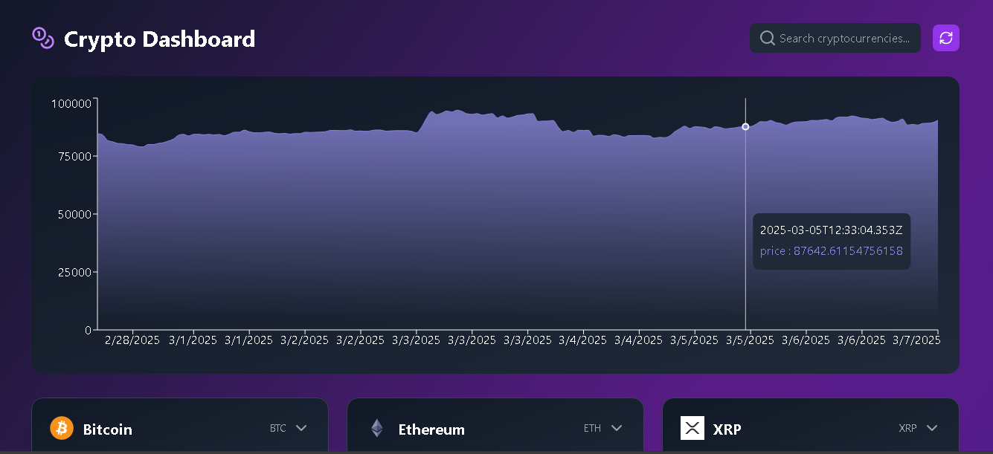

⮚ Crypto currencies page: This page contains all cryptocurrencies that are currently in flow in the world. There is also a search feature where users can search and find out about their desired cryptocurrency.

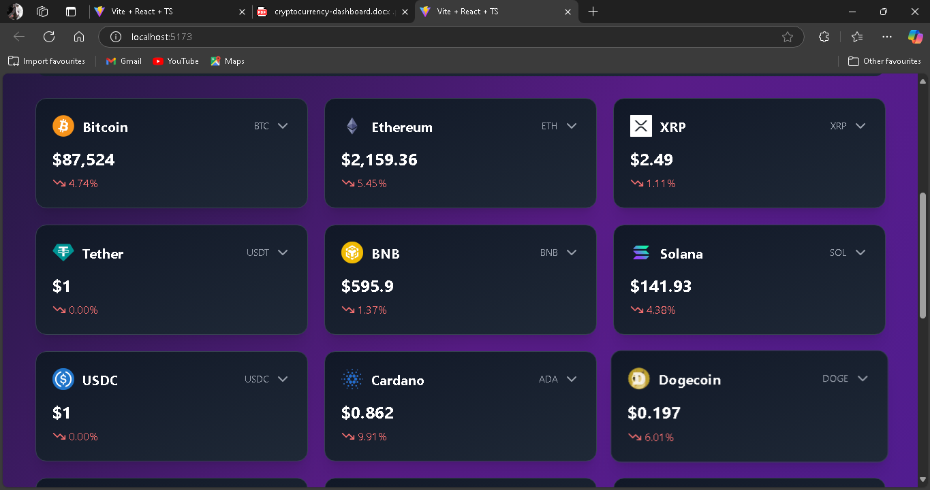

⮚ Crypto currency details page: This page contains the line chart with data representation of the price of cryptocurrencies. Also includes statistics and website links of cryptocurrencies.

