The SOF file named “Basic_Organ_Solution.sof” is located in directory “*/rtl/ Basic_Organ_Solution.sof”

**State of the Lab:** Finished. Everything is functioning as expected **except** the bonus part.

**Simulations:**

Operation & explanation of the simulation is written in the comment of every testbench code.

For LED controller:

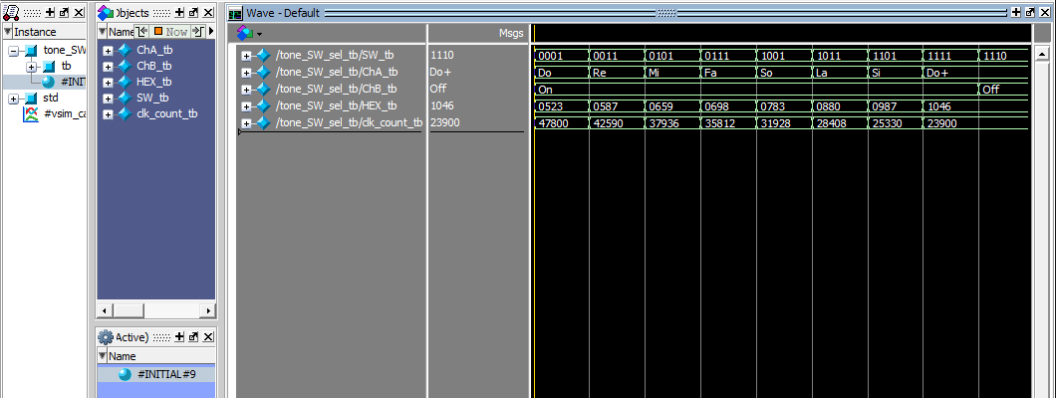

File "*/rtl/Led.sv" is the Led controller, and "*/rtl/Led_tb.sv" is its testbench

For tone/character selector:

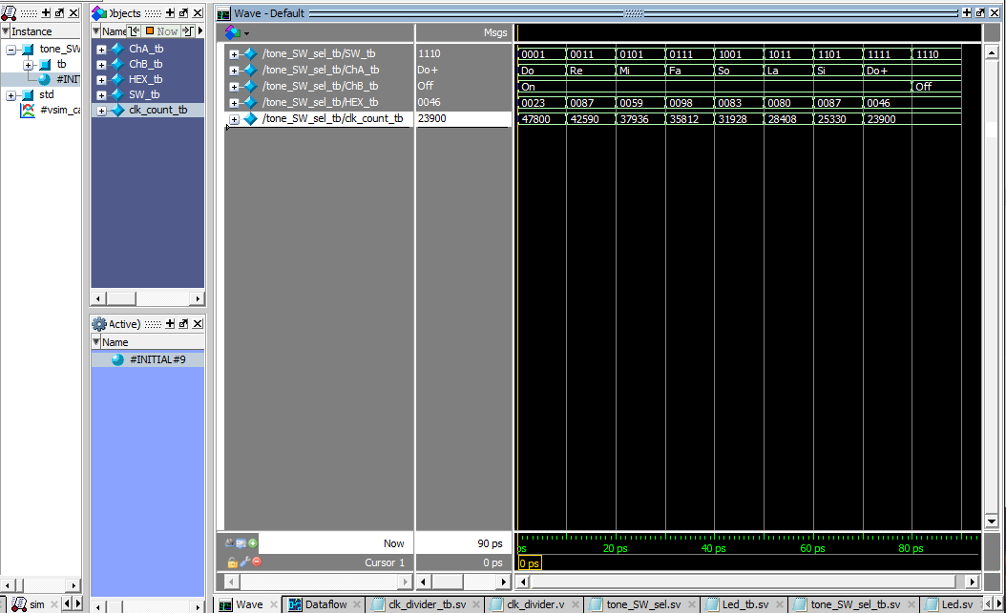

File "*/rtl/tone_sel.sv" orresponds to the tone organ module, and "*/rtl/tone_sel_tb.sv" is its testbench. The actual code is implemented in the "Basic_Organ_Solution.v"

For clk_divider:

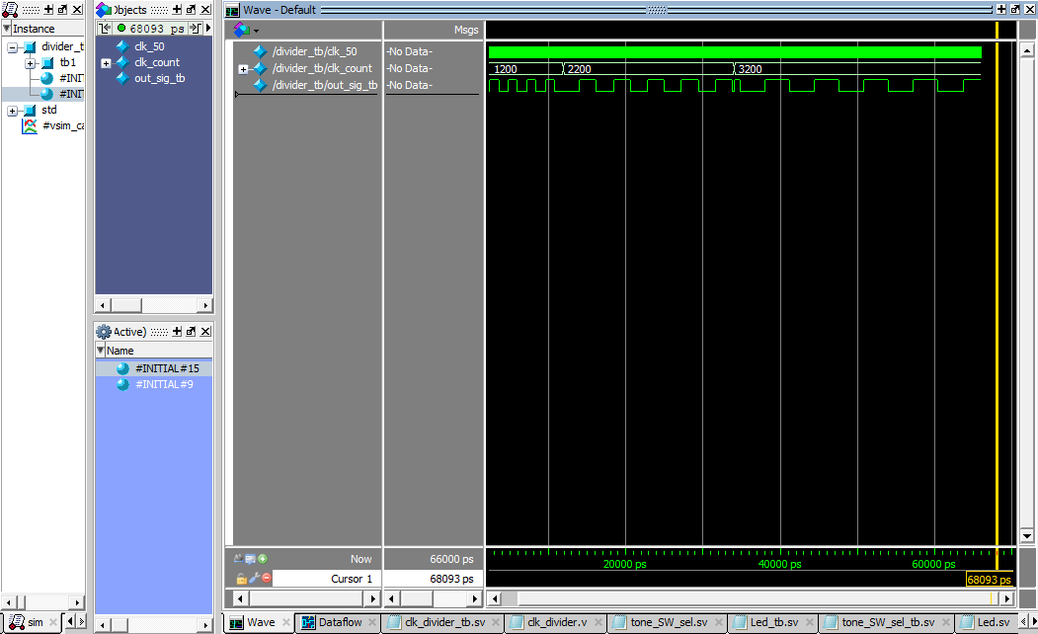

File "*/rtl/clk_divider.v" is the frequency divider, and "*/rtl/clk_divider_tb.sv" is its testbench

There are wave format file “*/sim/Sel.do ”, “*/sim/Led.do” and “*/sim/clk_divider.do” respectively.