Koketso Rabothata - ST10447912
Lindo Mphenyeke-ST10446906
Given Mudau - ST10451061
Alan Chauke - ST10445966
Lwanda Godlwana -ST10450796

1. Introduction
Personal budgeting applications have become essential tools for individuals who want to manage their finances effectively. Young professionals in particular often face multiple financial responsibilities such as rent, transport, groceries, subscriptions, and savings goals. Without proper financial tracking, it can become difficult to maintain spending discipline and achieve long-term financial stability.
Many budgeting applications exist on the Android platform. However, these applications differ greatly in their design, functionality, and approach to helping users manage their money. Some apps focus on structured financial tracking and analytics, while others prioritize user engagement through visual design or gamification features.
This research evaluates three existing Android budgeting applications: Mint, Emma, and Fortune City. Each of these apps represents a different strength in the personal finance market. Mint focuses on structured budgeting and financial monitoring, Emma emphasizes modern interface design and financial insights, and Fortune City introduces gamification to make expense tracking more engaging.
The purpose of this research is to analyze the strengths, weaknesses, and innovative features of these applications. By comparing them, valuable insights can be identified that will inform the design of a new budgeting application called SpendWise. SpendWise aims to combine structured budgeting, clear data visualization, and motivational gamification features to help users develop consistent and effective financial habits.

2 Research on Each App:

2.1 Mint – The Professional Standard
Overview :
Mint is a professional-grade personal finance application that connects directly to users’ bank accounts to automatically import transactions and categorize them. Its dashboard provides real-time overviews of account balances, monthly spending, and budget performance. The app allows users to set category-specific limits and receive alerts when nearing or exceeding these limits.
Core features: - Automated transaction importing and categorization - Monthly budget limits by category - Spending alerts and notifications - Visual reports including pie and bar charts - Credit score monitoring
Strengths :
Mint’s key strength is its structured approach to financial management. It provides users with clear insight into their spending habits, offering a professional dashboard that emphasizes financial accuracy and accountability. By automating transaction tracking, Mint reduces manual effort and helps users maintain a disciplined budgeting routine.
Weaknesses:
Mint relies heavily on bank account integration, which can raise privacy concerns. Free versions include advertisements, which can be distracting. Most importantly, Mint lacks built-in motivational mechanisms to encourage consistent engagement.
Innovative Features :
- Automated categorization of transactions
- Budget threshold alerts
- Real-time dashboard summaries
Insight for SpendWise:
SpendWise will adopt Mint’s structured category-based budgeting system and dashboard overview. This will allow users to clearly track their spending and understand their financial habits.

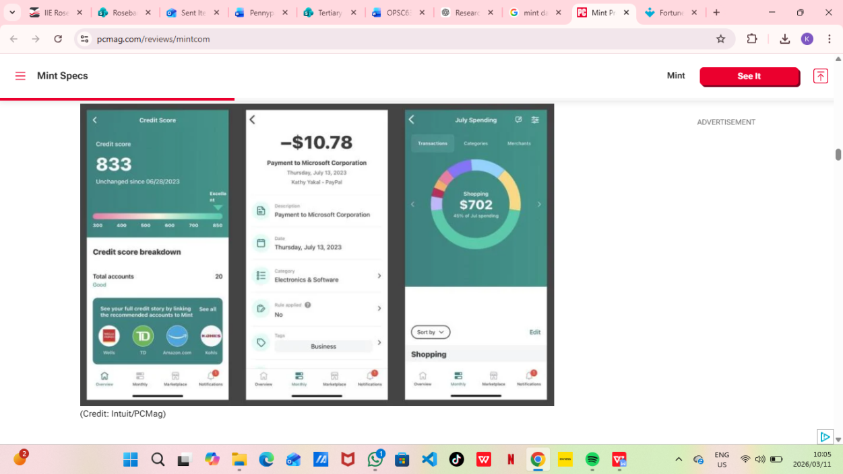
The dashboard provides users with a quick overview of their financial situation. It displays account balances, total monthly spending, and progress toward budget limits. Visual graphs and summaries help users quickly understand how their money is being spent.
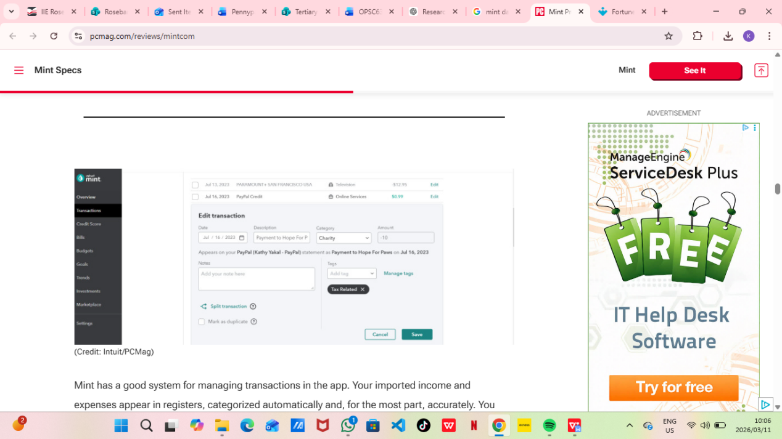
This screen allows users to create budgets for different spending categories such as groceries, transport, and entertainment. The app tracks expenses in each category and alerts the user when they are close to exceeding their limits.

2.2 Emma – Innovative UI and Automation

Overview:
Emma is a modern personal finance application designed to help users track their spending and better understand their financial behaviour. The app connects to users’ bank accounts and automatically categorizes transactions, allowing users to see where their money is going without manually entering every expense.
One of Emma’s key design goals is simplicity and usability. The interface uses clear visual elements such as charts, icons, and colour-coded categories to help users quickly understand their spending habits. The app also analyses financial behaviour and highlights recurring payments, such as subscriptions, helping users identify areas where they may be overspending.
Core features include:
- Automatic transaction categorization
- Subscription detection and tracking
- Goal-based savings tracking
- A visually organized dashboard showing spending insights
These features make Emma particularly attractive to users who prefer an intuitive and visually appealing budgeting experience.

Strengths:
Emma’s strongest feature is its user interface design. The app presents financial data in a way that is easy to understand, even for users who are not familiar with budgeting tools. Graphs and charts are used effectively to display spending trends, helping users identify patterns in their financial behaviour.
Another strength is Emma’s subscription management feature, which automatically detects recurring payments such as streaming services or mobile subscriptions. This helps users identify unnecessary expenses that they may want to cancel.
The app also provides spending insights, where it analyses user transactions and highlights financial habits that could be improved. These insights help guide users toward smarter financial decisions.

Weaknesses:
Despite its strong design, Emma has some limitations. Many advanced features are only available through a premium subscription, which may discourage users who prefer completely free applications.
Another potential weakness is that heavy reliance on automation may reduce active engagement. Since the app performs much of the tracking automatically, some users may become passive observers of their finances rather than actively managing their spending.

Innovative Features:
Emma introduces several innovative features that improve financial awareness:
- Automatic subscription detection, helping users identify recurring payments
- Smart financial insights, where the app analyses spending behaviour
- Modern dashboard design, presenting financial data in a visually clear format
These features demonstrate how thoughtful interface design can make financial information easier to understand and more engaging for users.

Insight for SpendWise:
SpendWise will adopt Emma’s modern user interface principles, focusing on clarity, simplicity, and visual feedback. The dashboard will prioritize important financial information such as total spending, income, and remaining budget. Clear graphs and visual indicators will help users quickly understand their financial progress.
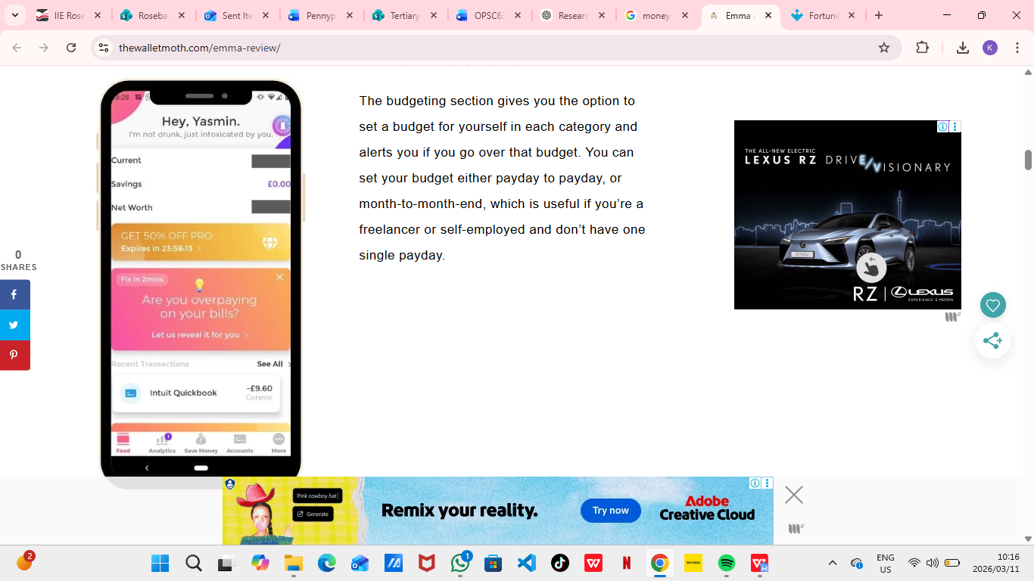
The Emma dashboard provides a clear overview of a user’s financial activity. It displays total spending, remaining balance, and category breakdowns using graphs and colour-coded visual elements.

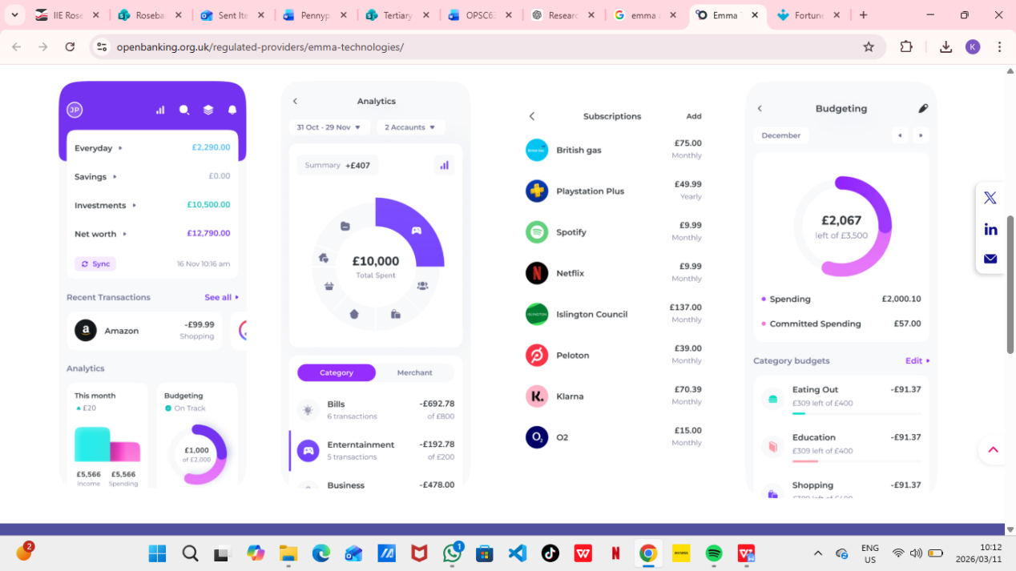
This screen highlights recurring payments such as subscriptions. The feature allows users to identify unnecessary expenses and manage their subscriptions more effectively.

2.3 Fortune City – Gamification Benchmark

Overview:
Fortune City is a unique personal finance application that combines expense tracking with a gamified city-building experience. Instead of simply listing transactions, the app turns each recorded expense into part of a virtual city. As users log their expenses, new buildings appear, gradually expanding the city.
The purpose of this design is to make financial tracking more engaging and enjoyable. Users are encouraged to consistently record their expenses because doing so helps grow their virtual city and unlock new achievements. This approach transforms budgeting from a routine task into an interactive activity.
Core features of Fortune City include:
- Manual expense tracking
- Optional receipt photo attachment
- Achievement rewards for consistent tracking
- A visual city that grows as expenses are recorded
- Daily and monthly financial summaries
The combination of financial tracking and game mechanics makes Fortune City different from most traditional budgeting applications.

Strengths:
The main strength of Fortune City is its gamification system. By rewarding users for consistently logging expenses, the app encourages positive financial habits. The visual representation of a growing city provides immediate feedback and creates a sense of progress.
Another advantage is the simple and enjoyable interface. The design makes budgeting feel less stressful and more like a game, which can motivate users who normally find financial tracking boring. The ability to attach receipt photos to expense entries is also useful. It allows users to keep a digital record of their purchases and makes expense tracking more organized.

Weaknesses:
Despite its engaging design, Fortune City has some limitations. The strong focus on gamification may reduce the seriousness of financial management. Users may become more interested in expanding their virtual city than analyzing their spending patterns.
The app also provides less detailed financial analysis compared to professional budgeting applications such as Mint. Charts, reports, and budgeting tools are more limited. As a result, Fortune City is very effective at encouraging expense tracking but may not provide enough financial insights for users who want detailed budgeting analysis.

Innovative Features
Fortune City introduces several innovative ideas that make budgeting more engaging:
- City-building reward system that visually represents financial activity
- Achievement and reward mechanics for consistent behaviour
- Receipt photo attachments for better record keeping
- Habit-forming design that encourages daily expense logging
These features demonstrate how gamification can motivate users to develop consistent financial tracking habits.

Insight for SpendWise:
SpendWise will incorporate gamification elements inspired by Fortune City but in a more balanced way. Instead of a city-building system, SpendWise will introduce a level-based reward system where users gain experience points for logging expenses, staying within budget limits, and achieving savings goals.
This approach allows SpendWise to maintain a professional budgeting structure while still providing motivational rewards that encourage consistent use.
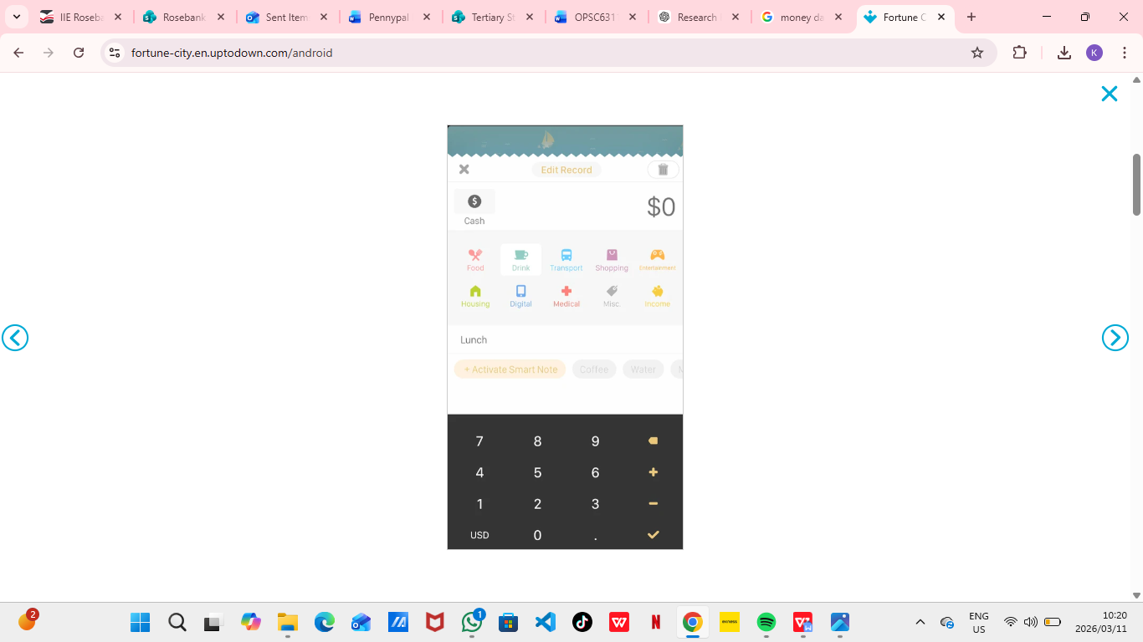
This screen allows users to record expenses by entering the amount, category, and optional receipt photo. Once the expense is logged, it contributes to the growth of the user’s virtual city.
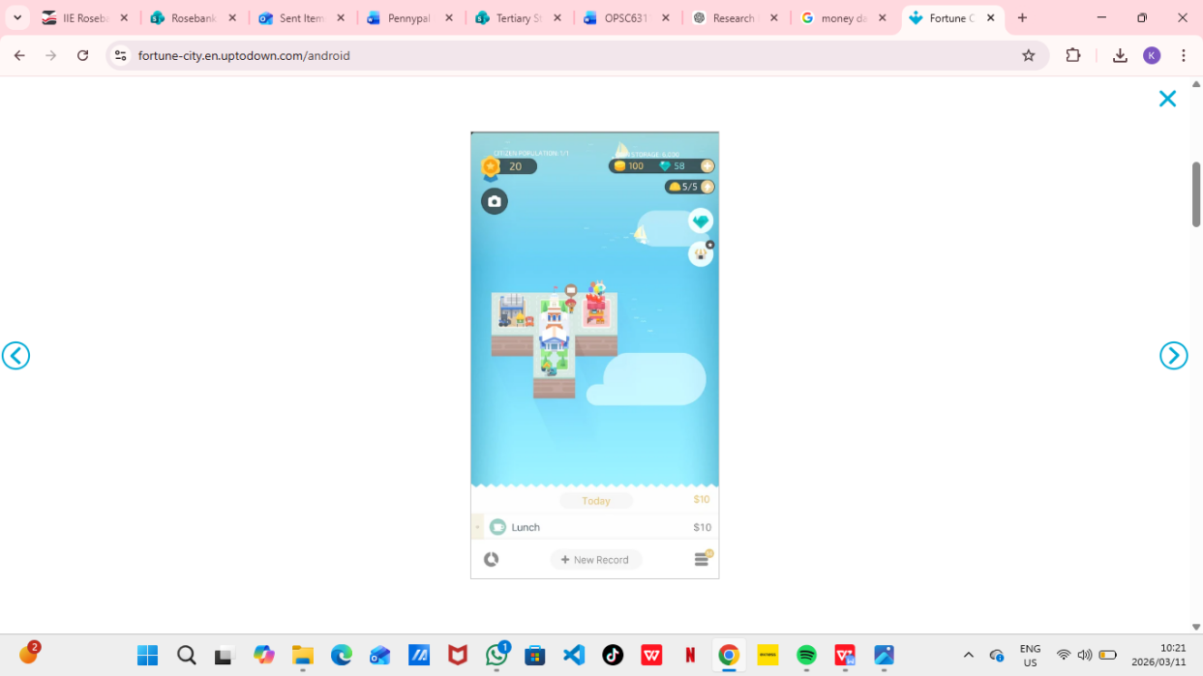
The city view visually represents the user’s financial activity. Each building represents recorded expenses, and the city expands as the user continues logging transactions.

3. Visual Comparison of Budgeting Applications
The three researched applications focus on different aspects of personal finance management. Mint focuses on structured budgeting and financial analysis, Emma emphasizes user-friendly design and financial insights, while Fortune City focuses on engagement through gamification.
The following comparison summarizes the main differences between the applications in terms of budgeting functionality, automation, user interface design, and motivational features.
Feature | Mint | Emma | Fortune City
Primary Focus | Structured financial management | User-friendly financial insights | Gamified expense tracking
Category Budgets | Yes – detailed monthly budgets | Yes – simplified budgets | Limited
Automation | High – imports transactions automatically | High – smart transaction categorisation | Low – mostly manual entry
User Interface Design | Professional but basic | Modern and visually appealing | Playful and game-like
Gamification | None | Minimal | Very strong
Receipt Photo Attachment | Limited | Limited | Yes
Financial Reports | Detailed charts and reports | Clear visual summaries | Basic summaries
User Motivation | Financial alerts and notifications | Spending insights | Rewards and achievements

Key Observations
From this comparison it becomes clear that each application excels in a different area:
- Mint provides the strongest financial structure and budgeting tools.
- Emma offers the most modern and visually clear user interface.
- Fortune City provides the most engaging experience through gamification.
However, none of these applications fully combine structured budgeting, clear data visualisation, and strong motivational elements within a single platform.This observation highlights an opportunity for the development of a new application that integrates these strengths.

4. Best Features to Include in SpendWise
Based on the research conducted, several successful features from the three analysed applications can be incorporated into the design of SpendWise. By combining the strongest elements of each app, SpendWise can provide a balanced budgeting experience that is both practical and engaging.

Features Inspired by Mint
- Structured category-based budgeting, allowing users to organise expenses such as groceries, transport, and entertainment.
- Monthly spending summaries, helping users understand where their money is being spent.
- Budget alerts, notifying users when they are close to exceeding their category limits.
These features ensure that SpendWise provides a strong financial structure similar to professional budgeting applications.

Features Inspired by Emma
- Clean and modern user interface design, making financial information easy to understand.
- Visual graphs and spending summaries, helping users identify patterns in their financial behaviour.
- Insight-based notifications, encouraging smarter spending habits.
These features will ensure that SpendWise remains visually appealing and user-friendly.

Features Inspired by Fortune City
- Gamification mechanics, encouraging users to consistently log their expenses.
- Achievement rewards, motivating users to reach budgeting goals.
- Receipt photo attachments, allowing users to store proof of purchases.
These features add an engaging element that encourages users to remain active in managing their finances.

Unique Feature for SpendWise – Level-Based Reward System
Unlike Fortune City’s city-building mechanic, SpendWise will introduce a level-based progression system. Users will earn experience points (XP) by logging expenses, staying within their budgets, and reaching savings goals.
Example levels include:
Level | Title | Unlock Condition
Level 1 | Budget Beginner | Log first 5 expenses
Level 2 | Smart Spender | Stay within category limits for one week
Level 3 | Savings Sidekick | Reach 25% of monthly savings goal
Level 4 | Money Maestro | Avoid overspending for one month
Level 5 | Budget Ninja | Achieve all goals for three consecutive months
Additional gamification elements may include badges, progress bars, and small visual rewards that celebrate financial achievements.

5. Conclusion
The research conducted in this section analysed three popular personal budgeting applications available on the Android platform: Mint, Emma, and Fortune City. Each of these applications demonstrates different strengths in helping users manage their finances.
Mint provides a highly structured budgeting system with detailed financial reports and spending alerts, making it a strong tool for users who want precise control over their finances. Emma focuses on user experience and modern design, presenting financial data in a clear and visually appealing way that helps users better understand their spending habits. Fortune City introduces a different approach by incorporating gamification, encouraging users to track their expenses through rewards and interactive features.
While each application performs well in its specific area, the research shows that no single application successfully combines structured financial management, intuitive visual design, and strong motivational features. This creates an opportunity to design a new budgeting application that integrates the strengths of all three systems.
The proposed application, SpendWise, aims to combine the structured budgeting features of Mint, the modern user interface principles of Emma, and the motivational gamification elements of Fortune City. By doing so, SpendWise can help users not only track their spending but also remain engaged and motivated to maintain positive financial habits.Overall, the insights gained from analysing these existing applications will guide the design and development of SpendWise, ensuring that the final application provides both practical financial tools and an engaging user experience.

6. References
Emma Technologies, 2025. Emma – Budgeting and Expense Tracker App. [online] Available at: <https://emma-app.com> [Accessed 14 March 2026].
Fourdesire, 2025. Fortune City – Gamified Finance App. [online] Available at: <https://fourdesire.com> [Accessed 13 March 2026].
Intuit, 2025. Mint Personal Finance and Budget Tracker. [online] Available at: <https://mint.intuit.com> [Accessed 19 March 2026].
Google Play Store, 2025. Application descriptions and user reviews for Mint, Emma, and Fortune City. [online] Available at: <https://play.google.com> [Accessed 9 March 2026].
Hamari, J., Koivisto, J., & Sarsa, H., 2014. Does Gamification Work? A Literature Review of Empirical Studies on Gamification. Proceedings of the 47th Hawaii International Conference on System Sciences.

