SELECT * FROM EMPLOYEES;

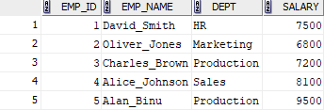

SELECT * FROM EMPLOYEES WHERE Salary > 7000;
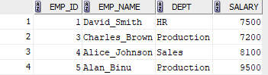
UPDATE EMPLOYEES SET Salary = 8200.00 WHERE Emp_name = 'David_Smith';
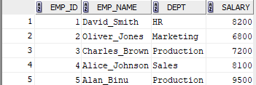

SELECT * FROM EMPLOYEES;
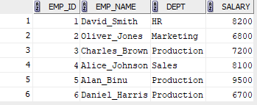

SELECT * FROM EMPLOYEES;
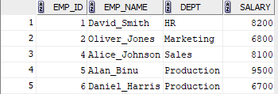
SELECT * FROM EMPLOYEES WHERE Emp_name NOT LIKE 'D%' AND Emp_name NOT LIKE 'O%';
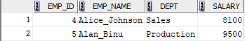

SELECT Dept, SUM(Salary) AS Total_Salary FROM EMPLOYEES GROUP BY Dept;
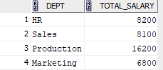

SELECT * FROM EMPLOYEES;
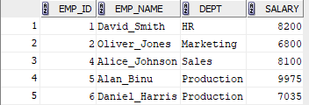

SELECT * FROM EMPLOYEES;
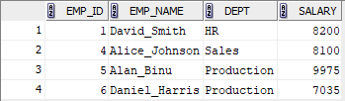

SELECT Emp_name, Salary FROM EMPLOYEES WHERE Salary =(SELECT MIN(Salary) FROM EMPLOYEES);
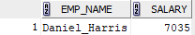

SELECT * FROM EMPLOYEES;
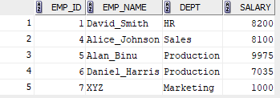

SELECT * FROM EMPLOYEES;
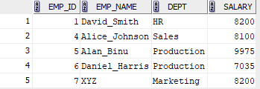

SELECT Emp_name FROM EMPLOYEES WHERE Emp_name LIKE 'A%';
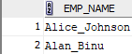

SELECT Emp_name FROM EMPLOYEES WHERE Emp_name LIKE '%it%';
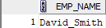

SELECT DISTINCT UPPER(Dept) FROM EMPLOYEES;
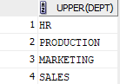

SELECT * FROM EMPLOYEES WHERE Dept LIKE 'M_r%' AND Dept LIKE '%ket%';


SELECT DISTINCT UPPER(REVERSE(Dept)) FROM EMPLOYEES;
