SELECT * FROM STUDENT_2;
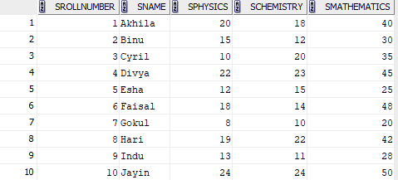

SELECT AVG(SPHYSICS) FROM STUDENT_2;
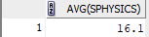
SELECT MAX(SMATHEMATICS) AS highest_marks_maths FROM STUDENT_2;

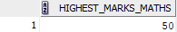

SELECT MIN(SCHEMISTRY) AS lowest_mark_chemistry FROM STUDENT_2;
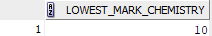

SELECT COUNT(*) FROM STUDENT_2 WHERE SPHYSICS>=12;
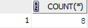

SELECT * FROM STUDENT_2 WHERE SPHYSICS>=12 AND SCHEMISTRY>=12 AND SMATHEMATICS>=25;
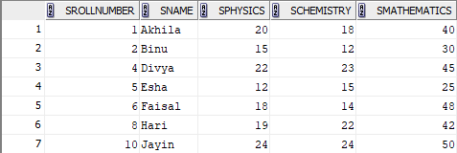

SELECT SROLLNUMBER, SNAME, SPHYSICS, SCHEMISTRY, SMATHEMATICS, (SPHYSICS + SCHEMISTRY + SMATHEMATICS) AS TOTAL_MARKS, CASE WHEN SPHYSICS >= 12 AND SCHEMISTRY >= 12 AND SMATHEMATICS >= 25 THEN 'Pass' ELSE 'Fail' END AS RESULT FROM STUDENT_2 ORDER BY TOTAL_MARKS DESC;

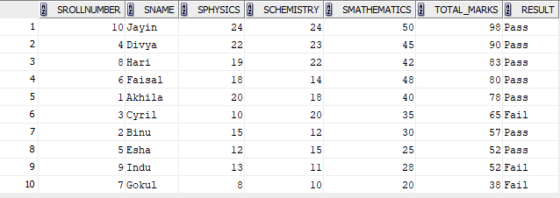

SELECT (COUNT(SMATHEMATICS))/10*100 FROM STUDENT_2 WHERE SMATHEMATICS>=25;
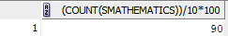

SELECT ROUND( (COUNT(CASE WHEN SPHYSICS >= 12 AND SCHEMISTRY >= 12 AND SMATHEMATICS >= 25 THEN 1 END) * 100.0) / COUNT(*), 2 ) AS overall_pass_percentage FROM STUDENT_2;
