CREATE VIEW bank_heads_offices AS
SELECT *
FROM BANK_6767
WHERE headoffice = 'Ernakulam';
CREATE VIEW banks_branchs AS
SELECT B.*
FROM BANK_6767 B
JOIN BRANCH_13 BR ON B.bankcode = BR.bankid
WHERE BR.branchname = 'Kottayam';
CREATE VIEW bank_mores_than_50 AS
SELECT *
FROM BANK_6767
WHERE branches > 50;
CREATE VIEW banks_branchs_details AS
SELECT B.bankname, BR.branchname
FROM BANK_6767 B
JOIN BRANCH_13 BR ON B.bankcode = BR.bankid;
CREATE VIEW banks_outsidee_ernakulam AS
SELECT *
FROM BANK_6767
WHERE headoffice <> 'Ernakulam';
SELECT * FROM bank_heads_offices;
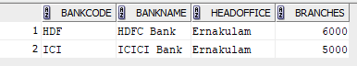
SELECT * FROM banks_branchs;
SELECT * FROM bank_mores_than_50;
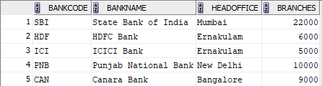
SELECT * FROM banks_branchs_details;
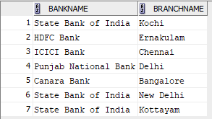

SELECT * FROM banks_outsidee_ernakulam;
