SELECT * FROM ITEMS_74;

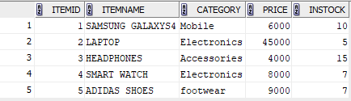

SELECT * FROM CUSTOMERS_74;

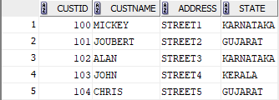

SELECT * FROM ORDERS_74;

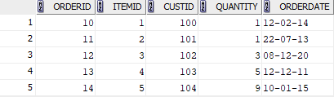

SELECT * FROM DELIVERY_74;

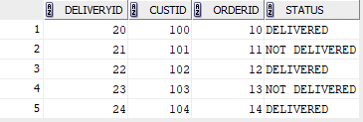

1.SELECT * FROM CUSTOMERS_74 WHERE CUSTID IN (
SELECT CUSTID FROM ORDERS_74 );
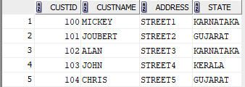

2. SELECT DISTINCT c.*
FROM CUSTOMERS_74 c
JOIN ORDERS_74 o ON c.CUSTID = o.CUSTID
JOIN DELIVERY_74 d ON o.ORDERID = d.ORDERID
WHERE d.STATUS = 'DELIVERED';
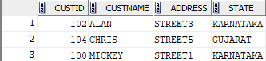
3. SELECT C.CUSTNAME, O.ORDERDATE
FROM CUSTOMERS_74 C
JOIN ORDERS_74 O
ON C.CUSTID = O.CUSTID
WHERE C.CUSTNAME LIKE 'J%';

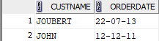

4. SELECT I.ITEMNAME, I.PRICE
FROM CUSTOMERS_74 C
JOIN ORDERS_74 O ON C.CUSTID = O.CUSTID
JOIN ITEMS_74 I ON O.ITEMID = I.ITEMID
WHERE C.CUSTNAME = 'MICKEY';
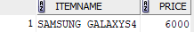

6. SELECT DISTINCT C.*
FROM CUSTOMERS_74 C
JOIN ORDERS_74 O ON C.CUSTID = O.CUSTID
LEFT JOIN DELIVERY_74 D ON O.ORDERID = D.ORDERID
WHERE O.ORDERDATE > DATE '2013-01-31'
AND (D.STATUS <> 'DELIVERED' OR D.STATUS IS NULL);

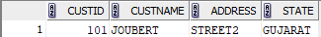

7. SELECT DISTINCT ITEMID FROM ORDERS_74 UNION SELECT DISTINCT O.ITEMID FROM ORDERS_74 O JOIN DELIVERY_74 D ON O.ORDERID = D.ORDERID WHERE D.STATUS <> 'DELIVERED';
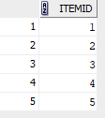

8. SELECT DISTINCT C.CUSTNAME FROM CUSTOMERS_74 C JOIN DELIVERY_74 D ON C.CUSTID = D.CUSTID WHERE D.STATUS = 'DELIVERED';
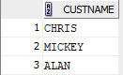

9.

