SELECT* FROM BANK_13;
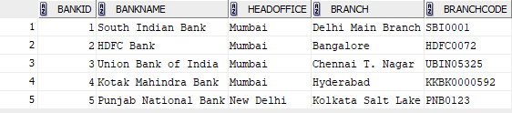

commit;

SELECT* FROM BANK_13;
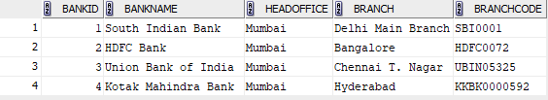

ROLLBACK;
SELECT *FROM BANK_13;
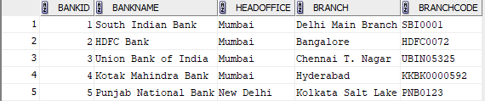

SAVEPOINT sp1;

SELECT* FROM BANK_13;
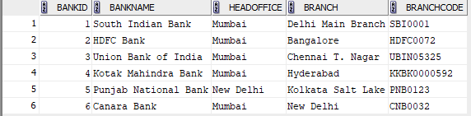

ROLLBACK TO sp1;

SELECT *FROM BANK_13;
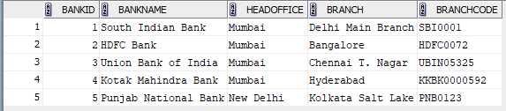

grant all on BANK_13 TO c24csa14;
select * from c24csa14.BANK_1;
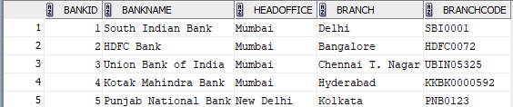

REVOKE ALL on BANK_13 from c24csa14;

