

**Course Code : CBS3007**

**Course: Data Mining and Analytics**

Alan Thomas

21BBS0115

Github link for the datasets and code-

<https://github.com/ALANT535/DATA-MINING-RESOURCES/tree/main/DA2>

# Aim

To Collect the data set consists of 50 observations about patient enrolment in diet maintenance based on gender, weight, BMI etc (minimum 7 features). Implement a model that will recommend a strict diet is necessary or not for a patient using the naïve Bayes classification algorithm.

LIBRARIES USED: Pandas, Numpy, Scikit Learn

Dataset : https://github.com/ALANT535/DATA-MINING-RESOURCES/tree/main/DA2/Q1

# SECTION 1

Sample Input

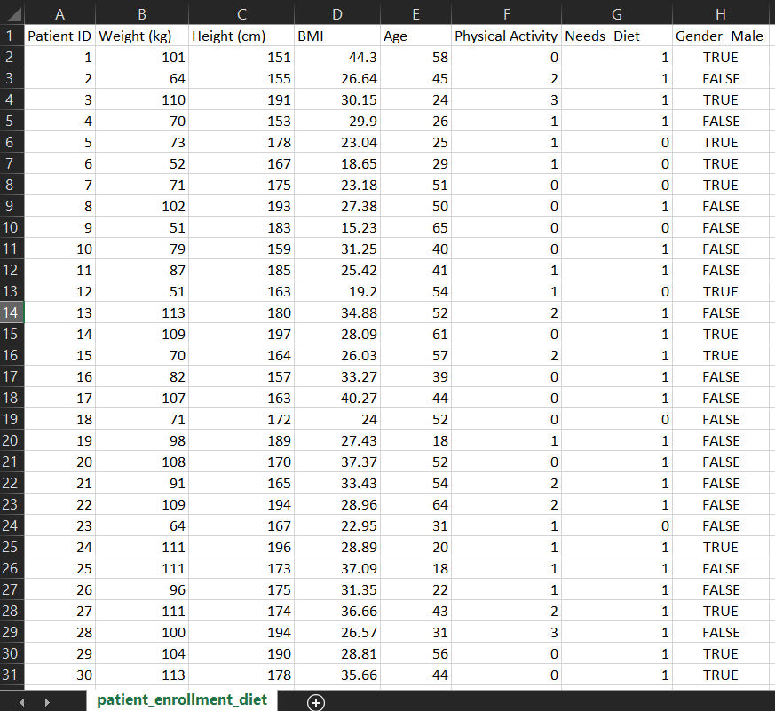

Code

import pandas as pd

from sklearn import naive_bayes

from sklearn import model_selection

from sklearn import metrics

from sklearn import preprocessing as pp

import numpy as np

data = pd.read_csv('patient_enrollment_diet.csv')

# encoding

le = pp.LabelEncoder()

data['Physical Activity'] = le.fit_transform(data['Physical Activity'])

temp = list(data.columns)

temp[7] = 'Physical Activity'

data.columns = temp

data = pd.get_dummies(data, columns=['Gender'], drop_first=True)

y = data['Needs_Diet']

X = data.drop(['Needs_Diet' , 'Patient ID'],axis = 1)

X_train, X_test, y_train, y_test = model_selection.train_test_split(X, y, test_size=0.25, random_state=42)

nb = naive_bayes.GaussianNB()

nb.fit(X_train,y_train)

y_pred = nb.predict(X_test)

print('accuracy score:' , metrics.accuracy_score(y_test, y_pred))

print('precision score:' , metrics.precision_score(y_test, y_pred))

print('recall score:' , metrics.recall_score(y_test, y_pred))

print('F1 score:' , metrics.f1_score(y_test, y_pred))

Output

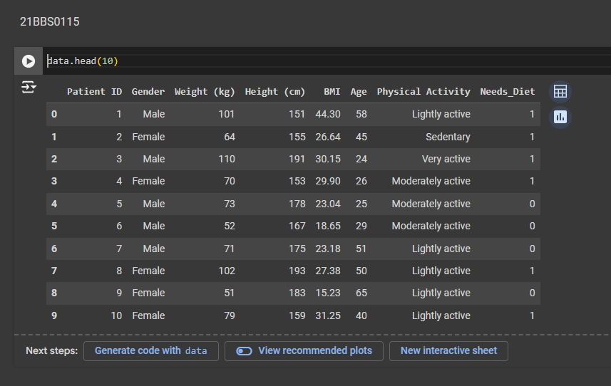

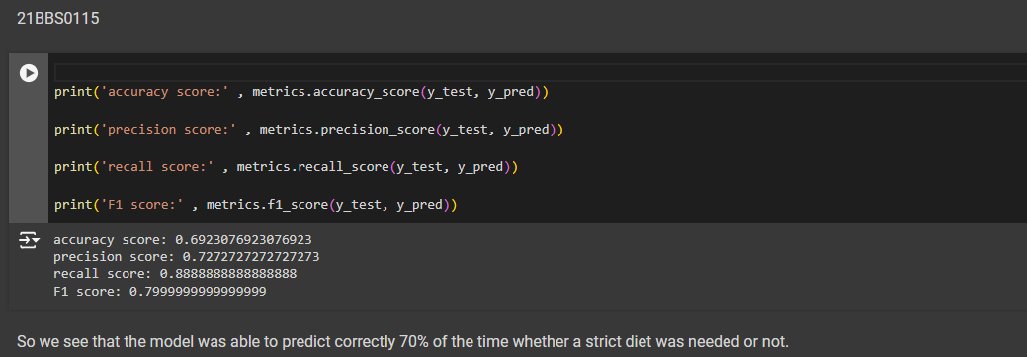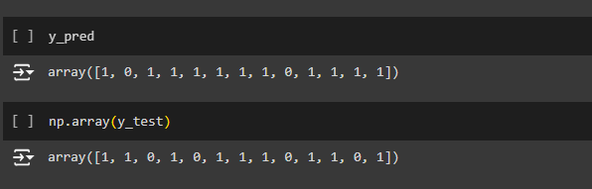

**SECTION 2**

Aim : To Implement K-means method of clustering and use the patient details data set to classify into 3 clusters such as a person is normal, healthy and weak. A person must be clustered as any one of normal/healthy or weak based on their input values.

Libraries : Numpy, Pandas, sklearn, seaborn

Dataset : https://github.com/ALANT535/DATA-MINING-RESOURCES/tree/main/DA2/Q2

Sample Input

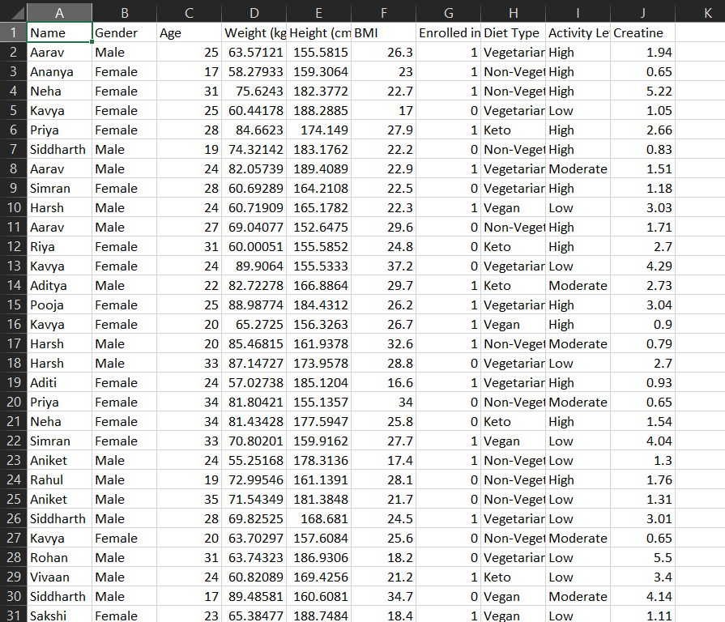

# Code

import pandas as pd

from sklearn import naive_bayes

from sklearn import model_selection

from sklearn import metrics

from sklearn import preprocessing as pp

from sklearn.cluster import KMeans

from sklearn.metrics import silhouette_score

from sklearn.preprocessing import StandardScaler

import numpy as np

import seaborn as sns

data = pd.read_csv('patient_dataset.csv')

data.head(10)

data = data.drop(['Name' , 'Gender' , 'Age' , 'Enrolled in Diet Plan' , 'Diet Type' , 'Activity Level'] , axis = 1)

# check missing vlaues

data.any().isna().sum()

data.head()

num_clusters = [i for i in range(2, 7)]

def kmeans_inertia(num_clusters, x_vals):

inertia = []

for num in num_clusters:

kms = KMeans(n_clusters=num, random_state=42)

kms.fit(x_vals)

inertia.append(kms.inertia_)

return inertia

X_scaled = StandardScaler().fit_transform(data)

inertia = kmeans_inertia(num_clusters,X_scaled)

inertia

kmeans3 = KMeans(n_clusters=3, random_state=42)

kmeans3.fit(X_scaled)

data['cluster'] = kmeans3.labels_

def give_label(cluster_num):

if cluster_num == 0:

return 'Weak'

elif cluster_num == 1:

return 'Normal'

else:

return 'Healthy'

data['Class'] = data['cluster'].apply(give_label)

import matplotlib.pyplot as plt

df = data.copy()

features = ['BMI', 'Creatine']

X = df[features]

# Plotting the clusters

plt.figure(figsize=(10, 8))

for cluster in df['cluster'].unique():

cluster_data = df[df['cluster'] == cluster]

plt.scatter(cluster_data['BMI'], cluster_data['Creatine'], label=f'Cluster {cluster}', s=50, alpha=0.6)

plt.xlabel('BMI')

plt.ylabel('Creatine')

plt.title('Clusters Visualization with BMI and Creatine')

plt.legend()

plt.grid(True)

plt.show()

centroids = kmeans3.cluster_centers_

print(centroids)

Output :



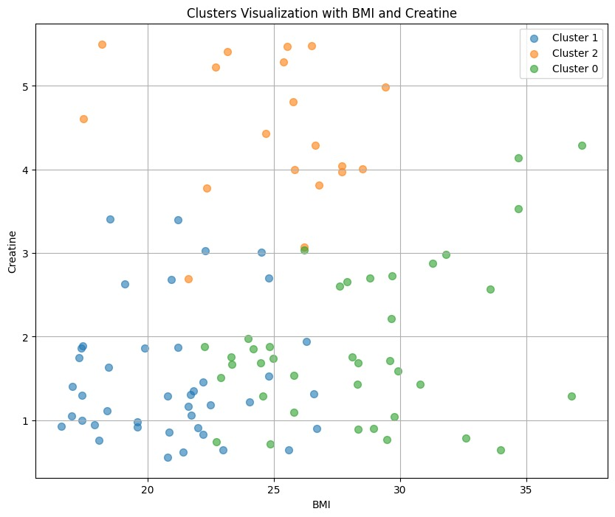

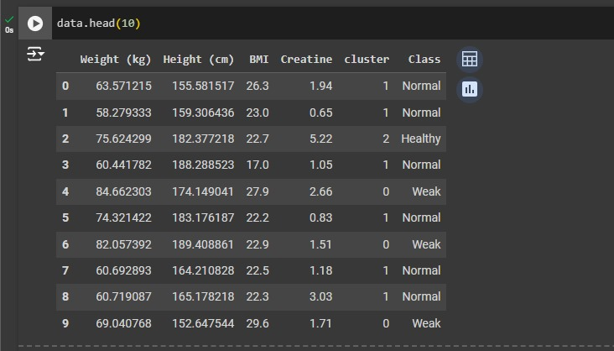

# SECTION 3

Aim: Implement the ID3 algorithm on the dataset to recommend the decision tree to classify the data.

Libraries Used : Numpy, Pandas, sklearn, matplotlib, seaborn

Dataset : https://github.com/ALANT535/DATA-MINING-RESOURCES/tree/main/DA2/Q3

Sample Input

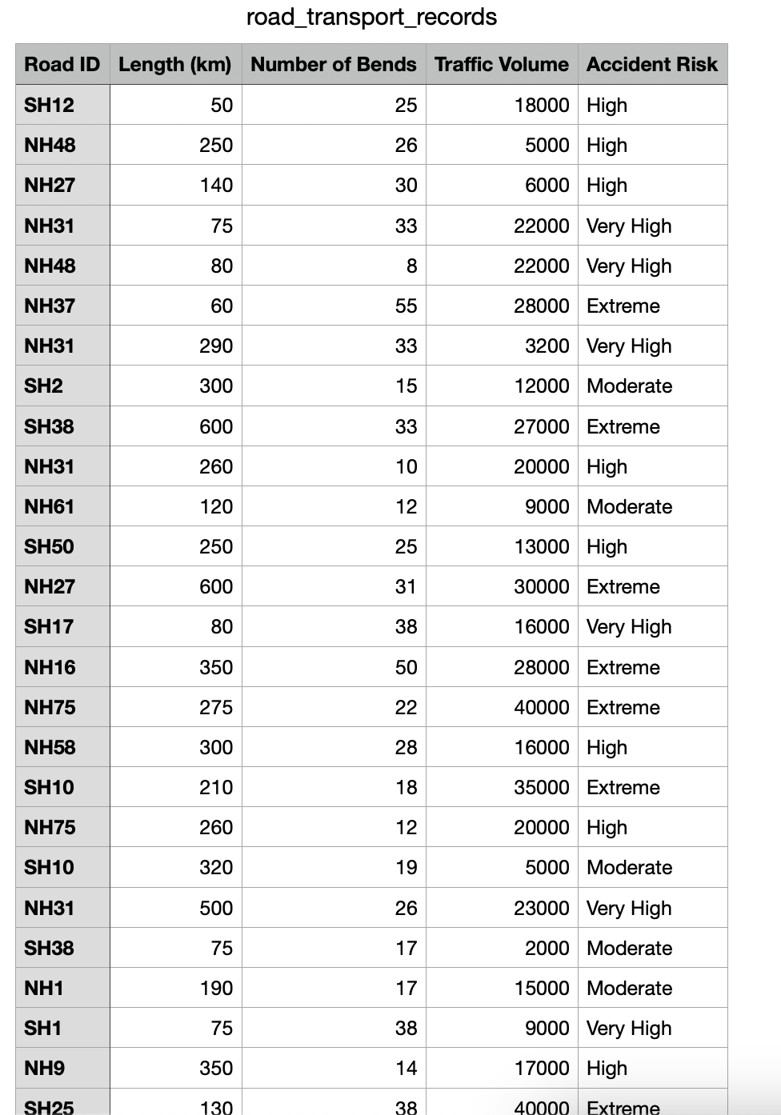

**Code and Output Code**

Code :

import pandas as pd

import math

import matplotlib.pyplot as plt

import networkx as nx

from networkx.drawing.nx_agraph import graphviz_layout

df = pd.read_csv(r"DA2\Q3\road_transport_records.csv")

def calculate_entropy(data, target_column):

total_rows = len(data)

target_values = data[target_column].unique()

entropy = 0

for value in target_values:

value_count = len(data[data[target_column] == value])

proportion = value_count / total_rows

entropy -= proportion * math.log2(proportion) if proportion != 0 else 0

return entropy

def calculate_information_gain(data, feature, target_column, entropy_outcome):

unique_values = data[feature].unique()

weighted_entropy = 0

for value in unique_values:

subset = data[data[feature] == value]

proportion = len(subset) / len(data)

weighted_entropy += proportion * calculate_entropy(subset, target_column)

information_gain = entropy_outcome - weighted_entropy

return information_gain

def id3(data, target_column, features):

if len(data[target_column].unique()) == 1:

return data[target_column].iloc[0]

if len(features) == 0:

return data[target_column].mode().iloc[0]

entropy_outcome = calculate_entropy(data, target_column)

best_feature = max(features, key=lambda x: calculate_information_gain(data, x, target_column, entropy_outcome))

tree = {best_feature: {}}

features = [f for f in features if f != best_feature]

for value in data[best_feature].unique():

subset = data[data[best_feature] == value]

subtree = id3(subset, target_column, features)

tree[best_feature][value] = subtree

return tree

def plot_tree(tree, parent_name, graph, depth, max_depth):

if depth > max_depth:

return

if isinstance(tree, dict):

feature = list(tree.keys())[0]

for value, subtree in tree[feature].items():

node_name = f"{feature} = {value}"

graph.add_node(node_name)

graph.add_edge(parent_name, node_name)

plot_tree(subtree, node_name, graph, depth + 1, max_depth)

else:

leaf_name = f"Accident Risk: {tree}"

graph.add_node(leaf_name)

graph.add_edge(parent_name, leaf_name)

def visualize_decision_tree(decision_tree, max_depth=3):

graph = nx.DiGraph()

root_name = list(decision_tree.keys())[0]

graph.add_node(root_name)

plot_tree(decision_tree, root_name, graph, 0, max_depth)

plt.figure(figsize=(20, 15))

pos = nx.spring_layout(graph, seed=42, k=0.5, iterations=50)

nx.draw(graph, pos, with_labels=True, node_size=3500, node_color="lightblue", font_size=12, font_weight="bold", arrows=True, connectionstyle='arc3,rad=0.1')

plt.title("Decision Tree Visualization")

plt.show()

features = ['Length (km)', 'Number of Bends', 'Traffic Volume']

decision_tree = id3(df, 'Accident Risk', features)

print("\nGenerated Decision Tree using ID3 algorithm:")

print(decision_tree)

print("\n\nNow printing it-")

visualize_decision_tree(decision_tree)

Output :

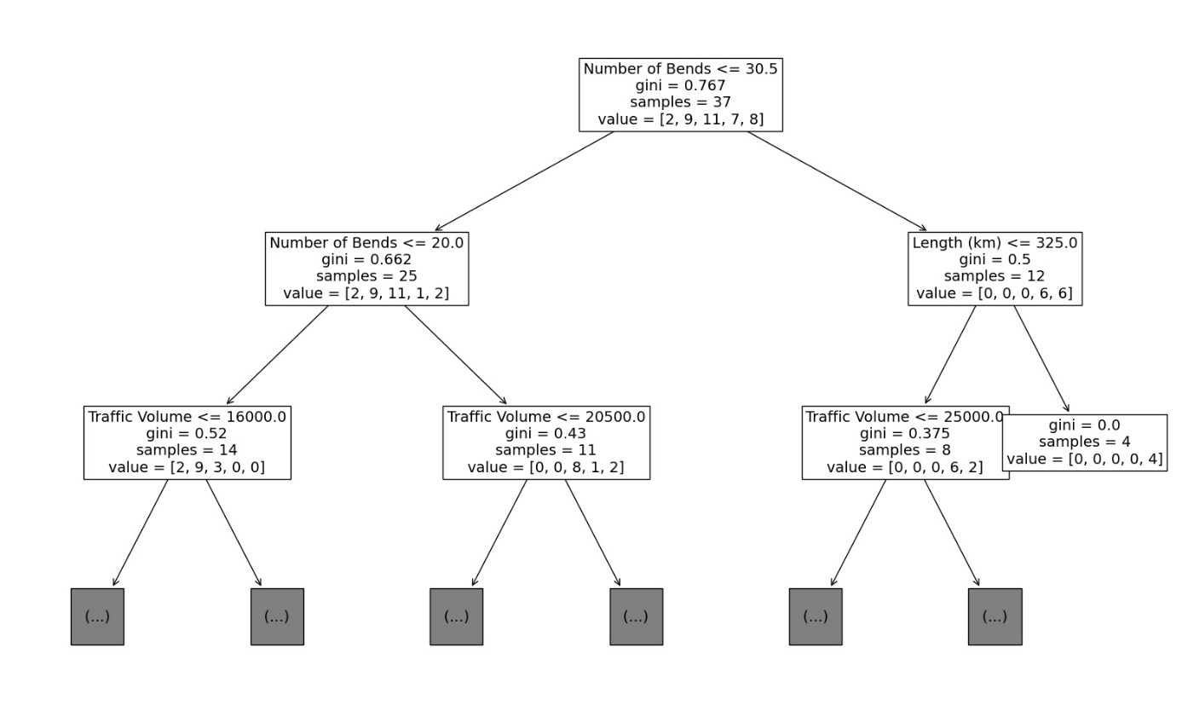

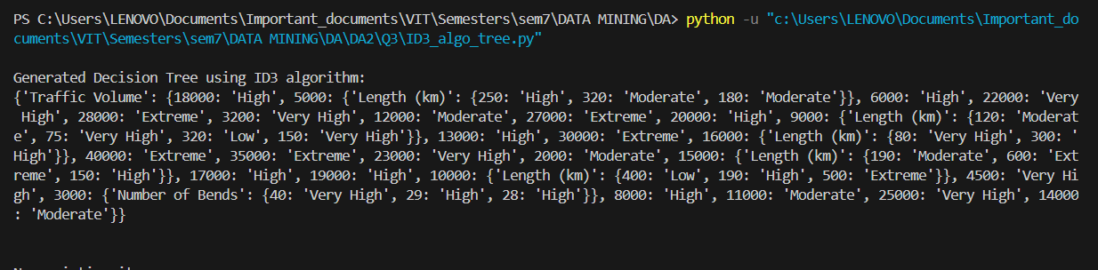

RESULT:

Created the Decision Tree based on the concept of ID3 algorithm.

**XXXXXXXXXXXXXXX**