

**Course Code : CBS3007**

**Course: Data Mining and Analytics**

Alan Thomas

21BBS0115

Github link for the datasets and code-

<https://github.com/ALANT535/DATA-MINING-RESOURCES/tree/main/DA3>

**SECTION 1**

**Aim:**

Implementation of KNN classification on dataset

Libraries Used : Numpy, Pandas, sklearn, matplotlib, seaborn

Dataset :

<https://github.com/ALANT535/DATA-MINING-RESOURCES/tree/main/DA3/Q1>

Sample Input

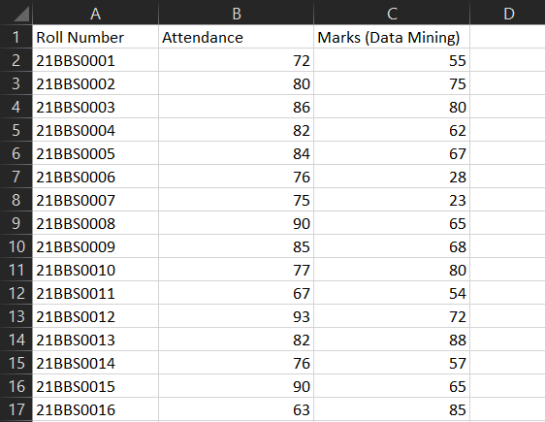

**Code**

import pandas as pd

import numpy as np

import matplotlib.pyplot as plt

import seaborn as sns

from sklearn.model_selection import train_test_split

from sklearn.preprocessing import StandardScaler

from sklearn.neighbors import KNeighborsClassifier

from sklearn.metrics import classification_report, confusion_matrix

print("21BBS0115")

df=pd.read_csv(r"C:\Users\LENOVO\Documents\Important_documents\VIT\Semesters\sem7\DATA MINING\DA\DA3\Q1\student.csv")

X = df[['Attendance', 'Marks (Data Mining)']]

y = np.where(X['Attendance'] < 75, 'Drop',

np.where(X['Marks (Data Mining)'] < 40, 'Fail', 'Pass'))

X_train, X_test, y_train, y_test = train_test_split(

X, y, test_size=0.2, random_state=42)

scaler = StandardScaler()

X_train_scaled = scaler.fit_transform(X_train)

X_test_scaled = scaler.transform(X_test)

knn = KNeighborsClassifier(n_neighbors=5)

knn.fit(X_train_scaled, y_train)

y_pred = knn.predict(X_test_scaled)

print("Classification Report:")

print(classification_report(y_test, y_pred))

print("\nConfusion Matrix:")

print(confusion_matrix(y_test, y_pred))

all_predictions = knn.predict(scaler.transform(X))

df['Prediction'] = all_predictions

plt.figure(figsize=(12, 6))

sns.scatterplot(data=df, x='Attendance', y='Marks (Data Mining)', hue='Prediction',

palette={'Pass': 'green', 'Fail': 'red', 'Drop': 'blue'},

style='Prediction', markers={"Drop": "X", "Fail": "o", "Pass": "s"}, s=100)

plt.title("Student Performance Classification")

plt.xlabel("Attendance (%)")

plt.ylabel("Marks (Data Mining)")

plt.axhline(40, color='red', linestyle='--', label='Pass/Fail Threshold (40 Marks)')

plt.axvline(75, color='orange', linestyle='--', label='Drop Threshold (75 Attendance)')

plt.legend()

plt.grid()

plt.show()

drop_count = (df['Prediction'] == 'Drop').sum()

fail_count = (df['Prediction'] == 'Fail').sum()

pass_count = (df['Prediction'] == 'Pass').sum()

print(f"\nTotal students at risk of dropping out: {drop_count}")

print(f"Total failing students: {fail_count}")

print(f"Total passing students: {pass_count}")

Output :

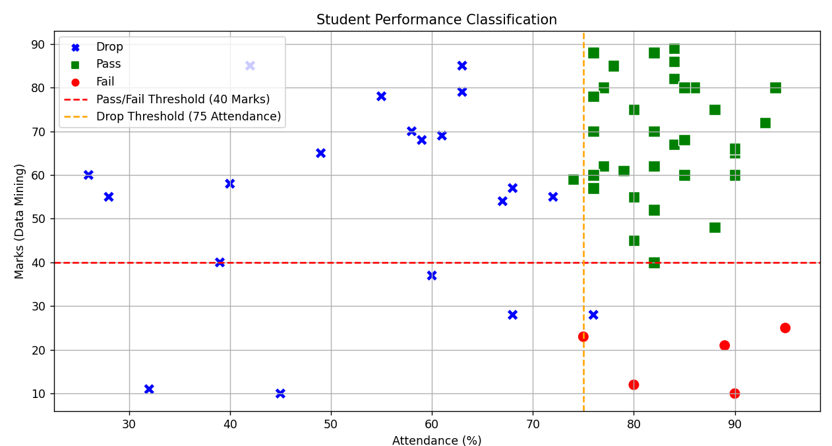

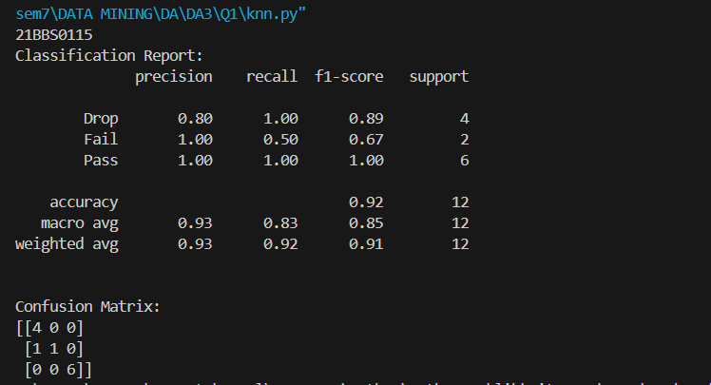

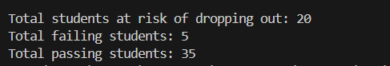

RESULT:

The KNN was created thereby classifying the students into one of three categories, pass, fail or drop.

# SECTION 2

# Aim

Implement the Linear regression Technique for prediction of total number of DEMAT accounts for the month of January 2-25. The dataset consists of 60 past months.

LIBRARIES USED: Pandas, Numpy, Matplotlib, Sklearn

Dataset:   
<https://github.com/ALANT535/DATA-MINING-RESOURCES/tree/main/DA3/Q2>

Sample Input

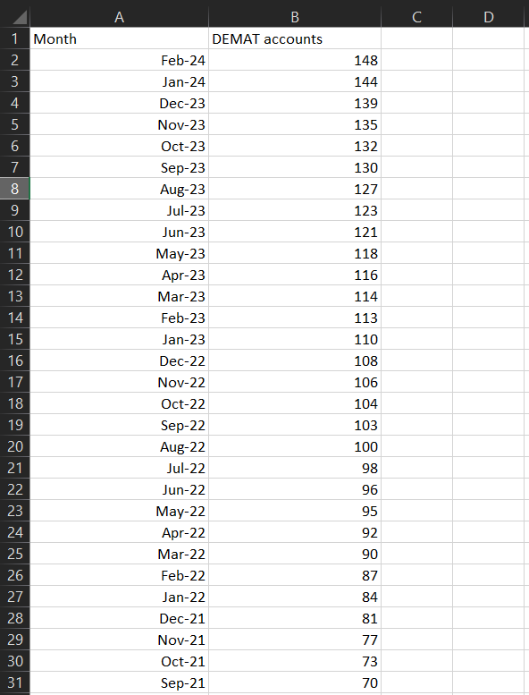

Code

import numpy as np

import pandas as pd

from sklearn.model_selection import train_test_split

from sklearn.linear_model import LinearRegression

import matplotlib.pyplot as plt

from sklearn.metrics import r2_score

data_df = pd.read_excel('Demat_account_dataset.xlsx')

data_df.columns = ["Month" , "DEMAT_accounts"]

data_df['Date'] = pd.to_datetime(data_df['Month'], format='%B-%Y')

start_date = pd.to_datetime('January-2000', format='%B-%Y')

data_df['Elapsed Time (Months)'] = ((data_df['Date'].dt.year - start_date.year) * 12

+ data_df['Date'].dt.month - start_date.month)

data_df['MontH_Number'] = data_df['Date'].dt.month

data_df['Year'] = data_df['Date'].dt.year

data_df['Previous_Month_Account'] = data_df['DEMAT_accounts'].shift(-1)

data_2 = data_df.drop(["Month" , "Date" , "Previous_Month_Account"] , axis = 1)

data_2.head()

X = data_2[['Elapsed Time (Months)', 'MontH_Number', 'Year']]

y = data_df['DEMAT_accounts']

X = X.dropna()

y = y[X.index]

X_train, X_test, y_train, y_test = train_test_split(X, y, test_size=0.2, random_state=42)

model = LinearRegression()

model.fit(X_train, y_train)

y_pred = model.predict(X_test)

print("Predictions on test set:", y_pred)

print("Model coefficients:", model.coef_)

print("Model intercept:", model.intercept_)

y_pred = model.predict(X_test)

r2 = r2_score(y_test, y_pred)

print("R-squared (model accuracy):", r2)

input_data = {

'Elapsed Time (Months)': [300,299,298,297,296,295,294,293],

'MontH_Number': [1,12,11,10,9,8,7,6],

'Year': [2025,2024,2024,2024,2024,2024,2024,2024],

}

input_df = pd.DataFrame(input_data)

predicted_demat_accounts = model.predict(input_df)

for i in range(7,-1,-1):

print("Predicted DEMAT accounts for month " , input_data['MontH_Number'][i] ,"2025(in millions):", predicted_demat_accounts[i])

print("\n\nPredicted DEMAT accounts for January 2025(in millions):", predicted_demat_accounts[0])

print("21BBS0115")

X = data_df[['Elapsed Time (Months)', 'MontH_Number', 'Year']]

predicted_accounts = (

model.intercept_ +

model.coef_[0] * X['Elapsed Time (Months)'] +

model.coef_[1] * X['MontH_Number'] +

model.coef_[2] * X['Year']

)

plt.figure(figsize=(12, 6))

plt.plot(data_df['Date'], data_df['DEMAT_accounts'], marker='o', label='Actual DEMAT Accounts')

plt.plot(data_df['Date'], predicted_accounts, color='red', label='Predicted Linear Regression Line')

plt.title('Demat Accounts Over Time with Linear Regression Line')

plt.xlabel('Month-Year')

plt.ylabel('Number of Demat Accounts')

plt.xticks(rotation=45)

plt.legend()

plt.grid()

plt.tight_layout()

plt.show()

Output

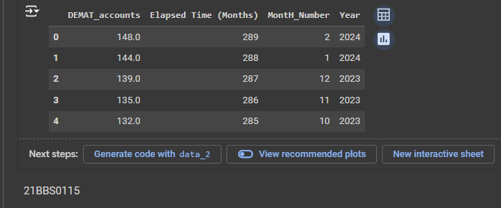

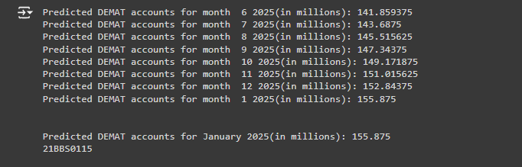

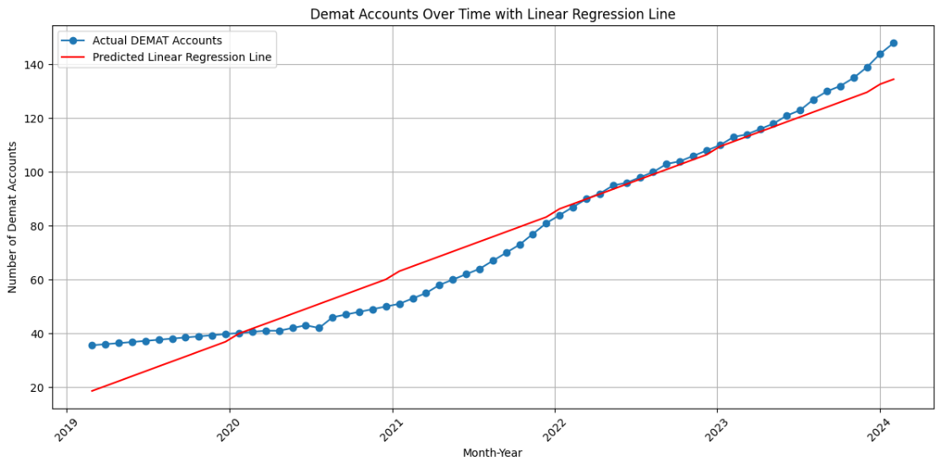

**Result:**

Successfully predicted the number of DEMAT accounts in Januray 2025 using 3 features. Tracked the same using a graph to make it clear how the number of DEMAT accounts is progressing through the years.

**SECTION 3**

Aim : Implement the Random Forest Supervised Machine Learning Algorithm

Libraries : Numpy, Pandas, sklearn, seaborn

Dataset :

<https://github.com/ALANT535/DATA-MINING-RESOURCES/tree/main/DA3/Q3>

Sample Input

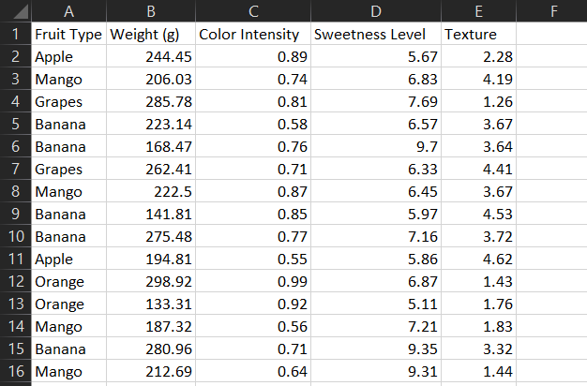

# Code

import pandas as pd

import seaborn as sns

import matplotlib.pyplot as plt

from sklearn.model_selection import train_test_split

from sklearn.ensemble import RandomForestClassifier

from sklearn.metrics import classification_report, confusion_matrix, accuracy_score

print("21BBS0115")

df=pd.read_csv(r"C:\Users\LENOVO\Documents\Important_documents\VIT\Semesters\sem7\DATA MINING\DA\DA3\Q3\fruits.csv")

df['Fruit Type'] = df['Fruit Type'].astype('category').cat.codes

X = df.drop('Fruit Type', axis=1)

y = df['Fruit Type']

X_train, X_test, y_train, y_test = train_test_split(X, y, test_size=0.2, random_state=42)

model = RandomForestClassifier(n_estimators=100, random_state=42)

model.fit(X_train, y_train)

y_pred = model.predict(X_test)

print("Confusion Matrix:")

print(confusion_matrix(y_test, y_pred))

print("\nClassification Report:")

print(classification_report(y_test, y_pred))

print("Accuracy Score:", accuracy_score(y_test, y_pred))

conf_matrix = confusion_matrix(y_test, y_pred)

plt.figure(figsize=(8, 6))

sns.heatmap(conf_matrix, annot=True, fmt='d', cmap='Greens', xticklabels=df['Fruit Type'].astype('category').cat.categories, yticklabels=df['Fruit Type'].astype('category').cat.categories)

plt.title('Confusion Matrix')

plt.xlabel('Predicted Label')

plt.ylabel('True Label')

plt.show()

# Plotting Feature Importance

feature_importances = model.feature_importances_

features = X.columns

importance_df = pd.DataFrame({'Feature': features, 'Importance': feature_importances})

importance_df = importance_df.sort_values(by='Importance', ascending=False)

plt.figure(figsize=(10, 6))

sns.barplot(x='Importance', y='Feature', data=importance_df)

plt.title('Feature Importance')

plt.show()

plt.figure(figsize=(12, 10))

for i, feature in enumerate(X.columns):

plt.subplot(2, 2, i + 1)

sns.histplot(X[feature], bins=15, kde=True)

plt.title(f'Distribution of {feature}')

plt.tight_layout()

plt.show()

Output :

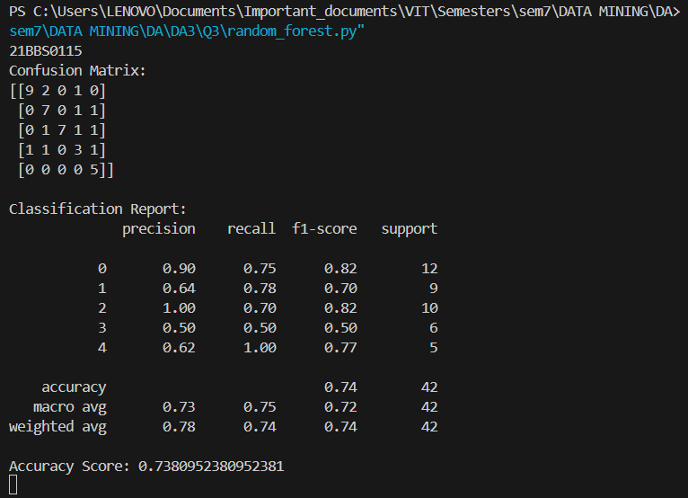

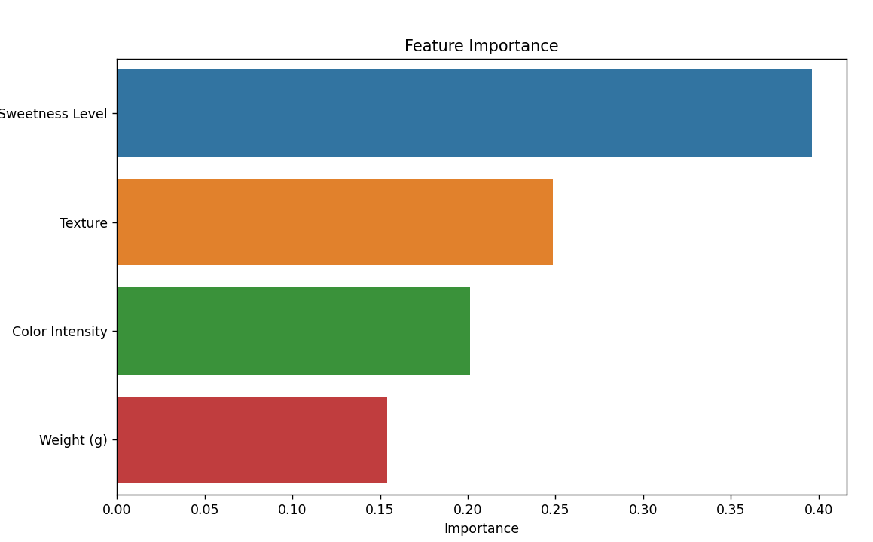

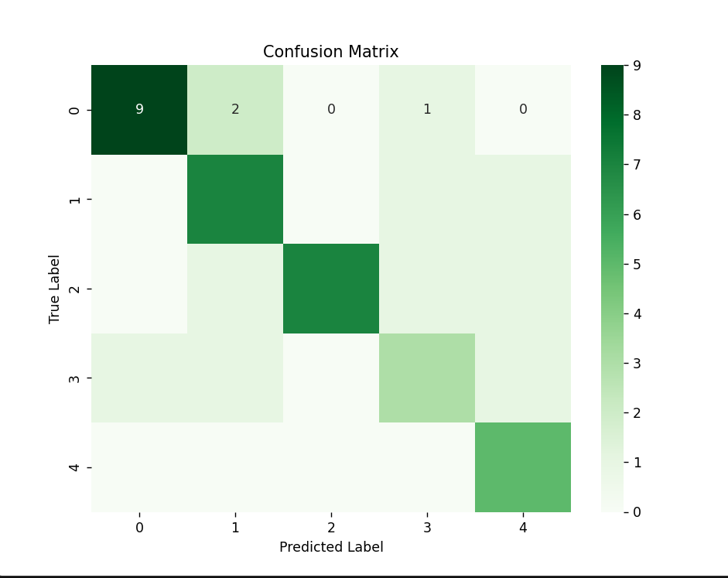

**Result:**

We have created the Random Forest Algorithm, we were able to assign feature importance to each of the 4 features, and we were also able to classify the fruits into one of 5 categories.

XXXXXXXXXXXXXXXXXXXXXXXXX