*Revision 6*

TANGO Device Servers

**Design & Implementation Guidelines**



**Versions of the document**

|  |  |  |  |  |
| --- | --- | --- | --- | --- |
| **Date** | **Writer** | **Reviewer** | **Modifications** | **Revision** |
| 19/06/2012 | S.GARA  S. MINOLLI | N.LECLERCQ  A.BUTEAU |  | 0 |
| 11/09/2012 | MIRJAM LINDBERG | N.LECLERCQ  A.BUTEAU |  | 1 |
| 12/09/2012 | E.TAUREL  P.VERDIER | N.LECLERCQ  A.BUTEAU |  | 2 |
| 16/11/2012 | JM CHAIZE  E.TAUREL | A.BUTEAU | Remarks following SOLEIL/ESRF meeting | 3 |
| 14/12/2012 | J.MEYER | A.BUTEAU | Remarks following SOLEIL/ESRF meeting | 4 |
| 21/12 | A.BUTEAU |  | Remark from Teresa Nunez (DESY) | 5 |
| 13/11/2013 | A.BUTEAU |  | clarification of 3.3.3.7 | 6 |
| 15/07/2015 | A.GOTZ | A.BUTEAU | License Creative Commons  New Tango LOGO | 7 |

Table of contents

TANGO Device Servers 1

Introduction 6

1.1 Scope of the document 6

1.2 Authors 6

1.3 About this document 6

Reference Documents 7

TANGO Concepts overview 8

1.4 Tango Model 8

1.4.1 TANGO Control system 8

1.4.2 Device concept 8

1.4.3 Hierarchy 8

1.5 Communication paradigm 9

1.6 Class, Device and Device Server 10

1.6.1 Reminders 10

1.6.2 Device 11

1.6.3 Device attributes 12

1.6.4 Device commands 16

1.6.5 Device State 17

1.6.6 Properties 18

TANGO Device Design 21

1.7 Elements of general design 21

1.7.1 Reusability 21

1.7.2 Generic interface programming 21

1.7.3 Abstract interfaces 21

1.7.4 Singleton device 21

1.7.5 Device states 22

1.8 Device interface definition 22

1.9 Service availability 22

1.9.1 TANGO polling mechanism 22

1.9.2 Threading mechanism 23

TANGO device implementation 24

1.10 General rules 24

1.10.1 Language 24

1.10.2 Types 24

1.10.3 Generated code 24

1.11 Device interface 24

1.11.1 Naming rules 24

1.11.2 Device attributes nomenclature 25

1.11.3 Data types choice 25

1.11.4 Interface level choice 26

1.12 POGO use 26

1.12.1 Device generation 26

1.12.2 Attributes generation in C++ 27

1.13 Internal device implementation 27

1.13.1 Separation between the TANGO interface and the internal system function 27

1.13.2 Details on method for accessing the hardware: always_executed_hook versus read_attr_hardware 28

1.13.3 Static database as persistent data storage 29

1.14 Device state management 29

1.14.1 States choice 29

1.14.2 Semantics of non-nominal states 31

1.14.3 State machine management 31

1.15 Logging management 33

1.15.1 The importance of rigorous logging management 33

1.15.2 Implementation 34

1.16 Error handling 35

1.16.1 The importance of rigorous error handling 35

1.16.2 Implementation 36

1.16.3 Standardized name for error types 36

1.16.4 Details for an attribute 39

1.16.5 Details for the properties 39

Appendices 41

1.17 Appendix 1 –Code Quality Checklist 41

1.18 Appendix 2 – Full code samples 41

Illustrations table

Figure 1 : The software bus view of devices 9

Figure 2 : Hierarchical view of devices 9

Figure 3 : TANGO Deployment 11

Figure 4 : States transitions 18

Tables table

Table 1 : Reference documents 7

Table 2 : List of standardized error types for an exception 37

# Introduction

## Scope of the document

This document is a Design and Implementation Guidelines about TANGO device development.

The purpose of this document is not to rewrite the TANGO documentation but to propose the community an interpretation of TANGO device development..

To this aim the document is divided in 3 main chapters:

1. The first one presents the Tango concepts
2. The second one focuses on DeviceServers design consideration
3. The last one insists on implementation good practices

## Authors

The following people have contributed to this document : Alain Buteau (SOLEIL), Jens Meyer (ESRF), J-M.Chaize (ESRF), E.Taurel (ESRF), P. Verdier (ESRF), N.Leclerq (SOLEIL), M.Lindberg (NEXEYA), S.Gara (NEXEYA), S. Minolli (NEXEYA), and A. Götz (ESRF).

## About this document

The document has been initiated within the collaborative framework between SOLEIL and MAX-IV to define common software quality rules for shared software between these 2 institutes. It has since been adopted by the TANGO community and is maintained for and by the community[1].

The objectives are then to enhance the general software quality of DeviceServers developed by the various institutes using Tango. This will also ease the reusability of developments between institutes by allowing finding “reliable off-the-shelves” Tango servers on the tango-ds public repository.

**Last but not least, this document can be freely distributed (under the Creative Commons license) to subcontractors, students, etc...**

Our hope is (*as all writers*) to have as many readers as possible!!

**Bonne lecture**

**Initial Remark:** Throughout the rest of the document, the issued recommendations are specified with the format below:

The recommendation is to …

The recommendation checklist is included in Annex 1.17.

**Important note:** The content of this document is generally independent of the programming language used. However, there are some “C++ oriented” exceptions. A dedicated documentation exists for devices written in Java and Python – see [www.tango-controls.org](http://www.tango-controls.org) for more details.

The present document refers to the Tango 8 (or higher versions) features.

**Licence**: This work is licensed under the **Creative Commons Attribution 4.0 International License**. To view a copy of this license, visit <http://creativecommons.org/licenses/by/4.0/>.

# Reference Documents

| **Code** | **Reference** | **Title** |
| --- | --- | --- |
|  | TANGO Documentation | The TANGO Control System Manual  Version 7.2 |
|  | TANGO Documentation | The TANGO Control System Manual  Version 8 |
|  | YAT and YAT4Tango documentation | On line documentation of the YAT and YAT4Tango libraries is available on  http://www.tango-controls.org/ |

Table 1 : Reference documents

# TANGO Concepts overview

## Tango Model

The following explanations are from the chapter 3 *« The TANGO Device Server Model »* of TANGO documentation (see [A1]).

### TANGO Control system

The TANGO control system is an abstract concept which represents a set of “services” based on a common technology: TANGO. TANGO is itself a control/command oriented specialization of CORBA/ZMQ. CORBA supports the concept of software bus running over a network interconnected machines. It provides transparent access to any software object (or service) connected to the bus and abstracts the notions of programming language (C++, Java, Python…) and operating systems (Linux, Windows…) using an interoperable protocol (IIOP).

TANGO hides the complexity of the underlying protocols to the programmer, while adding specific control system features (alarms, events, logging, data archiving…).

### Device concept

The “device” is the core concept of TANGO. This concept can be directly linked to the notion of service: **1 device = 1 service**

A device can represent:

* An equipment (eg: a power supply),
* A set of equipments (eg: a set of 4 motors driven by the same controller),
* A set of software functions (eg: image processing),
* A group of devices representing a subsystem

The TANGO Device allows making abstraction of the equipment’s nature: the device hides the implementation specific details from the user who does not need to care about communication protocols etc.

### Hierarchy

A TANGO control system can be (logically) hierarchically organized.

At the lower level, we will find elementary devices which are associated with equipments.

* Eg: a vacuum pump, a motor, an I/O card

At higher levels, the devices are « logical ». These devices, based on the lower-level devices, manage and represent a subset of the control system. This is usually a synthetic view of a set of equipments with a high-level steering (functions can perform sequences of actions on several basic devices).

For example, a high-level device achieves “complex” features. This device is usually bound to evolve regardless of the hardware. Therefore, it is necessary to separate and segregate responsibilities related to the logic functionality and those related to hardware interfaces.

By default it is possible to access any device from any device.

The following diagram illustrates the concept of hierarchy of devices:



Figure 1 : The software bus view of devices

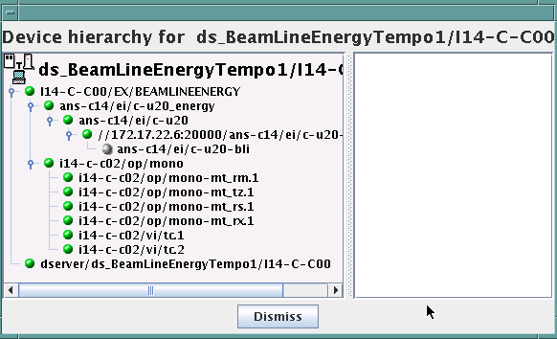

Figure 2 : Hierarchical view of devices

## Communication paradigm

The standard TANGO communication paradigm is a synchronous/asynchronous two-way call. In this paradigm the call is initiated by the client who contacts the server. The server handles the client's request and sends the answer to the client or throws an exception which the client catches. This paradigm involves two calls to receive a single answer and requires the client to be active in initiating the request. The calls initiated by the client may be done by 2 mechanisms:

* the synchronous mechanism where client waits (and is blocked) for the server to send the answer or until the timeout is reached
* the asynchronous mechanism where the clients send the request and immediately returns. It is not blocked. It is free to do whatever it has to do like updating a graphical user interface. The client has the choice to retrieve the server answer by checking if the reply is arrived by calling an API specific call or by requesting that a call-back method is executed when the client receives the server answer.

If the client has a permanent interest in a value he is obliged to poll the server for an update in a value every time. This is not efficient in terms of network bandwidth nor in terms of client programming.

For clients who are permanently interested in values the event-driven communication paradigm is a more efficient and natural way of programming. In this paradigm the client registers his interest once in an event (value). After that the server informs the client every time the event has occurred. This paradigm avoids the client polling, frees it for doing other things, is fast and makes efficient use of the network.

## Class, Device and Device Server

### Reminders

Sometimes, there are misuses of language regarding the concepts of: device, device server and TANGO class.

* TANGO class: a class defining the interface and implementing the device control or the implementation of a software treatment.
* Device: An instance of a TANGO class giving access to the services of the class.
* Device Server: process in which one or more TANGO classes are executed.

**These three concepts are closely related, but they express very important concepts of Tango.**

**Take time to clearly understand them!**

The diagrams below illustrate these concepts:



Figure 3 : TANGO Deployment

A Device Server can host several Tango classes, each class can be instantiated “several” times within the same device server. There are no specific rules regarding the maximum number of classes or the maximum number of instances operating within a single Device Server.

Be careful, in particular cases, for technical constraints, it is not always possible to run several instances of a TANGO class within the same Device Server:

* Case of a DLL’s use: some DLLs can’t be used by two threads of the same process.

In other cases, it is useful to have multiple devices running in the same Device Server:

* Case of motors: a single axis controller for 4 motors.

### Device

This is the basic entity of the control system. In the TANGO world, everything is Device.

A TANGO Device must be “self-consistent”. In case it represents a subset of the control system, it must enable the access to all the associated features (unless otherwise specified). The limit of its “responsibilities”, meaning “separation of concerns”, is clearly defined: 1 Device = 1 service = 1 element of the system. The analogy with object-oriented programming is straightforward.

A Device is a **service** made available to any number of unspecified clients. Its implementation and/or behaviour mustn’t be guided by **assumptions about the nature and the number of its potential clients**. In all cases, responsiveness must be maximized (i.e. the response time of the device, must be minimized).

A Device has an interface composed of commands and attributes, which provides the service of the device. It also has “*properties*”, stored in the relational database, which are generally used as configuration settings. These concepts are explained later in this document.

### Device attributes

#### Purpose of an attribute

This chapter is from Appendix *« A.2 Device Attribute »* of the TANGO documentation (see [A1]).

Attributes correspond to physical quantities carried by the device. Any value that you want available on the TANGO bus is an attribute. For example:

* A device associated with a motor **has** a *position* attribute expressed in mm.
* A device associated with a thermocouple **has** a *temperature* attribute expressed in Celsius (or any another suitable unit).

T**he main purpose of an attribute is to replace getters and setters.**

* For example: the position of a motor will be obtained by reading the associated attribute (position) and not by running a command like *get_position.*
* The data associated with the TANGO attributes are the only values that can be archived. The TANGO *archiving system* (HDB/TDB) doesn’t have any functions to archive the result of a command. Similarly, some mechanisms to store the experimental data (such as those implemented by the DataRecorder of SOLEIL) are essentially based on the concept of attribute.

#### Attributes Properties

A TANGO attribute owns a group of settings that describes it *(see Tango control system manual Appendix A.2)*

These configuration parameters are called AttributeProperties. They can be considered as meta-data to enhance the semantic and describe the data. They can be used by GUI clients for configuring their viewers in the best manner and displaying extra information.

Those Attribute properties describe the attribute data and define some behaviours such as alarm limits, units etc…

The first set of *Attribute Properties* are static metadata. They describe the kind of data carried by the Tango Attribute. The static metadata includes properties such as the name, the type, the dimension, if the attribute is writable or not. These data are hardcoded, defined for the whole life of the attribute and cannot be modified.

The second set of *Attribute Properties*, are dynamic. They describe more precisely the meaning of the data and some behaviours. They are used by GUI viewers to configure themselves. They can be modified at run time.

All these metadata are hosted in the class itself and can be set by the programmer or by a configuration in the Tango database.

#### Static attribute Properties

* + ***name***: the attribute name
    - Type: string e.g : OutCurrent, InCurrent…
  + ***data_type***: the attribute data type
    - Identifier of the Tango numeric type associated to the attribute: *DevBoolean, DevUChar, Dev[U]Short, Dev[U]Long, Dev[U]Long64, DevFloat, DevDouble, DevString, DevEncoded*
    - Note: *Tango::DevEncoded* is the TANGO type that encapsulates client data.
  + ***data_format***: describes the dimension of the data.
    - Type: scalar (value), spectrum (1D array), image (2D array)
  + ***writable***: Defines 4 possible types of access. In practical, we can say that only 2 are really useful and answer to practically all the cases.
    - READ, The attribute can only be read (e.g. a temperature)
    - WRITE, The attribute can only be written ( to be used only in very specific cases. the READ_WRITE is generally more suitable for real cases)
    - READ_WRITE, The attribute can be written and read (the most common case) e.g. The current of a powersupply, The position of an axis…
    - READ_WITH_WRITE (deprecated, do not use)
  + ***max_dim_x*** : This property is valid only for data_format spectrum or image. It gives the maximum number of element in the dimension X. e.g. the max length of a spectrum or the maximum number of rows of an image. This property is used to reserve memory space to host the data. Nothing prevent to have a real length much shorter that this maximum.
    - E.g. 0 for a scalar, n for a spectrum of max n elements, n for an image of max n rows
  + ***max_dim_y*** : This property is valid only for data_format image. It gives the maximum number of element in the dimension Y. e.g. the maximum number of columns of an image. This property is used to reserve memory space to host the data. Nothing prevent to have a real length much shorter that this maximum.
    - 0 for a scalar or a spectrum, n for an image of max n columns
  + ***display_level*** : enables to hide the attribute regarding the client mode (expert or not)
    - Tango::OPERATOR or Tango::EXPERT
  + *(writable_attr_name)*: Deprecated, do not use

#### Modifiable attribute properties

These properties carries out information regarding the display of a value (they are editable while the device is running). Those properties enhance the meaning of the attribute and should as much as possible be defined by the device server programmer as default value when known. For instance, in the general case, the programmer knows the unit of the data and is able to describe it. Feeling the attribute property at the development stage will allow all generic clients to display the data in the best manner

* + ***description***: describes the attribute
    - Type: string e.g. “The powersupply output current”
  + ***label***: label used on the GUIs
    - Type: string e.g. “Output Current”, “Input Current”
  + ***unit***: attribute unit to be displayed in the client viewer
    - Type: string (eg “mA”, “mm”...)
  + ***standard_unit***: conversion factor to get attribute value into S.I (M.K.S.A)_unit. Be careful this information is intended to be used ONLY by the client (.e.g ATKPanel uses it, but jive->test device does not)
    - Type: string interpreted as a floating point value E.g. If the device attribute gives the current in mA, we have to divide by 1000 to obtain it in Amp. Then we will set this property to 1E-03
  + ***display_unit***: used by the GUIs to display the attribute into a unit more appropriate for the user. Be careful this information is intended to be used ONLY by the client (e.g ATKPanel uses it, but Jive🡪Test device does not).
    - Type: string interpreted as a floating point value If the device attribute gives a current in mA. If we want to display it in microA, then we have to multiply by 1000 to obtain it in microAmp. Then we will set this property to 1000.0.
  + ***format***: specifies how a numeric attribute value should be presented
    - Type: string : e.g. « %6.3f »
    - Note: we use a “printf” like syntax – see paragraph A.2.2.1 of the Tango documentation for more details.
  + ***min_value*** *and* ***max_value***: minimum and maximum allowable value. These properties are automatically checked at each execution of a write attribute. If the value requested is not between the min_value and the max_value, an exception will be returned to the client.
    - Type: string interpreted as a floating point value (e.g. 10.1, 1E01, 0.12.)
    - Note: these properties are valid only for writable attributes

#### Attributes properties related to ALARM configuration

Tango provides an automatic way for defining alarms. An alarm condition will switch the attribute quality factor to alarm and the device state will automatically switched to ALARM in certain conditions. (See chapter 5.5 of the present guide and paragraph A.2.2.2 of the Tango documentation.)

4 properties are available for alarm purpose.

* + - ***min_alarm*** *and* ***max_alarm***: Define the range outside which the attribute is considered in alarm. If the value of the attribute is > max_alarm or < min_alarm, then the attribute quality factor will be switched to ALARM.
    - ***Delta_val*** *and* ***delta_t***: (*could also be called maximum noise and time constant*) Valid for a writeable attribute. Define a maximum difference between the set_value and the read_value of an attribute after a standard time.

E.g, the voltage of a powersupply is set via a DAC and read via an ADC convertor. Both values are different due to various factors such as internal resistor or noise on the ADC. Furthermore when setting a voltage, the powersupply may need a certain time to establish its output voltage. The *delta_val* property allows to define the limit of the acceptable difference between set and read values (noise threshold) and *delta_t* defines the time the device needs to establish the voltage after the writing of the setpoint (time constant). When writing a new value of the attribute, if the read value is still not close enough from the set value after the time constant, the attribute quality factor will be set to ALARM.

If these properties are not set, nothing is done. As soon as one of these properties is set, then the attribute quality factor is automatically calculated at each read and is taken into account by the default State attribute method. Device_Impl.dev_state(); The programmer should be aware of possible effect of these mechanisms in the response time of the State method. (Refer to chapter 1.14 of the present guide).

Warning: the behaviour described in the paragraph A.2.2.2 is only correct in the case the device’s method *Tango::Device_[X]Impl::dev_state()* is executed*.* In case of overwrite of the dev_state() in the device code, it is recommended to finish the method by calling DeviceImpl::dev_state();

* + - ***min_warning****and* ***max_warning*** : lower and upper bound for WARNING (deprecated)

#### Attributes properties related to Events configuration

These settings are used for tuning the events related to the attribute. It is strongly advised to read paragraph A.2.2.3 of the Tango documentation. This paragraph details the parameters listed here.

* + *Rel_change:* relative change in the value in percent
  + *Abs_change*: absolute change in the value in the standard unit.
  + *Period*: period between two consecutive events
  + *Archive_rel_change*: relative change in the value
  + *Archvie_abs_change*: absolute change in the value
  + *Archive_period*: period between two consecutives events.

#### Particular case of a memorized attribute

*(only possible with an attribute with WRITE or READ_WRITE mode and SCALAR type):*

A memorized attribute can store its last written value in the database (i.e. the last setpoint received by the device for this attribute can optionally persist into the Tango database).

The stored value will be reloaded into the set value associated with this attribute at device start-up and (optionally) upon each execution of the “Init” command. The Tango code generator (POGO) provides the interface allowing the developer to select the expected behaviour.

**BE CAREFUL:** this mechanism has the following **behaviour**:

* The writing of the memorized attributes is carried out after the function “init_device”, executed by the TANGO layer, and not by the Tango DeviceServer code. Then if a failure occurs during the “init_device” it cannot be catched by the Tango DeviceServer programmer.
* If in the init_device method an error occurs that causes a change of state in which the writing of an attribute is impossible, this error will prohibit the restoration of the memorized value of the attribute.
* The order of reloading is deterministic but complex (*order of ClassFactory then device definition in database then attribute definition in POGO*). Therefore relying on this order might have some side effects particularly in case attributes are modified through POGO when attributes values are linked (*eg: sampling frequency and number of samples*).
* Performance issues may happen in case the setpoint is written at high frequency, the static Tango database is requested on each write of the memorized attribute.

If this standard Tango behaviour for reloading memorized values doesn’t fit your need, we recommend to code the reloading of attribute values yourself.

### Device commands

**A command is associated with an action. *On, Off, Start, Stop* are commons examples.**

A TANGO command has, optionally, ONE input argument and ONE output argument.

The different types of data compatible for input and output are:

* void, boolean, short, long, long64, float, double, string, unsigned short, unsigned long, unsigned long64
* *1D array of the followings types :* char, short, long, long64, float, double, unsigned short, unsigned long, unsigned long64, string
* State: enumeration, representing the different states described in chapter 1.6.5.
* 2 particular types: longstringarray and doublestringarray. These are structures including one array of long/double and one array of string.

It is impossible to add types, this list is fixed.

For each command to implement, it is essential to generate exceptions depending on the cases of errors. The error handling is described more in details in chapter 1.16.

### Device State

#### State transitions

A TANGO device has a state (meaning a *finite state machine*). The device state is a key element in its integration into the control system. Therefore, **you should be very careful in the management of state transitions** in the device implementation.

**The device state must, at any time, reflect the internal state of the system it represents. The state should represent any change made by a client’s request.**

This is crucial information. Indeed, the “clients” will primarily, or only, use this information to determine the internal state of a system.

The available states are limited to:

* ON, OFF, CLOSE, OPEN, INSERT, EXTRACT, MOVING, STANDBY, FAULT, INIT, RUNNING, ALARM, DISABLE, UNKNOWN

The main thing is to ensure a predictable behaviour of the device regarding the state transitions.

For example:

* Consider the case of a motor system. The client knows the motor state (*STANDBY, MOVING, FAULT,)* with a *polling* mechanism (periodic reading of the state attribute of the motor – instead of using the TANGO event system).

In such cases, this can easily lead to inconsistent behaviour due to inappropriate management of the state.

A typical example is to launch an axis movement through the writing of the position attribute then the client is pending on the MOVING state (the motor is supposed to make a transition *STANDBY 🡪MOVING*). Such a method will only work if the writing of the position attribute switches the device state to MOVING before the return of the writing request of the position attribute. Otherwise, the client can read (non-zero probability) the STANDBY state, and interpret it as “movement ended” while this one had not even started!

This behaviour is described in figure 4 below.

The developer has to guarantee the clients the same behaviour regardless the type of state monitoring (polling or events). This relates to the above rule: **Do not make assumptions about the nature of the clients!**

The state transitions and the “associated guarantees” must be documented. In the previous example, rereading the STANDBY state after performing any movement must ensure that the required movement is completed (and not that it has not yet been started!!).

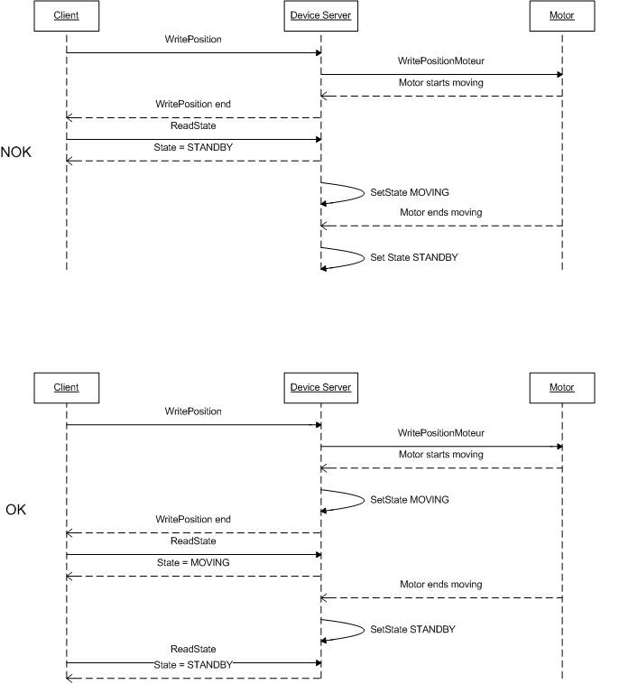

Figure 4 : States transitions

The principle of the states machine is described in the paragraph 1.14.3.

### Properties

#### Concepts

By default TANGO is based on a relational database (MYSQL) to store configuration information for devices: the *properties*.

The properties are used to configure a device, without changing the TANGO class code. Taking an axis controller as example, the controller must be configured for the motor mechanic according to the characteristics of the actuator and the movements to achieve.

Configuration properties are available on different levels:

1. **The device level:** These are properties to configure the device itself and its attributes. The device properties configure the device with the necessary set-up information during initialisation. Attribute properties are used to configure alarms or specify the way the attribute value is displayed to the user (Label, Format, Unit...).
2. **The class level:** Device or attribute properties configured at the class level are valid for all instances of a class. A property defined on the class level will be overwritten by a property of the same name on the device level.
3. **Free properties:** These are configuration values which are not attached to any device or class and can be freely used by programmers.

Class level and device level properties are automatically loaded during device initialisation when starting-up a device server or calling the “Init” command. The reading and writing of free properties must be handled by the programmer.

Configuration properties can have the following data types:

* boolean, short, long, float, double, unsigned short, unsigned long, string
* array of: short, long, float, double, string

On top of those basic concepts, device and class level properties can be initialised with default values which are entered, for example, with Pogo at the interface creation time. Default values are stored in the device server code and are overwritten when another value is found in the configuration database.

Not for every device property a useful default value can be assigned. In this case the device property can be declared as mandatory (with Pogo). A mandatory property has to have a value configured in the TANGO database. If no value could be found, the device initialisation will stop with an exception on the missing property value.

It is necessary to assign a default value for every property. This value will be used when the property is not defined in the TANGO database. If a default value for a device property does not make sense, the property should be declared as mandatory.

#### Device property vs memorized attributes

In some cases, you could be tempted to use a property for a memorized attribute and vice-versa. It is important to distinguish the function of each, and use them wisely.

* The use of a property must be limited to configuration data which value doesn’t change at runtime (the IP address of equipment for example).
* The memorized attributes are reserved for physical quantities subject to change at runtime (*attribute read/write*) for which you want to retain (store) the value from one execution to the other.

Eg: speed or acceleration on a motor.

In the case you want to manually manage the memorization of the attribute set points, you should use an attribute property called *__value* (as natively done by Tango).

#### How to configure a new device

To set-up a new device you need to know about all the device properties and their values which must be configured to make the device work. You need to have a description on the property which should indicate clearly its use. Also you need to know about a specified default value.

When creating the device interface with Pogo a description and a default value can be entered for every device property. This information is used by the device installation wizard (available with Jive) to guide you through the configuration.

When creating a new server start the wizard from the Tools menu -> Server Wizard. It allows you to create a new device and to initialise it property by property. For every property the description is displayed and the default value can be viewed. To use the wizard on an already existing device you can right click on the device and choose Device Wizard. You will be guided again through all the properties of the device. At the end the device can be re-started when necessary. Because the wizard is part of Jive, you can test the device configuration immediately.

# TANGO Device Design

## Elements of general design

### Reusability

In a TANGO control system, each device is a software component potentially reusable.

It is necessary to:

* Estimates systematically, prior the coding of a device, the possibility of reusing a device available in the code repositories (TANGO community, local repository), in order to avoid several implementations of the same equipment.
* Design the device as reusable/extensible as possible because it may interest the others developers in the community.

As such, the device must be:

* Configurable: (e.g.: no port number “hard coded”, but use of a parameter via a property),
* Self-supporting: the device must be usable outside the private programming environment (eg: all the necessary elements to use the device (compile, link) must be provided to the community). Theuse of the GPL should be considered, and the use of proprietary libraries should be avoided if possible
* Portable: the device code must be (as much as possible) independent of the target platform unless it depends on platform specific drivers,
* Documented in English

### Generic interface programming

The device must be as generic as possible which means the definition of its interface should

* Reflect the service rather its underlying implementation. For example, a command named “WriteRead” reflects the communication service of a bus (type: message exchange), while a command named “NI488_Send” reflects a specific implementation of the supplier.
* Show the general characteristics (attributes and commands) of a common type of equipment that it represents. For example, a command ”On” reflects the action of powering on a PowerSupply , while a command named “BruckerPSON” reflects a specific implementation which must be avoided.

The device interface must be service oriented, and not implementation oriented.

### Abstract interfaces

### Singleton device

Tango allows a device server to host several devices which are instantiations of the same TANGO class.

However, in particular case some technical constraints may forbid it (see § 1.6.1). In this case, the DeviceServer programmer must anticipate it in the device design phase (add for example a static variable counting device instances or other) to detect this misconfiguration. For example, it can authorize the creation of a second instance (within the meaning of the device creation) but systematically put the state to FAULT (in the method init_device) and indicate the problem in the Status.

In the case where technical constraints prohibit the deployment of multiple instances of a TANGO device within the same device server, the developer has to ensure that only one instance can be created.

### Device states

When designing the device, you should clearly define the state machine that will reflect the different states in which the device can be, and also the associated transitions.

The state machine must follow these rules:

* At any time, the device state must reflect the internal state of the system it represents.
* The state should represent any change made by a client’s request.
* The device behaviour is specified and documented.

## Device interface definition

The first step in designing a device is to define the commands and the attributes via POGO (interface with the TANGO “entities”).

Except in (very) particular cases, always use an attribute to expose the data produced by the device. The command concept exists (see § 1.6.4) but its use as an attribute substitute is prohibited. Example: a motor must be moved writing its associated ‘position’ attribute instead of using a ‘GotoPosition’ command.

The choice will be made following these rules:

* Attribute: for all values to be presented to the “client”. **It is imperative to use the attributes and to not use TANGO commands that would act like a get/set couple.**
* Command: for every action, of void-void type in most cases.

Any deviation from these rules must be justified in the description of the attribute or command particular case.

## Service availability

From the operator perspective, the “**response time**” or “**reactivity**” (admittedly rather fuzzy concept) is THE reference metric to describe the performance of a device. Ideally, the device implementation must ensure the service availability regardless of the external client load or the internal load. For the end user, it is always very unpleasant to suffer a TANGO timeout and receive an exception instead of the expected response.

The response time of the device should be minimised and in any case lower than the default Tango timeout

If the action to be performed takes longer than that, execution should be done asynchronously in the Tango class: its progress being reported in the state/status.

Several technical solutions are available to the device developer to ensure service availability:

* Use the TANGO polling mechanism,
* Use a threading mechanism, managed by the developer.

### TANGO polling mechanism

#### Polling interest

The polling mechanism is detailed in the TANGO documentation [A1], *“9.2 Device Polling”*.

TANGO implements a mechanism called *polling* which alleviates the problem of equipment response time (which is usually the weak point in terms of performance). The response time of a GPIB link or a RS-232 link is usually one to two orders of magnitude higher than the performance of the TANGO code done by a client request.

#### Polling limitations

From the perspective of the device activity, the polling is in direct competition with client requests. The client load is therefore competing with polling activity.

This means that polling activity has to be tuned in order to keep some device free time to answer client requests. Do not try to poll a device object with a polling period of let say 200 mS if the object access time is 300 mS (*even if TANGO implements some algorithm to minimize the bad behavior of such bad polling tuning*).

For polled Tango device objects (attribute or command), client reading does not generate any activity on the device whatever the client number. The data are returned from the so-called polling buffer instead of coming from the device itself. Therefore, an obvious rule is to poll the key device object (state attribute, pressure attribute for a vacuum valve...)

The recommendation for device polling tuning is to keep the device free 40% of time.

Let's take an example: for a power supply device, you want to poll the device state and its current attribute which for such a device are the device key objects.

* State access needs 100 mS while current attribute reading needs 50 mS.
* Because, you want to poll these two objects, time required on the device by the polling mechanism will be 150 mS (100 + 50).
* In order to keep the 40% ratio, tune the polling period for this device to 250 mS.
* The device is then occupied by the polling mechanism during 150 mS (60 %) but free for other client activity during 100 mS (40 %).

Device polling is easily tunable at run time using Jive and/or Astor TANGO tools.

### Threading mechanism

*Threading* is a possible solution for the load problem: a thread (managed by the device developer) supports communication with the material (*polling* or other) and the data obtained are put in the “cache”. You can now produce the “last known value” to the client at any time and optimize the response time. This approach, however, has a limit where it is necessary to reread the hardware to assure clients that the returned value is the system “current state”.

For a C++ device, the implementation of a threading mechanism can be done via the *DeviceTask* class from the *Yat4Tango library*. This class owns a thread associated with a FIFO message list. Processing messages can be synchronous or asynchronous.

See the complete example in the appendix (§ 1.18) for the implementation details.

When the design of the Tango class requires threading:

• in case of simple thread usage, in C++ the recommendation is to use a C++11 thread

• In case of acquisition thread with messages exchange in C++ the recommendation is to use Yat4TANGO::DeviceTask class..

# TANGO device implementation

## General rules

### Language

The TANGO community is international and the developments could be shared with the community, so it is recommended to use ENGLISH for a device development.

English will be used for:

* The interfaces definition (attributes and commands),
* The device documentation (online help for command usage and attributes description),
* The comments inserted in the code by the developer,
* The error messages,
* The name of variables and internal methods added by the developer.

The choice of the language used for the user’s documentation of the device server (“DeviceServer User’s Guide”) is left free, to focus on the editorial quality. In the case of a joint development with another institute, English will be used.

### Types

The types used for the device interface definition are TANGO types (TANGO::DevDouble, TANGO::DevFloat …). These types are presented by POGO and are not modifiable.

The types used by the developer in its own code are left free to choose, as long as they are not platform specific. Standard types of the language used (Boolean, int, double …), TANGO types or types from a common library (Yat, Yat4TANGO for C++) can potentially be used.

Direct conversions from the C++ type long to TANGO::DevLong are only supported on 32-bit platforms and should be avoided.

### Generated code

The automatically generated code by POGO must not be modified by the developer.

The developer must include its own code in the “PROTECTED REGION” specified parts.

## Device interface

### Naming rules

Having homogeneous conventions for naming attributes, commands and properties is a good way to promote DeviceServers reuse inside the Tango collaboration.

In fact it makes the development done by another institute easier to understand and integrate in another Control System.

#### Class name

The Tango class name is obtained by concatenating the fields that compose it – each field beginning with a capital letter:

Eg : MyDeviceClass

#### Device attributes

The device command and attributes names must be explicit and should enable to quickly understand the nature of the attribute or the command.

* Eg: for a power supply, you will have an attribute “outputCurrent” (not OC1) or a command “ActivateOutput1” (not ActO1).

The nomenclature recommendations are on § 1.11.2.

**The attribute naming recommendations are:**

* Name composed of at least two characters,
* Only alphanumeric characters are allowed (no underscore, no dashes),
* Start with a **lowercase** letter,
* In case of a composite name, each sub-words must be capitalized (except the first letter),
* Prohibit any use of vague terms (eg: readValue).

#### Device Commands

The recommendations are the same as those proposed for an attribute (see § 1.11.1.2), except for the first letter of the name.

**The command naming recommendations are:**

* Name composed of at least two characters,
* Only alphanumeric characters are allowed (no underscore, no dashes),
* Start with a **uppercase** letter,
* In case of a composite name, each sub-words must be capitalized,
* Prohibit any use of vague terms (eg: Control).

#### Device properties

The recommendations are the same as those proposed for a command (see § 1.11.1.3).

**The property naming recommendations are:**

* Name composed of at least two characters,
* Only alphanumeric characters are allowed (no underscore, no dashes),
* Start with a **uppercase** letter,
* In case of a composite name, each sub-words must be capitalized,
* Prohibit any use of vague terms (eg: Prop1).

### Device attributes nomenclature

It is a good practice that a particular signal type is always named in a similar way in various DeviceServers.

For example the intensity of a current should always be name “***intensity***” (and not “***intens***”, “***intensity***”, “***current***”,”***I***” depending on the DeviceServers).

This allow the user to quickly make the link between the software information and the physical sensor and reciprocally.

### Data types choice

Always use data types consistent with the underlying information

* Unsigned integer must be used for the physical quantities that are suitable.
  + Eg: A number of samples numSamples, where negative values have no meaning, will be a TANGO::DevULong (unsigned integer 32 bits) and not a TANGO::DevLong (signed integer 32 bits).
  + Similarly, in such a case, the use of a floating point number is to be prohibited, non-integer values having no meaning.
* This rule is applicable to input/output arguments of commands.

### Interface level choice

The choice between the *Expert* or the *Operator* level for an interface must be thoughtful.

Only necessary and sufficient commands for a nominal control of the equipment must be accessible to the *Operator* level. The commands for fine control of the equipment (eg: metrology, maintenance, unit test) must only be accessible to the *Expert* level.

## POGO use

### Device generation

The use of POGO is mandatory for creating or modifying the device interface.

TANGO is constantly evolving, this tool will support all or part of the porting, associated to the kernel and their consequences on the IDL interface.

In addition, it simplifies maintenance / development operations.

Every command, attribute, property or device state must be fully documented; this documentation is done via the POGO tool.

Specifically, when creating an attribute with POGO, the entire configuration of the attribute must be fully filled in by the developer (maximum possible) to avoid ambiguities.

Similarly, the states and their transitions must be described with precision and clarity.

In fact:

* In operation, this documentation will be the reference for understanding the device behaviour. Remember that the operator will have this information with the generic tools (like “*Test Device*” from “*Jive*”).
* The HTML documentations generated by POGO can also be accessed from a local server (peculiar to the institute).
* Consider also to fill in the alarm values.
  + Eg: set the alarm values according to the specifications of a power supply, ie, 0V-24V for the voltage, or 0A-3A for the output current.

Example for a temperature reading:

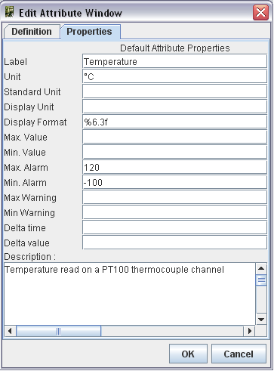

### Attributes generation in C++

In C++, POGO automatically generates **pointers** to the data associated with the attributes values (ie a pointer is generated for the read part). The use of these pointers is not mandatory. The developer is free to use his own data structure in the attribute value affectation.

## Internal device implementation

### Separation between the TANGO interface and the internal system function

Don’t forget that the TANGO interface is only a mean to insert a service in a control system. Therefore, it is necessary to think the device internal design like any other application and just add the TANGO as an interface on top of it.

As a rule of thumb if the code implemented within the POGO markers is too long, a good practice is to move it to another class. Then Pogo generated methods will be only a few lines of code long.

In practice, it is necessary to avoid mixing the generated code by POGO and the developer’s one.

The TANGO sub-class inherited from *TANGO::DeviceImpl[_X]* instantiates a class derived from the model object implementing the system, and ensure the replacement between the external requests (clients) and the implementation class(es).

In the choice of data structures, we are talking about those of the developer’s object model, we will consider the technical constraints imposed by TANGO and/or the underlying layers (CORBA). The idea here is to avoid copy and/or reorganization of the data when transferred to the client. For this, the developer needs to know/master the underlying memory management mechanism (especially in C++). The TANGO documentation referenced [A1] contains a dedicated chapter “*8.2 -* *Exchanging data between client and server”*.

### Details on method for accessing the hardware: always_executed_hook versus read_attr_hardware

It is essential to master the concepts implemented by these two methods (common methods for all TANGO devices).

It is also necessary to clearly identify, in the design phase, the possible consequences of implementing these two methods on the device behaviour (remember that they are initially just empty shells generated by POGO).

* *Always_executed_hook()* method is called before each command execution or each reading/writing of an attribute (*but it is called only once when reading several attributes: see calling sequence below*)
* *Read_attr_hardware()* is called before each reading of attribute(s)( *but it is called only once when reading several attributes: see calling sequence below)*. This method aims to optimize (minimize) the equipment access in case of simultaneous reading of multiple attributes in the same request.

Reminder about the calling sequence of these methods:

* *Command execution*
  + 1 – always_executed_hook()
  + 2 – is_MyCmd_allowed()
  + 3 – MyCmd()
* *Attribute reading*
  + 1 – always_executed_hook()
  + 2 – read_attr_hardware()
  + 3 – is_MyAttr_allowed()
  + 4 – read_MyAttr()
* *Attribute writing*
  + 1 – always_executed_hook()
  + 2 – is_MyAttr_allowed()
  + 3 – write_MyAttr()
* *Attributes reading*
  + 1 – always_executed_hook()
  + 2 – read_attr_hardware()
  + 3 – is_MyAttr_allowed()

N times

* + 4 – read_MyAttr()
* *Attributes writing*
  + 1 – always_executed_hook()
  + 2 – is_MyAttr_allowed()

N times

* + 3 – write_MyAttr()

When reading the sequence above, we understand why the mastery of these concepts is important. Particularly, having “slow code” in the *MyDevice::always_executed_hook* method can have serious consequences on the device performance.

**WARNING:** There is no obligation to use the *read_attr_hardware* method; it depends on the equipment to drive and its communication channel (Ethernet, GPIB, DLL). You can have a call to the equipment in the code of each attribute reading method.

Example: For an attribute “temperature”, of READ type, we can insert the call to the equipment in the generated attribute reading method “*read_Temperature*” instead of “*read_attr_hardware*”.

### Static database as persistent data storage

As noted in paragraph 1.6.6.2, the TANGO database can (in some cases) be used to ensure values persistence, to store the value as a property (of device or attribute).

However, this practice should be reserved for special cases that don’t require writing at high frequency. An over-solicitation of the TANGO database will penalize the entire control system.

It is therefore recommended to use a property for storage only for methods that are performed rarely, compared to other functions.

For example: storage of calibration operations results

In the general case, we recommend to:

* Use a property to store configuration data,
* Use a memorized attribute to store values changing during the execution,
* Use a memorized attribute to store values that you want to re-inject during a new execution of the device.

## Device state management

### States choice

Tango, as already said, the state is seen as an enumerated type with a fix number of values. These states have an implicit default meaning and are not equivalent. Furthermore a color code is associated to each state and is used in the main GUI tools to have a unified manner of representing the state of equipment.

|  |  |  |
| --- | --- | --- |
| State | Associated color | meaning |
| UNKNOWN | grey | The device cannot retrieve its state. It is the case when there is a communication problem to the hardware (network cut, broken cable etc…) It could also represent an incoherent situation |
| INIT | beige | This state is reserved to the starting phase of the device server. It means that the software is not fully operational and that the user must wait |
| FAULT | red | The device has a major failure that prevents it to work. For instance, A powersupply has stopped due to over temperature A motor cannot move because it has fault conditions. Usually we cannot get out from this state without an intervention on the hardware or a reset command. |
| DISABLE | magenta | The device cannot be switched ON for an external reason. E.g. the powersupply has it’s door open, the safety conditions are not satisfactory to allow the device to operate |
| OFF | white | The device is in normal condition but is not active. E.g the powersupply main circuit breaker is open; the RF transmitter has no power etc… |
| STANDBY | yellow | The device is not fully active but is ready to operate. This state does not exist in many devices but may be useful when the device has an intermediate state between OFF and ON. E.g the main circuit breaker is closed but there is no output current. Usually Standby is used when it can be immediately switched ON. While OFF is used when a certain time is necessary before switching ON. |
| MOVING | light blue | The device is in a transitory state. It is the case of a device moving from one state to another.( E.g a motor moving from one position to another, a big instrument is executing a sequence of operation, a macro command is being executed.) |
| ON | green | This state could have been called OK or OPERATIONAL. It means that the device is in its operational state. (E.g. the powersupply is giving its nominal current, the motor is ON and ready to move, the instrument is operating). This state is modified by the Attribute alarm checking of the DeviceImpl:dev_state method. i.e if the state is ON and one attribute has it’s quality factor to ALARM, then the state is modifiend to ALARM |
| ALARM | orange | The device is operating but one of this attribute is out of range. It can be linked to alarm conditions set by attribute properties or a specific case. (E.g. temperature alarm on a stepper motor, end switch pressed on a steppermotor, up water level in a tank, etc…) In alarm, usually the device does it’s job but the operator has to perform an action to avoid a bigger problem that may switch the state to FAULT. |
| RUNNING | dark green | This state does not exist in many devices but may be useful when the device has a specific state above the ON state. (E.g. the detector system is acquiring data, An automatic job is being executed). Note that this state is different from the MOVING state. It is not a transitory situation and may be a normal operating state above the ON state. |
| OPEN | green | Synonym of ON state. Can be used when ON is not adequate for the device. E.g case of a valve, a door, a relay, a switch. |
| CLOSE | white | Synonym of OFF state. Can be used when OFF is not adequate for the device. E.g case of a valve, a door, a relay, a switch. |
| EXTRACT | green | Synonym of ON state. Can be used when ON is not adequate for the device. Case of insertable/extractable equipment, absorbers, etc…  This state is here for compatibility reason we recommend to use ON or OPEN when possible. |
| INSERT | white | Synonym of OFF state. Can be used when OFF is not adequate for the device. Case of insertable/extractable equipment, absorbers, etc…  This state is here for compatibility reason we recommend to use OFF or CLOSE when possible. |

Unless strict specification, the developer is free to use the TANGO state he considers appropriate to the situation, with all the subjectivity involved.

The only practice that ensures overall consistency is to use a limited number of TANGO states, especially for a family of equipment.

It is recommended for an equipment of type motor, slit, monochromator and more generally for any equipment that can change his position, to use the “MOVING” state when the equipment is in “movement” toward his set point.

### Semantics of non-nominal states

Although the developer is free to choose the device states, we must define a common error state for all the devices.

In general, any dysfunction is associated with the state *TANGO:: FAULT*.

The use of the *TANGO::ALARM* state should be reserved for very special cases where it is necessary to define an intermediate state between normal operation and fault. Its use must be documented via POGO in order to define the semantics.

In the case of a problem occurring at initialization, it is recommended to set the device state to FAULT.

For the init_device method, we recommend:

- If the initialization method is long, thread it.

- The device state INIT must be used only in the start-up of the device. The device states changes when the init execution is over.

Semantics recommended for FAULT and ALARM states is as follows:

• UNKNOWN (grey): communication problem with the equipment or the “sub”-devices which prevents the device to really know his real state

• FAULT (red): A problem which prevents the normal functioning (including during the initialization). Getting out from a FAULT state is possible only by repairing the cause of the problem and/or executing a Reset command.

• ALARM (orange): the device is functional but one element is out of range (bad parameters but not preventing the functioning, limit switch of a motor). An attribute is out of range.

### State machine management

#### POGO or developer code

TANGO has a basic management of its state machine. *Is_allowed* methods filter the external request depending on the current device state. The developer must define the device behaviour (regarding its internal state) via POGO.

By default, any request (reading, writing, or command execution) is authorized whatever the current device state is.

The example below illustrates two ways for the state machine management of a device (here NITC01) in C++:

* + - Managing the “On” command via POGO
    - Managing the reading of the attribute “temperature” directly in the code

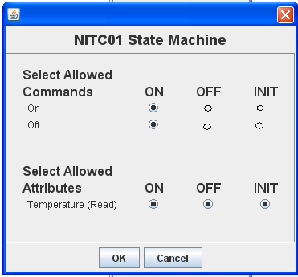

Reading allowed in all states

Commands allowed only in ON state

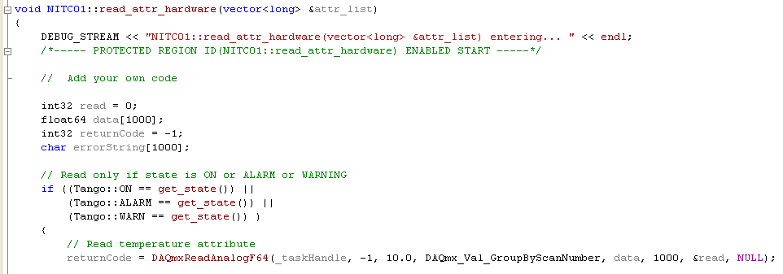

Testing the device state before reading the instrument

However, the POGO implementation is “basic”. If, for example, the execution of the “On” command on a power supply is prohibited when the current state is “*TANGO::ON*”, then the TANGO layer, generated by POGO, will systematically trigger an exception to the client. From the operator perspective, this may surprise.

In such a case, it is recommended to authorize the command but to ignore it

#### Particular case : FAULT state

**The *TANGO::FAULT* state shouldn’t prohibit everything.** The attributes and/or commands that are valid and/or allows the device to get out of the *TANGO::FAULT* state must remain accessible.

For example, in some cases, when a device used several elementary devices, its state is a combination of the elementary devices states. If one of them is in “FAULT”, we must be able to execute commands on others elementary devices, and, in all cases, have a command to get out of this state.

The transition to a “FAULT” state needs reflection and a clear definition of the device management in this state and the output conditions of this state.

#### Init and error acknowledgement

A common mistake is to associate the generic command MyDevice::Init to an acknowledgement mechanism for the current defect.

**The execution of the *Init* command must be reserved to the device re-initialization** (hardware reconnection after its reboot or reconfiguration following a property modification).

Any device that requires an acknowledgement mechanism must have a dedicated command (like *Reset* or *AcknowledgeError*).

#### Other implementations

You can also create a specific state machine, without using TANGO types, in the interface class with the device. Thus, we use this state machine to determine the TANGO state of the device. The aims here is to define an internal state machine (with a design pattern “state” for example) then do a mapping with the existing TANGO states to determine the device state.

The developer also has the ability to override the *State* and *Status* methods in order to centralize, in a unique method, the management of the internal device state, which simplifies the update of this fundamental information.

## Logging management

### The importance of rigorous logging management

The introduction of logging in the device code enables easy development, bug research and the user understanding of the device operations.

The device developer must always use the facilities offered by the *TANGO Logging Service* to produce “Runtime” messages, facilitating the understanding of the device operations. Implementations classes can inherit *TANGO::LogAdaptater* to redirect the logs to the common service.

The rules to follow are:

• Logs to the console are prohibited. The developer must use the logging stream proposed by TANGO (there is a stream for every logging level, the levels being inclusive in the order specified below). : *DEBUG_STREAM, INFO_STREAM, WARN_STREAM, ERROR_STREAM, FATAL_STREAM*

* It is important to use the right level of *logging*: on a higher level than DEBUG, the device should be a little wordy. Beyond the INFO level, it should produce only critical logs.

Recommendations of use:

* DEBUG_STREAM : developer information (route trace)
* INFO_STREAM : user information (measure, start/stop of a process)
* WARN_STREAM : warning (eg deprecated operation)
* ERROR_STREAM : general error
* FATAL_STREAM : fatal error, shutdown

It is important to use these *streams* early in the development. They allow an easier debugging.

**You shouldn’t have to modify the code to add traces.**

* Eg: use a debug_stream level for the input parameters, the display of a conversion result, the return code from a DLL function…

It is also recommended to adopt a unified formalism for logs, for example:

* “<class_name>::<method_name>() - <text trace with parameter (eventually)>”

Example of using different logs levels in C++:

Input log automatically generated by POGO

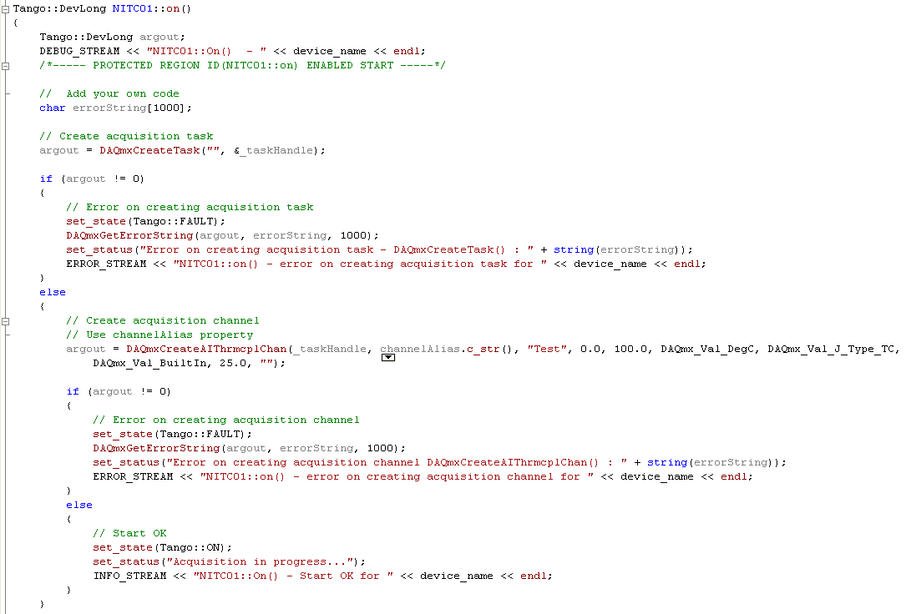

It is also possible to redirect the stream to a file (via Jive). This can be useful in the case of “random” bugs, for which a long log is required.

### Implementation

It is not mandatory, but highly recommended to add an attribute named “log” in the device interface, strings spectrum type, which tracks all the internal activity of the device (as defined in TANGO Logging).

* In C++, the class *Yat4TANGO::InnerAppender* implements this functionality based on a dynamic attribute (no need to use POGO).
* This system facilitates the recovery of errors and therefore the problems diagnosis. Problem solving will be faster and optimized.
* This feature is in particular very interesting for devices that manage automatic processes (like doing scans,..) which involve other devices. The operator has then an easy access through this “log” attribute to the behaviour and decisions taken by the device.

Example of using C++ (look at the YAT documentation for further explanations:

In the header file of the device

* Declaration of the service to use

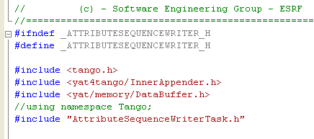

In the source code of the device

* init_device method: initialization of the “innerAppender”
* delete_device method: deletion of the “innerAppender”

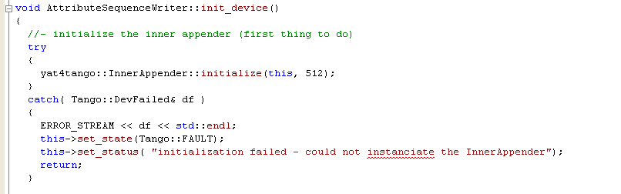

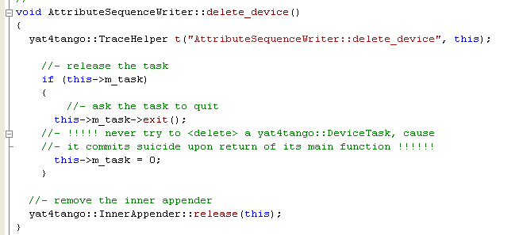

## Error handling

### The importance of rigorous error handling

The purpose of this paragraph is based on a statement on the TANGO developers practice. Indeed, the error handling is often overlooked. A good error handling means easier debugging and maintenance.

**This part is important**, it is essential for the coding quality. These concepts are detailed in the TANGO documentation referenced [A1], *“8.2.4 Reporting Error”*.

Typical cases to avoid:

* A device doesn’t behave as expected but there is no indication why.
* The device is in FAULT state but the *Status* (the attribute) gives no indication on the problem nature, or worse, a bad indication (thus guiding the users in a wrong trail, with a loss of time and energy).
* The error messages are written in the jargon of the developer or the system expert.

The developer has to ensure:

* That any exception is caught, completed (TANGO allows it) and spread (use of the rethrow_exception method),
* If an error occur it must be logged using the Tango Logging Service
* That the return code of a function is always analyzed,
* That the device *Status* is always coherent with the *State,*
* That the error messages are understandable for the final user and that they are supplemented by *logs* (*ERROR level, use of the error_stream macro*). The *Status* is the indicator that will help the user to find the error reason.
* **Ignore the “ideal situation”:** In operation, the ideal setting is often jeopardized.
  + Eg: use of communication sockets: anticipate all the common communication problems: cable not connected, equipment off, sub-devices not started or in FAULT.

### Implementation

On a more technical view, the TANGO exceptions don’t provide numerical identifier for discriminating exceptions. In the code, it isn’t possible to distinguish two exceptions without having knowledge of the text (as string) conveyed by the said exception.

All exceptions are of type *TANGO::DevFailed*. A DevFailed exception consists of these fields:

* Reason: string, defining the error type
  + Aim: refer the **operator** to the root cause
* Description: string, giving a more precise description
  + Aim: refer the **expert** of this system to the root cause.
* Origin: string, method where the exception was thrown
  + Aim : refer the **computer scientist** on the location of the failure in its code
* Severity: enumeration (rarely uses)
* To easily distinguish exceptions, it is recommended to use a finite list of error types for the Reason field, specify in capital letters:

### Standardized name for error types

|  |
| --- |
| **Standardized name for the error types** |
| OUT_OF_MEMORY |
| HARDWARE_FAILURE |
| SOFTWARE_FAILURE |
| HDB_FAILURE |
| DATA_OUT_OF_RANGE |
| COMMUNICATION_BROKEN |
| OPERATION_NOT_ALLOWED |
| DRIVER_FAILURE |
| UNKNOW_ERROR |
| CORBA_TIMEOUT |
| TANGO_CONNECTION_FAILED |
| TANGO_COMMUNICATION_ERROR |
| TANGO_WRONG_NAME_SYNTAX_ERROR |
| TANGO_NON_DB_DEVICE_ERROR |
| TANGO_WRONG_DATA_ERROR |
| TANGO_NON_SUPPORTED_FEATURE_ERROR |
| TANGO_ASYNC_CALL_ERROR |
| TANGO_ASYNC_REPLY_NOT_ARRIVED_ERROR |
| TANGO_EVENT_ERROR |
| TANGO_DEVICE_ERROR |
| CONFIGURATION_ERROR |
| DEPENDENCY_ERROR |
| NO_DEPENDENCY |

Table 2 : List of standardized error types for an exception

Example of an exception message:

**Reason**: DATA_OUT_OF_RANGE

**Description**: AxisMotionAccuracy must be at least of 1 motor step!

**Origin**: GalilAxis::write_attr_hardware

The exception hierarchy defined by TANGO has been thought only for internal use (TANGO core), the developer can’t inherit and define its own inherited exceptions classes. This strong constraint is related to the underlying CORBA IDL.

**Always keep the original exception.** It must be the first visible item in the device status.

If there is a succession of exceptions, the logic dictates that the first exception has possibly generated all the others. By resolving the first exception, the others can disappear.

**Exception handling in init_device method:**

- no exceptions should be propagated from the method *MyDevice::init_device***.** Otherwise, **the device quits.** The device should be kept alive regardless of any failure.

- The code for this method must contain a try / catch block, which guarantees that no exception is propagated in this context

- If an exception is thrown, the developer must set the device state to FAULT and update the Status to indicate the error nature. (*The goal is to understand easily why the device failed to initialize properly, while still allowing the operator to adjust this or these problems*)

**Examples of error handling in C++:**

* If an error occurs, always log it
* Always update *State* **AND** *Status*
* Manage the return code for function that have one
* Manage the exceptions for methods which can throw some

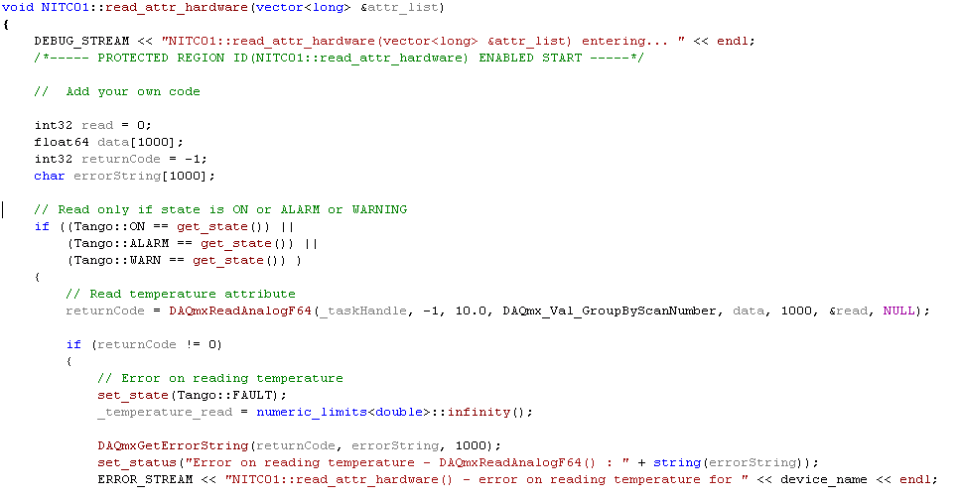



### Details for an attribute

Although TANGO supports the quality notion on an attribute value (*Tango::VALID*, *Tango::INVALID*, ...), only few clients use this information to judge the validity of the data returned (which is a shame). So it is best to not make assumptions on the use that would be made (client side) to report an invalid value to the client. In other words, **forcing the attribute quality to *TANGO::INVALID* is necessary but not sufficient.**

For float values, it is possible to set the value to “NaN”, but there is no equivalent for an integer. To avoid the handling of special cases, it is recommended to throw an exception to indicate the data invalidity.

It is recommended to throw an exception for all invalid values, regardless of their type. There is, however, two exceptions to this rule: State and Status. For these two attributes, always return a value.

This solution has the disadvantage to show a pop-up on the client side, but this is the most effective method to indicate that the attribute reading has failed.

### Details for the properties

#### Properties reading during device initialization

As it stands, the code generated by POGO doesn’t wrap in a try / catch block the method which ensures the properties reading in the TANGO database (see *MyDevice::init_device*). However, it may fail and cause the generation of an exception. As mentioned above, the developer must ensure that any exception thrown in the *init_device* method (or a method called from it) is catch and not spread.

In case of TANGO exception on the *properties* reading, the developer should systematically:

1. detect the error (catch).
2. log it with level ERROR.
3. set the device to the FAULT state.
4. update the Status indicating the problem origin.

Example in C++ :

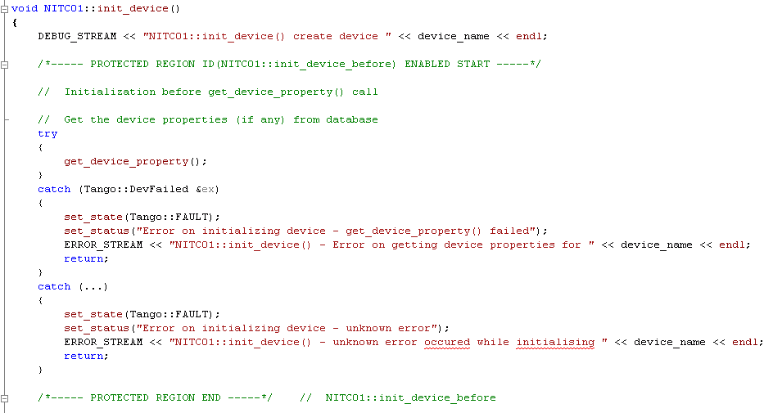

As a reminder, the default value for a property is defined with POGO, the value is stored in the database via the *put_property()* method.

#### Properties without default values

POGO allows defining a default value for a *property* not present in the TANGO database.

For mandatory properties that have no default values, the developer should systematically:

* detect the absence of the value in the database.
* log the problem explicitly with the level ERROR ( indicate the missing property).
* set the device to the FAULT state.
* update the Status indicating the problem origin.

# Appendices

## Appendix 1 –Code Quality Checklist

The following checklist defines the conformity level of a source code for a TANGO device development with the recommendations detailed in this document.



## Appendix 2 – Full code samples

Example C++ « AttributeSequenceWriter » :



Example C++ « NITC01 » :



1. http://www.tango-controls.org