Apartment Management System (AMS) - Technical Documentation
Welcome to the technical documentation for the Apartment Management System (AMS). This document provides a comprehensive, easy-to-understand breakdown of the project's technology stack, architecture, database design, API endpoints, and role-based access control system.

Project Overview & Architecture
The Apartment Management System (AMS) is a full-stack, client-server web application designed to streamline interactions between property administrators, staff, maintenance crews, homeowners, and tenants.

High-Level Architecture
The system follows a classic Three-Tier Architecture:
  - Presentation Layer (Frontend): A React-based Single Page Application (SPA) styled with Tailwind CSS and bundled using Vite. It communicates with the backend via RESTful HTTP requests.
  - Application Layer (Backend): An Express/Node.js API server that handles business logic, authorization, routing, and processes requests from the client.
  - Data Layer (Database): A relational MySQL database containing tables for users, apartment units, bills, notices, complaints, and facility reservations.
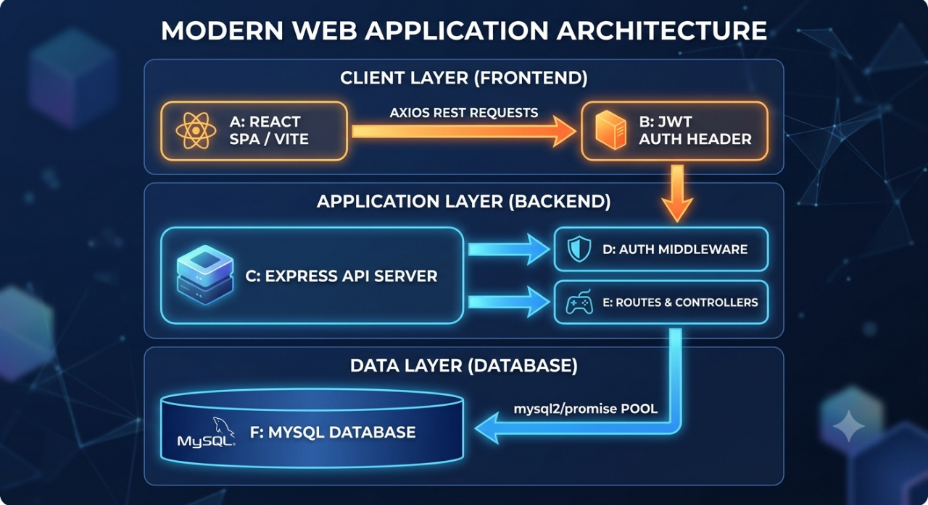

Technology Stack

Frontend (Client-Side)
- React (v19.x): UI library utilizing a component-based model.
- Vite: Next-generation frontend build tool and development server providing fast HMR (Hot Module Replacement).

- Tailwind CSS (v4.x): Utility-first CSS framework for custom responsive styling.
- React Router DOM (v7.x): For client-side routing, navigation, and page management.
- Axios: Promise-based HTTP client for making API requests to the backend. Includes an interceptor to automatically attach JWT authorization headers.
- Lucide React: Vector icons set used across all dashboards.

Backend (Server-Side)
- Node.js: JavaScript runtime environment.
- Express (v4.x): Fast, unopinionated web framework used to design the REST API routing.
- mysql2: MySQL client supporting promises, used with connection pooling for performant database operations.
- JSON Web Token (JWT): Used for stateless session management and security.
- BcryptJS: Used for securely hashing user passwords before database storage.
- Dotenv: Zero-dependency module that loads environment variables from a .env file.

Database
- MySQL Server: Relational Database Management System (RDBMS) storing application state, configurations, and relationships.

Database Schema Design
The database schema consists of 7 primary tables with foreign key constraints establishing relationships.
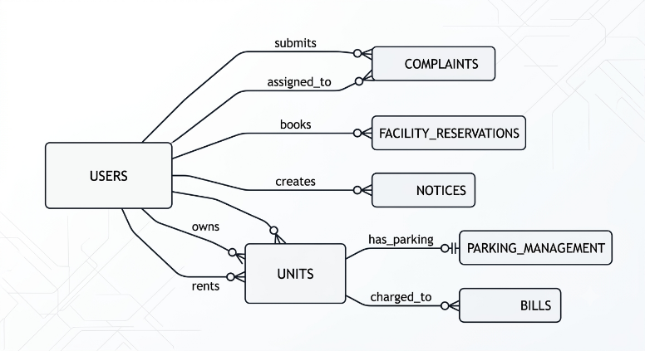

Table Details

users
Stores user profile information, authentication credentials, and user roles.
    - id (INT, PK, Auto Increment)
    - email (VARCHAR(255), Unique, Not Null)
    - password_hash (VARCHAR(255), Not Null)

    - role (ENUM: 'admin', 'staff', 'maintenance', 'homeowner', 'tenant', Not Null)
    - status (ENUM: 'pending', 'approved', 'rejected', Default: 'pending')
    - owner_id (INT, FK -> users.id, Nullable) - Used by tenants to associate with their landlord.
    - owner_approved (TINYINT(1), Default: 0) - Flag showing if the landlord approved this tenant.
    - full_name, nic_or_passport, phone_number, building_name, unit_number, vehicle_number, relationship_to_owner (Profile details)
    - created_at (TIMESTAMP)

units
Represents physical apartment units in the complex.
    - id (INT, PK, Auto Increment)
    - block_name (VARCHAR(50), Not Null)
    - floor_number (INT, Not Null)
    - unit_number (VARCHAR(50), Not Null)
    - owner_id (INT, FK -> users.id, Null)
    - tenant_id (INT, FK -> users.id, Null)
    - parking_slot_id (INT, FK -> parking_management.id, Null)
    - Unique Key: (block_name, floor_number, unit_number) to prevent duplicates.
  - parking_management
Manages permanent and guest parking slots.
    - id (INT, PK, Auto Increment)
    - unit_id (INT, FK -> units.id, Null)
    - slot_number (VARCHAR(50), Unique, Not Null)
    - type (ENUM: 'permanent', 'guest', Not Null)
    - guest_date (DATE, Null) - Reserved date if booking a guest spot.
    - status (ENUM: 'active', 'pending', 'approved', 'rejected', Default:
'active')
    - created_at (TIMESTAMP)

complaints
Tracks issues or maintenance requests submitted by residents.
    - id (INT, PK, Auto Increment)
    - user_id (INT, FK -> users.id, Not Null) - Reporter
    - category (VARCHAR(100), Not Null) (e.g., Plumbing, Electrical)
    - description (TEXT, Not Null)
    - priority (ENUM: 'low', 'medium', 'high', Default: 'medium')
    - status (ENUM: 'pending', 'in_progress', 'resolved', Default:
'pending')
    - assigned_staff_id (INT, FK -> users.id, Null) - Assigned maintenance technician
    - created_at (TIMESTAMP)

  - facility_reservations
Handles bookings for common amenities (e.g., gym, pool, clubhouse).
    - id (INT, PK, Auto Increment)
    - user_id (INT, FK -> users.id, Not Null)
    - facility_name (VARCHAR(100), Not Null)
    - date (DATE, Not Null)
    - status (ENUM: 'pending', 'approved', 'rejected', Default: 'pending')
    - created_at (TIMESTAMP)

notices
Broadcast board for management notices and community updates.
    - id (INT, PK, Auto Increment)
    - title (VARCHAR(255), Not Null)
    - content (TEXT, Not Null)
    - created_by (INT, FK -> users.id, Not Null)
    - created_at (TIMESTAMP)

bills
Invoices for water, electricity, or general maintenance.
    - id (INT, PK, Auto Increment)
    - unit_id (INT, FK -> units.id, Not Null)

    - amount (DECIMAL(10,2), Not Null)
    - description (VARCHAR(255), Not Null)
    - due_date (DATE, Not Null)
    - status (ENUM: 'unpaid', 'paid', Default: 'unpaid')
    - created_at (TIMESTAMP)

File and Directory Structure
The repository is cleanly divided into separate backend and frontend projects.
KDU_P1111_Apartment_Management_System/
│
├── SETUP.md # Initial local setup instructions
├── TECHNICAL_DOCUMENTATION.md # Current document (System Architecture & details)
│
├── backend/ # Express Node.js Backend Server
│ ├── config/
│ │ └── db.js # MySQL2 Connection Pool setup
│ ├── controllers/ # Business Logic Handlers
│ │ ├── authController.js # Auth, Approvals, Profile, Stats
│ │ ├── billController.js # Invoice management
│ │ ├── complaintController.js # Complaint assignment and tracking
│ │ ├── facilityController.js # Amenity reservations
│ │ ├── noticeController.js # Notice board publishing
│ │ ├── parkingController.js # Parking slot operations
│ │ └── unitController.js # Apartment unit setup and assignments
│ ├── db/
│ │ ├── migration.sql # Database tables construction
│ │ └── seed.js # Seed data populator for development
│ ├── middleware/
│ │ └── authMiddleware.js # JWT token validation & role checkers
│ ├── routes/ # Express REST Endpoint routes
│ │ ├── authRoutes.js
│ │ ├── billRoutes.js
│ │ ├── complaintRoutes.js
│ │ ├── facilityRoutes.js
│ │ ├── noticeRoutes.js
│ │ ├── parkingRoutes.js
│ │ └── unitRoutes.js
│ ├── .env.example # Template for local configurations
│ ├── package.json # Backend dependencies list
│ └── server.js # App entrypoint & middleware registrations
│
└── frontend/ # Vite + React Frontend Client
├── public/ # Static assets
├── src/
│ ├── assets/ # Icons and custom design materials
│ ├── components/ # Segregated Role-Based Dashboards
│ │ ├── Admin/
│ │ │ └── AdminDashboard.jsx # Unified dashboard for Admin & Staff
│ │ ├── Layout/
│ │ │ └── Navbar.jsx # Shared Navigation bar
│ │ ├── Maintenance/
│ │ │ └── MaintenanceDashboard.jsx # Work Order tracker for Maintenance

│ │ └── Resident/
│ │ └── ResidentDashboard.jsx # Homeowner/Tenant portal (Bills, complaints, bookings)
│ ├── context/
│ │ └── AuthContext.jsx # Global Authentication, Login, Register, Logout State
│ |  | ├── pages/ | # | Routing View Components
│ |  | │ ├── Dashboard.jsx | # | Dynamic Dashboard redirector based on roles
│ |  | │ ├── Login.jsx | # | Login Screen
│ |  | │ ├── Register.jsx | # | Registration Screen (Homeowners / Tenants /
Staff | / | Techs)
│ |  | │ └── NotFound.jsx | # | 404 page
│ |  | ├── App.css
│ |  | ├── App.jsx | # | Main App React-Router declaration
│ |  | ├── index.css | # | Tailwind Imports & Global CSS styles
│ |  | └── main.jsx | # | DOM mounting entrypoint
├── tailwind.config.js # Styling configuration
└── package.json # Frontend libraries and build tasks

API Reference
All requests to protected routes must include the authorization header: Authorization: Bearer <jwt_token>.

Authentication & Users

Method | Endpoint | Access | Purpose
POST | /api/auth/ register | Public | Register a new user with a specific role
POST | /api/auth/login | Public | Sign in and retrieve JWT token
GET | /api/auth/ homeowners | Public/Register | Fetch approved homeowners (needed for tenant linking)
GET | /api/auth/ pending-approvals | Admin / Staff | Get list of user registrations waiting for approval
POST | /api/auth/ approve | Admin / Staff | Approve or reject a user registration
GET | /api/auth/ admin-dashboard-stats | Admin / Staff | Retrieve total statistics for Admin Dashboard summary
GET | /api/auth/ residents | Admin / Staff | Get all registered homeowners and tenants
GET | /api/auth/ resident-dashboard-stats | Resident / Tenant | Get personal metrics (unpaid bills, bookings, complaints)
PUT | /api/auth/ | Auth Users | Update personal profile

Method | Endpoint | Access | Purpose
 | profile |  | details (Phone, Vehicle, Name)

Apartment Units

Method | Endpoint | Access | Purpose
GET | /api/units | Admin / Staff | List all apartment units along with owners & tenants
POST | /api/units | Admin / Staff | Create a new unit
PUT | /api/units/:id | Admin / Staff | Edit unit details or update owner/tenant associations
DELETE | /api/units/:id | Admin / Staff | Delete an apartment unit

Complaints (Maintenance Requests)

Method | Endpoint | Access | Purpose
GET | /api/complaints | Authenticated | View complaints (Residents view own; Staff/Maintenance view all)
POST | /api/complaints | Resident / Tenant | File a new complaint/maintenance request
PUT | /api/ complaints/:id | Staff / Maintenance | Update complaint status, priority, or assign technician
DELETE | /api/ complaints/:id | Admin / Staff | Remove a complaint entry

Facilities (Bookings)

Method | Endpoint | Access | Purpose
GET | /api/ facilities/ reservations | Authenticated | View reservations (Residents view own; Admin/Staff view all)
POST | /api/ facilities/ reserve | Resident / Tenant | Request a facility reservation
PUT | /api/ | Admin / Staff | Approve or reject a

Method | Endpoint | Access | Purpose
 | facilities/ reservations/:i d |  | facility booking request

Parking Management

Method | Endpoint | Access | Purpose
GET | /api/parking | Authenticated | View parking spots (Permanent & Guest)
POST | /api/parking/ allocate | Admin / Staff | Allocate/Assign a permanent slot to an apartment unit
POST | /api/parking/ guest | Resident / Tenant | Request a guest parking space for a specific date
PUT | /api/parking/ guest/:id | Admin / Staff | Approve or reject guest parking requests

Notices & Announcements

Method | Endpoint | Access | Purpose
GET | /api/notices | Authenticated | Fetch notices for the dashboard
POST | /api/notices | Admin / Staff | Publish a new community notice/announcement
DELETE | /api/ notices/:id | Admin / Staff | Delete a notice

Utility & Maintenance Bills

Method | Endpoint | Access | Purpose
GET | /api/bills | Authenticated | View bills (Residents view their unit's bills; Admin/Staff view all)
POST | /api/bills | Admin / Staff | Issue a new bill to an apartment unit
PUT | /api/ bills/:id/pay | Resident / Staff | Pay/Mark bill status as Paid

Access Control (RBAC) & Router Protection
The system implements Role-Based Access Control (RBAC) across both frontend views and backend API routes:

Route Protection (Frontend)
In frontend/src/App.jsx:
    - ProtectedRoute: Validates if the user is authenticated. If the JWT is expired or missing, redirects to /login.
    - AuthRoute: Prevents logged-in users from returning to the /login or /register
screens (automatically pushes them back to /dashboard).
    - Dashboard Router Redirect: Inside frontend/src/pages/Dashboard.jsx, the app reads the user's role and serves the appropriate dashboard components (AdminDashboard, MaintenanceDashboard, or ResidentDashboard).

Role-Based Permissions Summary

Feature Area | Admin | Staff | Maintenance | Homeowner | Tenant
User Approvals | Full | Full | Read Only | None | None
Manage Units | Full | Full | None | None | None
Issue Bills | Full | Full | None | None | None
Pay Bills | Read | Read | None | Pay Own | Pay Own
Publish Notices | Full | Full | None | Read Only | Read Only
Manage Parking | Full | Full | None | Request Guest | Request Guest
Manage Facilities | Approve/ Reject | Approve/ Reject | None | Request Booking | Request Booking
Resolve Complaints | Assign | Assign | Resolve | View/Submit Own | View/Submit Own
Tenant Linking | - | - | - | Approve Tenant | Link to Landlord

