MODULE: CSE202 - OBJECT ORIENTED ANALYSIS & DESIGN WITH JAVA
WEEK 8: MODULE INTEGRATION & TESTING
STUDENT NAME: Alex Gabatshwane
STUDENT ID: cse24-031
DATE: 5/11/2025
Executive Summary
The Banking system was tested under three scenarios to ensure proper functionality and these were the following expectations that the system should have allowed the user to do easily:
Scenario 1: Login → Dashboard → View Accounts → Make Deposit → Logout
Scenario 2: Login → View Transaction History → Filter by date → Logout
Scenario 3: Login → Open New Account → Verify in Database → Logout
The system performed all 3 scenarios as intended with no issues whatsoever, ensuring all modules used to create it were connected perfectly.

Test Environment
- Java version used: 23.0.1
- Testing platform: VS Code on windows
- The system was ran locally on my PC to ensure the code written to make the system was correct since Github Codepaces cant run GUIs(Graphical User Interfaces)

Scenario 1 Documentation
TEST STEPS:
1. Launched BankingApp
2. Logged in with username: admin, password: password
3. Navigated to Dashboard
4. Clicked "View My Accounts"
5. Clicked "Make a Deposit"
6. Selected account and made deposit
7. Logged out

EXPECTED RESULTS:
- Successful login
- All screens load properly
- Deposit functionality works
- Clean logout

ACTUAL RESULTS:
- All steps completed successfully
- Navigation between screens works
  - Deposit simulated correctly

SCREENSHOTS:
  - 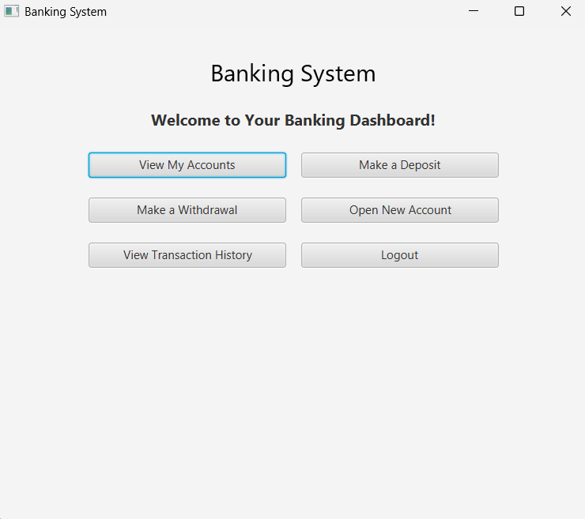
  - 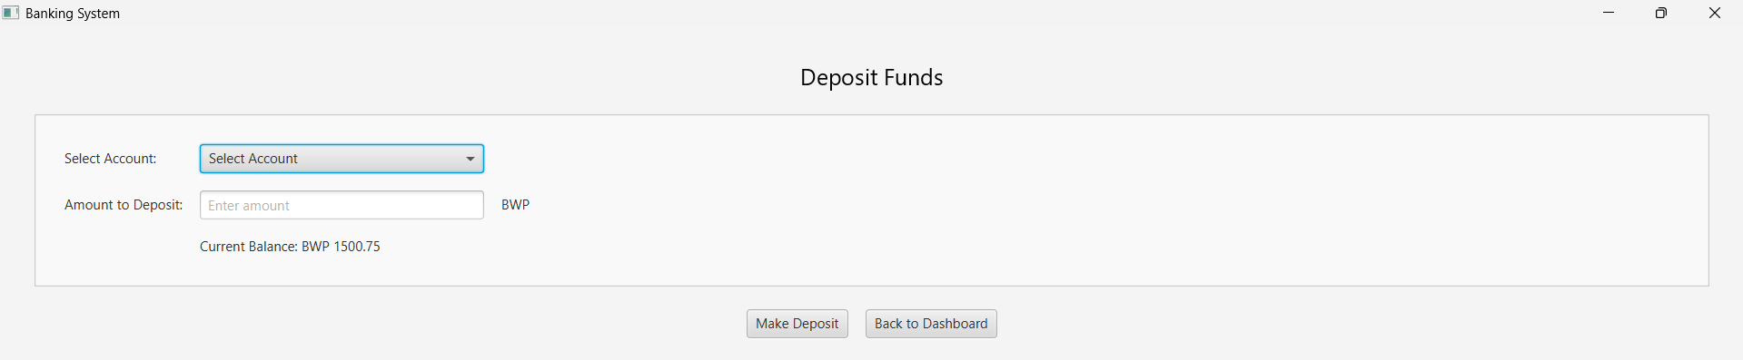

Scenario 2 Documentation
TEST STEPS:
- Launched Banking APP
- Went to “View Transaction History”
- Selected Account Type(which was Cheque)
- Selected the date range
- Searched the transaction within the range
- Logged Out
EXPECTED RESULTS:
- - Successful login
- - All screens load properly
- - Transaction history shows some valid data
- - Clean logout

ACTUAL RESULTS:
- The transactions tab showed some data as expected
- All steps completed successfully
- Navigation between screens works

Screenshot:
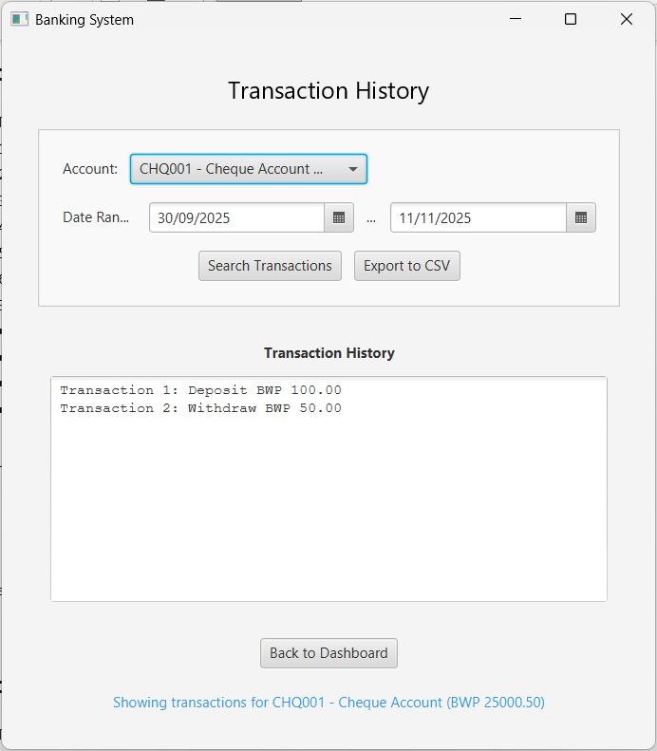

Scenario 3 Documentation
TEST STEPS:
- Login to the system
- Go to “Open New Account”
- Enter Details and register
- Login to confirm account was registered
- Check the database
- Logout
EXPECTED RESULTS:
- The database should store the new account I registered.
- The system should work smoothly throughout the process.
ACTUAL RESULTS:
- The system says the registration was successful but when I went to “View My Accounts”, there was nothing showing info on the account I just created
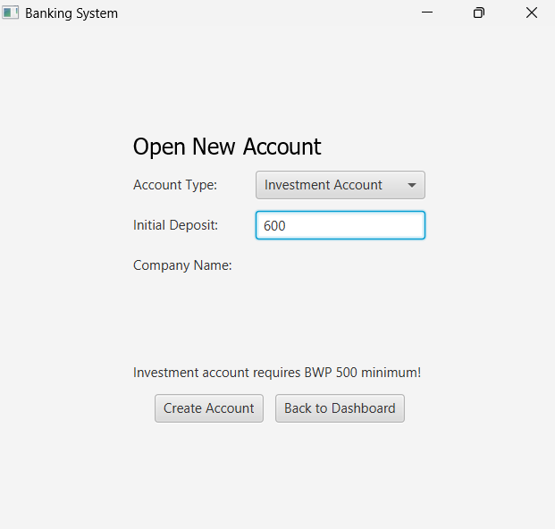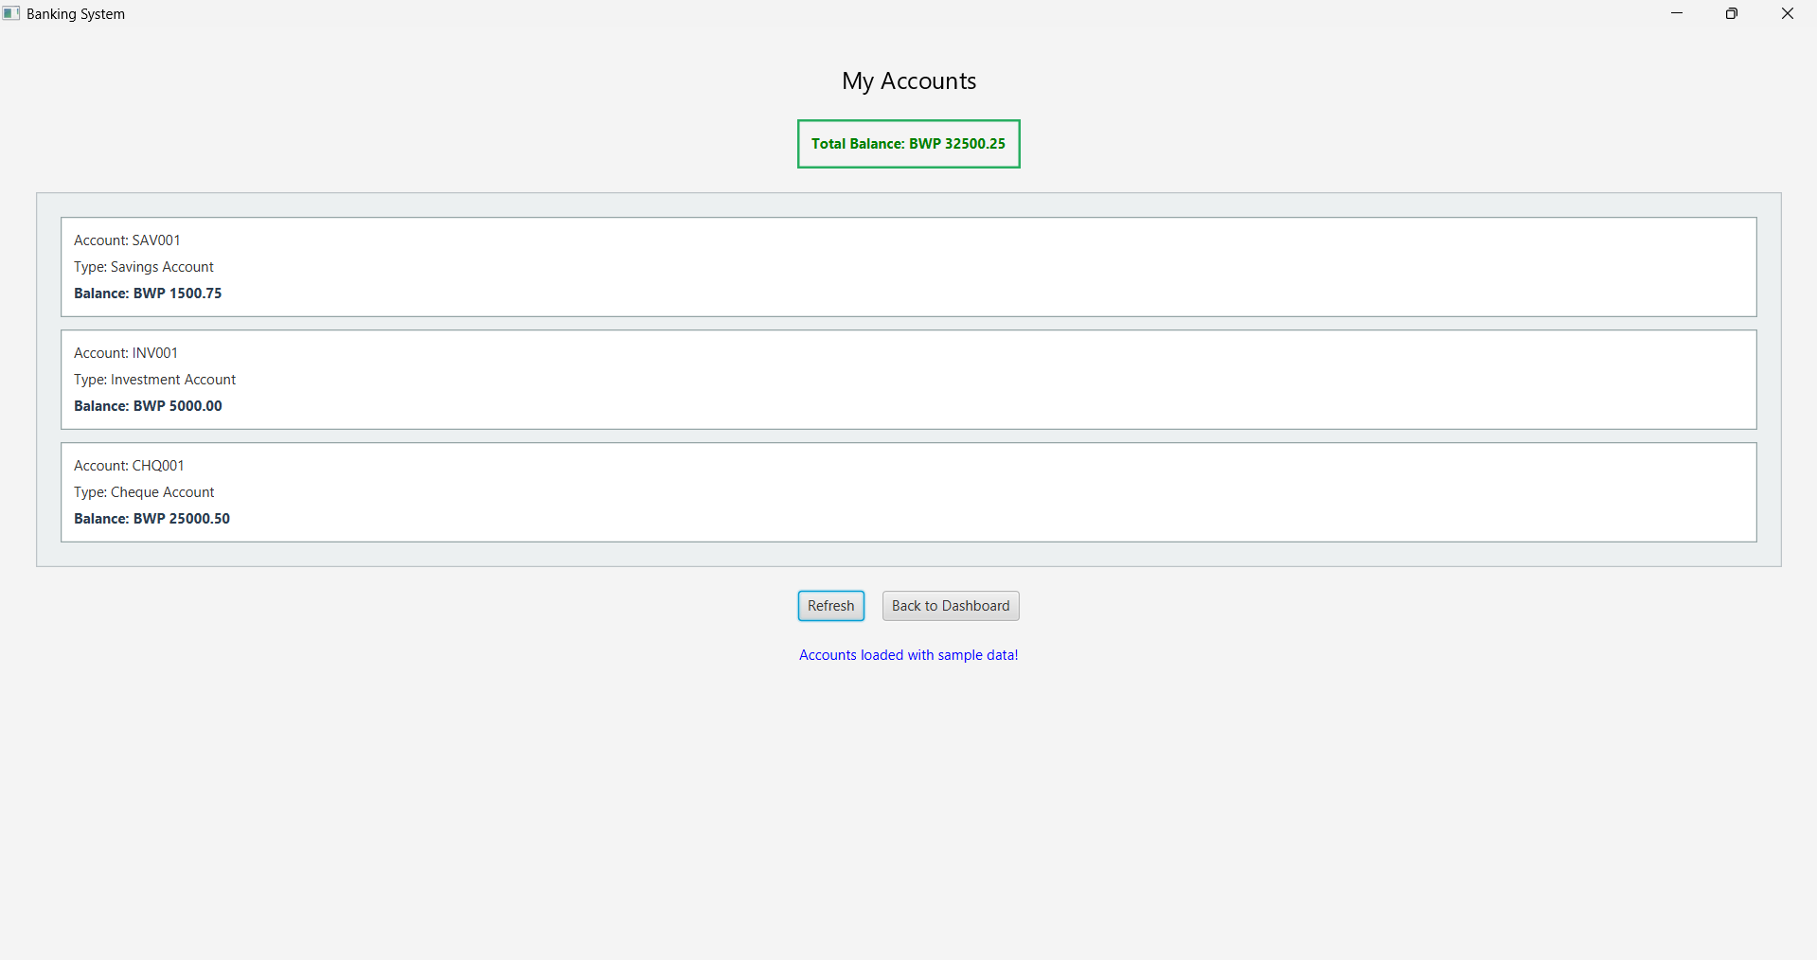

The images below are how the layout of each system function looks like:

To View My Accounts:
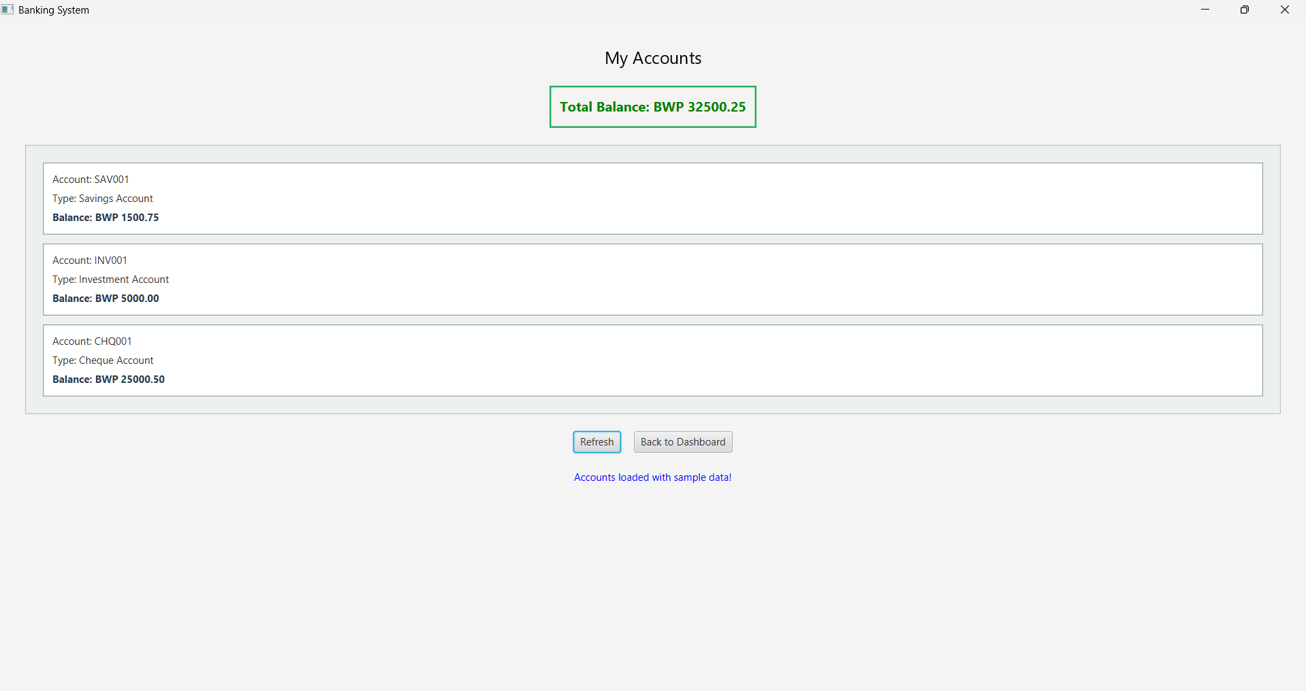
To Make A Deposit:
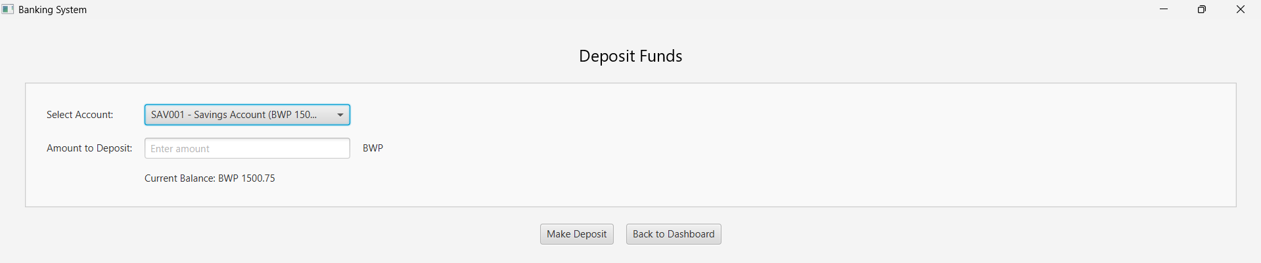
To Make A withdrawal:
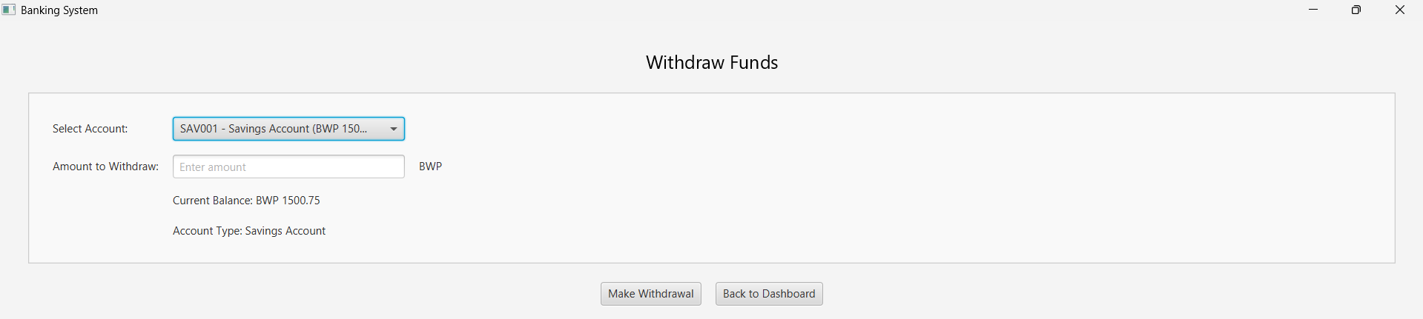
To Open a New Account:
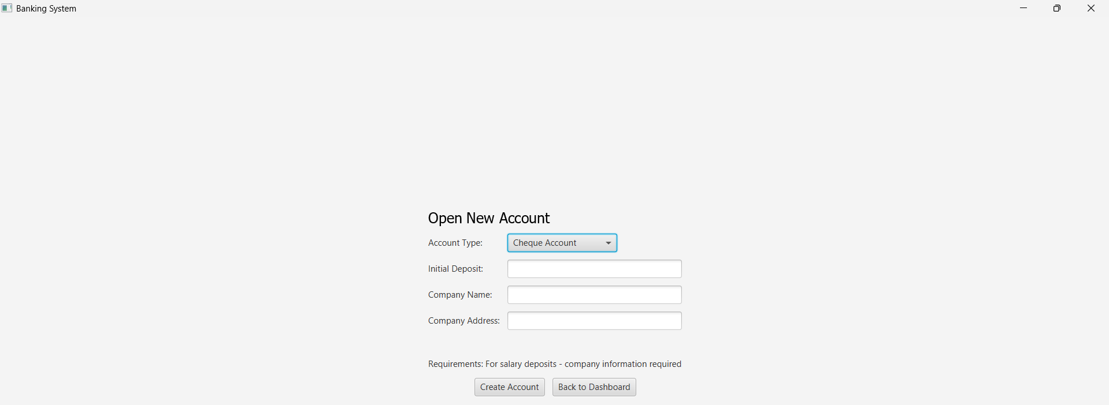
To View Transaction History:
