**LAB REPORT 7**

**Name:** **Vinay Datta Pinnaka**

**Class:** **COSC 5327- Intro to computer Graphics**

**Semester:** **Spring 2016**

**Instructor:** **Dr. Scott, King**

**Assignment:** **7**

**Date Submitted:** **05/11/2016**

**Time Spent:** **30hrs**

**PORPOSE OF THE ASSIGNMENT**

# A final project to make nice demo in the lab. This is a Maze game with predefined start and stop positions.

# IMPLEMENTATION

A complete object oriented approach is used to develop the Maze as well as to render cubes. A specific approach is used to obtain the Maze indexes using the ray tracer code. Maze is created using skeleton obtained from the text file. This application has two views one the bird eye view to see the maze from the top angle to figure out the path to the destination. And the other is player view where player can navigate in the maze to the destination.

# CONTROLS TO PLAY

ARROW UP --- Move forward

ARROW DOWN ---Move backward

ARROW LEFT ---- Move Left

ARROW RIGHT ----- Move Right

To watch surroundings

W Key ---- Watch front

S key ---- Watch Back

A key ---- Watch Left

D Key ----- Watch Right

B Key --- to Switch from birds eye view to Player view

# 

Maze game home screen

User determines the path to solve the maze from birds eye view as shown in the above figure

To toggle to players view hit the Key ‘B’.

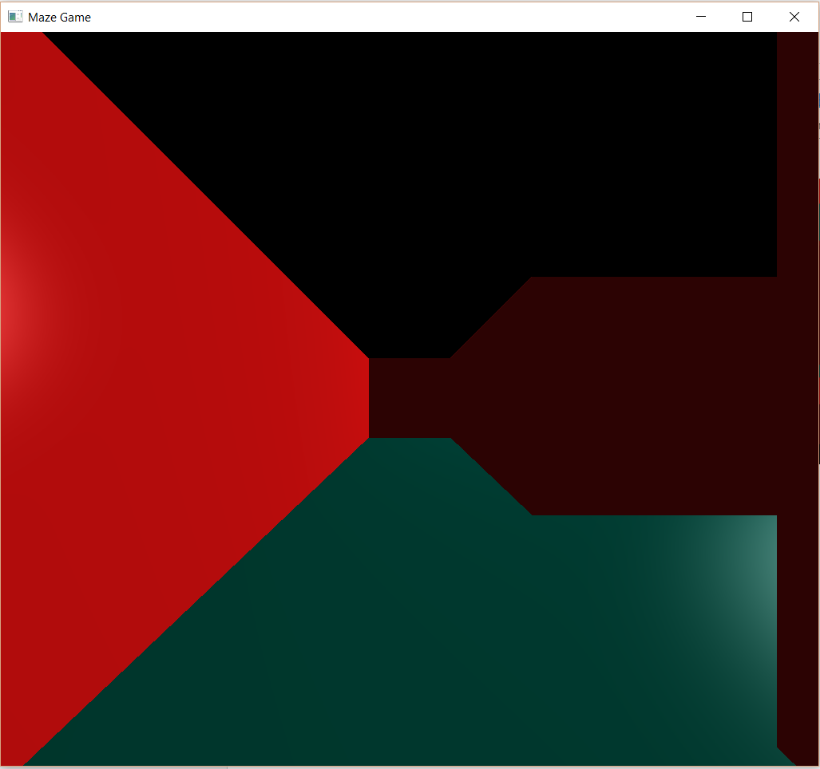

Players view of the Maze

Player can navigate through the maze with the arrow keys and he can look around with WASD keys

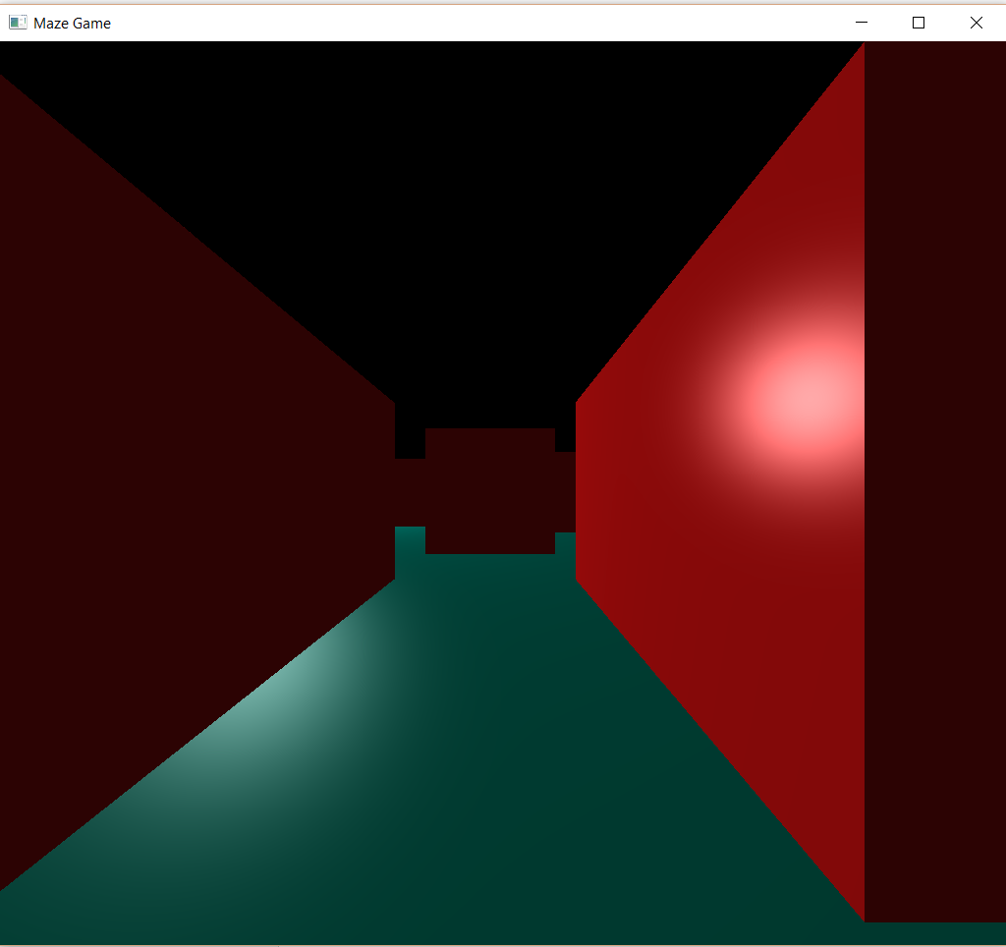

Right side view of the players position

Looking around helps the player to identify the right path.

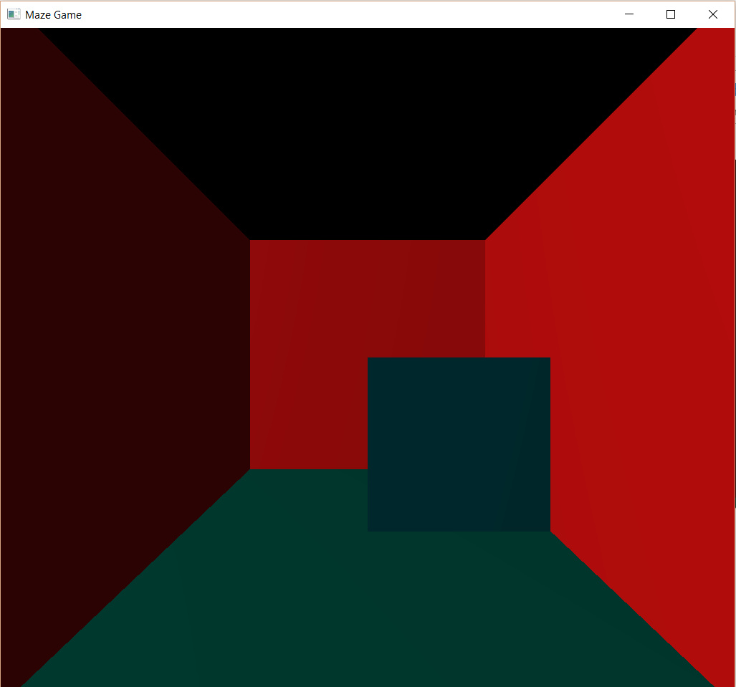

Blinking cubes are placed at the start and stop locations of the maze

# COMPILATION

This project has many source code files add all of them to the Visual Studio project and compile as normal.