**BAND GAP REFERENCE**

**NAME OF THE STUDENT : YERUVA ALEKHYA**

**ID NO : N190565**

**Abstract:**

Band gap reference play a crucial role in electronic circuits, serving as a stable voltage source for various applications. This abstract provides an overview of band gap reference leverage the temperature-dependent characteristic of semiconductor materials to generate a stable voltage reference that is largely immune to temperature variations. This abstract explores the fundamental principles behind band gap references, emphasizing the use of semiconductor devices such as diodes and transistors.

This project is design of 1.1v supply using BGR circuit in LTspice 180nm model. The generated voltage 1.1v is constant over temperature ranging from -40 to 130. In simulation we achieve a reference of 1.12V with a coefficient of temperature 160 ppm/°C for the temperature range -40 to 130 at 1.8 V supply voltage.

**Keywords:**- Band gap reference, PTAT-proportional to absolute temperature, CTAT-complementary to absolute temperature, temperature coefficient, process variations

1. **Introduction**

Here,we will learn how to produce a reference voltage for given supply voltage . The band gap reference is an electronic circuit to provide an accurate and stable voltage that is very insensitive to the change in supply voltage and temperature and also process parameters.

A band gap reference circuit is versatile structure for analog and mixed signal design. A reference circuit generates a dc voltage or current which is not dependent on power supply, process and temperature variations. A conventional reference circuit which generates a dc voltage (1.25 V) equivalent to the band gap of Silicon is known as a band gap reference circuit. A BGR circuit is designed to achieve the insensitive behavior with respect to process, voltage and temperature.Reference voltage should be independent of

* + Process variation
  + Temperature variation
  + Supply variation

BGR circuit consists of two parts

* + CTAT -complimentary to absolute temperature
  + PTAT –proportional to absolute temperature

|  |  |
| --- | --- |
| **PTAT** | **CTAT** |

|  |  |
| --- | --- |
| **report 1** | **T**  **Vref**  **CTAT reference** |

Vref

PTAT

CTAT

T

* If I add PTAT and CTAT = Vref
* If you want to get Const Vref then,they should cancel each other exactly,then we will get a const Vref Voltage.

**IN MATHEMATICALLY:**

α1PTAT+α2CTAT=BGR

**BLOCK DIAGRAM:**

Const Vref

α2

α1

CTAT

PTAT

**2. IMPLEMENTATION AND METHODOLOGY**

**INTRODUCTION TO THE TECHNOLOGY**

LTspice is a [SPICE](https://en.wikipedia.org/wiki/SPICE)-based [analog](https://en.wikipedia.org/wiki/Analog_electronics) [electronic circuit simulator](https://en.wikipedia.org/wiki/Electronic_circuit_simulation) computer software, produced by [semiconductor](https://en.wikipedia.org/wiki/Semiconductor) manufacturer [Analog Devices](https://en.wikipedia.org/wiki/Analog_Devices) (originally by [Linear Technology](https://en.wikipedia.org/wiki/Linear_Technology)).It is the most widely distributed and used SPICE software in the industry. Though it is [freeware](https://en.wikipedia.org/wiki/Freeware), LTSpice is not artificially restricted to limit its capabilities (no feature limits, no node limits, no component limits, no sub circuit limits). It ships with a library of SPICE models from [Analog Devices](https://en.wikipedia.org/wiki/Analog_Devices), [Linear Technology](https://en.wikipedia.org/wiki/Linear_Technology), [Maxim Integrated](https://en.wikipedia.org/wiki/Maxim_Integrated), and third-party sources.

**IMPLEMENTATION ANALYSIS**

**CTAT-Complimentary to absolute temperature:**

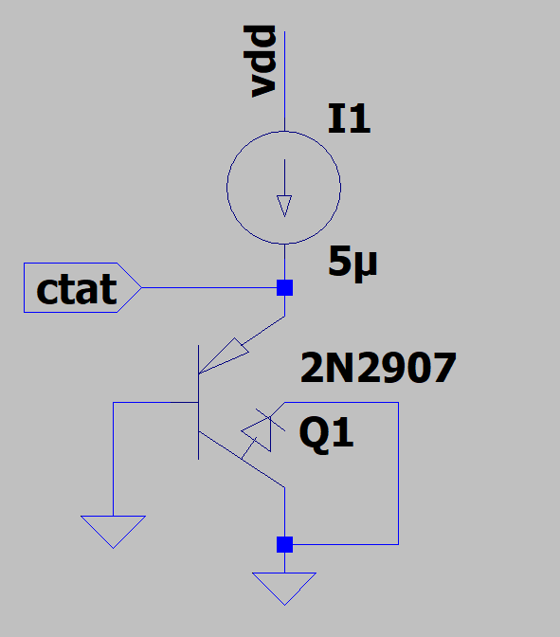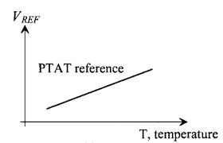

If we connect constant current source through diode then the voltage across diode gives CTAT voltage which is complementary to absolute temperature. While implementing the circuit in LTspice by diode is not feasible as ‘p’ node is not free (grounded) to connect in fabrication. So we shall be using following PNP structure to validate our design in LTspice. Now the voltage across the diode is given as follows.

Where is the Thermal Voltage=26mV/℃,

is the Reverse saturation current , is the voltage across the diode , is the current passing through the diode.

CTAT is a negative temperature coefficient in BGR circuit. Voltage across diode is inversely proportional to absolute temperature. Voltage across diode will decrease at a rate of -1.6mv/℃ provided constant current flowing through diode.

**PTAT-Proportional to absolute temperature:**

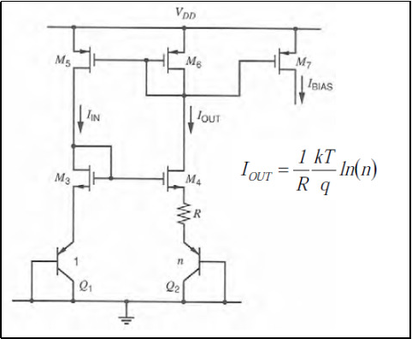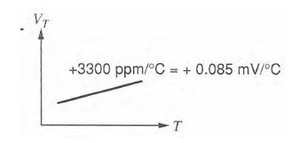

PTAT voltage refers to the voltage that is proportional to the absolute temperature. PTAT voltage achieved by taking difference of voltages across diodes i.e., as follows

=-

=

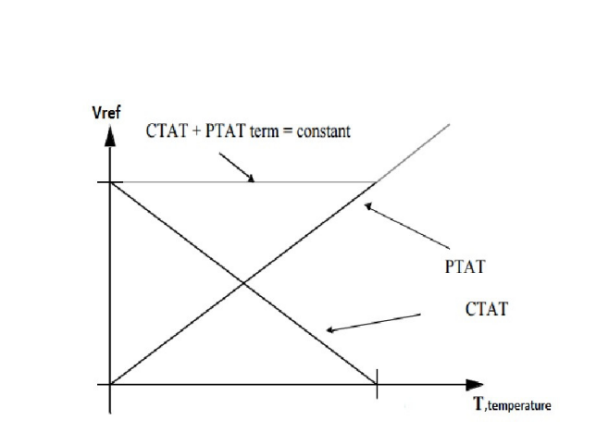Where N is the number of transistors. From this equation we can say that change in voltage is directly proportional to thermal voltage.

**Generation of reference voltage:**

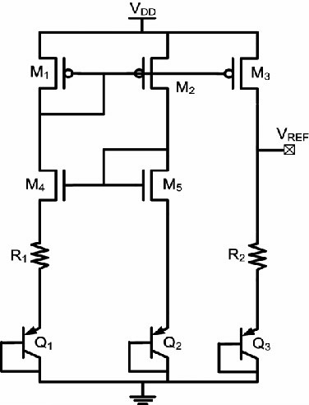

**By adding CTAT and PTAT generates a reference voltage**

=

Where is the CTAT voltage and is the PTAT voltage.

**SIMULATION RESULTS:**

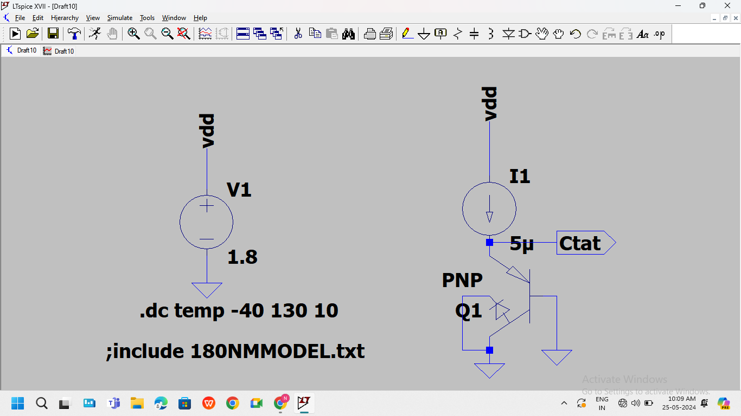

**Figure 1:CTAT circuit Schematic**

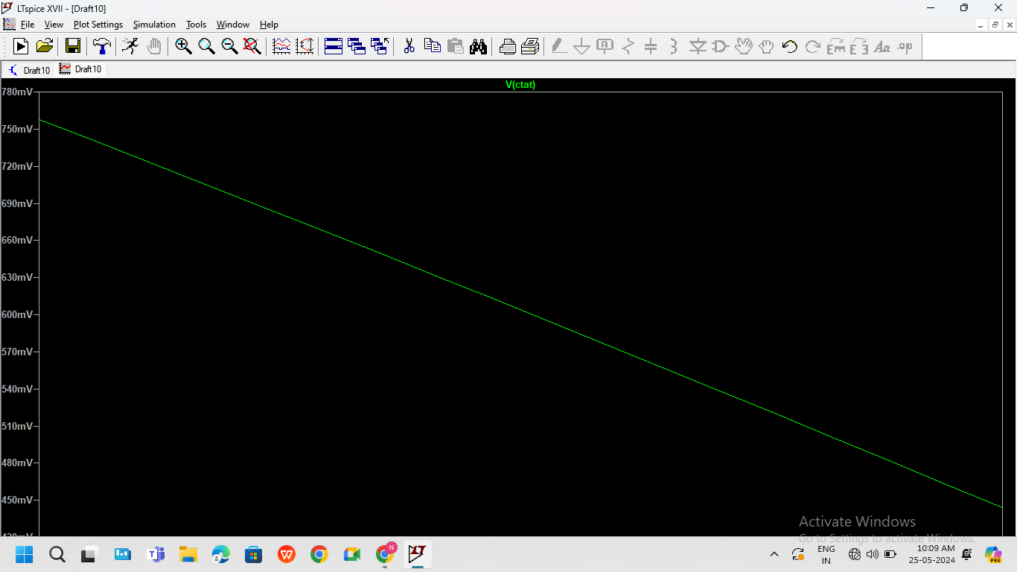

**Figure 2:CTAT voltage plot**

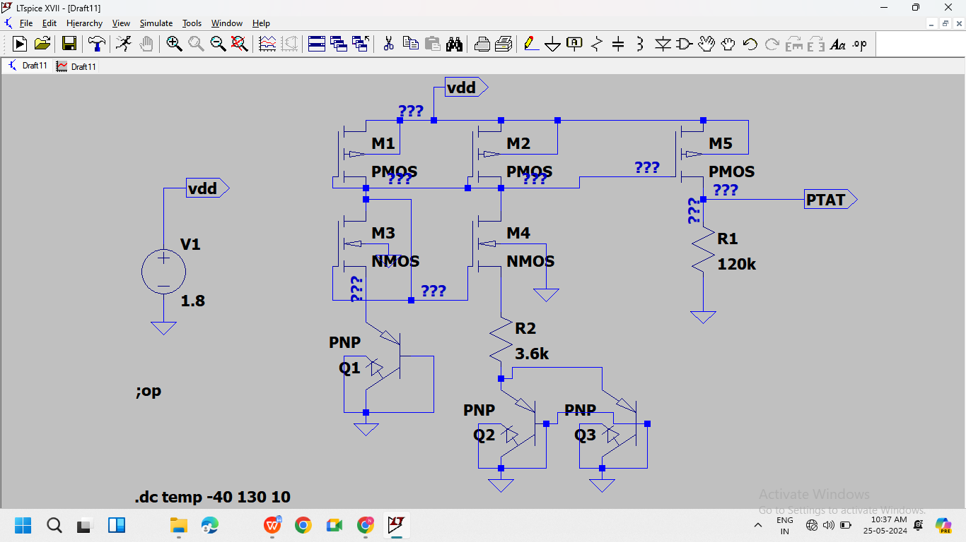

**Figure 3: PTAT circuit Schematic**

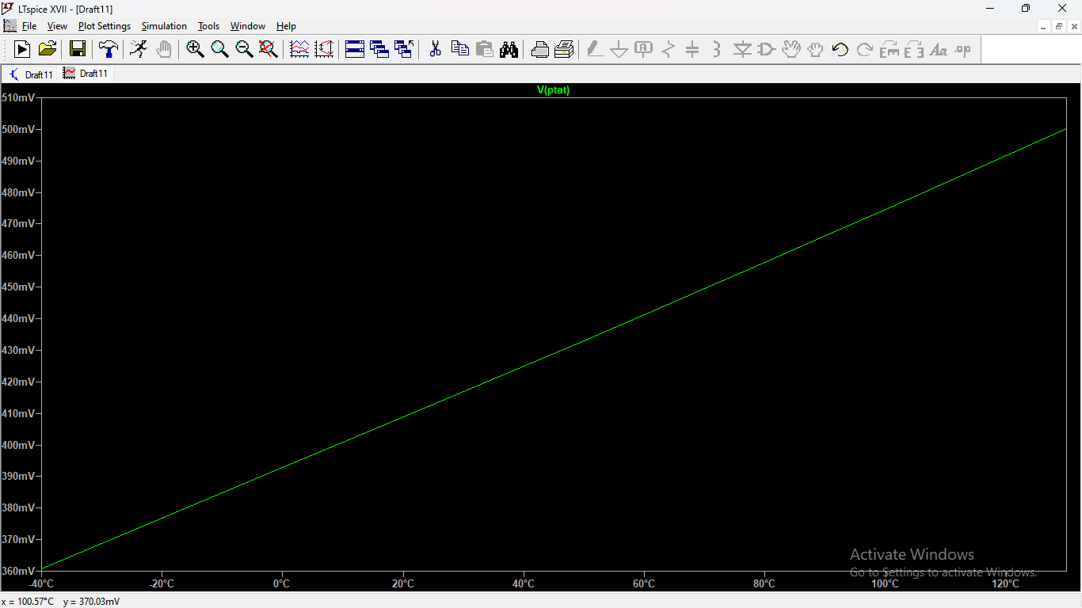

**Figure 4: PTAT plot**

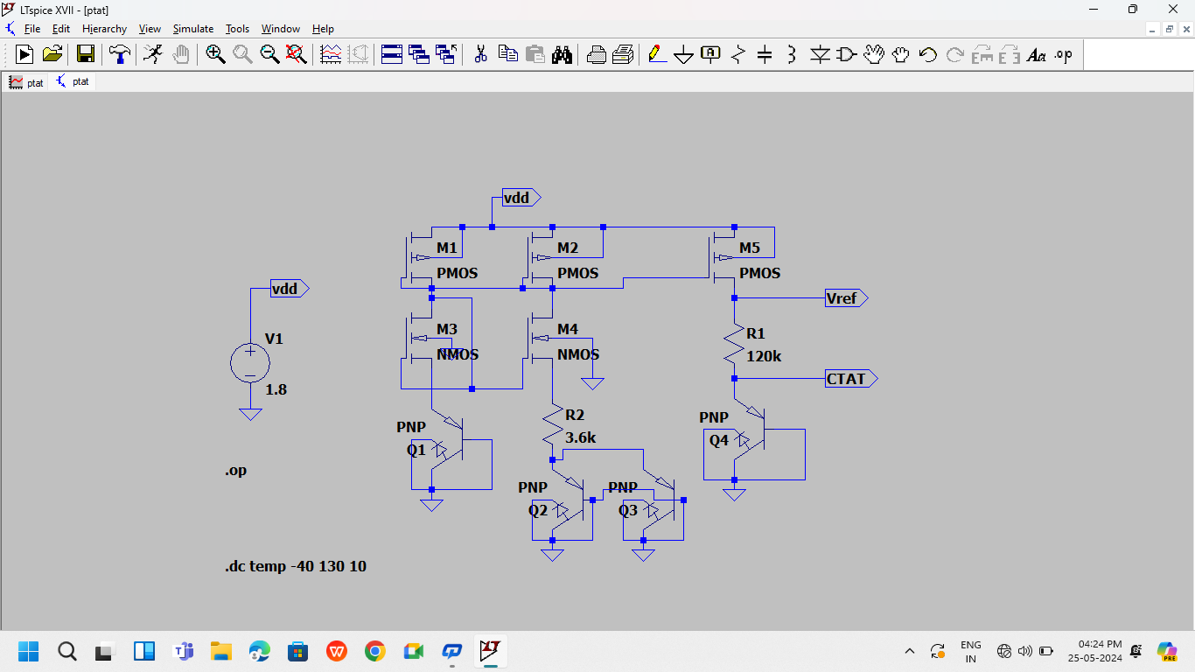

**Figure 5: Vref circuit schematic**

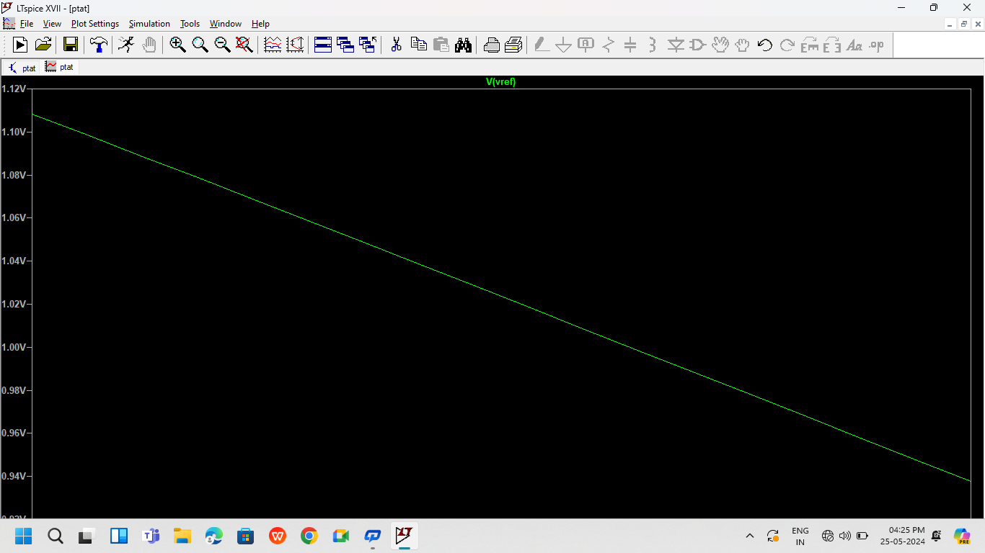

**Figure 6: Voltage Reference plot**

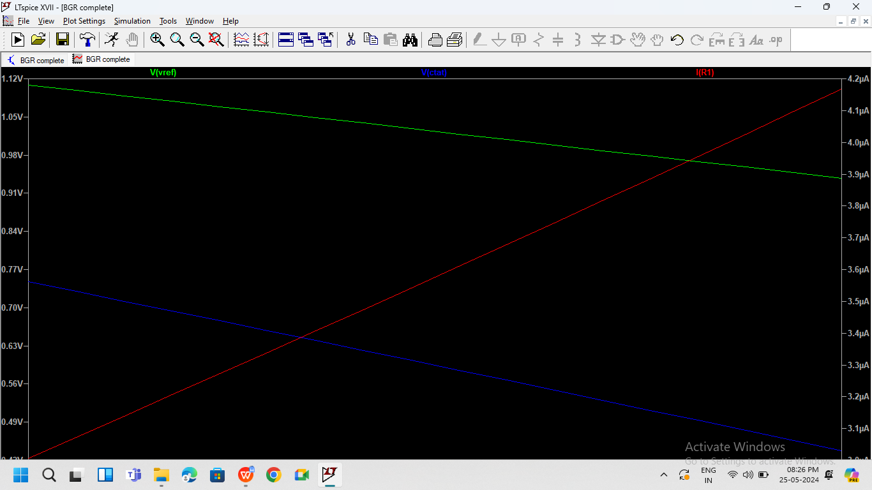

CTAT

PTATAT

Vref

**Figure 7: Generation of BGR voltage plot**

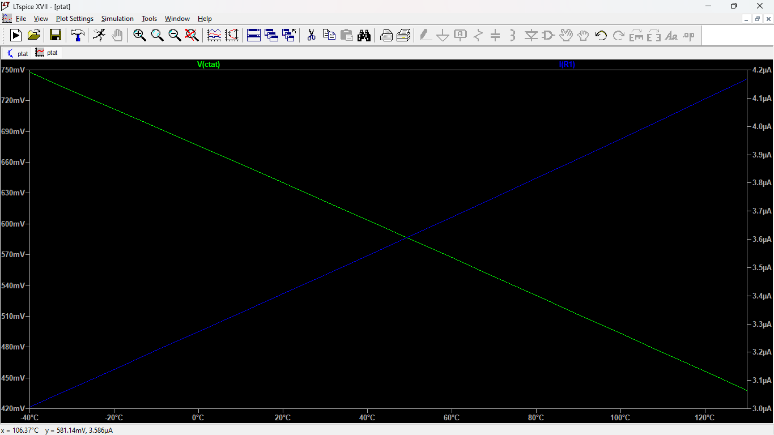

CTAT

PTAT

**Figure 8: Generation of BGR voltage plot**

**CONCLUSION:**

**How to Build a Bandgap.-**

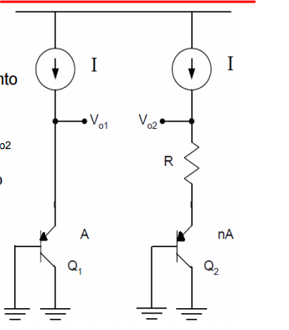

1. Generate two currents and dump into

the transistors

1. Add a mechanism to force Vo1 = Vo2

The designed circuit is he designed circuit is suitable to be used as a generic biasing circuit. The core idea for generating

a reference voltage is by summing the PTAT and CTAT currents across a resistor. In simulation we achieve a reference of 1.12V with a coefficient of temperature 160 ppm/°C with the supply voltage of 1.8V.

**REFERENCES:**

1. Design of analog CMOS integrated circuits by *Behzad Razavi.*
2. YouTube lectures by *Hafeez KT* and *Ali Hajimiri.*