**Title**

**A Project Proposal**

**WIN SEM 2022-23**

**ECS1002**

**(Engineering Clinics: Raspberry PI and Python)**

*Submitted by*

**ADARSH SURESH MENON**

*(20BCR7010 - SCOPE)*

**N K V MANASA**

*(20BCR7035 - SCOPE)*

**JUAN JOHNSON**

*(20BEC7007 - SENSE)*

**FAZAL K MOHAMMAD**

*(20BCR7008 - SCOPE)*

**GAUTAHM H S**

*(20BCE7190 - SCOPE)*

**ALEN SEBASTIAN**

*(20BCR7018 - SCOPE)*



**VIT-AP UNIVERSITY**

**AMARAVATI**

**ANDHRA PRADESH, INDIA**

**2023**

**ABSTRACT:**

*Fire incidents have a huge damaging impact on human life as well as property in residential and industrial areas. On the other hand, the risk of fires is growing in conjunction with the growth of urban buildings due to increase in population and lack of ventilation. Traditional fire detection equipment’s have a chance of failure and also have a high possibility of giving false alarm moreover they cannot give dynamic attributes like number of people trapped in fire and the intensity of fire. One of the major problems among fire fighters is to find the number of trapped people in the building among all the smoke generated in fire. In this report, we propose an architecture using raspberry pi and a camera to provide an accurate number of people trapped in the building and moreover, find the location of trapped people and detect fire using, deep neural network (DNN) models, i.e., MobileNet SSD and ResNet101 which are embedded in the vision node which is the camera and raspberry pi. We also use FOMO algorithm to find out the estimated number of people trapped inside the whole building. A web application is developed and integrated with the vision node through a local server for visualizing the real-time events in the building related to the fire and getting the count of people.*

**ARCHITECTURE:**

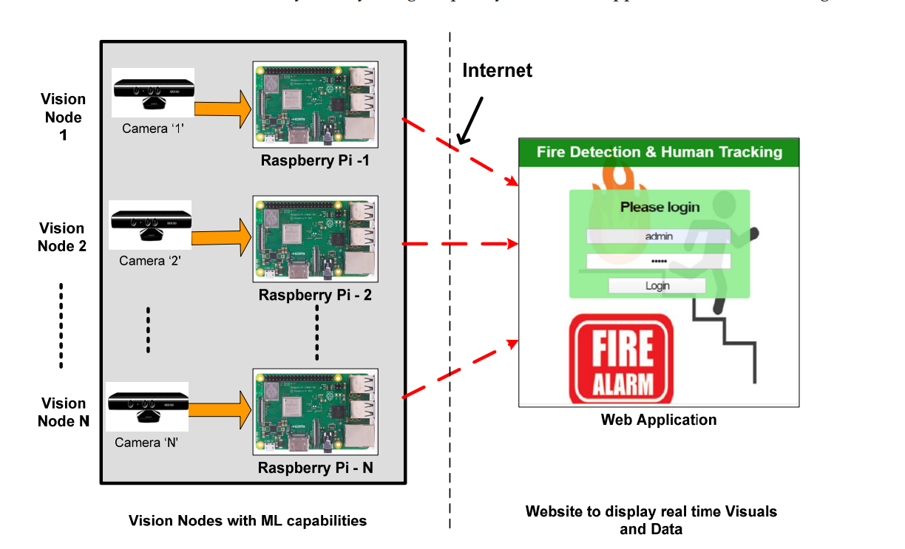

Figure 1 – Architecture of the proposed system

* *Camera is connected to raspberry pi which together is called as visual node here.*
* *A web application is developed for visualizing real-time data that is obtained from the vision node and Raspberry Pi is integrated with a web application through a local server enabled via the internet.*
* *The real-time detection of fire and people count estimation is achieved with the vision node because it is loaded with a machine learning (ML) model, i.e., a deep neural network.*
* *The real-time result regarding fire detection and people count is communicated with the web application through the local server.*

**BLOCK DIAGRAM:**

DETECTION OF FIRE USING HSV COLOUR

SENDING THE ALARM USING MICROPHONE IN THE CAMERA

DETECTION OF NUMBER OF PEOPLE USING FOMO ALGORITHM

FINDING THE LOCATION OF NUMBER OF PEOPLE USING MOBILENET SSD

DISPLAYING THE VALUES TO WEBSITE ALONG WITH THE VISUALS

**Steps for OpenCV optimization for Raspberry Pi**

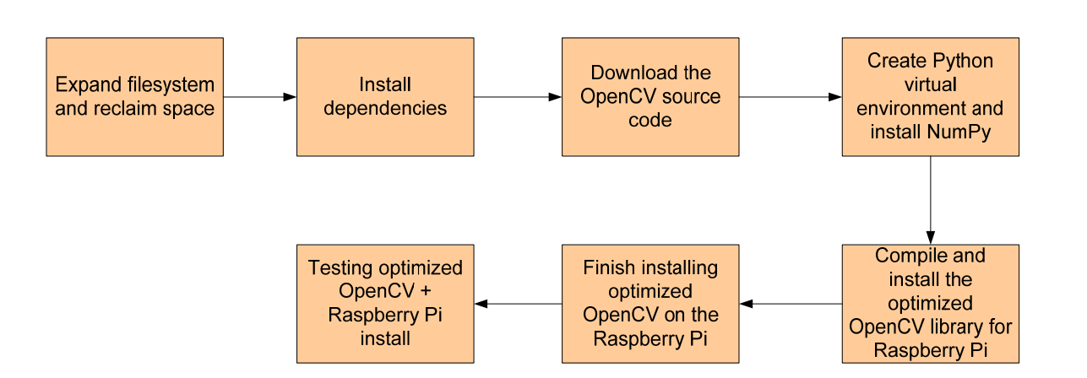

**REFERENCES**