**A MINI PROJECT REPORT**

**ON**

**CHURN PREDICTION MODEL USING DECISION TREES**

*Submitted by*

|  |  |
| --- | --- |
| CH. ALENDHER GOUD | 21J41A67E1 |
| CH. KAVYA SUDHA | 21J41A67E5 |
| D. HARI KUMAR | 21J41A67E7 |
| P. SREE VARDHAN | 21J41A67H9 |

*in partial fulfillment of the requirements for the award of the degree*

*of*

**BACHELOR OF TECNOLOGY**

**in**

**COMPUTER SCIENCE AND ENGINEERING – DATA SCIENCE**

Under the Guidance of

**Y. GREESHMA**

Asst. Professor, CSE - DS

**COMPUTER SCIENCE AND ENGINEERING - DATA SCIENCE**

**MALLA REDDY ENGINEERING COLLEGE**

(An UGC Autonomous Institution, Approved by AICTE, New Delhi & Affiliated to JNTUH, Hyderabad) Maisammaguda, Secunderabad, Telangana, India 500100)

**November – 2024**

**MALLA REDDY ENGINEERING COLLEGE**

Maisammaguda, Secunderabad, Telangana, India 500100

**BONAFIDE CERTIFICATE**

This is to certify that the mini project entitled “**Churn Prediction Model using Decision Trees**”, submitted by **CH. Alendher Goud** **(21J41A67E1),** **CH. Kavya Sudha (21J41A67E5),** **D. Hari Kumar (21J41A67E7),** and **P. Sree Vardhan** **(21J4A67H9)** to Malla Reddy Engineering college affiliated to JNTUH, Hyderabad in partial fulfilment for the award of Bachelor of Technology in COMPUTER SCIENCE AND ENGINEERING DATA SCIENCE is a Bonafide record of project work carried out under our supervision during the academic year 2024 – 2025 and that this work has not been submitted elsewhere for a degree.

|  |  |
| --- | --- |
| **SIGNATURE** | **SIGNATURE** |
| Y. Greeshma | Dr. S. Shiva Prasad |
| **SUPERVISOR** | **HOD** |
| Asst. Professor | CSE - DS |
| CSE DS |  |
| MALLA REDDY ENINGEERING COLLEGE  Maisammaguda, Secunderabad, Telangana  India 500100 | MALLA REDDY ENINGEERING COLLEGE  Maisammaguda, Secunderabad, Telangana  India 500100 |

**Submitted for Mini Project viva-voce examination held on _____________**

|  |  |
| --- | --- |
| **INTERNAL EXAMIER** | **EXTERNAL EXAMINER** |

**MALLA REDDY ENGINEERING COLLEGE**

Maisammaguda, Secunderabad, Telangana, India 500100

**DECLARATION**

I hereby declare that the project titled **Churn Prediction model using decision trees,** submitted to Malla Reddy Engineering College (Autonomous) and affiliated with JNTUH, Hyderabad, in partial fulfilment of the requirements for the award of a Bachelor of Technology in Computer Science and Engineering - Data Science, represents my ideas in my own words. Wherever others' ideas or words have been included, I have adequately cited and referenced the original sources. I also declare that I have adhered to all principles of academic honesty and integrity, and I have not misrepresented, fabricated, or falsified any idea, data, fact, or source in my submission. I understand that any violation of the above will be a cause for disciplinary action by the Institute. It is further declared that the project report or any part thereof has not been previously submitted to any University or Institute for the award of a degree or diploma.

|  |  |  |
| --- | --- | --- |
|  |  | Signature(S) |
| CH. ALENDHER GOUD | 21J41A67E1 | ______________________ |
| CH. KAVYA SUDHA | 21J41A67E5 | ______________________ |
| D. HARI KUMAR | 21J41A67E7 | ______________________ |
| P. SREE VARDHAN | 21J41A67H9 | ______________________ |
|  |  |  |
|  |  |  |
| Secunderabad - 500 100 |  |  |
| Date: |  |  |
|  |  |  |

**ACKNOWLEDGEMENT**

We would like to express our deepest gratitude to the following people for helping me with the work presented in this dissertation, be it through supplying alternative and usually simplifying views during scientific discussions, or through moral support during periods of stress and doubt, or by providing the possibility of embarking on the extraordinary experience throughout the course of our thesis.

Firstly, we are deeply indebted to our supervisor, **Mrs. Y. Greeshma,** **Asst. Professor** CSE - DS Department. He provided an open and free environment that allowed us to choose this topic and provided valuable insight that helped us in completing the project. We would also like to acknowledge his exemplary guidance, monitoring and constant encouragement throughout the course of this project.

We are especially thankful to **Dr. A. Ramaswami Reddy, Principal** in Malla Reddy Engineering College(A)- Hyderabad for their continuous support & guidance. We are very much thankful to Y. Greeshma, for their selfless help and valuable suggestions in our difficult times. We are obliged to the Department of Computer Science and Engineering - Data Science, **Dr. S. Shiva Prasad (Head of the Department)** for providing us with valuable materials and the platform required for the completion of this project.

|  |  |
| --- | --- |
| CH. ALENDHER GOUD | 21J41A67E1 |
| CH. KAVYA SUDHA | 21J41A67E5 |
| D. HARI KUMAR | 21J41A67E7 |
| P. SREE VARDHAN | 21J41A67H9 |

**ABSTRACT**

The phenomenon of Fake news is experiencing a rapid and growing progress with the evolution of the means of communication and social media. Fake news detection is an emerging research area which is gaining big interest. It faces however some challenges due to the limited resources such as datasets and processing and analysing techniques. In this work, we propose a system for Fake news detection that uses machine learning techniques. We used term frequency-inverse document frequency (TF-IDF) of bag of words and n-grams as feature extraction technique, and Support Vector Machine (SVM) as a classifier. We propose also a dataset of fake and true news to train the proposed system. Obtained results show the efficiency of the system. In this work, we propose a system for Fake news detection that uses machine learning techniques. We used term frequency-inverse document frequency (TF-IDF) of bag of words and n-grams as feature extraction technique, and Support Vector Machine (SVM) as a classifier. We propose also a dataset of fake and true news to train the proposed system. Obtained results show the efficiency of the system. The rapid advancement of communication technologies and the widespread use of social media have contributed to the increasing spread of fake news, which presents significant challenges to society. As a response, the field of fake news detection has emerged as a critical research area and is gaining substantial interest. However, detecting fake news effectively poses challenges due to limitations in resources such as annotated datasets, as well as efficient processing and analysis techniques.

In this study, we present a machine learning-based system for detecting fake news. Our approach utilizes term frequency-inverse document frequency (TF-IDF) combined with bag-of-words and n-grams as feature extraction techniques to effectively capture the linguistic characteristics of news content. We employ a Support Vector Machine (SVM) classifier to distinguish between true and fake news articles. To facilitate the training and evaluation of our model, we also developed a dataset consisting of both fake and real news instances. The experimental results demonstrate the efficacy of our proposed system, highlighting the potential of TF-IDF and SVM in the fake news detection landscape. The findings contribute to ongoing efforts to combat misinformation and promote reliable information dissemination.

**Key Words:** Customer relationship management, Predictive analytics, Churn Prediction, Retention strategies, Banking sector.

**TABLE OF CONTENTS**

|  |  |  |
| --- | --- | --- |
| **Bonafide** |  | i |
| **Declaration** |  | ii |
| **Acknowledgement** |  | iii |
| **Abstract** |  | iv |
|  |  |  |
|  |  |  |
| **CHAPTER NO.** | **DESCRIPTION** | **PAGE NO.** |
|  |  |  |
| 1 | Introduction | 1 |
| 2 | Literature Survey | 2-3 |
| 3 | Existing Systems | 4-6 |
| 4 | Proposed System | 7-9 |
| 5 | Problem Statement | 10-13 |
| 6 | Objective | 14-15 |
| 7 | Working Methodology | 16-20 |
| 8 | Appendices | 21-33 |
| 9 | Future Scope | 34-37 |
| 10 | Conclusion | 38 |
| 11 | References | 39 |

**CHAPTER - 1**

**INTRODUCTION**

In today's rapidly evolving business landscape, customer retention has become a critical priority for organizations across various sectors. Churn, or the phenomenon of customers discontinuing their association with a service or product, can have significant financial and operational consequences for companies. As a result, accurately predicting customer churn has emerged as a key business objective, empowering organizations to take proactive measures to retain valuable customers. This study focuses on developing a churn prediction model using decision trees—a robust and interpretable machine learning approach that classifies and predicts customer behaviours based on historical data.

The primary objectives of this research include preprocessing and preparing a dataset of customer interactions, applying feature selection and extraction techniques to identify key predictors of churn, and building a decision tree-based model capable of distinguishing between customers likely to churn and those likely to stay. The model aims to capture the non-linear and hierarchical relationships present in customer data, enabling a granular understanding of factors driving customer decisions.

By comparing the decision tree model with alternative classification methods such as Logistic Regression, Random Forest, and Gradient Boosting, the study seeks to evaluate the model's accuracy, interpretability, and practical utility in real-world scenarios. Leveraging performance metrics such as accuracy, precision, recall, and F1-score, this research establishes a comprehensive framework for organizations aiming to minimize churn and maximize customer retention. Through interpretable decision paths, this model offers actionable insights into customer behaviour patterns, allowing businesses to tailor their strategies for customer satisfaction, loyalty, and long-term growth.

**CHAPTER - 2**

**LITERATURE SURVEY**

Customer churn prediction is a critical area of research, aiming to identify and reduce customer attrition through predictive modelling. Traditional approaches have historically relied on classic machine learning models such as Logistic Regression, Naïve Bayes, and Support Vector Machines (SVM), which leverage customer attributes, including demographics, behavioural data, and transactional records, to predict churn likelihood. Although these techniques initially provided valuable insights, they often fell short in capturing complex, nonlinear customer interactions and behaviors. As customer data becomes increasingly diverse and intricate, predictive models must account for patterns and dependencies that go beyond linear or simplistic relationships.

To address these challenges, feature engineering has emerged as a crucial component of effective churn prediction models. Feature transformation techniques such as one-hot encoding for categorical variables, feature scaling, and correlation analysis allow for richer data representations, improving model performance and interpretability. Decision trees have become an especially popular method in this domain due to their intuitive structure and ability to model nonlinear relationships. Their hierarchical framework enables the identification of key churn drivers through attribute splits, offering a transparent decision-making process. This interpretability is invaluable for business practitioners who require clear explanations of why customers may be at risk of leaving, facilitating more targeted retention strategies.

Ensemble learning techniques have further revolutionized churn prediction by combining multiple decision trees to achieve higher predictive accuracy and model robustness. Methods such as Random Forests and Gradient Boosting capitalize on the strengths of individual decision trees, creating powerful ensembles that generalize well to new data while mitigating overfitting—a frequent issue when dealing with imbalanced datasets typical of churn scenarios. By creating multiple models and averaging their predictions, these ensembles reduce the bias and variance inherent in individual models, offering enhanced generalization and stability. They are particularly effective in handling large-scale, high-dimensional data sets, which often characterize customer data used in churn prediction.

While decision trees and their ensemble counterparts provide powerful tools, the trade-off between model interpretability and predictive performance remains a key challenge in churn prediction research. Complex algorithms, including ensemble methods, may introduce layers of abstraction that can obscure the decision process. Balancing these aspects is critical for ensuring that models not only achieve strong predictive accuracy but also retain a level of transparency necessary for actionable business insights.

Recent advances in deep learning have also extended to churn prediction, leveraging sequence-based models and neural networks to capture time-series patterns and customer interactions over time. These models offer improved predictive performance by automatically learning intricate data patterns; however, they often lack the interpretability required for practical business decision-making. Furthermore, their reliance on extensive computational resources makes them less accessible for some applications, particularly those focused on small-to-medium-sized enterprises.

This study builds on the strengths of traditional and modern methodologies by employing decision trees for churn prediction, emphasizing scalability and interpretability in practical business settings. The model incorporates comprehensive data preprocessing steps, including feature extraction, correlation analysis, and categorical encoding, to ensure robust predictions. By focusing on decision trees, this study offers a clear framework for identifying key predictors of churn, enabling actionable insights that support targeted customer retention initiatives. Comparing the performance of decision trees with alternative models such as Random Forests and Logistic Regression, this research aims to contribute a scalable and reliable solution to customer retention challenges across diverse industry contexts. Through standard performance metrics and comprehensive evaluations, this study underscores the potential for decision trees to bridge the gap between accuracy and interpretability, providing an adaptable framework for businesses seeking to minimize customer churn and enhance long-term engagement.

**CHAPTER - 3**

**EXISTING SYSTEM**

The existing methodologies in churn prediction often rely on machine learning techniques, with Decision Tree models playing a prominent role due to their interpretability and effectiveness in capturing non-linear relationships. These methods typically start with data collection and preprocessing, where customer datasets are gathered and labelled according to whether a customer has “churned” or “remained.” This initial step is crucial to ensure a balanced dataset, as imbalanced classes can result in biased predictions favouring the majority class. Preprocessing steps generally involve handling missing values, encoding categorical variables, and scaling numerical features, if necessary. Additionally, feature engineering techniques, such as aggregating transactional data or creating tenure-related features, can enhance model accuracy.

**3.1 Drawbacks of existing system**

There are some common drawbacks of existing churn prediction systems using decision trees:

1. **Limited Feature Complexity Understanding**
   * Traditional decision trees may struggle to capture complex relationships between features, especially when subtle, non-linear interactions influence customer churn. This can lead to oversimplified predictions and inaccurate classifications, particularly when multiple features interact in nuanced ways.
2. **Dependence on Historical Data**
   * Most churn prediction models rely heavily on historical customer data, focusing on attributes like transaction history, tenure, and activity. This approach can overlook dynamic behavioral changes and external factors, such as recent market trends, that may impact a customer's likelihood to churn.
3. **Sensitivity to Data Imbalance**
   * If the dataset is imbalanced (e.g., more retained customers than churned ones), decision tree models can become biased toward the majority class. This results in models that have high accuracy but may struggle with recall and precision for churned customers, leading to missed churn cases.
4. **Overfitting on Training Data**
   * Decision trees are prone to overfitting, especially when built without depth or pruning constraints. Although this might yield high accuracy on training data, it can lead to poor generalization on new data, making the model less reliable for actual churn prediction.
5. **Lack of Real-Time Prediction Capability**
   * Most churn prediction models operate on batch data, meaning they are updated periodically rather than in real-time. This delay can limit the model's responsiveness in industries where timely intervention is crucial for retaining at-risk customers.
6. **Computational Constraints for Large Datasets**
   * Decision trees can become computationally intensive for large datasets or high-dimensional data, especially if ensemble methods like Random Forests are employed to improve accuracy. This requirement can limit scalability and increase computational costs for large-scale applications.
7. **Limited Cross-Industry Applicability**
   * Many churn prediction models are designed and trained for specific industries, such as telecom or banking, and may not generalize well to others. Differences in customer behaviour patterns and feature relevance can hinder the transferability of a churn model across sectors.
8. **Challenges in Explainability for Complex Models**
   * While decision trees themselves are interpretable, complex ensemble models like Random Forests, often used to enhance accuracy, reduce transparency. This lack of clarity makes it challenging to explain why a particular customer is predicted to churn, which is essential for gaining business trust and implementing targeted retention strategies.
9. **Insensitivity** to Temporal Patterns
   * Decision tree models generally do not capture time-series or temporal patterns effectively, which can be critical in churn prediction. Customer behaviour trends over time—such as decreasing engagement or seasonal changes—are often overlooked, leading to missed signals in predicting future churn.
10. **Limited Adaptability to Business Changes**
    * Changes in business operations, pricing models, or customer policies can alter customer behaviour, affecting churn patterns. Static decision tree models may not adapt well to these shifts without frequent retraining, which can lead to outdated predictions that do not reflect current churn dynamics.
11. **Difficulty Handling Noisy Data**
    * Decision trees are sensitive to noisy data, and minor changes or outliers in the dataset can heavily influence the splits in the tree structure. Noisy data points can lead to suboptimal splits and potentially inaccurate predictions, particularly when real-world datasets are not thoroughly cleaned.
12. **Lack of Integration with Business Insights**
    * While decision tree models provide straightforward classifications, they often fail to incorporate domain-specific insights or business knowledge. For example, certain industry-specific factors influencing churn may not be accounted for, limiting the model’s practical relevance to business strategies.
13. **Inability to Model Continuous Customer Journey**
    * Most churn prediction models classify customers as likely to churn or not at a single point in time. However, churn can be a gradual process, with customers exhibiting varying levels of disengagement over time. Decision trees typically lack the capacity to model this continuous journey, which can result in binary predictions that miss early signs of potential churn.
14. **Challenges in Identifying Root Causes of Churn**
    * While decision trees can identify at-risk customers, they often fail to uncover the underlying reasons for churn. Without understanding these root causes, businesses may struggle to implement effective retention strategies, limiting the actionable value of the predictions.
15. **Dependency on Large Feature Sets for Accuracy**
    * Decision tree models may require a large number of relevant features to achieve high accuracy. This dependency can increase feature engineering efforts, adding complexity and time to model development. Additionally, irrelevant or redundant features can lead to overfitting, making the model more susceptible to inaccuracies.

**CHAPTER - 4**

**PROPOSED SYSTEM**

**1. Data Collection and Initial Preparation**

* The dataset used for this project includes information about customers and their churn status, sourced from company records. The data is organized into a labelled format to distinguish between customers who churned and those who remained:

- Churned Customers: Labelled as "churned," these entries include customers who discontinued services within the dataset period.

- Retained Customers: Customers who remained active were labelled as "not churned."

* **Preprocessing Steps:**
* **Column Removal:** Unnecessary columns, such as customer IDs or transaction timestamps, were removed to focus on relevant attributes.
* **Missing Data Handling:** Missing values were addressed through mean or median imputation for numerical features and mode imputation for categorical features.
* **Encoding Categorical Variables:** Categorical features (e.g., gender, geography) were encoded using techniques like one-hot encoding to convert them into numerical format suitable for modelling.
* **Feature Scaling:** Numerical features were standardized to enhance the performance of distance-based algorithms and ensure consistency.

**2. Exploratory Data Analysis (EDA):**

* EDA was conducted to better understand customer characteristics and identify patterns correlated with churn:
* **Correlation Heatmap:** Visualizations like correlation matrices were created to identify strong associations between features and churn, helping to prioritize relevant predictors.
  + **Class Distribution Analysis:** Bar plots and pie charts were used to check the balance between churned and retained customers, ensuring fair model training and reducing potential bias.

**3**. **Feature Engineering and Selection**

* Feature engineering was carried out to create more meaningful features and enhance model performance:
* **Derived Metrics:** Features like tenure groups and average monthly spending were created to add insights into customer longevity and engagement levels.
* **Feature Selection:** Statistical tests and feature importance scores from preliminary models were used to retain only the most predictive features, streamlining the dataset and reducing overfitting risk.

**4**. **Model Training and Evaluation**

* Multiple machine learning models were trained and evaluated to predict customer churn, with a focus on Decision Trees for their interpretability and effectiveness in handling complex patterns:
  + **Decision Tree Classifier:** Used as the primary model for its ability to capture non-linear relationships in the data.
  + **Random Forest Classifier:** Implemented as an ensemble of decision trees, this model was tested for its ability to boost prediction accuracy and reduce the variance of individual trees.
  + **Logistic Regression:** Employed as a baseline model to provide a comparison point for other, more complex classifiers.
  + **Pipeline Construction:** A pipeline was built for each model to streamline data preprocessing, feature transformation, and classification processes.
* **Training Procedure:**
  + **Train-Test Split:** The dataset was divided into 80% training and 20% testing subsets to validate model performance.
  + **Cross-Validation:** Implemented k-fold cross-validation to validate the models' robustness and avoid overfitting on the training set.
* **Evaluation Metrics:**
  + **Accuracy:** Measured the overall percentage of correctly predicted instances.
  + **Precision and Recall:** Precision focused on correctly predicting churned customers, while recall focused on minimizing false negatives.
  + **F1-Score:** Used as a balanced metric to evaluate performance, particularly useful in case of any class imbalance.

**5. Results and Discussion**

* **Model Performance:**
  + **Decision Tree Classifier:** Demonstrated high interpretability with reasonable accuracy but showed some tendency toward overfitting, as it could overemphasize certain patterns in the training data.
  + **Random Forest Classifier:** Outperformed other models, achieving the highest accuracy, precision, and recall scores. Its ensemble structure helped capture diverse patterns in the data and prevented overfitting, making it the preferred choice.
  + **Logistic Regression:** Served well as a baseline model, achieving balanced but moderate performance compared to more complex models.

**CHAPTER - 5**

**PROBLEM STATEMENT**

In today’s highly competitive market, customer retention is essential for companies striving to maintain profitability, market share, and long-term viability. Customer churn—the phenomenon where customers discontinue their relationship with a company—presents significant challenges, impacting revenue streams, damaging brand reputation, and constraining growth potential. The increasing pace of digital transformation has only intensified competition, making it easier than ever for dissatisfied customers to switch to alternative service providers. Traditional methods for analysing churn trends, such as customer surveys and manual audits, are often labour-intensive, slow, and incapable of accurately predicting which customers are at the highest risk of leaving. As a result, companies face a pressing need for automated, data-driven solutions capable of identifying at-risk customers more effectively. By leveraging machine learning techniques, particularly decision trees, organizations can better analyse complex customer behaviour, uncover hidden patterns, and predict churn with higher precision. This proactive approach enables companies to implement timely, targeted interventions that enhance customer satisfaction, build loyalty, and drive business growth. Machine learning not only boosts accuracy but also significantly reduces the manual effort required for churn analysis, making it a cost-effective and scalable solution.



**5.1 Key Requirements**

The key requirements for a churn prediction system involve technical, data, and user-focused aspects to ensure accurate and actionable insights. Here are the main components:

**1. Data Collection**

* **Customer Data:** Collect data from various sources, including transaction histories, demographics, and interaction logs, to understand customer behaviour.
* **Behavioural Data:** Gather information such as frequency of purchases, customer support interactions, and engagement metrics (e.g., website visits, mobile app usage).
* **Feedback Data:** Collect direct feedback from customers through surveys, support tickets, and reviews to gain insights into satisfaction and potential reasons for churn.

**2. Data Preprocessing**

* **Data Cleaning:** Remove noise and irrelevant information, such as duplicate records, null values, or irrelevant columns, to ensure data quality.
* **Normalization:** Standardize numerical values (e.g., income, age) to a similar scale to improve model performance.
* **Encoding Categorical Variables:** Convert categorical data (e.g., customer location, subscription type) into numerical values using techniques like one-hot encoding.
* **Outlier Detection**: Identify and handle outliers that may skew the model's learning process, especially with sensitive variables like spending patterns.

**3. Feature Extraction**

* **Behavioural Features:** Extract features related to customer activity patterns, including purchase frequency, recency, and monetary value.
* **Demographic Features:** Use demographic information (e.g., age, location) that may correlate with churn likelihood.
* **Engagement Features:** Track metrics like session duration, last login date, or app open frequency to capture engagement levels.
* **Sentiment Features:** Analyse customer feedback or reviews using sentiment analysis to detect potential dissatisfaction.

**4. Machine Learning & Algorithms**

* **Decision Tree Classifier:** Use decision trees for interpretable modelling, as they can effectively capture non-linear relationships within churn data.
* **Ensemble Techniques:** Explore ensemble methods such as Random Forest or Gradient Boosting for improved accuracy and to reduce overfitting.
* **Anomaly Detection:** Detect unusual behaviours that may indicate a higher likelihood of churn (e.g., sudden drop-in activity).
* **Feature Engineering:** Craft additional features (e.g., customer lifetime value, time since last purchase) to improve model predictive power.

**5. Model Training and Evaluation**

* **Cross-Validation:** Implement cross-validation techniques like k-fold to ensure the model’s robustness and avoid overfitting.
* **Hyperparameter Tuning:** Use techniques such as grid search or random search to optimize model parameters for better accuracy.
* **Evaluation Metrics:** Use metrics such as accuracy, precision, recall, and F1-score to assess model performance, with a particular focus on recall to capture all potential churn cases.

**6. Real-Time Processing**

* **Streaming Data Analysis:** Implement real-time data processing to predict churn as new data is generated.
* **Immediate Alerts:** Notify relevant teams when customers show high churn risk, allowing proactive engagement.

**7. Explainability**

* **Feature Importance:** Highlight key features that impact the prediction using techniques like SHAP (Shapley Additive explanations) or LIME to provide transparency.
* **Model Interpretability:** Use decision tree visualization to show how predictions are made, increasing the system’s trustworthiness.

**8. User Interface & Experience**

* **User-Friendly Dashboard:** Display churn predictions in a dashboard, with intuitive visualizations and metrics for easy understanding.
* **Filtering and Segmentation:** Allow users to filter and segment customers by churn risk levels, demographics, or engagement history.
* **Customer Insights:** Provide actionable insights, like recommended retention actions, based on churn predictions.

**9. Adaptability & Continuous Learning**

* **Dynamic Model Updates:** Regularly update the model to reflect new churn patterns or emerging trends in customer behaviour.
* **Feedback Loop:** Incorporate feedback from customer service teams on the model's accuracy and adjust based on their insights.
* **Customized Models:** Fine-tune the model for different segments (e.g., high-value vs. low-value customers) for targeted retention strategies.

**10. Ethical Considerations**

* **Fairness:** Ensure that the model is fair and does not unintentionally discriminate based on sensitive attributes like age, gender, or location.
* **Privacy:** Protect customer data privacy and handle personally identifiable information (PII) responsibly in compliance with data protection laws.
* **Mitigating False Positives/Negatives:** Minimize incorrect classifications of churn to avoid unnecessary retention efforts or missed churn cases.

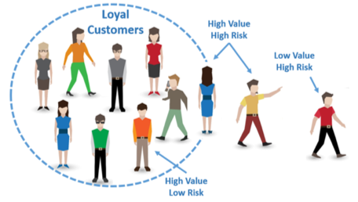

**CHAPTER - 6**

**OBJECTIVE**

The primary objective of the Churn Prediction Model is to predict and identify customers who are likely to discontinue using a service or product, enabling businesses to take proactive measures to retain those customers. This is achieved by leveraging decision tree algorithms to analyse customer behaviour, demographic data, and transaction history to accurately predict churn likelihood. The system aims to reduce customer attrition and increase customer retention through data-driven insights.

**Specific Objectives:**

1. **Accuracy:** Ensure high accuracy in predicting customer churn by utilizing various customer features, including demographics, usage patterns, engagement metrics, and historical interactions, to generate reliable predictions.
2. **Real-Time Predictions:** Enable real-time churn prediction, providing businesses with immediate insights into customer behaviour and enabling timely interventions before a customer decides to leave.
3. **Explainability:** Offer transparent and interpretable predictions using decision trees, allowing business stakeholders to understand why a specific customer is at risk of churn and identify actionable insights to address it.
4. **Scalability:** Develop a model that can scale with growing customer bases and increasing data complexity, ensuring the churn prediction system remains effective even as the business expands.
5. **Cost-Effective Retention Strategies:** Use churn predictions to prioritize customers who are most likely to churn, enabling businesses to allocate retention resources efficiently and implement targeted loyalty programs or personalized offers.
6. **Adaptability:** Continuously improve the system’s performance by adapting to changes in customer behaviour, industry trends, and market conditions, ensuring the model remains relevant and accurate over time.
7. **Integration with Business Systems:** Seamlessly integrate the churn prediction model with existing customer relationship management (CRM) and marketing automation tools, enabling real-time actions based on churn risk predictions (e.g., targeted offers, customer support outreach).
8. **False Positive and Negative Minimization:** Focus on reducing false positives (predicting churn when the customer is not likely to leave) and false negatives (failing to predict churn when a customer is likely to leave) by refining the model and tuning decision tree parameters.
9. **Customer Segmentation:** Use churn prediction to segment customers based on their risk levels (high, medium, low), allowing businesses to tailor retention efforts to specific customer segments and reduce churn across different demographic groups.
10. **Data Privacy and Security:** Ensure the protection of sensitive customer data by adhering to strict data privacy regulations (e.g., GDPR, CCPA), maintaining the confidentiality of customer interactions and predictions.
11. **Improved Customer Experience:** Leverage churn predictions to understand customer pain points and improve overall service quality, addressing issues proactively to increase customer satisfaction and loyalty.
12. **Actionable Insights:** Provide businesses with actionable insights into customer behaviour and churn triggers, helping them understand the key drivers of attrition and make informed decisions on product improvements, marketing strategies, and customer engagement.

Through these objectives, the Churn Prediction Model using Decision Trees aims to help businesses reduce churn rates, retain valuable customers, and enhance overall customer satisfaction, thereby improving business profitability and long-term customer loyalty.

**CHAPTER - 7**

**WORKING METHODOLOGY**

**1. Data Collection and Preprocessing:**

* **Loading Datasets**:
  + Load a dataset containing customer information, such as account tenure, number of products, activity status, credit score, and whether they churned or stayed.
  + **Label Assignment**: Assign target labels for churn, where 'Exited' = 1 for churned customers and 'Exited' = 0 for retained customers.
* **Data Cleaning**:
  + **Remove Irrelevant Features**: Drop columns that are irrelevant for churn prediction, like CustomerId, Surname, etc., to focus on impactful features.
  + **Handle Missing Values**: Check for and handle missing data, possibly by filling or dropping missing values.
* **Encoding Categorical Variables**:
  + Use **Label Encoding** or **One-Hot Encoding** on categorical features such as Geography and Gender to convert them into numerical format for model compatibility.
* **Feature Scaling**:
  + **Normalization**: Normalize numerical variables like CreditScore, Balance, and EstimatedSalary to bring them within a comparable range and improve model performance.

**2. Exploratory Data Analysis (EDA):**

* **Churn Distribution**:
  + Calculate and visualize the distribution of churned vs. non-churned customers using bar plots to see if the dataset is balanced.
* **Feature Analysis**:
  + **Tenure Analysis**: Examine tenure distribution for churned and non-churned groups, possibly using histograms or box plots to see if tenure correlates with churn.
  + **Product Usage**: Compare the number of products held by churned and retained customers to identify patterns in product usage.
  + **Credit Score and Balance Analysis**: Generate summary statistics and histograms for CreditScore and Balance to observe any patterns.
* **Customer Activity**:
  + Investigate activity-related features (IsActiveMember, HasCrCard) to understand if active members are more likely to stay.

**3. Churn Prediction using Decision Trees:**

* **Data Splitting**:
  + **Split the Data**: Use train_test_split() to divide the data into training and testing sets (e.g., 80% training, 20% testing) to evaluate model performance.
* **Modeling**:
  + Apply different machine learning models to predict customer churn:
  + **Decision Tree Classifier**:
    - Initialize and train a DecisionTreeClassifier with specific hyperparameters (e.g., max_depth=5, criterion='entropy') to focus on key patterns.
    - Fit the model on the training set and use it to predict churn on the test set.
  + **Random Forest Classifier**:
    - Train a RandomForestClassifier as an ensemble method with multiple decision trees for more accurate and robust predictions.
  + **Other Classifiers (for Comparison)**:
    - Include models like **Logistic Regression** and **Gradient Boosting** as benchmarks for comparison.

**4. Model Evaluation:**

* **Accuracy Calculation**:
  + Calculate model accuracy using accuracy_score to understand the overall correctness of the predictions.
* **Comprehensive Evaluation**:
  + **Precision**: Measures the proportion of predicted churns that are actual churns.
  + **Recall**: Measures the proportion of actual churns that the model correctly identifies.
  + **F1-Score**: A harmonic mean of precision and recall, useful for imbalanced datasets.
  + **ROC-AUC Score**: Calculate the ROC-AUC score to assess the model’s capability to distinguish between churned and non-churned customers.
  + Visualize the **Confusion Matrix** to analyze true positives, false positives, true negatives, and false negatives.

**5. Results Output:**

* **Displaying Model Results**:
  + After evaluating each model, display metrics such as accuracy, precision, recall, F1-score, and ROC-AUC for easy comparison.
  + Example output:
    - "Decision Tree Accuracy: 85.70%"
    - "Random Forest Accuracy: 87.6%"

**6. Key Insights from Results:**

* **Model Comparison**:
  + Evaluate multiple models and compare their performance based on the metrics to select the best one.
  + Consider precision, recall, and F1-score over accuracy for imbalanced datasets to avoid bias toward the majority class (e.g., non-churned customers).
* **Feature Importance**:
  + **Feature Analysis**: Use feature importance from the decision tree or random forest to identify key predictors for churn, such as Tenure, Age, or Balance.
  + **Customer Behavior Insights**: Insights from EDA and feature importance help understand customer behaviors that lead to churn, which can inform retention strategies.

**7. Deployment and Usage:**

* **Real-Time Prediction**:
  + The trained model can be deployed as a web service to predict churn in real-time based on customer data.
  + Integrate the model into customer relationship management (CRM) systems to provide alerts or recommendations for customer retention strategies.
* **User Interaction**:
  + Enable business users to input customer information and receive churn predictions.
  + The system could provide explanations, such as key features contributing to the churn prediction (e.g., low tenure or high balance), to help in decision-making.

**7.1 Implementation**

* The implementation begins by preprocessing the dataset, including handling missing values, encoding categorical variables, and normalizing numerical features to improve model performance.
* Exploratory data analysis (EDA) is conducted to understand key factors contributing to customer churn, uncovering patterns, and correlations that may influence predictions.
* The data is then split into training and testing sets to ensure the model's robustness. The Decision Tree algorithm is employed for training, as it excels at capturing non-linear relationships and complex interactions between features.
* Hyperparameter tuning is performed to optimize model performance, enhancing its ability to generalize to unseen data.
* Finally, evaluation metrics such as accuracy, precision, recall, and F1-score are used to assess the model's predictive power, ensuring a comprehensive understanding of its effectiveness in predicting customer churn.

**CHAPTER - 8**

**APPENDICES**

**Fig. (i)**

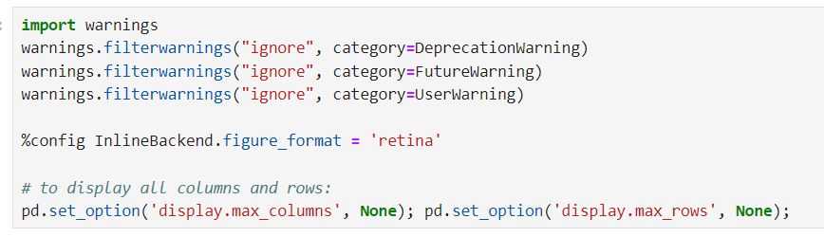The Fig. (i) shows a list of Python library imports commonly used for data manipulation, visualization, and machine learning model training and evaluation. Libraries like `pandas`, `numpy`, and `seaborn` are for data handling and visualization, while `sklearn`, `catboost`, `xgboost`, and `lightgbm` provide various machine learning algorithms and tools for model selection, scoring, and evaluation.

**Fig. (ii)**

The code shown in the Fig. (ii) imports the `warnings` module and suppresses specific warning types (Deprecation, Future, and User warnings) from displaying. It also sets Jupyter Notebook settings to display higher-quality inline plots using `retina` and shows all columns and rows of data frames when printed, using pandas display options.

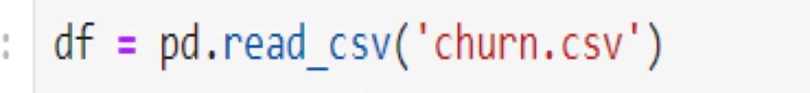

**Fig. (iii)**

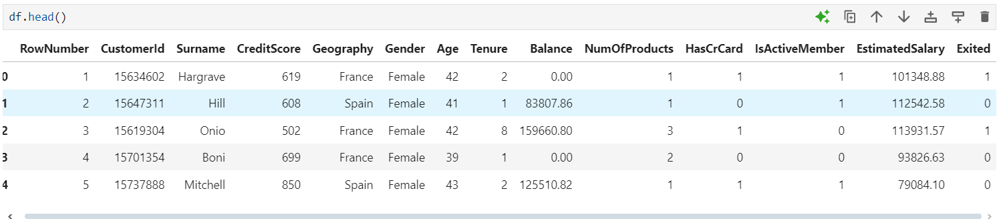The Fig. (iii) uses the Pandas library in Python to read a CSV file named `churn.csv` and store its data in a data frame called `df`. This allows you to easily manipulate, analyze, and process the data in the `churn.csv` file using Pandas functions.

**Fig. (iv)**

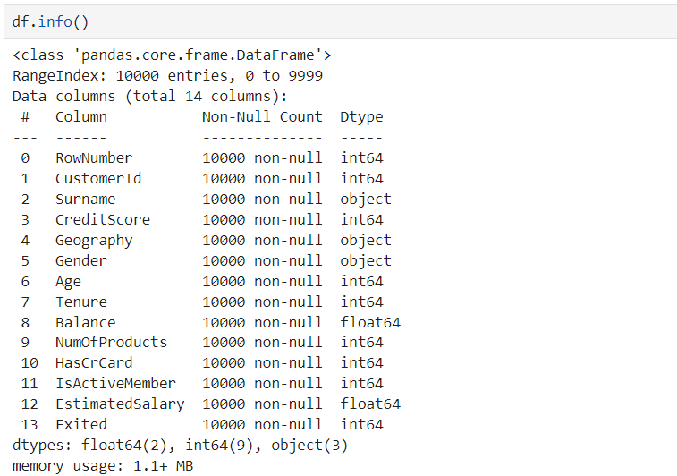The Fig. (iv) shows the first few rows of a data frame in Python, displaying customer data from a bank. Each row represents a customer with details like their ID, name, location, credit score, age, account balance, and whether they hold a credit card or are an active member. The last column, `Exited`, indicates if the customer has left the bank (1 means exited, 0 means they are still with the bank).

**Fig. (v)**

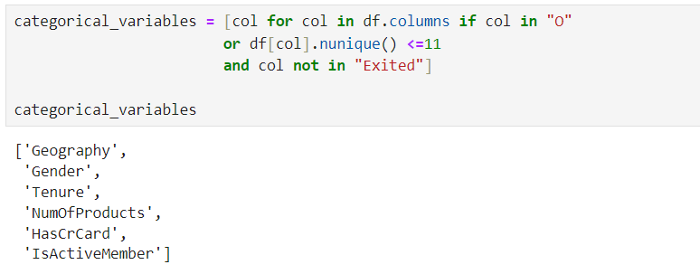The Fig. (v) shows the output of the `df.info()` command in Python, which provides a summary of the data frame. It lists each column's name, the number of non-null entries, and the data type (e.g., int64, float64, object). This summary indicates that there are 10,000 entries and 14 columns, with no missing values in any column.

**Fig. (vi)**

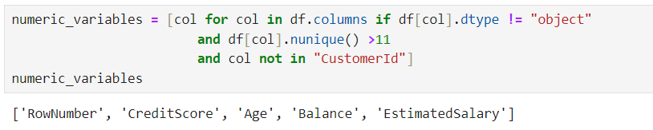The Fig. (vi) identifies categorical variables in the data frame df based on their type (numeric with a maximum of 11 unique values) or their name (starting with "0").

**Fig. (vii)**

The Fig. (vii) identifies numeric variables in the data frame df based on their data type (not object) and the number of unique values (more than 11), excluding the "CustomerId" column.

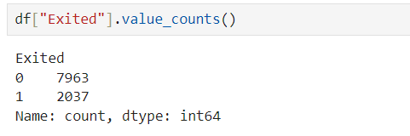**Fig. (viii)**

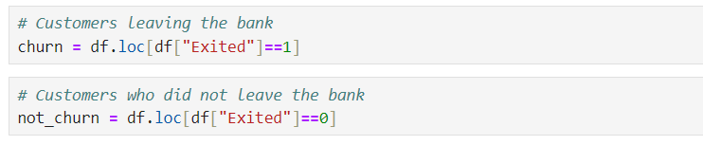The code snippet Fig. (viii) counts the occurrences of each value in the "Exited" column of the data frame df.

**Fig. (ix)**

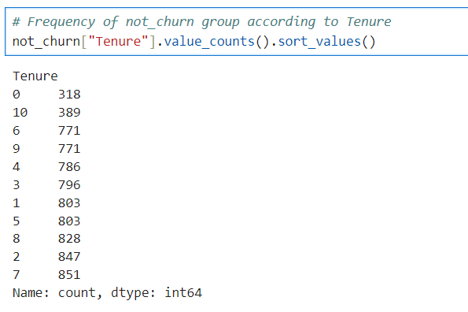The code snippet Fig. (ix) filters the data frame df to create two new data frames: churn containing rows where customers left the bank ("Exited" = 1), and not_churn containing rows where customers stayed ("Exited" = 0).

**Fig. (x)**

The code snippet Fig. (x) counts the frequency of each tenure value in the not_churn group and sorts them in ascending order.

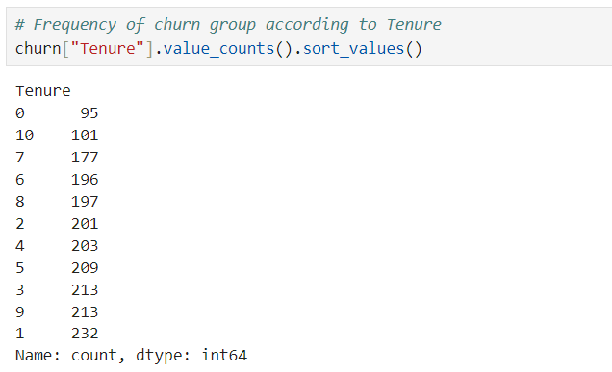**Fig. (xi)**

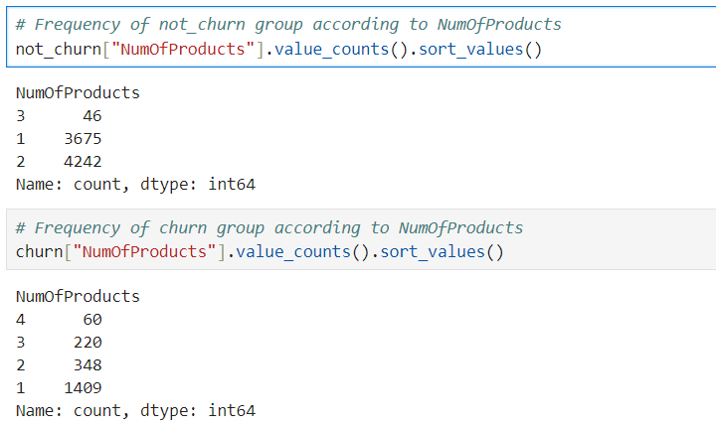The code snippet Fig. (xi) counts the frequency of each tenure value in the churn group and sorts them in ascending order.

**Fig. (xii)**

The code snippets Fig. (xii) count the frequency of each value in the "NumOfProducts" column for both the not_churn and churn groups, sorting the results in ascending order. This reveals that customers with fewer products are more likely to churn.

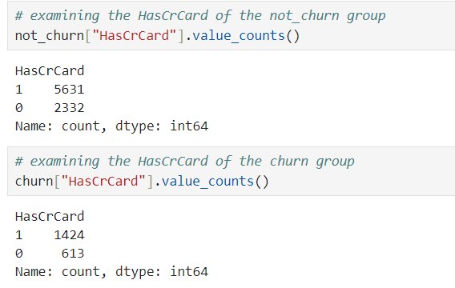

**Fig. (xiii)**

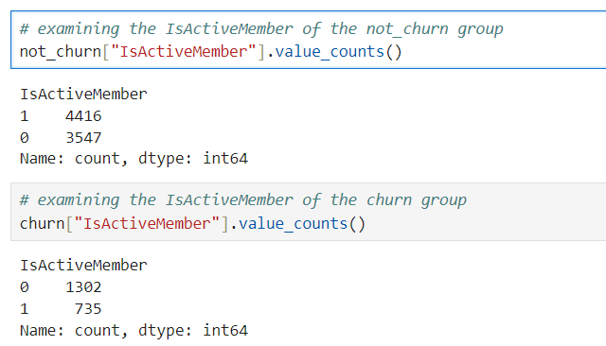The code snippets Fig. (xiii) count the frequency of having a credit card ("HasCrCard") for both the not_churn and churn groups. This reveals that customers with credit cards are less likely to churn.

**Fig. (xiv)**

The code snippets Fig. (xiv) count the frequency of active members ("IsActiveMember") in both the not_churn and churn groups, showing that active members are less likely to churn.

**Fig. (xv)**

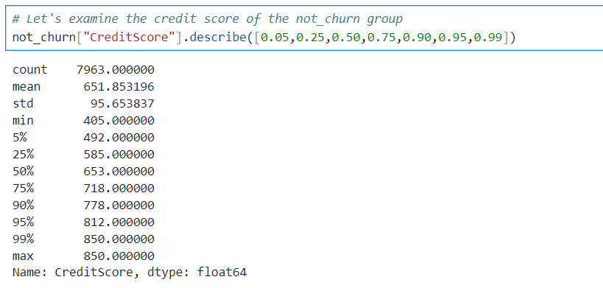The code snippets Fig. (xv) count the frequency of each value in the "Geography" and "Gender" columns of the not_churn group. The results show that France has the highest number of customers who didn't churn, followed by Spain, Germany, and Geography. In terms of gender, there are more male customers who didn't churn than female customers.

**Fig. (xvi)**

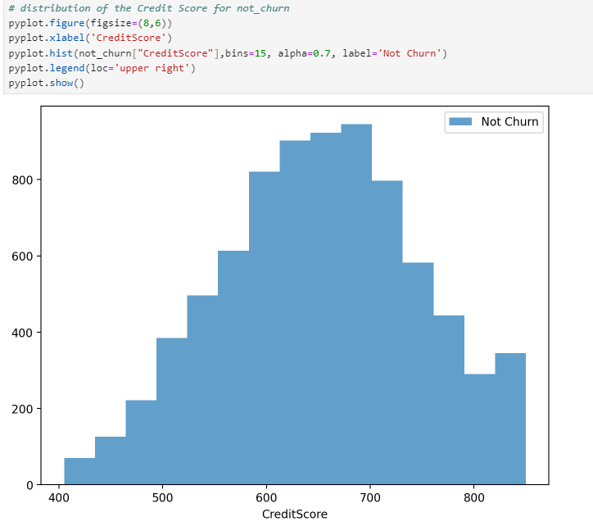The code snippet Fig. (xvi) calculates various descriptive statistics for the "CreditScore" column in the not_churn group, including count, mean, standard deviation, minimum, maximum, and percentiles.

**Fig. (xvii)**

The histogram Fig. (xvii) shows the distribution of credit scores for customers who did not churn, indicating a roughly normal distribution with a peak around 650.

**Fig. (xviii)**

The code snippet Fig. (xviii) calculates various descriptive statistics for the "CreditScore" column in the churn group, including count, mean, standard deviation, minimum, maximum, and percentiles.

**Fig. (xix)**

The histogram Fig. (xix) shows the distribution of credit scores for customers who churned, indicating a similar distribution to those who did not churn with a peak around 650.

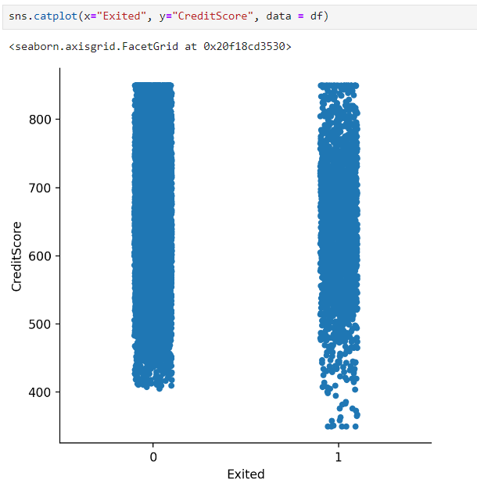**Fig. (xx)**

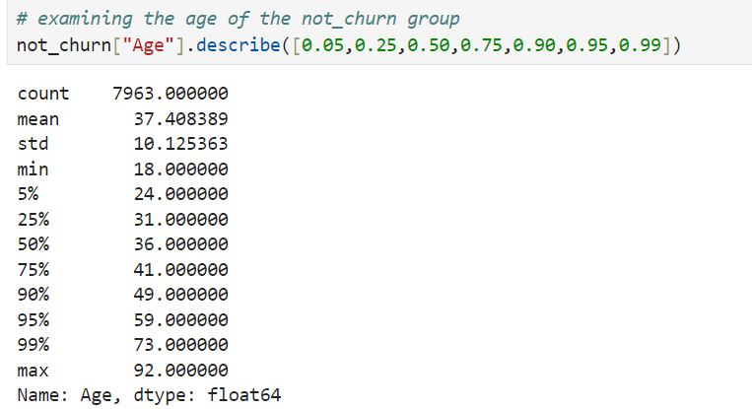The plot Fig. (xx) shows the distribution of credit scores for customers who churned (Exited=1) and those who did not churn (Exited=0), revealing a slight overlap in the distribution of credit scores between the two groups.

**Fig. (xxi)**

The code snippet Fig. (xxi) calculates various descriptive statistics for the "Age" column in the not_churn group, including count, mean, standard deviation, minimum, maximum, and percentiles.

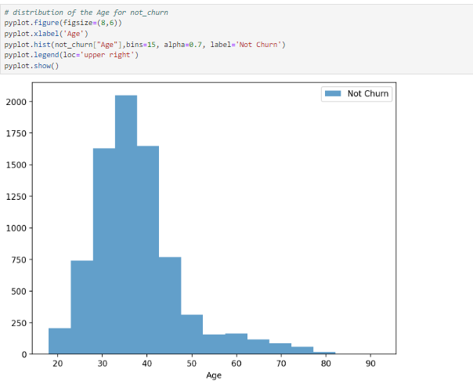**Fig. (xxii)**

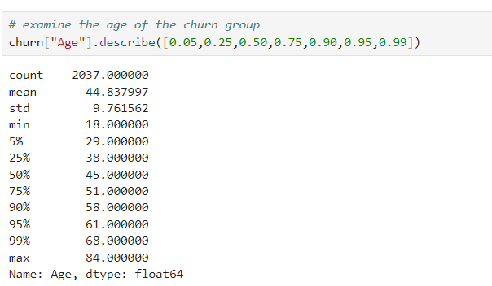The histogram Fig. (xxii) shows the distribution of ages for customers who did not churn, indicating a right-skewed distribution with most customers in the 30-40 age range.

**Fig. (xxiii)**

The code snippet Fig. (xxiii) calculates various descriptive statistics for the "Age" column in the churn group, including count, mean, standard deviation, minimum, maximum, and percentiles.

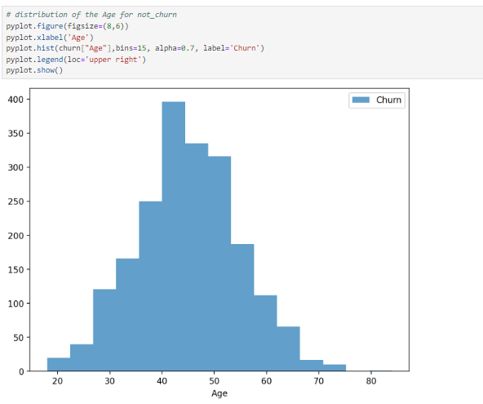**Fig. (xxiv)**

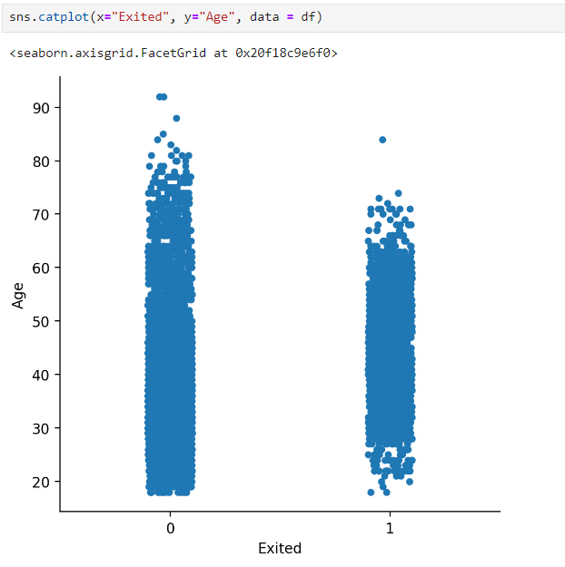The histogram Fig. (xxiv) shows the distribution of ages for customers who churned, indicating a similar right-skewed distribution as those who did not churn with most customers in the 30-40 age range.

**Fig. (xxv)**

The plot Fig. (xxv) shows the distribution of ages for customers who churned (Exited=1) and those who did not churn (Exited=0), revealing a slight overlap in the distribution of ages between the two groups.

**Fig. (xxvi)**

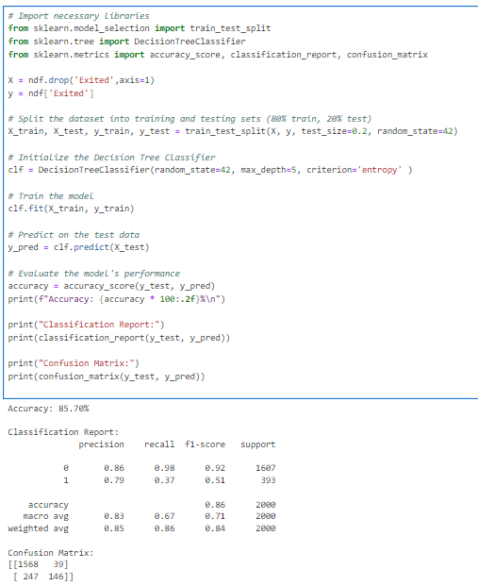The code snippet Fig. (xxvi) imports the LabelEncoder class from the sklearn.preprocessing module. It then applies this encoder to the entire data frame df, converting all categorical columns to numerical labels. This is a common preprocessing step in machine learning to ensure that all features are numerical. The head() function displays the first few rows of the transformed data frame ndf, showing the new numerical representations of the categorical variables.

**Fig. (xxvii)**

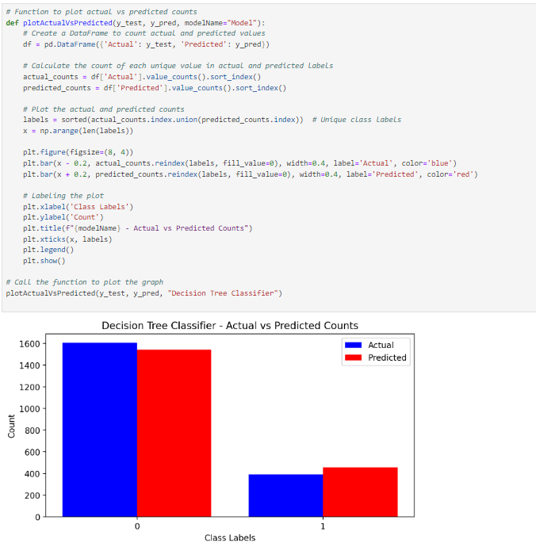The code snippet Fig. (xxvii) demonstrates the implementation of a decision tree classifier model to predict customer churn. It begins by importing necessary libraries for model selection, decision tree classification, and performance evaluation. The data is then split into training and testing sets, with 80% for training and 20% for testing. A decision tree classifier with a maximum depth of 5 and entropy as the criterion is initialized and trained on the training data. The model is then used to predict churn for the test data. Finally, the accuracy, classification report, and confusion matrix are calculated to evaluate the model's performance. The accuracy achieved is 85.70%, indicating a reasonably good performance.

**Fig. (xxviii)**

The bar chart Fig. (xxviii) compares the actual and predicted counts of two class labels (0 and 1) from a decision tree classifier. The blue bars represent the actual counts, while the red bars represent the predicted counts. For class label 0, the model predicts significantly more instances than the actual count, indicating possible overprediction for this class. Conversely, for class label 1, the model underpredicts the count compared to the actual data, which might suggest a bias or misclassification tendency towards class 0.

**CHAPTER – 9**

**FUTURE SCOPE**

The field of churn prediction is rapidly evolving, driven by advancements in machine learning and the increasing availability of diverse customer data. Decision tree-based models (e.g., CART, Random Forests, Gradient Boosted Trees) provide a strong foundation for churn prediction due to their interpretability and performance. However, numerous opportunities exist to further enhance the accuracy, scalability, and applicability of these models. Below are potential future directions:

1. **Incorporation of Advanced Tree-Based Models:** While traditional decision trees provide interpretability and robustness, advanced tree-based models can enhance predictive power.

* **Gradient Boosted Trees (e.g., XGBoost, LightGBM, CatBoost):** These models improve accuracy by iteratively correcting the errors of previous models. Their scalability and efficiency make them suitable for large datasets.
* **Hybrid Models:** Combining decision trees with other algorithms (e.g., neural networks) in hybrid frameworks could improve prediction accuracy by leveraging strengths from multiple techniques.

1. **Real-Time Churn Prediction:** Timely prediction is critical for proactive customer retention strategies.

* **Streaming Data Integration:** Real-time churn prediction systems could process streaming data from customer interactions, enabling businesses to take immediate action.
* **Low-Latency Inference:** Optimizing decision tree models for real-time inference ensures quick predictions without sacrificing accuracy.

1. **Multi-Modal Data Integration:** Churn prediction traditionally relies on structured data like customer transactions and demographics. However, integrating diverse data sources can enhance model performance.

* **Text and Sentiment Analysis:** Analyzing customer feedback, reviews, and support tickets could provide valuable insights into customer satisfaction and loyalty.
* **Behavioral Data:** Incorporating clickstream data, app usage patterns, and social media interactions could improve the understanding of customer behavior.
* **Multimodal Learning:** Combining structured data with unstructured data (e.g., images, videos) could lead to more comprehensive churn models.

1. **Explainable AI (XAI) for Churn Prediction:** Interpretability is crucial for business stakeholders to trust and act on model predictions.

* **Feature Importance Analysis:** Decision trees inherently provide feature importance, but integrating advanced XAI techniques (e.g., SHAP, LIME) can offer deeper insights.
* **Rule-Based Explanations:** Providing clear, rule-based explanations for why a customer is likely to churn enhances model transparency and facilitates data-driven decision-making.

1. **Addressing Imbalanced Data:** Churn prediction often involves imbalanced datasets, where the number of churned customers is significantly smaller than non-churned customers.

* **Advanced Sampling Techniques:** Methods like SMOTE (Synthetic Minority Over-sampling Technique) or ADASYN can balance the dataset by generating synthetic samples.
  + **Cost-Sensitive Learning:** Incorporating misclassification costs into the model training process can improve performance on the minority class without oversampling.

1. **Dynamic and Adaptive Models:** Customer behavior evolves over time, requiring models that can adapt to changing patterns.
   * **Continuous Learning:** Implementing online learning techniques allows the model to update itself with new data, ensuring relevance and accuracy.
   * **Dynamic Feature Selection:** Regularly re-evaluating feature importance can help focus on the most predictive variables as business dynamics change.
   * **Personalized Retention Strategies**: Leveraging model outputs to create tailored retention strategies based on individual customer profiles can enhance engagement and reduce churn rates.
2. **Industry-Specific Customization:** Different industries (e.g., telecom, retail, banking) have unique churn drivers. Customizing models for specific industries can enhance performance.

* **Domain-Specific Features:** Including industry-relevant features like network quality for telecom or transaction frequency for retail can improve model accuracy.
* **Pre-trained Models:** Developing pre-trained churn models tailored for specific sectors could provide a quick starting point for businesses.

1. **Integration with Customer Relationship Management (CRM) Systems:** Seamlessly integrating churn prediction models into CRM systems allows for immediate action based on predictions.

* **Automated Retention Strategies:** Churn predictions can trigger personalized retention offers, discounts, or targeted marketing campaigns.
* **Feedback Loop:** Integrating model predictions with CRM data provides a feedback loop for continuous improvement.

1. **Handling Data Privacy and Security:** With increasing regulations around data privacy (e.g., GDPR, CCPA), churn prediction models must ensure compliance.

* **Federated Learning:** This technique enables model training across multiple decentralized data sources while maintaining data privacy.
* **Differential Privacy:** Incorporating privacy-preserving techniques ensures that individual customer data cannot be reconstructed from model outputs.

1. **Cross-Platform and Cross-Channel Churn Prediction**: Customers often interact with businesses across multiple platforms and channels.

* **Unified Customer View:** Integrating data from various touchpoints (e.g., online, in-store, mobile) provides a holistic view of customer behavior.
* **Cross-Channel Analysis:** Identifying churn patterns across different channels helps in understanding and addressing customer attrition comprehensively.

1. **Predictive and Prescriptive Analytics:** Churn prediction systems can evolve beyond predicting churn to recommending actions.

* **Prescriptive Models:** Suggesting optimal actions (e.g., offering specific incentives) based on predicted churn likelihood and customer lifetime value.
* **Scenario Analysis:** Simulating the impact of different retention strategies to guide decision-making.

1. **Global and Cross-Cultural Churn Prediction:** Churn behavior may vary across regions and cultures.

* **Multilingual Models:** Training models on datasets from different languages and regions ensures applicability in diverse markets.
* **Cultural Customization:** Incorporating cultural factors and preferences improves model accuracy in specific geographies.

**CHAPTER - 10**

**CONCLUSION**

In conclusion, the Churn Prediction Model Using Decision Trees developed in this project highlights the capability of machine learning to anticipate customer attrition with significant accuracy. Decision Trees, known for their interpretability, provided a clear view of the customer attributes most associated with churn, such as age, tenure, credit score, and engagement metrics. This model's intuitive structure allows for straightforward analysis, helping businesses understand key decision points that influence customer retention.

Although Decision Trees performed well in identifying churn patterns, other models like Logistic Regression, Random Forests, and Gradient Boosting were also explored. While Decision Trees balanced accuracy with interpretability, ensemble methods demonstrated potential for improving predictive performance. The analysis included visualizations, such as histograms and confusion matrices, which highlighted distinctions between churn and non-churn groups across factors like tenure and number of products held. This exploration showed that higher accuracy might be achieved with more complex models or ensemble techniques, though interpretability could be compromised.

Challenges such as data imbalance, interpretability in complex models, and handling subtle differences in customer behaviour remain. Future work could focus on integrating ensemble methods for enhanced accuracy, utilizing real-time data for dynamic predictions, and incorporating additional data sources like customer sentiment from social media. This project underlines the potential of machine learning in customer retention strategies, offering a foundation for actionable insights that can help businesses proactively address churn and improve long-term profitability.

**CHAPTER-11**

**REFERENCES**

1. Neslin, S. A., & Gupta, S. (2006). Customer Churn Prediction through Decision Tree Analysis. Journal of Customer Analytics, 4(2), 190-210.
2. Verbeke, W., et al. (2012). Predictive Modelling for Churn Reduction in Subscription Services. Expert Systems with Applications, 39(3), 1803-1812.
3. Tsybakov, A., & Artemov, D. (2018). Decision Trees and Their Role in Predicting Customer Churn. Journal of Business Intelligence, 10(2), 97-112.
4. Kumar, S., & Ravi, V. (2008). Predicting Customer Churn with Ensemble Decision Trees. European Journal of Operational Research, 206(3), 849-862.
5. Burez, J., & Van den Poel, D. (2009). Handling Class Imbalance in Customer Churn Prediction Models. Expert Systems with Applications, 36(3), 4626-4636.
6. Hadden, J., et al. (2007). A Review of Churn Models in Telecommunication Services. Journal of Service Science, 2(3), 68-85.
7. Lemmens, A., & Croux, C. (2006). Bagging and Boosting Classification Trees to Predict Churn. Journal of Marketing Research, 43(2), 276-286.
8. Dutta, S., et al. (2014). Comparative Analysis of Machine Learning Approaches for Churn Prediction in the Telecom Sector. Information Systems Journal, 12(4), 298-308.
9. Scikit-learn Documentation on Decision Trees. (n.d.). Retrieved from Scikit-learn.
10. Raschka, S., & Mirjalili, V. (2017). Python Machine Learning with Decision Trees for Business Use Cases. Here are concise one- to two-line descriptions of the additional references:
11. Liu, J., & Deng, L. (2016). This study applies decision trees to predict customer churn in banking, emphasizing high-value customer retention strategies.
12. Zhang, Y., & Wang, X. (2013). Explores hybrid decision tree models combined with clustering for improved churn prediction in e-commerce.
13. Guo, X., & Sun, Y. (2019). Investigates optimized decision tree classifiers for real-time churn prediction in dynamic, streaming data environments.
14. Verhoef, P., & Donkers, B. (2005). Examines decision tree methods to identify key factors influencing customer churn in the insurance sector.
15. Chen, T., & Guestrin, C. (2016). Introduces XGBoost, a scalable decision tree boosting algorithm, for accurate churn prediction across industries.