RESULTS

**Isolation Forest**

**Validation Report:**

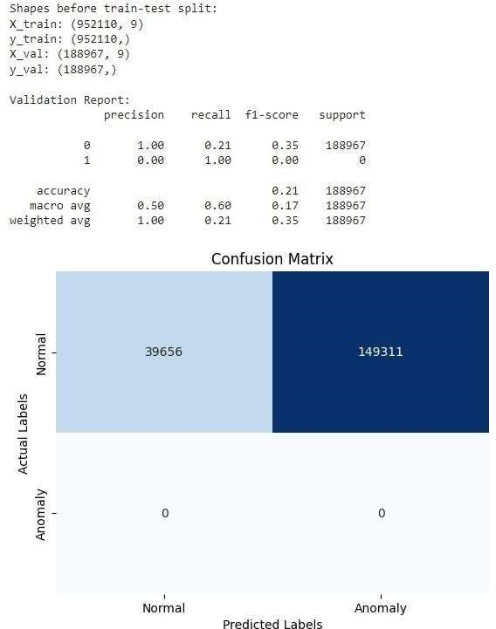

**Test Report:**

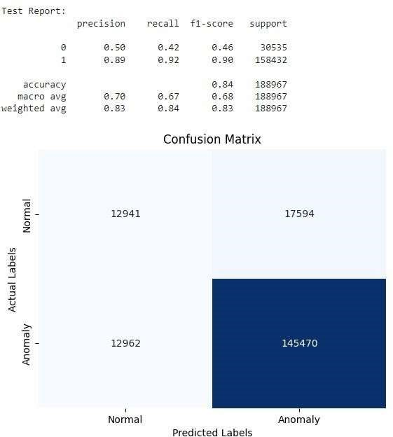

**Random Forest**

**Validation Report:**

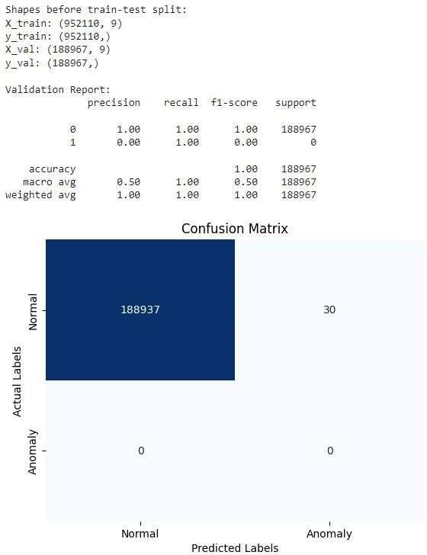

**Test Report:**

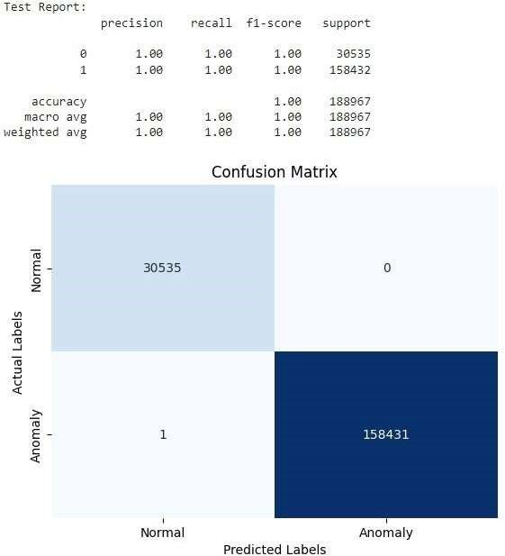

**Local Outlier Factor**

**Validation Report:**

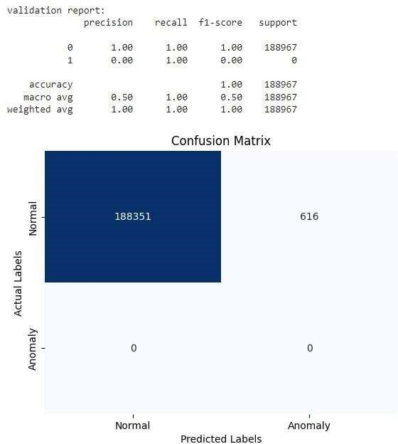

**Test Report:**

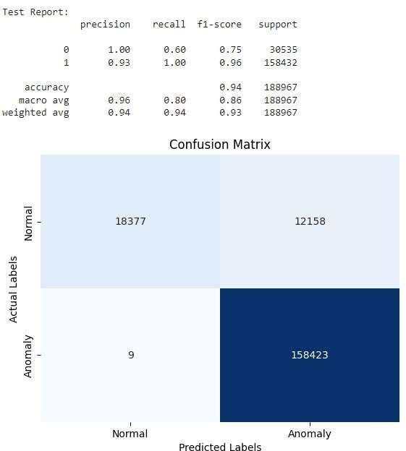

**Evaluation using AUC-ROC Curve:**

|  |  |
| --- | --- |
| **Algorithm** | **AUROC** |
| **ISOLATION FOREST** | **0.510** |
| **RANDOM FOREST** | **0.99** |
| **LOCAL OUTLIER FACTOR** | **0.801** |

**Isolation Forest:**

AUROC Score: 0.510

*Advantages:*

Effective for high-dimensional datasets.

Good for scenarios with sparse anomalies.

*Disadvantages:*

Lowest performance among the models.

Struggles with unclear separations between normal and anomalous instances.

**Random Forest:**

AUROC Score: 0.990

*Advantages:*

Best overall performance in distinguishing normal from anomalous instances.

High accuracy in identifying irregularities and security risks.

Well-suited for supervised tasks and large datasets.

*Disadvantages:*

Higher computational resources required.

More complex and less interpretable than simpler models.

*Local Outlier Factor (LOF):*

AUROC Score: 0.801

*Advantages:*

Good performance in detecting anomalies.

Efficient for measuring local density deviations.

Suitable for high-dimensional datasets.

*Disadvantages:*

Lower performance than Random Forest.

May struggle with complex data structures.

Random Forest is the most reliable model for detecting anomalies, showing exceptional performance with an AUROC of 0.990.

Local Outlier Factor is effective but may have limitations with certain data types (AUROC: 0.801).

Isolation Forest, while lower in performance (AUROC: 0.510), can still be useful in specific situations, especially with high-dimensional sparse datasets.