# **[GNIPTECH] Requirements & Design**

## 1. Project Overview

Through this document, we want to present you to the prototype of the application to develop. We will give you an overview of the project, the goals, the features, user cases, user stories, diagrams, wireframes but also a few different aspects.

This application will be targeting people looking for mentoring and being mentored around the sectors of technologies, accounting and medics but also to corporates: Human Ressources, universities, hospitals and other teal organizations.

The business advantage of this project is to offer our audience an efficient app, to use at an office or on the go ! But also to gather into 1 application all the possible technologies being used by the mentors and their mentees at the moment for being able to make the mentoring more lively, more secured in the defined length of time of the mentoring.

The main point of this application is to make mentoring an easier time for both parties, with all the tools

### Project Goals

We want to offer solutions such as :

* Making appointments for the next sessions
* Reminding the value of mentoring through tips and articles
* Helping the mentoring to improve through evaluations
* Messaging chats with video, audio call and access to the diary
* Taking notes during or after a session
* Giving an access to a profile with few statistics and a history of activity for boosting the motivation of both parties
* Giving an easy access to all mentoring programs, classified by category of user, and also all functions available
* Reminding and offering an easy access to a summary of the mentoring program including the expectations, the agreement of both parties but also a view on ongoing projects/courses which are being worked on.
* Easing the way of matching-up and requesting mentors or mentees, at the beginning or during the use of the application! The system will match-up automatically both parties in any case.

### Out of Scope

The aspect which has been considered but which has not been included in this part of the project is the administration and moderation aspect to avoid any abuse of the system (fake certificates, fake expertise of mentors) but also the financial retribution aspect. Both could be added as two extra modules later on in the project.t

### 

### Project Metrics

We will be able to monitor the metrics of this project through the number of new sign-ups, the reputation but also the user retention.

## 2. Features

### 2.1 Project Features

Here are the project features through the possible user cases:

* AUTHENTIFICATION
* REGISTRATION
* DEFINITION OF A MENTORING AGREEMENT
* REQUESTING A NEW MENTOR/MENTEE
* PLANIFICATION OF THE NEXT SESSION
* DEFINITION OF TOPICS FOR THE NEXT SESSION
* TAKING NOTES (DURING OR AFTER SESSIONS)
* GIVING A REVIEW ON THE MENTORSHIP
* DEFINITION OF THE FREQUENCY OF SESSIONS
* CONSULTATION AND MODIFICATION OF THE ONGOING PROJECT/COURSES
* CONSULTATION OF THE VALUE OF MENTORING AND EVALUATIONS
* MAKE VIDEO AND AUDIO CALLS

### 2.2 User Stories and Use Case Diagram

Below is a use case diagram giving the overview over the different user cases and their interactions with the actors

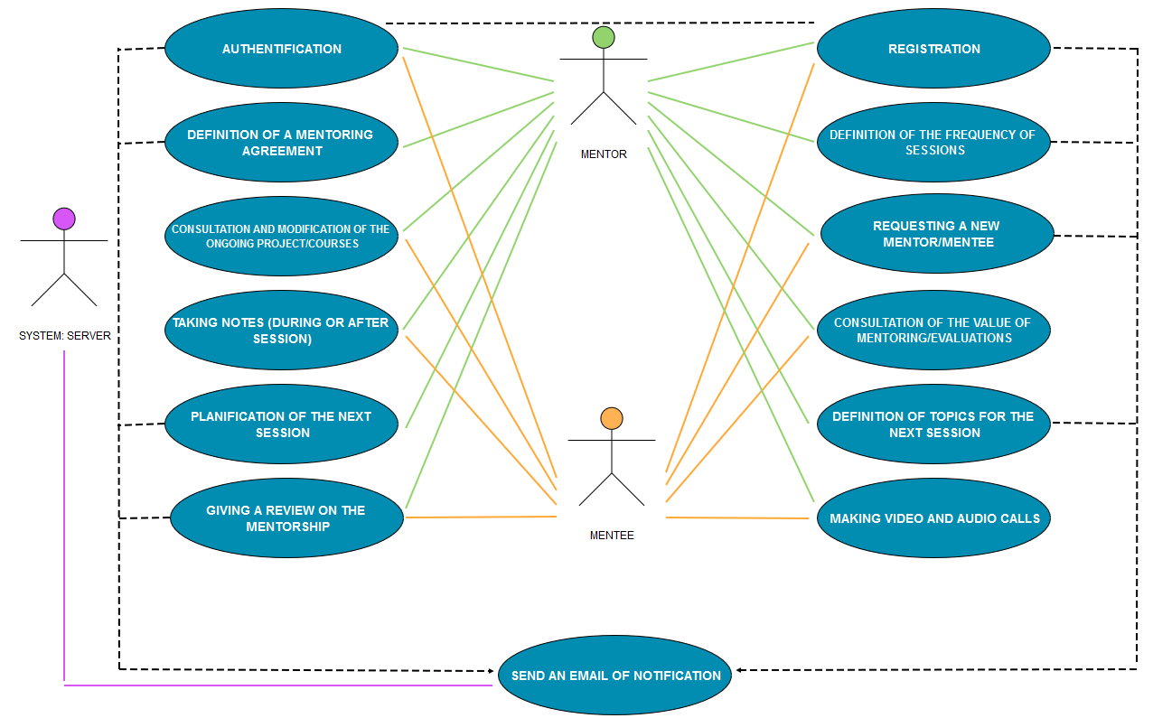

Below is the description of each user story:

**AUTHENTIFICATION**

The user launches the application  
The system displays the authentification page requesting USERNAME, PASSWORD, with a “Sign-up” button and also hypertext “Forgot Password”  
The user enters the USERNAME and the PASSWORD and click on the button “Access”  
The system verifies if the USERNAME matches with the PASSWORD  
 The USERNAME doesn’t match  
 => the system returns a message of error  
 The USERNAME doesn’t exist  
 => the system returns a message of error  
 The USERNAME matches  
 => the system connects the user to the app

**REGISTRATION**

1ST:

The user clicks on the “Sign-up now” button  
The system displays the sign-up page requesting FIRST NAME, LAST NAME, E-MAIL, confirmation of E-MAIL, PASSWORD, confirmation of PASSWORD  
The user enters those information and clicks on “Next”  
The system verifies if those information are correct and go to the 2nd step if correct  
If not => asking to reenter the wrong information

2nd:

The system displays the next step and requests the TYPE OF USER (MENTOR/MENTEE) is looking for  
The system requests the GENDER, the AGE, the SPOKEN LANGUAGE, the AREA OF MENTORING wanted and the DURATION OF MENTORING  
The user enters those information and click on “Next” button  
The system verifies if those information are correct and if correct, displays the next step

3rd (only if MENTOR is chosen):

The system displays the next step and requests the AREA OF STUDY and a listbox (the mentor can make as many choices as wanted)) with PROOF OF CERTIFICATION for each one  
The user enters those information and click on “Next” button  
The system verifies if those information are correct and if they are correct, displays the next step

4th (for MENTORS and MENTEES):

The system displays and requests the EXPECTATIONS  
The user enters those information and click on “Match-me up”  
The system displays a message asking for waiting and displays two different options with specific messages:  
=> MENTOR/MENTEE matched  
=> MENTOR/MENTEE not matched, with a message requesting to wait for the new user to subscribe and also to say that the USER is going to be notificated by e-mail once a USER has matched their request  
The system displays the homepage of the application

**DEFINITION OF A MENTORING AGREEMENT/MODIFICATION**

The user “MENTOR” clicks on the desired project from HOMEPAGE  
The system displays the summary of the mentoring, including the “MENTOR AGREEMENT” section and a button “Add a new mentoring agreement”  
The user clicks on the button  
The system opens the textbox of the mentoring agreement for editing  
The user “MENTOR” edits it, validate it.  
The system closes the editing of the mentoring agreement

**CONSULTATION AND MODIFICATION OF THE ONGOING COURSES/PROJECTS**

The user “MENTOR” clicks on the desire d project from HOMEPAGE  
The system displays the summary of the mentoring, including the “ONGOING PROJECTS/COURSES” and the button “Add/modify”  
The user clicks on the button  
The system opens the “tableau” of the “ONGOING PROJECTS/COURSES” with a column of the NAME and another column of “SCORE/PERCENTAGE”  
The user “MENTOR” edits information and validate it.  
The system closes the edition.

**DEFINING A FREQUENCY OF SESSIONS**

The user “MENTOR” clicks on the desired project.  
The system displays the summary of the mentoring, including the heading information with the button “Edit heading info”  
The user clicks on the button  
The system opens the textboxes of the info for modification  
The user “MENTOR” edits it and validate it  
The system updates and closes the edition of the info

**GIVING A REVIEW ON THE MENTORSHIP**

After each VIDEO CALL, AUDIO CALL, the system displays a new small window asking a choice for the review.

SKIP => the user chooses it, the system closes the window  
 YES => The system asks to write down an EVALUATION COMMENT and a SCORE (from 1 to 5 stars)

**MAKE A VIDEO or AUDIO CALL**

The user clicks on the summary of the project, then the button AUDIO CALL or VIDEO CALL  
The system displays the chat and start the mentoring call with the MENTOR or MENTEE

**CONSULTATION OF THE VALUE OF MENTORING AND EVALUATIONS**

The user clicks on the tab of “TIPS AND EVALUATIONS” from HOMEPAGE  
The system displays 3 ARTICLES and/or TIPS with an IDENTIFICATION NUMBER and a possibility of reading all, and a history of all EVALUATIONS, with FULL NAME of the person that has evaluated

* The user wants to see all the articles
  + The system displays a page with all the ARTICLES and TIPS

**CONSULTATION OF THE DIARIES**

The user clicks on the tab “DIARIES” from HOMEPAGE or “ACESS TO THE DIARY” button on the summary of the ONGOING PROJECTS/COURSES

* The system displays the summary of MENTORING’S NAMES with STATUS
* The system displays the current shared DIARY in two columns with MENTOR’S NAME and MENTEE’S NAME, with also the NAME OF THE MENTORSHIP as the PAGE’S TITTLE, and a button “EDITING”
* The system creates a new diary after each session, let opened the previous one for 48 hours and list a history of the previous ones up to 6 months.

**TAKING NOTES DURING AND AFTER SESSION IN THE DIARY**

The user is on the “DIARY” tab

* The user clicks on the desired PROJECT/COURSE
  + The system displays the shared DIARY

The user is on the chat with a mentor or mentee and click on “Add a quick comment to the diary”

* The system displays a small window with a text box to write the comment and push it into the diary.
* The system closes the windows previously opened

**DEFINITION OF TOPICS FOR THE NEXT SESSION**

The user “MENTOR” clicks on the button “DEFINING TOPICS FOR THE NEXT SESSION”  
The system displays a window requesting to the user “MENTOR” to define TOPICS for the MENTORING SESSION  
The user writes down the topics successively  
The system updates the DIARY with the new information and closes the windows.

**PLANNIFICATION OF THE NEXT SESSION**

The user “MENTOR” clicks on the button “PLANNIFICATION OF THE NEXT SESSION”  
The system displays a window requesting to choose a DATE and TIME for the next session  
The user “MENTOR” enters that information  
The system displays that DATE and TIME on the summary’s page of the project

**REQUESTING A NEW MENTOR/MENTEE**

The user clicks on “REQUEST A NEW MENTOR/MENTEE” tab  
The system displays the page with 2 buttons “FINDING A NEW MENTOR” and “FINDING A NEW MENTEE” and the pending requests (CATEGORY (NAME OF THE MENTORING REQUESTED), REQUESTED DATE, STATUS)

* The user chooses “Finding a new mentor”
  + The system opens a windows with a textbox of AREA OF MENTORING, DURATION OF MENTORING DESIRED
* The user chooses “Finding a new mentee”
  + The system opens a window with a textbox of AREA OF MENTORING, DURATION OF MENTORING DESIRED but also to attach proof of CERTIFICATE OF APTITUDES (attachment in uploading)

## 3. Proposed Solution

### 3.1 Technical Design Diagrams

You will also find below the class diagram of this project:

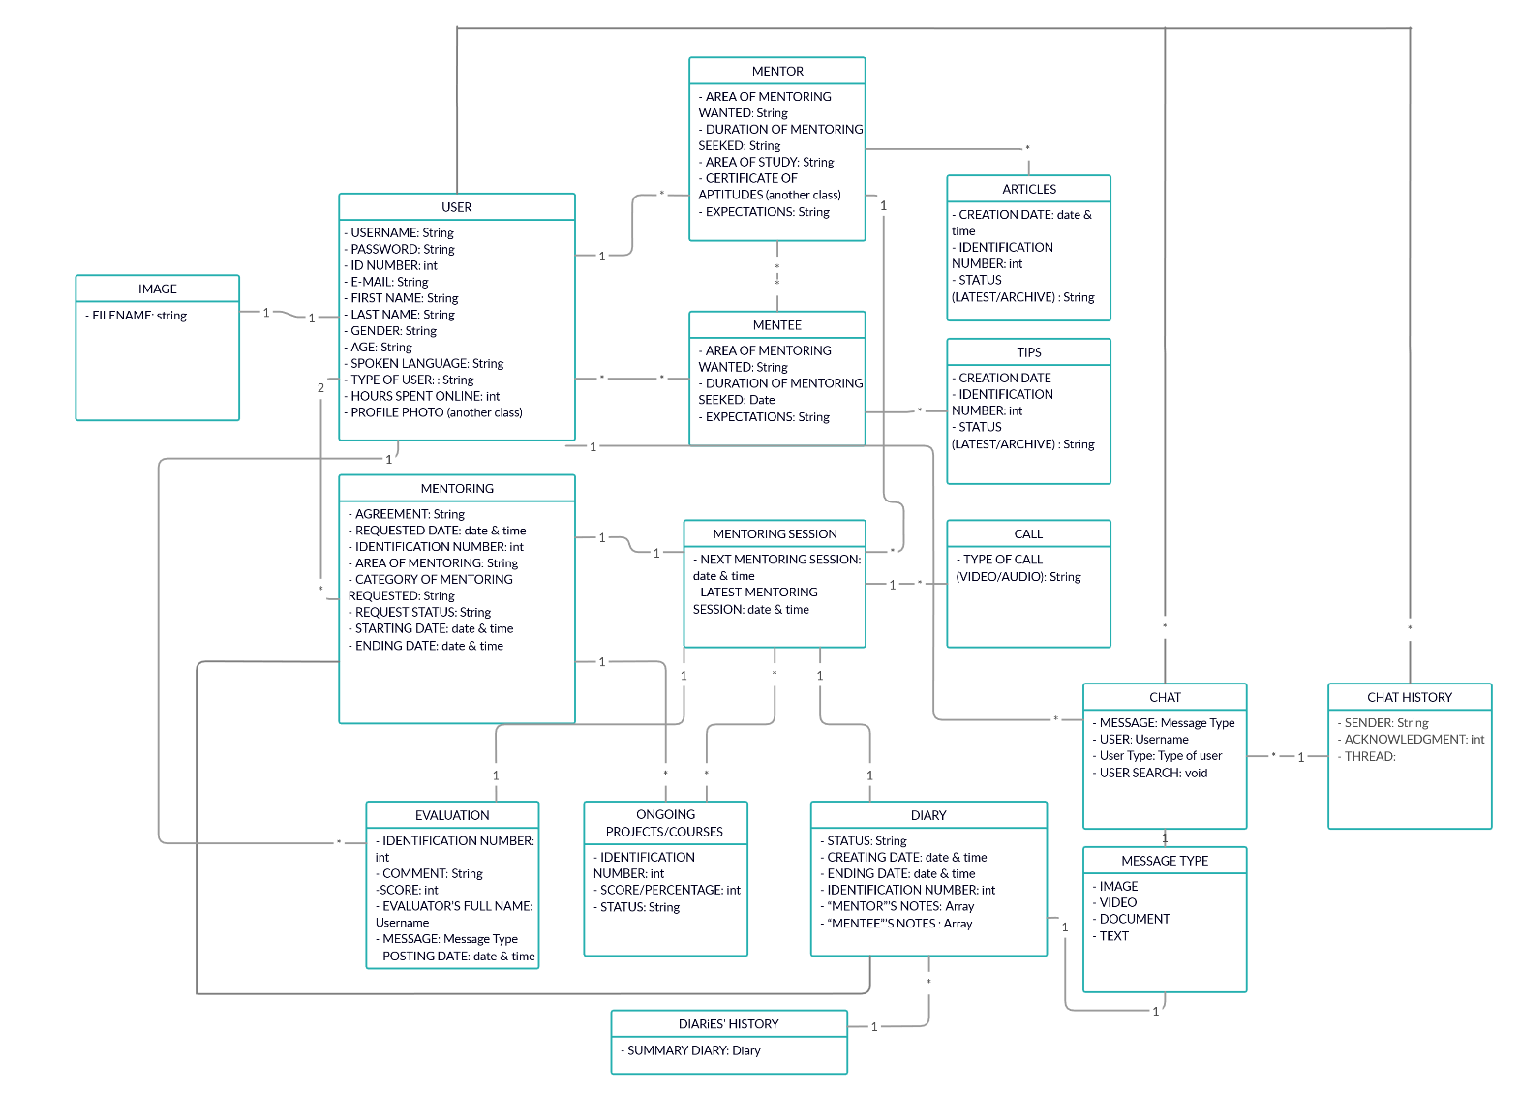

### 3.2 Glossary

Here is a list of the domain vocabulary:

**MENTORING AGREEMENT**: An agreement made of many key points between the Mentor and the Mentee, providing the personal commitment of each part towards the success of the encounter

**MENTOR**: An experienced and trusted person who gives another person advice and help, over a period of time

**MENTEE**: A person who is helped by a mentor

**SESSION FREQUENCY**: Defines the frequency of sessions between the Mentor and the Mentee

**VIDEO CALL**: Method used to call the Mentor or the Mentee, using video and audio to transmit a live picture and sound of both participants

**AUDIO CALL**: Method used to call the Mentor or the Mentee, using only audio to transmit a live sound of both participants

**EVALUATION**: The process of judging or calculating the quality, importance, amount, or value of the mentorship

**DIARY**: The person’s record of events, thoughts, ideas, etc., that are written down by the user

**MATCH-UP**: When the system is trying to pair a mentor and a mentee

**MENTORING**: The act or process of helping and giving advice to a less experienced person

### 3.3 Wireframes

