**Goals for the Project 3**

Build internal/independent private network storage server or private cloud-stored website solution/application, providing investment tools for in-house decision making and offering exclusively to the existing and potential investors(clients), based on predetermined algorithmic data calculations.

The website will provide the sentiment analysis for investors to discover, react and respond to market opinion, based Equity Rating and Action combined. The sentiment is monitored and analyzed by the algorithms.

Product solution designation is a Hedge-Fund/Private Equity Firm.

**Specifications**:

All Data to be kept secure (one-way communication) and not shared with outside cloud servers.

Up to date or live data to be scraped from Yahoo Finance or similar source using Python /HTML Beautiful Soup or similar.

The project dataset is saved as csv file. Ready to be plotted into the charts and displayed onto the webpage.

Web Charting and Visualization performed with JavaScript using all available libraries: D3, Plotly etc.

Tableau is also an option for charting and visualization. However, Tableau Public does not allow to save the file on the local drive.

**Disadvantages or cons using Tableau:**

Tableau is cloud based/ Security Issues

Subscription is expensive

Embedment Issues

**Advantages of alternative apps used to handle big data streaming:**

* Free no subscription fee applications used to handle large streaming
* JavaScript/HTML
* Python/Pandas
* Apache Spark

**Apache Spark Ecosystem corroborated streaming for fast performance ML computing in Real Time:**

1. Gathering
2. Analysis
3. Processing
4. Data Storage

Instead of public Cloud Storage shall be performed onto a local computer network.

**Concerns:**

How practical is Apache Spark for the project?

Can Apache Spark handle all project tasks at once?

GitHub Project private repository and has to be copyrighted ----ALBERT GENDELMAN.

Visualizations:

Create either a Gauge Chart or a Scale Bar displaying the relationship between a current stock price vs Annual Average Stock Price all presented as a (P/AA %) in column I, and column J (52-Week P/AA % Position) representing the position of the price percentage on Annual Time scale. Both columns I and J to be plotted on the Chart. Columns J & K cell values displayed in different colors to Highlight the action and rating. Example rating: Best and action: Buy w/ color is **Green**.

Gauge Chart Example:

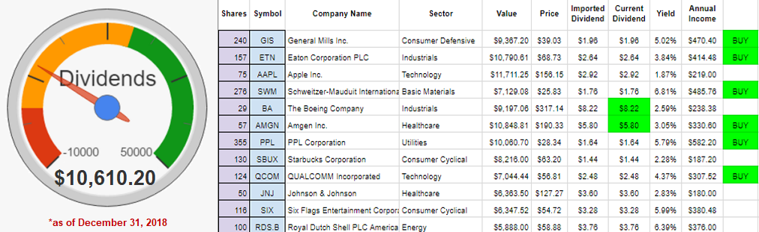

Scale Bar Example of 52-week range:

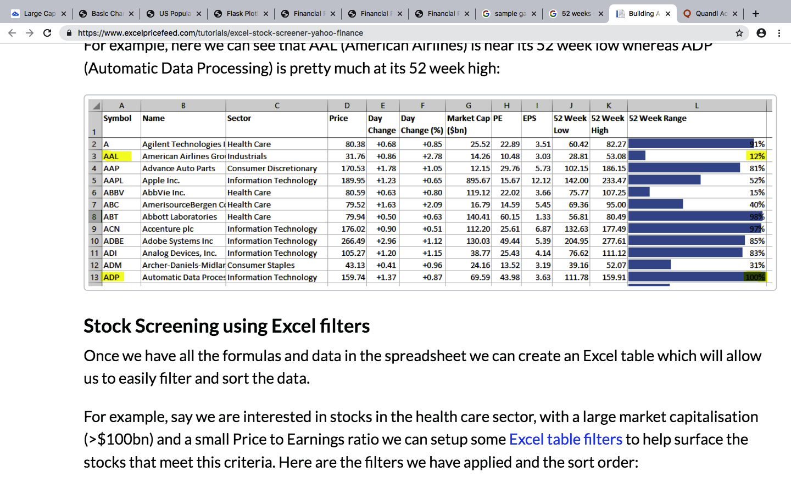

Create Table visualizing all the fields from the CSV data table similar to example:

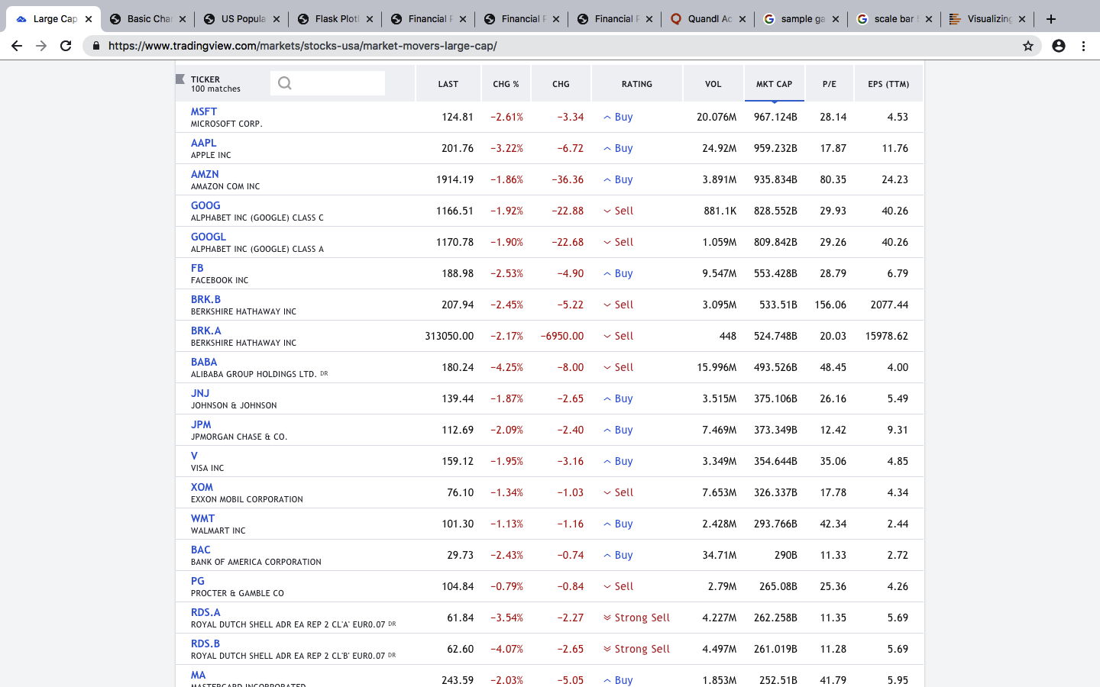

Individual Price Actions vs Time Line Charts interactive click access for each individual Equity:

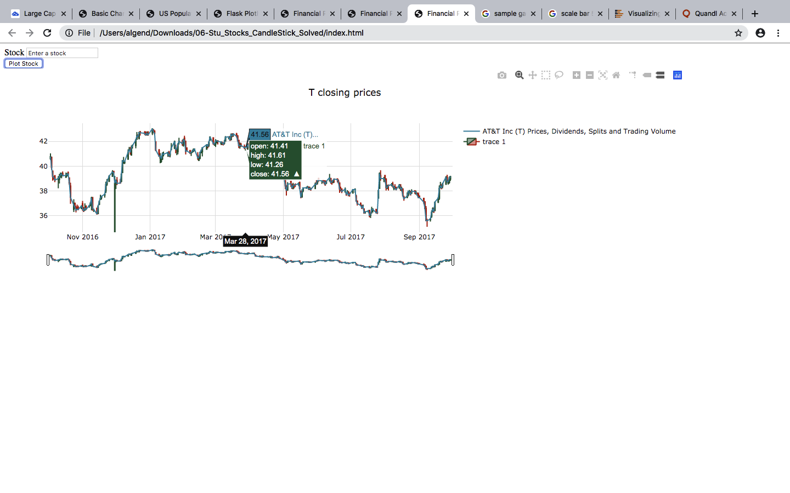

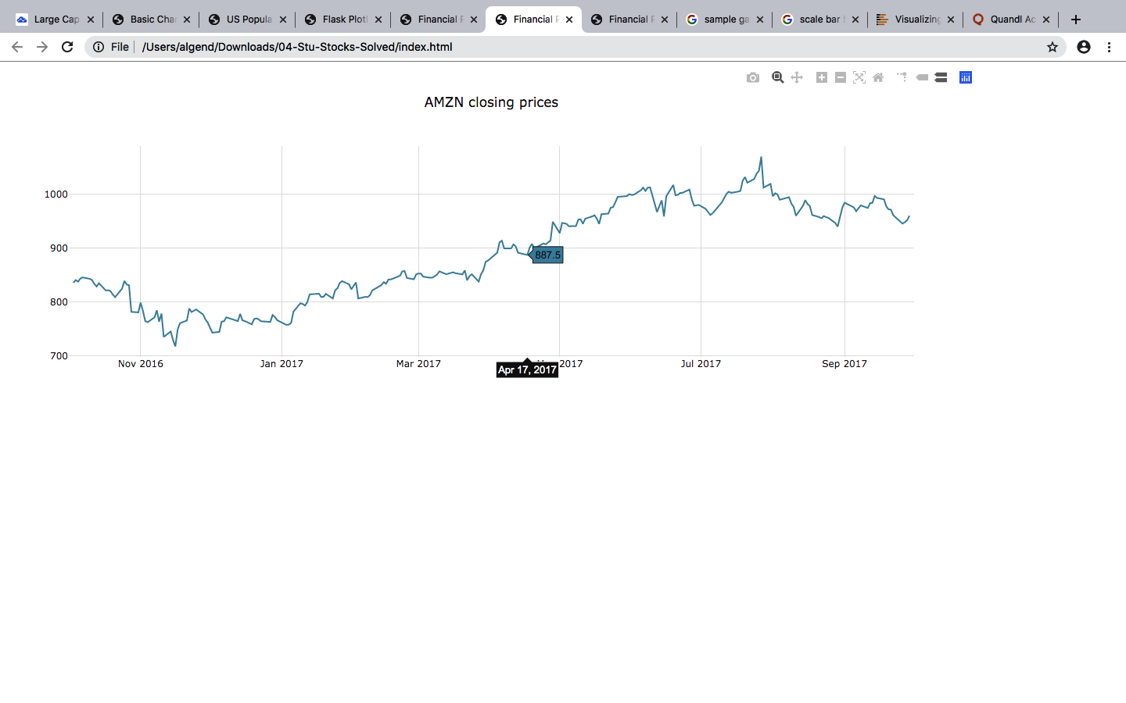

**Financials_2.CSV created columns I-L explanation:**

Column I = P/AA % (Percentage of Price per share / Annual Average Price)

Column J= P/AA% Position 3-Modes (in ascending order, top most valued):

1.Above 52Week Low

2.Below 52Week High

3.Below 52Week Low

Column K = Rating (a part of investment advice, in ascending order, top most valued)

1.Best

2.Good

3.Better

4.Caution

5.Bad

Column L = Action (a part of investment advice, in ascending order, top most valued)

1.Buy

2.Hold

3.Sell

4.Look

**Combined Column K and Column L together form an investment opinion.**

**Tested:**

Plot the price per earnings (P/E) to check k-means or similar model, to check for a possible relationship between Rating (Column K) and Action (Column J). Rating and Action values are to be assigned to X-Y axis on, & PPS to be plotted on a chart.

**Third Party Tools:**

Plan is to use a no cost approach and use all available resources to complete the project. For successful completion of the tasks. Participate in exchange of data between four parties, Albert_Gendelman vs. Microsoft_ALGEND / Trilogy_Mr. X / Open_Source_Internet, receive open-source code or data arrangement support via Microsoft GitHub+Excel+Visual Studio Code via open-access Internet and provide data via manipulation exchange (cloud connection) with Microsoft product.